
Indigenous Affairs and Public Administration: Can’t We Do Better?
Sydney, 9 and 10 October 2017
Post conference report

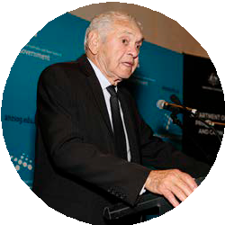
How the event came about
At the beginning of 2017 the Department of the Prime Minister and Cabinet (PM&C) approached the Australia and New Zealand School of Government (ANZSOG) proposing a partnership to work towards the clear objective of reflecting critically on the Australian Public Services’ (APS) past involvement in Indigenous Affairs,
and asking the question: how can we do better?
Fifty years since the landmark 1967 referendum, which gave the Commonwealth power over Indigenous Affairs, this question remains timely and pertinent.
The joint conference ‘Indigenous Affairs and Public Administration: Can’t we
do Better?’ was identified as a cornerstone for ANZSOG and PM&C in meeting this objective.
The conference was also made possible with the generous support of the University of Sydney and the active involvement of Indigenous and non-Indigenous representatives from Australia, New Zealand and globally.
Videos capturing some of the conversation and atmosphere of the conference have been produced by journalism interns from Griffith University, Cameron Weightman and Carla Westwood. (see www.anzsog.edu.au/indigenous-affairs-conference).
Who was involved? Delegate jurisdictions
The conference took place on 9 and 1%
10 October 2017, at the University 2%
of Sydney and brought together
more than 250 delegates from 4% 5%
across Australia and New Zealand, 4%
and some international delegates.
Delegates to the conference were 10% 38%
encouraged to think about what 3%
we can learn from each other,
about transformation in Aboriginal and Torres Strait Islander Affairs
and recognition of Indigenous 33%
communities and culture.
It was also a chance for community ^{CTH}
NSW
leaders, the academy and the public NT
sector to communicate their insights QLD
and lessons learned in supporting VIC
Indigenous leadership, retention of ^{SA} WA
staff and working with First Peoples. NZ
Other

Acknowledgement of Country
We would like to acknowledge and pay respects to the Gadigal people of the Eora Nation as traditional owners of the land on which we met. It is upon their ancestral lands that the University of Sydney was built. We pay respect to Indigenous knowledge embedded forever within the Aboriginal Custodianship of Country.

Welcome to Country
The conference took place on the land of the Gadigal people of the Eora Nation.
Uncle Charles (Chicka) Madden (pictured) provided a warm Welcome to country.

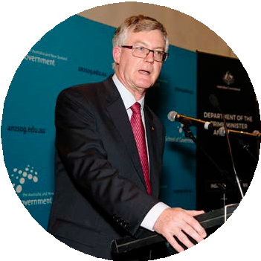
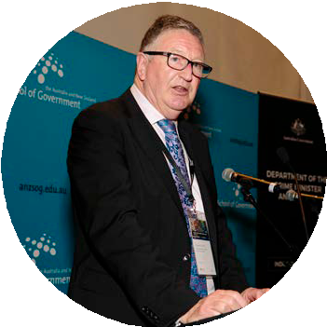
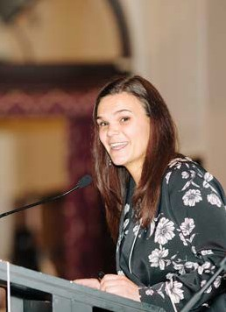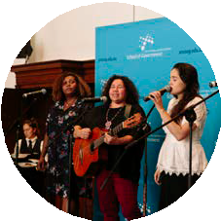
Conference dinner
Introductions from Professor Stephen Garton, Provost,
The University of Sydney, Professor Ken Smith, Dean and CEO, ANZSOG and Dr Martin Parkinson AO, Secretary PM&C.
Professor Ken Smith, Dean and CEO of ANZSOG opened the conference following a welcome from the University of Sydney’s Provost, Professor Stephen Garton.
Professor Smith stressed the need to do better in Indigenous Affairs and that failure is not an option.
“Public services need to become more responsive to the needs of Indigenous people, and to recognise that our whole nation can benefit from incorporating Indigenous knowledge and understandings into policy and practice.”
– Professor Ken Smith, Dean and CEO, ANZSOG
Professor Smith’s address was followed by Dr Martin Parkinson AO, Secretary of the Department of the Prime Minister and Cabinet. Dr Parkinson reflected on the historical significance of 2017, the fiftieth anniversary of the 1967 referendum – “For Aboriginal and Torres Strait Islanders themselves, the yes vote was about being acknowledged, at long last, as human.”
Policymakers need to listen to Indigenous people and communities, focus on strengths, not just deficits, and acknowledge the massive diversity in culture and life experiences of Australia’s First Peoples, Dr Parkinson said.

The Charlie Perkins Address
Leila Smith delivered the Charlie Perkins Address, which acknowledges the contribution of Charlie Perkins as an Aboriginal public servant whose commitment and leadership continues through initiatives such as the Charlie Perkins Scholarship. Smith drew on her own experiences as a Charlie Perkins scholar and a Wiradjuri woman, discussing exceptional performance among Aboriginal and Torres Strait Islander tertiary students, in particular the growing cohort at the University of Cambridge and other top global Universities.

Mission Songs Project
Conference delegates heard performances from the Mission Songs Project. Presented by Jessie Lloyd, the Mission Songs Project is performed as a vocal quartet with singers Deline Briscoe, Emma Donovan and Jessica Hitchcock.
Searching for the secular songs that were sung after church, the Mission Songs Project explores the day to day life on the missions, settlements and reserves through music. From cultural identity to love and loss, these rare songs consist of almost forgotten stories that can now shed light onto the history of our Indigenous elders, families and communities.
These powerful songs evoked strong emotions and provided historical grounding to help set the tone for the conference to follow.
Mission Songs music can be heard in one of the videos from the conference (see www.anzsog.edu.au/indigenous-affairs-conference).
For more information about the Mission Songs Project:
www.missionsongsproject.com

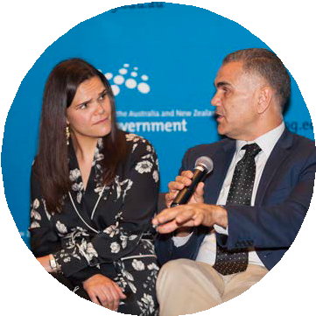
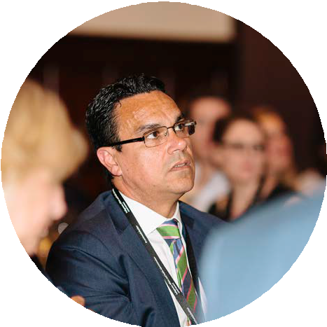
The Australian Public Service (APS) I’d like to see
The panel ‘The APS I’d like to see’ saw facilitator Leila Smith pose provocative questions to Brendan Thomas, CEO of Legal Aid NSW, Professor Steve Larkin, Pro Vice-Chancellor Indigenous Education and Research at the University of Newcastle and Professor Chris Sarra, CEO Stronger Smarter Institute.
Brendan Thomas reminded us that we need to maintain high expectations, and remember the potential for Aboriginal and Torres Strait Islander public servants to have positive impacts and affect change. Thomas said, “I love being a public servant
… the benefits of the work that we do can be profound, the difference we can make in the lives of people is incredible, and when things go well in the public sectors,
it creates rewards that you can carry with you for the rest of your life.”
“A major challenge for the public services is making sure that the needs of Aboriginal people are incorporated into decision-making across the sector. Too often today in the public service we still see Aboriginal policy buried down deep in the organisational chain.” – Brendan Thomas
Thomas said, “Aboriginal communities are in strong positions to know how to solve
a lot of the problems they have, and there are great opportunities for public agencies, public institutions and public service bodies to share decision making with Aboriginal communities in real and meaningful ways.”
Professor Chris Sarra echoed these sentiments, framing the path towards better outcomes around three points: “embrace our humanity and capacity to be exceptional”; “bring us policy approaches that nurture a sense of hope rather than an entrenched sense of despair”; and “do things with us not to us”.
Although there is potential for Aboriginal public servants to make positive change, there is also work that still needs to be done. Thomas explained that part of a respectful and high expectations relationship between the public sector and
First Peoples is giving autonomy and decision-making powers back to Aboriginal and Torres Strait Islander people where appropriate.
“I don’t want white fellas to stand down, I want them to stand up and be in a high expectations relationship with us, where you’re held to account as much as I am.” – Professor Chris Sarra
Drawing on his experience in the public sector, Professor Larkin identified government instability for Indigenous agencies and programs as a major problem. Larkin called for
“A bipartisan approach to financial structures and support for Aboriginal and Torres Strait Islander programs that goes beyond the electoral cycle. This will allow us to achieve the outcomes we have been set out to achieve, and do them well.”

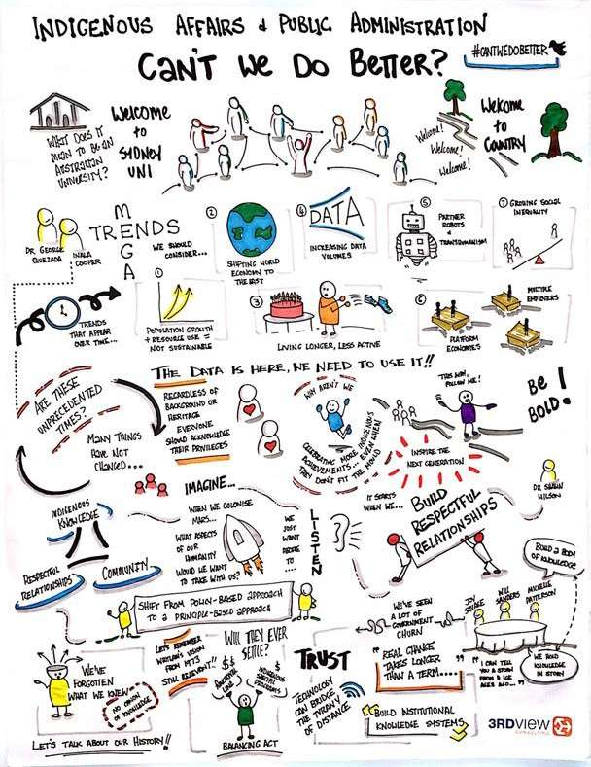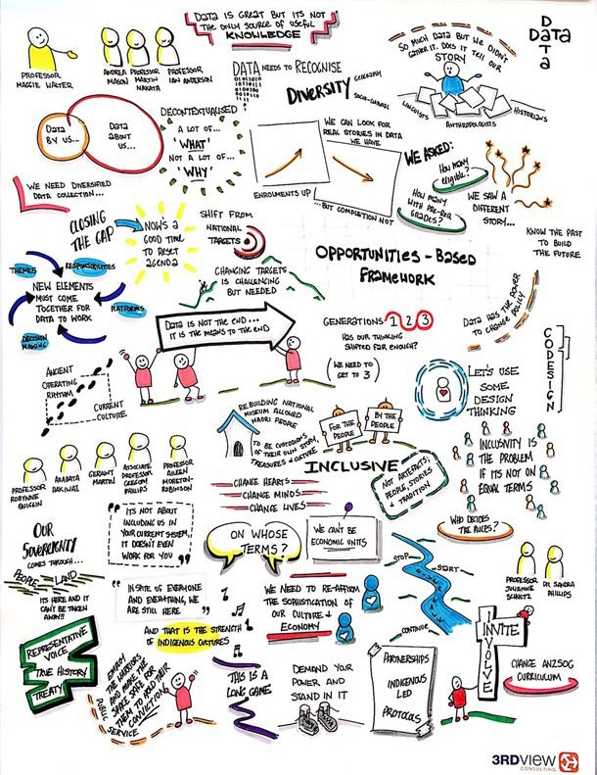
The Conference
A visual summary of the entire conference was drawn by
Hailey Langsdorf from 3rdView Consulting.
Our speakers, though acknowledging the challenges of the past, looked optimistically at the path for positive transformation in the public administration of Indigenous affairs.
One message came through clearly: it is the public sector, not Aboriginal and Torres Strait Islander peoples, that must change practice, culture and the relational basis of its interactions with
Australia’s First Peoples.


Creating an unprecedented public service for unprecedented times
Inala Cooper from Monash University followed Dr Quezada, speaking of the necessity for us all to be aware of our race and privilege. Cooper’s presentation brought the discussion back to Indigenous Affairs, reminding delegates of the great diversity of
Indigenous people, in their appearance, where they live, life experiences and culture.
It is incumbent upon those in government and the public sector to remember this diversity and make public policy accordingly. This means focusing on strengths, not just deficits, urban as well as remote communities and remembering, as Professor Maggie Walter for the University of Tasmania would make clear later in
the day, Indigeneity is not a binary category.
Dr George Quezada from the CSIRO discussed the megatrends – “…gradual yet powerful trajectories of change that will at some point
express themselves with explosive force and throw companies, individuals and societies into freefall.” (Stefan Hajkowicz (2015), p.3 of Global Megatrends) – that will shape Australia’s future.
Quezada outlined how the APS of the future will have to contend with: growing consumption of minerals, water, energy and food,
with increasingly constrained supply; digital immersion through more powerful computers, greater volumes of data and artificial intelligence; the emergence of economies in the
Indo-Pacific and East Asia; and the emergence of a networked and flexible economy which breaks through traditional employer-employee relations, government service delivery and organisational models.
This presentation prompted delegates to consider how data and evidence as it relates to public policy uniquely effects Aboriginal and Torres Strait Islander peoples and how Australia’s First People can make unique contributions to the public sector’s response to challenges of the future.

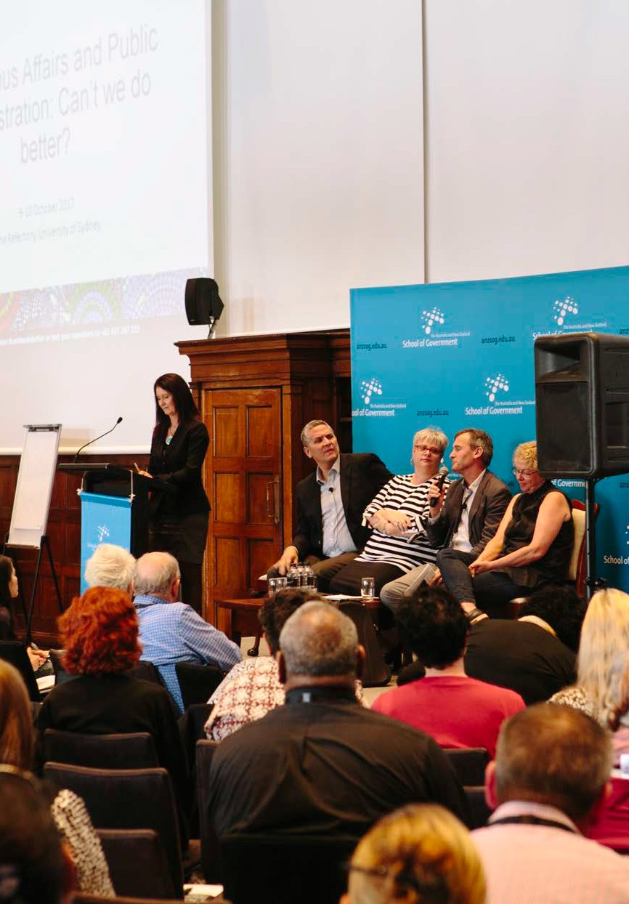
Government churn, institutional memory and the legacy of an experimental approach
Dr Shawn Wilson, a Opaskwayak
Cree from northern Manitoba, Canada, and academic at Southern Cross University, pointed to the necessity that we take Indigenous knowledge seriously. Wilson explained, “We all know how bad the system is, so what can we do differently?” He stressed that “it’s about the relationality; how can we behave relationally and who
do we engage in the relations? If we don’t change our relationships we will continue to do damage through the system.” For Wilson, better outcomes are about engaged government built on the three pillars of Indigenous knowledge, respectful relations and community.
approaches and the numerous restructures of administration, which have failed to lead to benefits on the ground.
Dr Will Sanders from the ANU framed the government churn that has characterised Indigenous Affairs in Australia over the past fifty years as
a product of competing principles in the Indigenous policy space,
between the normative imperative for equal opportunity, group choice and autonomy and group guardianship.
The outcome of these competing principles is that successive governments have changed the machinery of government as it relates to Indigenous Affairs, shifting from a principle of subsidiarity and delivery through line departments, towards the ‘people-focused omnibus’.
As Savage reflected, there have been nine machinery of government changes in Indigenous Affairs at the Commonwealth level during the past 30 years. By Sanders’ assessment this reflects a capacity by the Commonwealth to forget successes and failures of the recent past.
Sanders warns against a people- focused omnibus, which denies the responsibility across all government agencies to improve the lives of Indigenous peoples, but is optimistic that the current concentration of Indigenous Affairs in PM&C is focused more on policy advocacy, not service delivery.
“Knowledge is not a product, but a process”
– Dr Shawn Wilson
Wilson’s comments reflected a key theme of many speakers, that
overcoming policy failures must begin with respecting and learning from Indigenous knowledge and culture.
PM&C’s Joy Savage, Acting First Assistant Secretary – Business Transformation Office, emphasised the importance of co-producing policy with Indigenous peoples, saying we must “learn and embed to stop that top-down or centre-out approach, and learn from the experience of those on the ground.” She spoke
of the damaging churn of policy

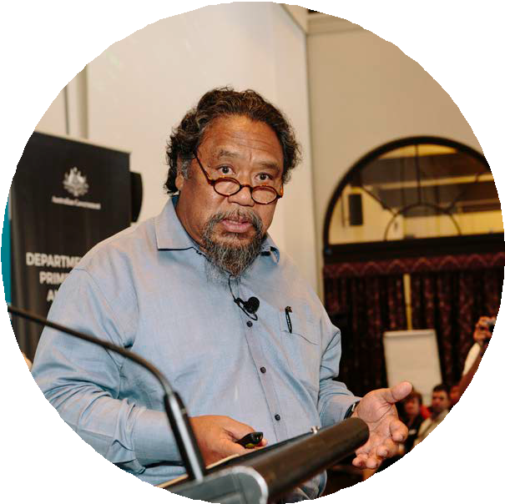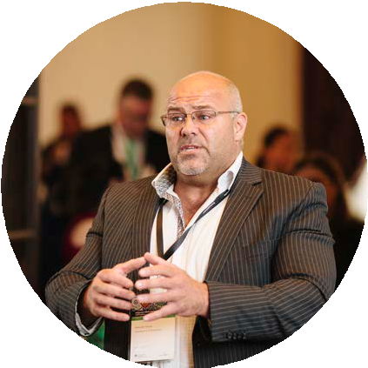
New boundaries for policymaking – Indigenous perspectives on data, cases and evidence
The damage of decision-making for, not with, Aboriginal and Torres Strait Islander peoples extends to the production and use of data.
Professor Maggie Walter explained, “Indigenous people give data but have not got value back from this data...
The data always points to what is wrong with Aboriginal and Torres Strait Islander peoples.”
Walters made the powerful point that data and statistics currently position Aboriginal and Torres Strait Islander peoples as blameworthy, aggregate, decontextualized, in deficit and reduced.
This point was echoed by Andrea Mason, CEO of Ngaanyatjarra Pitjantjatjara Yankunytjatjara Women’s Council, who emphasised the importance of culture, stating,
“Our culture owns us and we own it,
it gives us the foundation of our identity.”
To do its work properly, and have a strong relational basis for public sector interactions with Aboriginal and Torres Strait Islander peoples, there must be a sophisticated understanding and representation of Indigenous culture
in the public sector.
Deputy Secretary for Indigenous Affairs at PM&C, Professor Ian Anderson, brought his insights into how the Council of Australian Governments (COAG) is trying to bring Aboriginal and Torres Strait Islander perspectives more closely into decision-making around the Closing the Gap initiative. Professor Anderson also spoke powerfully about shifting from a deficit to a strengths based framework.
Anderson stressed the need to build more consultation and negotiation with Indigenous Australia into the COAG decision-making process. Although reforming the typically closed process of COAG negotiations to include Indigenous community representation is no easy feat, it offers an exciting opportunity to build Indigenous leadership into the decision-making processes of Australian federalism.
“Data frequently portrays Aboriginal and Torres Strait Islander Peoples as complicit in their
own unequal position.” – Professor Maggie Walter
Speakers, including Professor Martin Nakata from the University of NSW, said that data can never be fully objective or neutral, and is part of a process where Indigenous people are caught up in other people’s narratives and cannot ‘see and hear ourselves’.

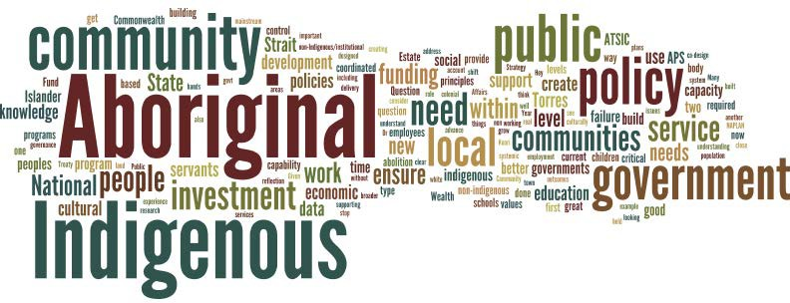
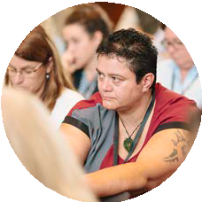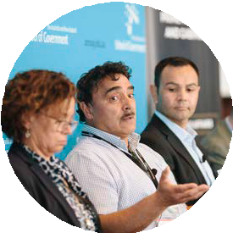
Culture, representation and
Indigenous ways of knowing and being – reimagining the public service
Arapata Hakiwai and Geraint Martin from Museum of New Zealand Te Papa Tongarewa presented on their bi-cultural approach. They explained the shift in practice at Te Papa, from exhibitions about Maori, to exhibitions with Maori. Quoting Professor Sid Mead, they explained, “One way of recapturing one’s culture is to take control of the language of definitions and descriptions and to have members of the culture speak for themselves, present their culture such as their music, their dances and their various art forms in a manner they consider appropriate to them.”
Te Papa is bicultural, which mean governance is shared between tangata whenua (Maori) and the tangata tiriti (European & other origins) peoples of New Zealand. The call from many conference speakers and delegates for Aboriginal and Torres Strait Islander involvement in decision-making and governance within organisations suggests that the bicultural experience of Te Papa may hold powerful lessons for our own ways of conducting Indigenous affairs.
Issues of relational accountability and inclusion – central to the bicultural approach – were addressed head-on by Associate Professor Gregory Phillips, stating, “Inclusion [in the public sector] is a problem if inclusion is on white people’s terms only.”
The strong message was that when we think about decision-making in government, governance structures or representation and Indigenous public sector leadership, we need to be engaged with First Peoples on the basis of respect and autonomy. We can no longer make public policy for Aboriginal and Torres Strait Islander peoples, but with them or indeed to empower communities to make public policy for themselves. Consultation cannot
be a substitute for involvement in program design and decision-making.
What we have learned and where do we go from here?
Questions from delegates
Delegates texted in questions to facilitators throughout the conference. You can see key themes in our word map of those questions.
There were calls for government to be more flexible and utilise Indigenous knowledge as well as Western practices – drawing on the best of both worlds – to facilitate better community engagement.
We also received a consistent call from delegates for the public sector to change the way policy is delivered, to decentralise policy and co-create with local communities wherever possible. A place based approach to Indigenous public administration would build local capacity for Aboriginal and Torres Strait Islander peoples, and create a path towards greater involvement for First Peoples in decision-making
and governance of their own affairs.
Delegates expressed a desire to see government policy invest in building cultural and community strength, not just the deficit focus and closing the gaps.

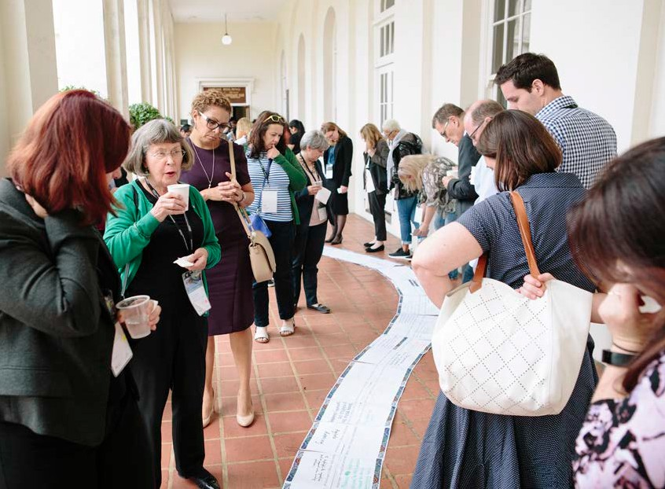
River walk – thematic analysis and overview
We chose the concept of a Riverwalk to honour Aboriginal and Torres Strait Islander cultures and traditions, which remind us to treasure our connection to land.
Rivers are life giving, they represent fertility and offer nourishment. They are places where land meets water in motion. We are reminded of how different substances combine for the betterment of all.
Rivers are gathering places. They are where vegetation, animals and peoples gravitate together, all striving for nourishment and peace.
The banks of the river remind us that there are at least two sides to every story, to every journey and that the place where two sides meet is a place that unites as well as divides.
Just as a river takes time to turn, pause, and aerate itself, we need to take time to pause, calibrate and alter course and refresh ourselves.
The movement of a river gives us hope that we are on a journey that, while not simple, is lifegiving and richly practical. Rivers join, as well as demarcate.
Drawing inspiration from the journey of the river, participants were asked to reflect on conference discussions and how those discussions related to their life and work. These reflections were written down responding to four prompts:
I will continue… I will stop… I will start… My big idea
Delegates’ reflections were then transformed into a collective ‘river walk’. During the afternoon conference participants had the opportunity to experience the river walk, where they followed participants’ reflections which had been recorded on sheets of paper and positioned along the ground like the path of a river.
Many people wrote about advocacy, agitation and speaking out. Some had a specific focus for their advocacy – stolen generations, Indigenous health or encouraging students to complete University. Most spoke of their intention to be a voice for Indigenous people and for better engagement, more effective policies and positive outcomes for Indigenous communities.
“Advocate innovative ways to implement policy change to Indigenous people starting with ensuring community engagement is done properly.”
“Pushing Indigenous affairs to the forefront – should be part of everything we do. “
People wrote about their own experience as Indigenous people working in the public sector and about communicating Indigenous issues to their colleagues.
Issues around data were frequently mentioned. Ideas from the session with Professor Maggie Walter and others caused people to reflect on the way they and their organisations use data.

People said they would stop assuming that the data provided is an accurate reflection, start questioning the data and the narrative created from the data, and seek out the stories behind the data. Some proposed to engage with Indigenous communities to determine what data to collect, to tell a clearer story about what really matters – and what really matters to Indigenous people, not just what matters to governments.
As well as encouraging community engagement, people wrote about their intention for stronger personal engagement, developing respectful relationships and listening to the stories and experiences of Indigenous people.
“Expanding understanding and appreciation of diverse Indigenous realities.”
“Ask different questions. See different answers.”
Several people mentioned the need to learn from the experiences of past policies and programs, and to acknowledge the past in planning for future policies.
“Critical to build an evidence base to inform government policy – data & research must inform decisions irrespective of government agenda. We must be effective.”
“I will start… Developing my curiosity and knowledge about the politics of the past and the perspectives of Aboriginal and Torres Strait Islander people.”
People also noted the value of sharing stories along with data. Some pointed out that listening to the Indigenous perspective and stories can be challenging for some non- Indigenous people.
“Bringing Indigenous and non-Indigenous Youth along a road of historical (Indigenous) awareness and learning. Focus on making them aware of where we come from to give vision on where they are leading as possible future leaders!”
“Sharing “stories” and experience with my younger non-Indigenous colleagues. They have to feel empowered to make a difference by working with Indigenous people.”
“I will continue… Working to inform the current generation of public servants about the histories of Indigenous affairs policy: all the ideas that went somewhere and all the ideas that went nowhere.”
“Listening / valuing / honouring the expertise of my Aboriginal colleagues.”
People’s big ideas ranged from changes they wanted to make in their own work,
to major national changes such as a treaty. Some suggested Indigenous programs in Australia be moved to the responsibility of line areas in mainstream agencies,
and there be greater coordination between agencies and across program streams. There were several specific suggestions for policy or programs:
Community engagement was often mentioned, with people emphasising that this must be real engagement, done with respect, drawing on Indigenous ways of knowing and recognising the diversity of Indigenous communities.
“To communicate at community level – to empower not take over with handouts.”
“Peer learning across Indigenous communities – accountability to each other; facilitated, not driven, by governments.”
“Promote the design of policy with Indigenous people not about them. LET OUR STORY BE TOLD.”
“A structure to engage young professionals in Aboriginal communities, new ideas and ways of thinking!”
“Develop place-based initiatives using a “shared value” approach which includes ATSI, Government, Corporate and Community sectors.”


Next Steps
The conference was not an end, but the beginning of a journey for ANZSOG.
It marks a recognition that we have not lived up to our responsibility in the past to contribute to public sector leadership and public value in Indigenous Affairs.
Consequently, ANZSOG will continue to work with PM&C, the New Zealand Government and states and territories to facilitate discussions and build networks to support Indigenous public sector leadership. To start, we have convened with PM&C a Chatham House roundtable of senior Indigenous Academic Administrators.
In December 2017, we will also co-host with PM&C a roundtable of senior Indigenous public servants to discuss and provide action proposals concerning issues of Indigenous leadership and representation in the public sector.
ANZSOG is also engaging in our own journey of transformation, a journey we started with our Listening Tour where we travelled to each of our owner jurisdictions to talk and listen to ANZSOG alumni and interested parties about what we can do to promote positive action in our work that benefits Indigenous peoples and communities.
We will start to implement the learnings from this conference in our teaching and research. We are developing materials and curriculum that will give the public sector leaders that undertake and connect with ANZSOG programs a fuller understanding of the continuing impact of history, and equip them with an appropriate understanding of Indigenous cultures, knowledges and civics as it relates to our First Peoples.
Our unique role spanning New Zealand and Australia offers us opportunities to honour and learn from each other and the experiences and leadership that is offered by Maori, and by Aboriginal and Torres Strait Islander peoples. Thank you to everyone who presented and participated. We have had very positive feedback.
Please visit the ANZSOG website for updates on our activities in this space.
www.anzsog.edu.au


Here is what he has to say about the artwork featured in this report:
“Timeless”
“I have tried to capture in this piece the importance of our culture and people to this country, our country. Our peoples journey through time on this land has been guided by the spirits of our ancestors. From the time of creation through to colonisation and now into the present day, our land and lives have changed dramatically.
The constant change and movement that Government policy direction and practices has had on our people and culture has been significant and felt deeply through the generations. It’s now been 50 years since Aboriginal and Torres Strait Islander people were finally recognised as citizens in the Australian constitution rather than flora and fauna. Only 50 years since we weren’t considered to be plants or animals in the constitution that was written for this land.
Over time and through many changes and hardship our people have remained strong and our culture has survived even during times that Government policy and practices have attempted to erode it. We can’t go back and change these experiences now.
We can only recognise the impact of the past on the present and continue moving forward to try to influence change where it is needed.
So, it’s time we come together to discuss how we can move forward together in unity and respect. To talk about how things can be done better for and with our people into the future.
Much respect to our elders who will be attending this conference I hope their voices and their wisdom will be heard.”
– Jordan Roser
To contact Jordan Roser: www.facebook.com/mirrabookadesigns
mirrabookadesigns@gmail.com

Artwork by Jordan Roser
ANZSOG commissioned artwork for this conference from Bigambul artist Jordan Roser.
Jordan Roser is a proud Bigambul man based in Redcliffe, Queensland.
A third-generation artist who endeavors to continue his family’s legacy in the arts and promotion of his culture through contemporary designs and themes. His work tries to reflect the modern experience and emotions of the new generation of Australian Aboriginal people through colour and storylines.

