Is regulatory failure a good teacher?: responses to unanswered questions on sli.do
David Chandler
Please note: the views represented here are the Building Commissioner’s alone in his personal capacity, and do not represent those of the Department of Customer Service or the New South Wales Government
Question: Regulatory failures can result in poor morale amongst the existing staff and a feeling they’re being punished for industry failures. In your experience, how can leaders turn this around?
Regulatory failure is systemic. It is a corrosive product of many fingers in the pie as evidenced in Bronwyn Weirs report "the house with no piers'. Everyone should read this: https://www.nsw.gov.au/sites/default/files/2021-02/the-house-with-no-piers.pdf.

There must be an honest situation analysis or any transformation effort could go down the wrong hole.

Every affected party will feel they are being punished and they will all point to a solution that always requires another correcting first

The reality is that all need to own the problem - both government and industry. We took 6 months to start to change the dial.

My starting point was that 20-percent of the regulator and 20-percent of industry players were the problem. A plan to deal with creating the difference between the problematic players and others needed to be credible, then the mandate.

In the regulator (refer to the Gartner Hype Cycle in my presentation) the regulatory team had their ticker worn out over 20-years. New fix it regulations, no investment in capability, constant staff cut-backs, industry always able to nullify under the 'red-tape' banner. There progressively became no reason anywhere to turn things around. A resignation to it is bad and it will get worse - just keep your head down.

Credible leadership is the key. A few players, empowered to drive change and bring the new support to get it done.

There needs to be a central rallying cause that is simple and everyone gets - in this case be proactive not reactive. Drive the bus from the front. Then the doing steps fall into place - legislation eg. RAB, risk ratings, remapping the accountability landscape etc.

Leaders need to deliver to enable the first small wins and then step up. This has been the case for every project/enterprise I have turned around. The first steps need to be celebrated and then the bar lifted. The public needs to see and believe.

Leaders need to be authentic, display the subject matter knowledge and be able to articulate how measurable change will look like. Leaders need the confidence to make a few mistakes, to be agile and be confident that their sponsor (NSW Minister for Better Regulation) has their back. In the case of NSW reform, all of the above is occurring.
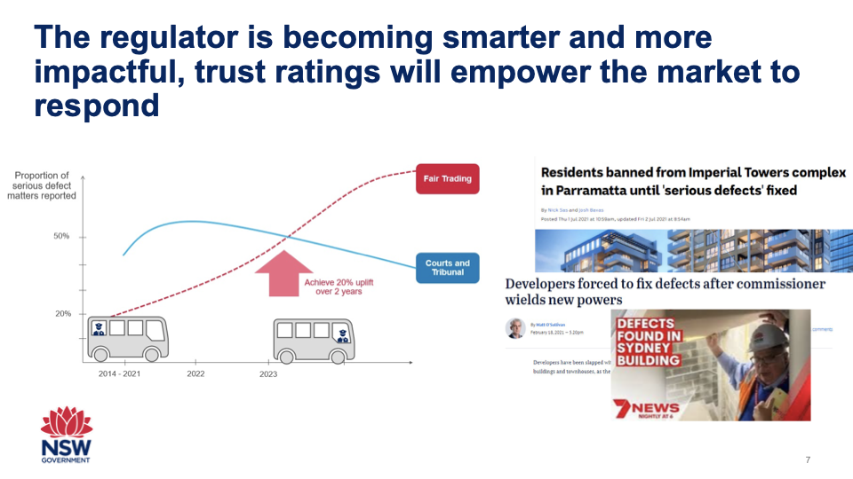

Question: In a recent article, you said an independent Building Commission was not essential for essential regulation in this sector. Could you elaborate?
In every turn around I have done it was not the organisation as the root cause. It was a lack of credible leadership.

I have a strong view that turning organisations around does not require another layer. On the contrary - thinning out, joining up and repurposing are the keys to this challenge. The existing building regulator has over 250 people in the team, hiring another 100 to sit on them would not have helped.

Leaders need to get their hands dirty and do the early strokes with the team being transformed - they learn the nuances and make great contributions. If any leader thinks they are smarter than the players then they are headed for a train wreck.

The embedded knowledge and sense of public interest runs deep in government – it’s just that they have felt impotent

We have found in hiring the first 30 - new players that onboarding is not simple. Governments have essential protocols and accountabilities. A new overlay could take years to bed down, if ever. (Another Gartner Hype). Time is of the essence.

In the NSW case - the government elected to be bold and run a sprint transformation project of 3-years. The Office of Building Commissioner is a high powered small team of <15 staff. The task was to bring everyone along - win hearts and minds. A small team has to network, engage, be respected, help do heavy lifting, solve blockages and add value.

A modern regulator will be different to the past - new harms, new technologies, multi-jurisdictions/global, changing ecosystem, new skills etc. There needs to be a reversal of all regulatory lifting coming from the government. This calls for industry to imagine and take on new roles.

The use of risk rating tools and eventually a new insurance landscape will be driven by this load shift being implemented in NSW. Again building acceptance of this pivot needs to be demonstrated with conviction and results.

The public confidence narrative in the NSW construction industry is changing - the daily claims that the regulator is incompetent has been quelled. The narrative now is about how the good players will distinguish themselves and how trustworthy buildings will be rewarded over those with low credentials.

None of this points to a Building Commission. I expect an ongoing person -Building Commission but the role would merge into a transformed regulator.

Bronwyn Weir
Question: What were the main regulatory learnings from this specific failure (building industry) that would be applicable in other industries?
The key learnings
- Need to respond to emerging and unregulated risks. I am not talking about ‘new shiny‘ risks. In the case of building the risks were amplified by external forces such as the material change in the insurance landscape in early 2000s, changes to planning policy, superannuation and foreign investment, global supply chains for products. The risks in the apartment sector of the building industry were emerging over decades but no regulator across the country was acting on them- even though the purchasers of apartments were the very same consumers that lived in single dwellings which were the focus of consumer protection regulation.

- Better manage fragmented regulatory oversight. The primary state (or federal) regulator is only as effective as all of its direct co-regulators, including those within industry. This often includes local gov and may include an outsourced regulatory function, such as private building surveyors in the case of building. In the building industry there has been an escalating dysfunctionality between state government, local government and the private building surveyor performing statutory functions. Each of them need the other to be successful in order for effective oversight of the system and yet each of them spend so much time criticising the other instead of working on their own improvements and their collective effort.

- Invest heavily in regulatory capacity and technical skill within the regulator to enable effective regulatory responses and proactive regulation on technical issues (see more in answer to question 2, below)

- Understand and effectively regulate the risks associated with outcomes based regulations – Outcomes based regulation is a form of outsourcing of regulation to industry – they get to decide what compliance looks like. This has massive risks. In building this is the ‘performance based’ technical code. The performance based code enabled the emergence of a ‘god like’ culture towards compliance with non-compliance able to be justified through undocumented ‘performance solutions’

- Investment in quality education and guidance to facilitate the improved competency of participants. The culture that sometimes prevails in regulators is ‘we are not going to tell them how to do it correctly – even if they ask because that’s too risky for us. But we will ‘punish’ them when they don’t do it correctly. Instead, the regulator should strive to be the centre for excellence within their sector with the best knowledge that it can share to continually lift and shape the capability of its regulated actors.

- Make industry associations accountable as ‘professions’ instead of them acting as clubs to protect those engaging in poor practices. Industry has to be expected to share the load with regulators. We can’t have a regulator on every building site every day and there is a chronic shortage of skills in industry so we have to be careful how much of those are put within regulators. There has to be a self interest in industry to deliver compliant buildings and industry associations are a key player in engendering this culture and complimenting the work of regulators.

Question: Is there a point in the regulatory improvement journey at which you can stop vigorously calling out the shonks and rogues and start praising the good performers?
From the start of the regulatory journey there needs to be supports for good performers and those that want to improve and strong action against those that are not. Good regulatory practice is removing a very small number of bad performers (about 5-10%) and continually lifting the capability and competency of a bigger number (to varying degrees approx. 60%) both of which require a lot of effort, determination and resources from the regulator.

The regulator needs to be a centre of excellence on what good practice is so that it can produce credible and clear guidance that industry participants can reply on to improve their practices. To be a centre for excellence they need to be in the field, auditing, engaging with stakeholders, collecting and evaluating data to see the trends and patterns. They also need to take strong decisive action against those that choose not to comply or not to improve.

In both cases the competency within the regulator is critical. The competency on technical issues to know what to write guidance about and to make it clear and useful. And the competency to investigate and gather the evidence to support strong regulatory action such as prosecution or cancellation of an approval or registration so that the shonks can be made an example of and excluded from participating in the sector. So what about the other 30% - these are your stars, praise them, put them on your advisory groups, encourage them to set an example among their peers and drive ethical behaviours and outcomes. Enable them to be the people that show the 60% why you don’t need to race to the bottom to be successful.

