Build unique leadership skills
THE TOWARDS STRATEGIC LEADERSHIP PROGRAM

CONTENTS

PAGE
- What is Towards Strategic Leadership (TSL)?
- Who is it for?
05 Not your average leadership program 06 Information for managers and
sponsoring agencies
- Understand your personal leadership style
- TSL Faculty
- Testimonials
- Frequently asked questions
- Our alumni
- Find out more

Cover:
Mary Manescu TSL 2020 alum
Executive General Manager Department of Health (VIC)

ANZSOG works for our government owners and with our university partners to lift the quality of public sector leadership across Australia and Aotearoa New Zealand. Our work inspires and connects people across agencies, sectors, jurisdictions and nations.
We acknowledge the Aboriginal and Torres Strait Islander peoples as First Peoples of Australia, and Māori as tangata whenua and Treaty of Waitangi partners in Aotearoa New Zealand.

Melbourne Connect building (ANZSOG HQ) Photography: Peter Casamento

03 Towards Strategic Leadership

“TSL helped me validate who I was, my personal self as a leader.
One of the lightbulb moments that still resonates with me is the
importance of authentic leadership – still delivering on government
policy but doing it in a way that I
am comfortable and confident with.”
Julie Etchells TSL 2020 alum
Senior Executive Leader
Department of Children, Youth Justice and Multicultural Affairs (QLD)

- Towards Strategic Leadership

What is
Towards Strategic Leadership?

ANZSOG’s Towards Strategic Leadership Program (TSL)
is a unique program tailored to prepare leaders for the exceptional challenges facing the public sector today.
Public sector leaders will develop the qualities needed to thrive in volatile and uncertain times. Participants walk away with a renewed strategic outlook, political astuteness, personal resilience and the capacity to reflect, collaborate, lead and learn continuously.
TSL is specifically designed to meet the needs of senior public servants and to provide you with the opportunity to reflect, learn and grow to be able to carry out their roles with clarity, wisdom and energy.
As a participant, you will leave the program with a defined sense of purpose, a stronger sense of self and the ability to recognise and manage urgent and important tasks within their organisation and the public sector more broadly.
TSL offers hybrid delivery and will nurture an inspiring environment where learning can happen that otherwise does not take place in a work context filled with day-to- day pressures or in a conventional classroom setting.
You will be co-contributors and an integral ingredient to the program’s success. TSL will harness the knowledge and experience of all participants who, as professional peers, share a common language and
a commitment to public service.
Previously delivered face-to-face across a two week period, TSL was moved online for the first time in 2020 as a result of the ongoing impact of the COVID-19 pandemic.
The online delivery received overwhelmingly positive feedback, maintaining the spirit and tradition of the face-to-face delivery by ensuring a keen focus on personal reflection in the context of the crisis environment.
The current delivery is designed to take the best of both these worlds, and merges them in
the form of two half-day online introductory modules, followed by an intensive 4.5 day residential,
and closed by three further online modules designed to consolidate the post-residential integration
of TSL learning experiences into participants’ work practices.
The entire program is run under Chatham House Rule.
Program duration:
TSL will be delivered in a blended format across six modules from 22 September 2022 to 7 February 2023. This includes a face-to-face residential in Sydney plus two x pre-face-to-face online modules and three x post face-to-face online modules.
Module details:
Orientation:
Thursday 22 September 2022
Module 1: (Online)
Tuesday 4 October 2022
Module 2: (Online)
Tuesday 11 October 2022
Module 3: (Face-to-face)
24 – 28 October 2022 (4.5 days in Sydney)
Module 4: (Online)
Friday 18 November
Module 5: (Online)
Monday 5 December 2022
Module 6: (Online)
Tuesday 7 February 2023
Location: Residential to take place in Sydney
Cost: $21,000 AUD + GST

- Towards Strategic Leadership

Who is it for?
  - Public sector directors and branch managers
  - Public sector leaders
  - Not-for-profit executives
TSL is the ideal program for senior public sector professionals, such as Directors and Branch Managers, and more generally those who are in the process of moving from tactical to strategic leadership roles. TSL is designed to help you perform your role with purpose, good judgement and strategic nous.
TSL will provide a tangible boost in confidence and capabilities and prepare leaders to face senior executive responsibilities.

Not your average leadership program
ANZSOG’s innovative and respected program co-directors Paul ‘t Hart and Robbie Macpherson have led TSL for more than 10 years. The program creates a dynamic forum which combines non-traditional learning methods, such as extensive individual and group- based reflection and real-world case studies, with peer consultations and critical thinking.
Across six modules, participants explore:
- the triangle of self, role and system within which strategic leadership takes place
- assumptions about themselves, their organisation and the wider public sector
- the distinctive governance challenges associated with different types of crises
- the factors driving the adaptive capacity of public institutions
- the opportunities for driving change, fostering learning and accelerating innovation that open up during critical junctures.

“My ANZSOG experience gave me a lens that in order to be an effective leader you need to be able to
take care of yourself and others.
To really make time for recharging and self-reflection, and for bringing everyone along on the journey and giving them time to adjust.”
Mary Manescu TSL 2020 alum
Executive General Manager Department of Health (VIC)

“The conversations with other participants are still ongoing now and it is incredibly valuable to be able to tap in to other people’s experiences and viewpoints.
I took something out of every component of the program.”
Adam Gwin TSL 2019 alum
Chief Superintendent Queensland Fire and Emergency Services (FNQ)

- Towards Strategic Leadership

Information for managers and sponsoring agencies

Owned by and working for the governments of Australia and Aotearoa New Zealand,
ANZSOG is not a regular training or education provider. We work with our government owners and university partners to create and deliver education programs and research which is tailored to meet the needs of public sector leaders today.
Led by renowned academics and top practitioners from the government and non-
government sectors, ANZSOG’s programs, unlike those of a standard business school, provide public servants with the capabilities and tools they need to address the distinct challenges they face on a
day to day basis.

Who should I nominate?
Nominate a public sector executive, such as a Director or Branch Manager, or someone who is moving, or is ready to move,
from an operational to a strategic leadership role.
The program will suit those seeking clarity in their decision-making to help them perform their roles with purpose and good judgment.
First Nations

Public Administration Scholarship
ANZSOG offers a scholarship to assist the development of a First Nations person working in the public sector in Australia or Aotearoa New Zealand. The scholarship, worth $21,000 to
$50,960 AUD, is used exclusively for an ANZSOG foundation program, either the Executive Master of Public Administration (EMPA), the Executive Fellows Program (EFP) or Towards Strategic Leadership (TSL).

The inaugural 2021 Scholarship was awarded to Palawa woman Brenda McDermott, currently working in the Victorian public service. Brenda commenced the EMPA in 2022.

ANZSOG is planning to offer a scholarship in 2023 to a First Nations public servant, for enrolment in late 2023 or early 2024. If you are interested in finding out more about the Scholarship, sign up to the ANZSOG Indigenous news, and/or our general e-news to be notified when scholarship applications open.

Investment
The sponsoring government or agency covers program costs, including tuition fee and program materials.
A student may enter into a salary sacrifice arrangement with their employer to attend the program. The student’s employer will be billed the program fee. This will be discussed on a case-by-case basis with the applicant’s sponsoring agency.

- Towards Strategic Leadership

Understand your personal leadership style

TSL encourages participants to identify personal and institutional strengths and weaknesses, helping you to understand your personal leadership style, and how your roles fits within your organisation, the broader public sector and the community.
You will develop reflective and strategic thinking and discover tools to discern and address the urgent and strategically important tasks, with an emphasis on integrating them into your everyday practices.

Outcomes
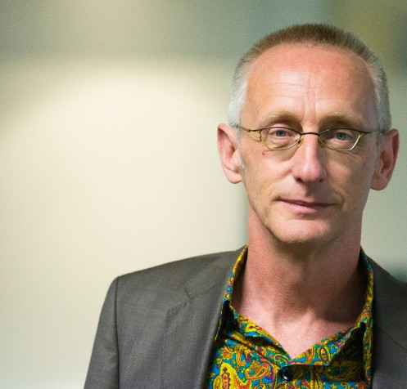TSL participants will explore thematic thrusts, that will be interwoven in the structure of the program and both the

“Our participants are leaders who value the importance of rising above ‘fire-fighting’ and relentless ‘issue management’ in public
service life. They are keen to get ahead of the game.”
PAUL ‘t HART
Towards Strategic Leadership Co-Director
Professor of Public Administration - Utrecht University
Associate Dean - Netherlands School of Public Administration
asynchronous and live activities, including:
Strategic leadership
› Self, role, system
› Authority vs Leadership
› Technical vs adaptive challenges
› Relational work: informal authority and leadership capital
› Identity work: navigating us and them
› Communicative work: rhetoric, dramaturgy, symbolism
› Political work: up, down, and out
› Collaborative work: Leading when no one is ‘in charge’.

- Towards Strategic Leadership

TSL faculty
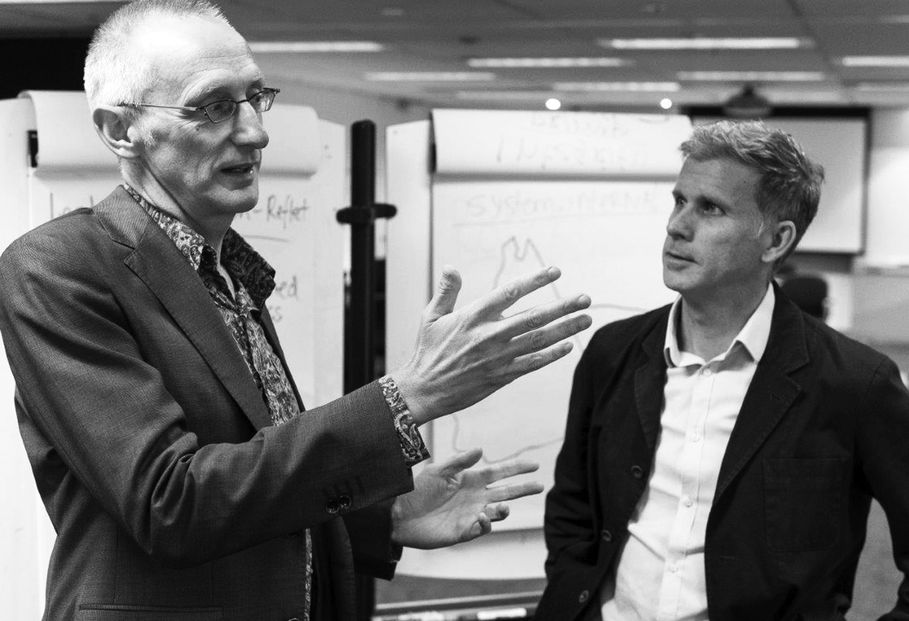
Paul ‘t Hart
Professor of Public Administration at Utrecht University and Associate Dean of the Netherlands School of Public Administration in The Hague. His experience with leadership is based on extensive and close-up research, training and consulting in the Netherlands, Sweden and Australia. His work focuses on political and public service leadership, policy evaluation, public accountability and crisis management. He currently leads a program of research in what makes public policies, organisations and networks particularly successful.

Robbie Macpherson
Managing Director of Adaptable Leadership and Principal at Reos Partners, a global consultancy that drives thinking and practice in solving tough, systemic problems. He has extensive experience
developing senior public sector leaders as well as executives in the corporate and not-for-profit sectors. He has worked in Scotland, Australia, the Netherlands, the US and South Africa.

- Towards Strategic Leadership

Testimonials

The following is a selection of testimonials from TSL past participants:

“Sometimes as a leader you can have moments of feeling alone/isolated and I think this course provided an opportunity to share with peers
in a safe environment.”

“The presenters Paul and Robbie were amazing – engaging, knowledgeable and extremely well versed in the topic. I would recommend this course to any leader seeking to improve their skills.”

“We bonded as a group and got to know each other through the group sessions and the break out rooms. I thought the Leadership Challenge was brilliant.”
“I realised that the challenges I am dealing with are not dissimilar for people in other departments/state governments.”

10 Towards Strategic Leadership

Frequently asked questions
Please see below for frequently asked questions relating to ANZSOG’s Towards Strategic Leadership.

What are the program fees?
The program fees are $21,000 AUD + GST
What does the program fee include?
The fee includes all program materials, teaching faculty and facilitation, and learning management system access.
When do applications open?
Applications are now open on ANZSOG’s website. Apply now or express your interest and we will contact you for the next iteration of Towards Strategic Leadership. Applications for TSL 2022 close on 1 September 2022.
What is the cancellation policy?
Places for TSL are limited to ensure an engaging environment for participants, as such, places are hotly contested. However, once you have been accepted into the program, cancellation will only be considered in exceptional circumstances due to the difficulty of filling places at short notice.
When is the program being held?
The program will be blended delivery (face-to-face and online). Module details are below:
› Orientation:
Thursday 22 September 2022
› Module 1: (Online) Tuesday 4 October 2022
› Module 2: (Online) Tuesday 11 October 2022
› Module 3: (Face-to-face) Monday 24 to Friday 28 October 2022 in Sydney
› Module 4: (Online) Friday 18 November
› Module 5: (Online) Monday 5 December 2022
› Module 6: (Online) Tuesday 7 February 2023
Who is the program for?
TSL is the ideal program for senior public sector
professionals, such as Directors and Branch Managers, and more generally those who are in the process of moving from tactical to strategic leadership roles.
The program is designed to help you perform your role with purpose, good judgement and strategic nous. TSL will provide a tangible boost in confidence and capabilities and prepare leaders to face senior executive responsibilities.
Can I speak with a previous TSL participant?
If you are interested in applying for TSL, we encourage you to
speak to our TSL alumni to get an insider’s perspective. Please contact our Alumni Coordinator via email at: alumni@anzsog.edu. au, to arrange an introduction.
Do I need managerial approval to attend the program?
Yes. In submitting the application form, you confirm that your manager agrees to support you to participate in the program and that your organisation will pay the full program fee if your application is successful. Your manager will also receive a copy of your application via email.
When will I be invoiced?
Once you submit your application, it will be reviewed by the selection committee and you will be advised as soon as possible of the outcome.
Once you have received formal acceptance into the program, your organisation will be invoiced.
Who teaches into the program?
Towards Strategic Leadership is co-led by Paul ‘t Hart, Professor Utrecht University and Netherlands School of Government and Robbie
Macpherson, Managing Director, Adaptable Leadership.
How long is the program?
TSL is delivered in a blended format (face-to-face and online) with six modules held over
five months. Sessions are usually five to six hours long and may occur outside of business hours (until 6pm or 7pm AEST).
How big is the cohort?
The program offers a maximum of 42 places each year.
A selection committee will assess each applicant’s level and experience and, where possible, seek a balance of jurisdictions and departments.
What are the program (learning) outcomes?
TSL participants will explore thematic thrusts, that will be interwoven in the structure of the program and both the
asynchronous and live activities, including:
› Strategic leadership
› Self, role, system
› Authority vs Leadership
› Technical vs adaptive challenges
› Relational work: informal authority and leadership capital
› Identity work: navigating us and them
› Communicative work: rhetoric, dramaturgy, symbolism
› Political work: up, down, and out
› Collaborative work: Leading when no one is ‘in charge’.
Will I become part of the alumni community upon completion of the program?
Yes, you will. Our Alumni Program helps you to maintain and
build on your peer-to-peer relationships, creating a broad community of public sector managers from across Aotearoa New Zealand, Australia and internationally. This provides
an opportunity for ongoing learning and support from peers, greater exposure to different perspectives, and
an appreciation of work done, and solutions found, elsewhere.
Can I use FEE-HELP to pay all or part of my tuition fees?
No unfortunately you can’t use FEE-HELP. You may enter a salary sacrifice arrangement with your employer to attend the program. Your employer will be billed the program fee.
This will be discussed on a case-by-case basis with your sponsoring agency.

11 Towards Strategic Leadership

Our alumni

ANZSOG’s alumni is a 3600+ community of influential public sector and public purpose leaders, with members based in about
40 countries. ANZSOG’s alumni embody its values of excellence, collaboration, integrity and respect.
ANZSOG plays a unique role in providing education and development opportunities
for people in the public sector, and a unique mission to create public value by lifting the quality of public sector leadership in
Australia and Aotearoa New Zealand.
The ANZSOG alumni is both a product and an extension of this role, which informs ANZSOG’s mission:
to be a world-leading organisation for public sector education, research and knowledge exchange.
The alumni features graduates of ANZSOG’s Executive Master of Public Administration, Executive
Fellows Program, Towards Strategic Leadership, Deputies Leadership Program and International programs, making it an unparalleled resource for your professional network.
Interested in organising an alumni meeting in your area or perhaps you want to connect with fellow alumni in an informal setting?
Email alumni@anzsog.edu.au or post in the Alumni LinkedIn group.

ANZSOG Alumni Program
Our alumni program seeks to deliver dynamic and engaging opportunities to help you build on and refresh your skills, knowledge and networks, and broaden your sphere of influence.
The program is designed to keep you connected, inspired, educated and enriched with your fellow alums and further equip you to face the real world problems of the modern public sector.
There are a number of opportunities for ANZSOG alumni to stay involved and informed. Please visit the ANZSOG website (https://anzsog. edu.au/communities-and-networks/ alumni/about-our-alumni-program/) for more information.

Stay connected
You can also keep in touch with ANZSOG and connect with fellow alumni via our social media channels:
Follow us on LinkedIn Follow us on Twitter
Like us on Facebook

OUTSTANDING PUBLIC SECTOR LEADERSHIP

Find out more

For more information, contact +61 3 8344 1909 or email: programs_team@anzsog.edu.au
ANZSOG.EDU.AU

