Enhance your leadership
Create positive impact
THE EXECUTIVE FELLOWS PROGRAM

CONTENTS

PAGE
- Introduction to the Executive Fellows Program (EFP)
- What is the EFP? 04 Who is the EFP for?
- Why should I choose the EFP? 06 What will I learn?
- Outcomes
- EFP faculty
- History of the EFP
10 How to apply?
- Information for managers and sponsoring agencies
- Frequently asked questions
- Our alumni
- Find out more

Melbourne Connect building (ANZSOG HQ) Photography: Peter Casamento

Nev Nichols
EFP 2021 alum Executive Director Sydney Trains

The Executive Fellows Program (EFP) features four, as well an orientation session and residential to take
place in Sydney, from 29 September to 6 December 2022.
Format: Blended
Dates:
› Orientation: 29 September 2022
(3 hours)
› Module 1: (Online)
10, 11, 12 October 2022
› Module 2: (Online) 9, 10, 11 November
› Module 3: (Face-to-face)
22, 23, 24, 24 November in Sydney
› Module 4: (Online) 5, 6 December 2022
Cost: The program costs
$26,000 AUD + GST
Find out more
Applications are now open.
To apply or find out more, visit: anzsog.edu.au/education-events/ executive-fellows-program or contact +61 3 8344 1909 or email: programs_team@anzsog.edu.au
Cover:
Michelle Campbell EFP 2021 alum Executive Director
Office of Projects Victoria

ANZSOG works for our government owners and with our university partners to lift the quality of public sector leadership across Australia and Aotearoa New Zealand. Our work inspires and connects people across agencies, sectors, jurisdictions and nations.
We acknowledge the Aboriginal and Torres Strait Islander peoples as First Peoples of Australia, and Māori as tangata whenua and Treaty of Waitangi partners in Aotearoa New Zealand.

Introduction to the EFP

In a time of volatility and uncertainty, senior public sector executives are facing constantly shifting priorities and increasing demands. More than ever before, it’s vital for you to develop the leadership, management and strategic skills you need to
lead high performing teams.
The Executive Fellows Program (EFP) challenges senior public sector executives to develop new leadership perspectives in a highly interactive setting while exploring contemporary issues, such as
the post-COVID environment, social movements, civil unrest, and preparedness amidst the global spectre of war.
The EFP is not just any executive leadership course. The EFP puts you in the ‘room’ with fellow public sector executives from across Australia and Aotearoa New Zealand,
expanding your professional network and creating an opportunity to
learn from the experiences of other jurisdictions. You will benefit from lively, interactive online sessions, including online sprints and offline reflection which can be done at your own pace – all tailored to fit around the lives of busy public sector executives. This delivery of EFP
will also feature the return of face-to-face interactions in a
highly engaging immersive learning experience in Sydney, Australia.
You will learn from a cast of renowned academics and senior public sector practitioners from Australia, Aotearoa New Zealand and around the world, in a program designed to help you take the next step in your career. The EFP alumni includes more than 200 public sector leaders who have gone on
to hold roles as CEOs or Secretaries (equivalents) or deputies after completing the program.
Develop a greater sense of who you are as a leader and how you can shape organisational change to deliver public value to the communities you serve.

03 Executive Fellows Program
Ro Allen
EFP 2021 alum
Victorian Equal Opportunity and Human Rights Commissioner

“The EFP gave me an in-depth understanding of change and how to manage change and some of the models around that – which is good because I’m taking my brand new organisation on a change journey. The whole experience gave me time to step out of what I was doing and step into the bigger picture of the public sector and the global situation.”

Ro Allen

Paul James
EFP 2009 alum Government Chief Digital Officer Department of Internal Affairs (NZ)

- Executive Fellows Program

What is the EFP?

The EFP is a highly respected program designed exclusively for senior public sector executives. It provides you with a unique opportunity to develop your ability to lead and learn alongside your peers from across Australia and Aotearoa New Zealand.
The four-module program featuring online sprints and face-to-face immersive engagement alongside offline reflection, is delivered by world-recognised academics and high-calibre practitioners.
You will be encouraged to share your personal leadership experiences in a creative and collaborative environment, and you will be able to at once apply what you learn when you return to work.
The EFP has evolved to embrace the best of face-to-face and online environments, creating a dynamic and interactive learning experience where you learn from presenters, and your peers, in short engaging sessions designed to maximise the positive impact on day-to-day work.
The EFP features:
- short, sharp interactive sessions including a mix of teacher-to-participant sessions, participant-led sessions, group work, immersive elements and facilitated panel discussions
- four modules designed to provide you with an opportunity to immediately apply what you learn between modules when you return to work
- opportunities for self-reflection, action-learning groups exploring solutions to your leadership challenges and leadership-in-practice workshops
- practical frameworks and techniques, immersive learning cases and live policy challenges.
If you’re searching for a public service leadership course, executive leadership training or looking to build high performing leadership qualities, the EFP is the program for you.

Who is the EFP for?

The EFP is designed for high performing leaders and senior public sector executives, such as Deputy Chief Executive Officers (CEO), Deputy Director-Generals and Deputy Secretaries, and executives two levels below CEO, Director-General or Secretary.
The program is also suitable for senior executives in the not-for-profit sector, international equivalent levels and other experienced, high-performing senior leaders.

- Executive Fellows Program

Why should I choose the EFP?

ANZSOG is a unique education provider. Our programs are designed for the public sector, with input from governments across Australia and Aotearoa New Zealand, and they are
led by renowned academics and respected practitioners. Our programs are tailored to meet the needs of public
sector leaders who face distinct challenges in today’s volatile environment.
The EFP is modelled on global executive leadership courses, but adapted for the specific challenges of the contemporary
public sector. By taking part in the EFP, you will build a long-lasting network of fellow public sector leaders from across Australia, Aotearoa New Zealand and beyond. You will also join the ANZSOG alumni, which includes thousands of public sector leaders.
You will benefit from strategies, frameworks and an international perspective, which are required to effectively lead across cultural boundaries and in an increasingly complex, virtual/digital operating environment.
The EFP focuses on the capabilities successful public sector leaders need to thrive in this environment, exploring:
› the interactive dynamics they face
› how to better respond to competing requirements
› how to frame discussion,
› planning and strategic actions.

- Executive Fellows Program

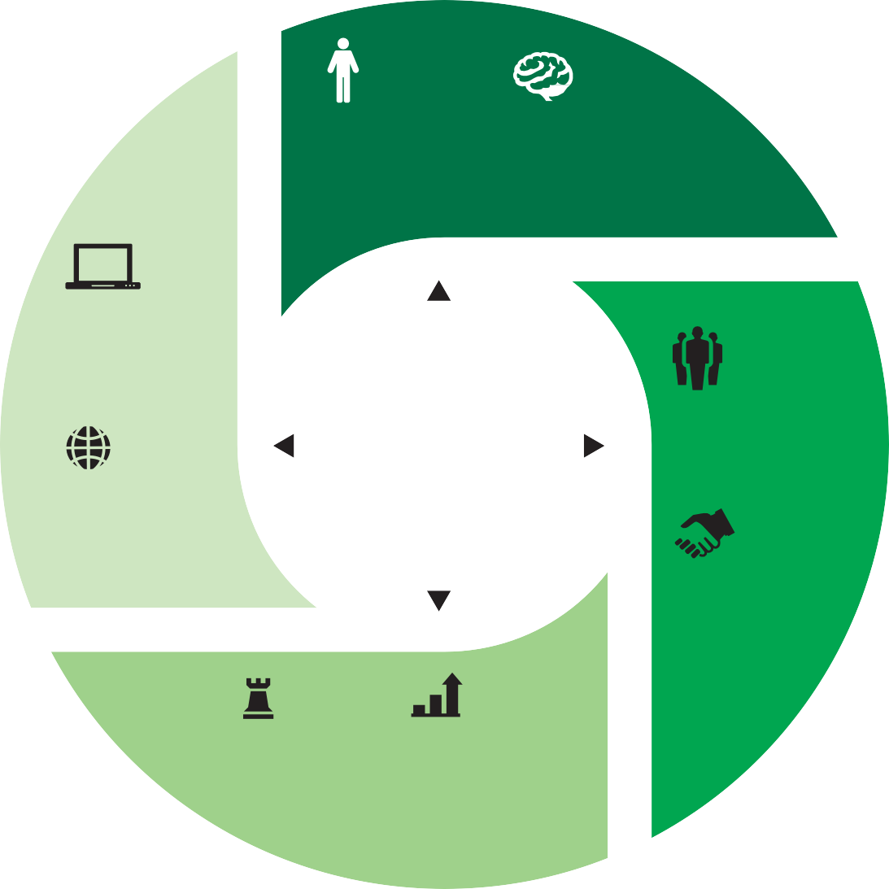What will I learn?
EMBODIED NEURO LEADERSHIP LEADERSHIP
Leading through Applying the findings
self-management, of neuroscience to physical awareness, mindful the work of leadership practice and creativity
DIGITAL LEADERSHIP
Leading with awareness of shifting technologies and leveraging the best of the new digital era
EFP
Leadership Framework and Toolkit
AUTHENTIC LEADERSHIP
Leading with a clear sense of self and purpose
SYSTEMS LEADERSHIP
Leading in the context of complex interactions, interdependencies
and interests
COMMUNITY LEADERSHIP
Leading through engagement, influence and connection
ADAPTIVE PUBLIC VALUE LEADERSHIP LEADERSHIP
Leading in the face of Leading in order to create volatility and uncertainty public value with the support
of the authorising environment
L

The EFP focuses on three key leadership themes:
› leading the self and others (including neuroleadership)
› leading an organisation (including adaptive leadership)
› systems leadership.
These themes are explored using contemporary issues
as a focal point, including the post-COVID-19 world, social
N
movements and civil unrest,

as well as preparedness in the face of the global spectre of war.
E
By exploring contemporary issues, you will benefit from engaging and relevant learning opportunities with real-world application. The EFP leadership framework underpins the themes, content and teaching methods
of our program, highlighting the capabilities required of a successful leader.
I

- Executive Fellows Program

Outcomes

“The EFP was valuable for me because it was the first time in some years I had spent time investing in my own management capacity. I am a more reflective leader as a result of having been on the
EFP and having been able to engage with other people in senior positions about the way they approach difficult problems.”
Grahame Morton

Throughout the program, you will explore the three leadership themes outlined on the previous page. Outcomes from these themes, include:

› explore the latest thinking on leadership
› discover leadership frameworks which can be applied immediately in your agency
› develop a greater sense of self as a leader
› build skills to effectively lead across cultural boundaries in an increasingly complex operating environment
› broaden and deepen your professional networks
› gain deeper insights into the operating environment of the public service with particular attention to politics, the media, the international sphere and other sectors
› increase capabilities in reading and shaping organisational cultures
› find inspiration and opportunities to take your leadership to the next level
› learn how to better communicate in your relationships with ministers, staff and stakeholders, to create and deliver public value
› understand the role of evidence in guiding complex decision making
› recognise the major concepts that underpin contemporary public sector financial management processes
› undertake ethical primary research and build your strategic capability in diagnosing, instigating
or adapting to change in the public sector.

Grahame Morton EFP 2019 alum Senior Diplomat
NZ Ministry of Foreign Affairs and Trade

- Executive Fellows Program

EFP faculty

Our faculty include leading national and international academics who are experts in the public sector. We also draw on the expertise of senior practitioners from the public, not-for-profit and private sectors.
Professor Catherine Althaus, ANZSOG Deputy Dean (Teaching and Learning), and ANZSOG Chair in Public Service Leadership and Reform, University of New South Wales Canberra (Extraordinary Professor, University of Pretoria and Adjunct Professor, University of Victoria, British Columbia and Griffith University)

“We’re recognising that leadership is not just a professional activity – it’s something that we need to embody, and it’s holistic – and we are very
committed to that in the delivery of this program.”
Catherine Althaus

Photography: Peter Casamento
Robin Ryde, former Chief Executive UK National School of Government, and leadership and organisational development expert.

“People that join the EFP are very experienced public servants – they’re looking at a period of time in their career when they can really make a profound impact. The EFP provides them with an opportunity to soak up experience and knowledge, and to return to work with a renewed energy.”
Robin Ryde

- Executive Fellows Program

History of the EFP

The EFP has been educating public sector executives since 2003 and continues to be one of ANZSOG’s highly-respected education offerings, attracting high performing leaders from across Australia and Aotearoa New Zealand.
The EFP has continually evolved and in recent years has been delivered as an intensive and lively three-week residential program for senior executives
to develop their capacity to lead. The three uninterrupted weeks provided a rare opportunity for focused learning and reflection for busy senior executives.
The program emphasised immersive and experiential learning, and was delivered in three cities across three countries by world-recognised academics and high-calibre practitioners.
Due to the impact of COVID-19 and current approach towards managing responses to the pandemic, EFP 2022 has been revamped for blended delivery.

The EFP has continually evolved and in recent years has been delivered as an intensive and lively three-week residential program for senior executives to develop their capacity to lead.
Due to the impact of COVID-19 on travel and indoor group gatherings, EFP 2022 has been revamped for blended delivery. Importantly, the 2022 program emphasises the engaging elements of the previous version of the EFP, translating them into the online environment while factoring in participant wellbeing, for example online fatigue.
2022 EFP participants will benefit from lively, interactive online sprints and offline reflection (which can be done at their
own pace).
These sessions are tailored to fit around the lives of busy public sector executives.
The blended delivery method of the 2022 EFP also provides access to renowned academics and senior public sector practitioners from Australia, Aotearoa
New Zealand and beyond.

10 Executive Fellows Program

How to apply?
Information for managers and sponsoring agencies

Applications for 2022 are now open. For more information, submit an expression of interest or contact +61 3 8344 1909
or email: programs_team@ anzsog.edu.au.
If you work for the governments of Western Australia, New South Wales or Victoria, please contact your department or agency’s Human Resources or Learning and Development team about your application or expression of interest.
If you work for the Northern Territory government, please contact the Office of the Commissioner for Public Employment at swpd.ocpe@ nt.gov.au about your application or expression of interest.
If you work for the Aotearoa New Zealand government, please contact Lynn Evans at the Leadership Development Centre at LDCProgrammes@ldc.govt.nz; about your application or expression of interest.
If you work for the Queensland government, your Public Sector Commission has a limited number of scholarships available for the program. If you would like to be considered for a scholarship via your jurisdiction’s Public Sector Commission, we encourage
you to contact them for further information including dates for application submission.
Owned by and working for the governments of Australia and Aotearoa New Zealand, ANZSOG creates and delivers education programs tailored to meet the needs of public sector leaders.
Our programs are designed with significant government input, for government, and led by renowned academics and respected practitioners.

Who should I nominate?
The EFP is designed for high performing senior public sector executives, from Deputy Chief Executive Officers (CEO),
Deputy Director-Generals and Deputy Secretaries, and
executives two-levels below CEO, Director-General or Secretary.
Executives seeking to take the next step in their careers or further their leadership
capabilities will thrive in the EFP.
We encourage you to nominate Māori and Aboriginal and Torres Strait Islander Peoples, people with disability and those from culturally and linguistically diverse backgrounds.
For more information about the suitability of your candidate/s, please complete the Expression of interest form or contact
+61 3 8344 1909 or email: programs_team@anzsog.edu.au.

Investment
The sponsoring agency, jurisdiction or organisation pays the program costs, which includes tuition fee and program materials.

Shared learning
Participants will have opportunities to apply new insights immediately in their workplace and are encouraged to share what they learn with others. The module delivery provides opportunities for participants to apply their insights into their workplace while completing the program.
The EFP deliberately invites managers into the learning environment at several points to witness the insights that have been gained and to share cross-jurisdictional learning.

11 Executive Fellows Program

Frequently asked questions
Please see below for frequently asked questions relating to ANZSOG’s Executive Fellows Program.

What are the entry requirements?
The EFP is designed for high performing leaders and senior public sector executives, such as Deputy Chief Executive Officers (CEO), Deputy Director-Generals and Deputy Secretaries, and executives up to two levels below CEO, Director-General or Secretary. The program is also suitable for senior executives
in the not-for-profit sector, international equivalent levels and other experienced, high- performing senior leaders.

What is the registration process?
Applications are now open if you wish to apply for the next
iteration of the Executive Fellows Program. If you are seeking more information, contact +61 3 8344 1909 or email: programs_team@ anzsog.edu.au.
Applications are encouraged from Aboriginal, Torres Strait Islander, Māori and Pacific Peoples, and from people with disabilities or from culturally and linguistically diverse backgrounds.
Some jurisdictions have specific registration processes. If you work for the governments of Western Australia, New South
Wales or Victoria, please contact your department or agency’s Human Resources or Learning and Development team about your application or expression of interest.
If you work for the Northern Territory government, please contact the Office of the Commissioner for Public Employment at swpd.ocpe@ nt.gov.au about your application or expression of interest.
If you work for the Aotearoa New Zealand government, please contact Lynn Evans at the Leadership Development Centre at LDCProgrammes@ldc.govt.nz about your application or expression of interest.
If you work for the Queensland government, your Public Sector Commission has a limited number of scholarships available for the program. If you would like to be considered for a scholarship via your jurisdiction’s Public Sector Commission, we encourage you to contact them for further information including dates for application submission.
You are also welcome to make your own arrangements with your agency.

When do applications open?
Applications are now open. Apply now or express your interest and we will contact you for the next iteration of the Executive Fellows Program.
Applications for EFP 2022 close on 9 September 2022.

How much does the program cost?
The program costs
$26,000 AUD + GST.

When will I/my agency be invoiced?
Invoices will be emailed to you/your agency invoice contact once your registration has been finalised. Note that cancellation conditions are enforced after the date of acceptance into
the program.

What is covered in the Program fee?
Program fees cover program design and preparation, tuition fees and learning materials.

What is the program structure?
The EFP features:
› short, sharp interactive sessions including a mix of teacher-to-participant sessions, participant-led sessions, group work,
immersive elements and facilitated panel discussions
› four modules designed to provide participants with an opportunity to immediately apply what they learn between modules when they return
to work
› opportunities for self- reflection, action-learning groups exploring solutions to participant’s leadership challenges and leadership- in-practice workshops
› practical frameworks and techniques, immersive learning cases and live policy challenges.
Orientation:
29 September 2022 (3 hours)
Module 1: (Online)
10, 11, 12 October 2022
Module 2: (Online)
9, 10, 11 November 2022
Module 3: (Face-to-face)
22, 23, 24, 25 November in Sydney
Module 4: (Online)
5, 6 December 2022

Can I speak with a previous EFP participant?
If you are interested in applying for EFP, we encourage you to speak to our EFP alumni to
get an insider’s perspective. Please contact our Alumni Coordinator via email at: alumni@anzsog.edu.au,
to arrange an introduction.

Do I need to download any software to participate?
Yes, you will need Zoom installed on your device. It will do this automatically when you click on your first webinar so just login
5 minutes before and allow it.

What is the time commitment of the program?
You will benefit from lively, interactive online sprints and offline reflection which can be done at their own pace - which maximise the positive impact on their workplace.
The structure is as follows: 3 x online modules and one face-to-face module.

Can I self-fund my participation if my agency won’t fund?
Yes.

12 Executive Fellows Program

What are the attendance requirements?
As a participant, you are expected are expected to attend all sessions to fully realise the benefits of
the program.

Do I need managerial approval to attend the program?
Yes. In signing the application form, your manager agrees to support you to participate in the program and that your organisation assumes the
full program fee.
Your nominated manager will also receive an email indicating you have applied to the program.

How big is the cohort?
The EFP 2022 cohort will be approximately 55-65 participants from across Australia and Aotearoa New Zealand
(and possibly beyond).

What are the outcomes?
Throughout this program, you will explore three key leadership themes: leading the self and others, leading an organisation, and systems leadership.
Outcomes from these themes, include:
› explore the latest thinking on leadership
› discover leadership frameworks which can be applied immediately in your agency
› develop a greater sense of self-as-a-leader
› build skills to effectively lead across cultural boundaries in an increasingly complex operating environment
› broaden and deepen your professional networks
› gain deeper insights into the operating environment of the public service with particular attention to politics, the media, the international sphere and other sectors
› increase capabilities in reading and shaping organisational cultures
› find inspiration and opportunities to take your leadership to the next level.

13 Executive Fellows Program

Our alumni

ANZSOG’s alumni is a 3600+ community of influential public sector and public purpose leaders, with members based in about
40 countries. ANZSOG’s alumni embody its values of excellence, collaboration, integrity and respect.
ANZSOG plays a unique role in providing education and development opportunities
for people in the public sector, and a unique mission to create public value by lifting the quality of public sector leadership in
Australia and Aotearoa New Zealand.
The ANZSOG alumni is both a product and an extension of this role, which informs ANZSOG’s mission:
to be a world-leading organisation for public sector education, research and knowledge exchange.
The alumni features graduates of ANZSOG’s Executive Master of Public Administration, Executive
Fellows Program, Towards Strategic Leadership, Deputies Leadership Program and International programs, making it an unparalleled resource for your professional network.
Interested in organising an alumni meeting in your area or perhaps you want to connect with fellow alumni in an informal setting?
Email alumni@anzsog.edu.au or post in the Alumni LinkedIn group.

ANZSOG Alumni Program
Our alumni program seeks to deliver dynamic and engaging opportunities to help you build on and refresh your skills, knowledge and networks, and broaden your sphere of influence.
The program is designed to keep you connected, inspired, educated and enriched with your fellow alums and further equip you to face the real world problems of the modern public sector.
There are a number of opportunities for ANZSOG alumni to stay involved and informed. Please visit the ANZSOG website (https://anzsog. edu.au/communities-and-networks/ alumni/about-our-alumni-program/) for more information.

Stay connected
You can also keep in touch with ANZSOG and connect with fellow alumni via our social media channels:
Follow us on LinkedIn Follow us on Twitter
Like us on Facebook

OUTSTANDING PUBLIC SECTOR LEADERSHIP

Find out more

For more information, contact +61 3 8344 1909 or email: programs_team@anzsog.edu.au
ANZSOG.EDU.AU

