EXECUTIVE FELLOWS PROGRAM
Take your leadership to the next level

CONTENTS

Location: Online
Dates:
- Module 1: Leading Self and others: 23-25 May 2022
- Module 2: Leading the organisation: 21-23 June 2022
- Module 3: Systems leadership: 4-6 July 2022
Find out more
Applictions are now open. To apply or find out more, visit: anzsog.edu.au/education-events/executive-fellows- program or contact +61 3 8344 1909 or email: programs_ team@anzsog.edu.au
PAGE
- What is the EFP? 04 Who is the EFP for?
- Why should I choose the EFP? 06 What will I learn?
- Outcomes
- Faculty
- History of the EFP 09 How do I apply?
- Information for managers and sponsoring agencies
10 Frequently asked questions
12 About ANZSOG
12 What we do
12 Alumni community
12 Find out more

03 Executive Fellows Program

In a time of volatility and uncertainty, senior public sector executives are facing constantly shifting priorities and increasing demands. More than ever before, it’s vital for you to develop the leadership, management and strategic skills you need to lead high-performing teams.
The Executive Fellows Program (EFP) challenges senior public sector executives to develop new leadership perspectives in a highly interactive online setting while exploring contemporary issues, such as the COVID-19 crisis (and beyond), Black Lives Matter, the climate crisis and the #metoo movement.
The EFP is not just any executive leadership course. The EFP puts you in the ‘room’ with fellow public sector executives from across Australia and Aotearoa-New Zealand, expanding your professional network and creating an opportunity to learn from the experiences of other jurisdictions. You will benefit from lively, interactive online sessions, including online sprints and offline reflection which can be done at your own pace – all tailored to fit around the lives of busy public sector executives.
You will learn from a cast of renowned academics and senior public sector practitioners from Australia, Aotearoa-New Zealand and around the world, in a program designed to help you take the next step in your career. The EFP alumni includes more than 200 public sector leaders who have gone on to hold roles as CEOs or Secretaries (equivalents) or deputies after completing the program.
Develop a greater sense of who you are as a leader and how you can shape organisational change to deliver public value to the communities you serve.
The EFP features three modules, as well as an orientation session and a pre-module check in session. There are two week breaks between the three modules (2x3 day sessions and 1x2.5 day session) to allow time for participants to complete self- reflection work and apply insights into their workplaces throughout the program. The modules will feature short sessions with ample break time to ensure participants are engaged in robust and insightful discussions.
- Orientation: 3 and 6 May 2022
- Module 1: Leading Self and others: 23-25 May 2022
- Module 2: Leading the organisation: 21-23 June 2022
- Module 3: Systems leadership: 4-6 July 2022

What is the EFP?

The EFP is a highly respected program designed exclusively for senior public sector executives. It provides you with a unique opportunity to develop your capacity to lead and learn alongside your peers from across Australia and Aotearoa-New Zealand (and possibly beyond).
The three-module program (2x3 day sessions and 1x2.5 day session), featuring online sprints
and offline reflection, is delivered by world-recognised academics and high-calibre practitioners.
You will be encouraged to share your personal leadership experiences in a creative and collaborative environment, and you will be able to immediately apply what you learn when you return to work.
The EFP has evolved to embrace the online environment, creating a dynamic and interactive learning experience where participants learn from presenters, and their peers, in short sessions designed to maximise the positive impact on day-to-day work.
The EFP features:
- Short, sharp interactive sessions including a mix of
teacher-to-participant sessions, participant-led sessions, group work, immersive elements and facilitated panel discussions
- three modules (2x3 day sessions and 1x2.5 day session) designed to provide participants with
an opportunity to immediately apply what they learn between modules when they return
to work
- opportunities for self- reflection, action-learning groups exploring solutions to participant’s leadership challenges and leadership- in-practice workshops
- practical frameworks and techniques, immersive learning cases and live policy challenges.
If you’re searching for a public service leadership course, executive leadership training or seeking to build high performing leadership qualities, the EFP is the program for you.

Who is the EFP for?
The EFP is designed for high performing leaders and senior public sector executives, such as Deputy Chief Executive Officers (CEO), Deputy Director-Generals and Deputy Secretaries, and executives two levels below CEO, Director-General or Secretary. The program is also suitable for senior executives in the not-for-profit sector, international
equivalent levels and other experienced, high-performing senior leaders.

“The EFP has given me confidence to challenge areas where I might think that I’m a bit comfortable to see if I can get more out of myself, and more importantly, more out of those that I work with, to deliver better public value to the community.”
Emma Catford, Deputy Secretary, Policy & Strategy, COVID-19 Quarantine Victoria

Why should I choose the EFP?

ANZSOG is a unique education provider. Our programs are designed for the public sector, with input from governments across Australia and Aotearoa
-New Zealand, and they are led by renowned academics and respected practitioners.
Our programs are tailored to meet the needs of public sector leaders who face distinct challenges in today’s volatile environment.
The EFP is modelled on global executive leadership courses, but adapted for the specific challenges of the contemporary public sector. By taking part in the EFP, you will build a long-lasting network of fellow public sector leaders from across Australia, Aotearoa-New Zealand and beyond. You will also join the ANZSOG alumni, which includes thousands of public sector leaders.
You will benefit from strategies, frameworks and an international perspective, which are required to effectively lead across cultural boundaries and in an increasingly complex, virtual/digital operating
environment. The EFP focusses on the capabilities successful public sector leaders need to thrive in this environment, exploring:
  - the interactive dynamics they face
  - how to better respond to competing requirements
  - how to frame discussion, planning and strategic actions

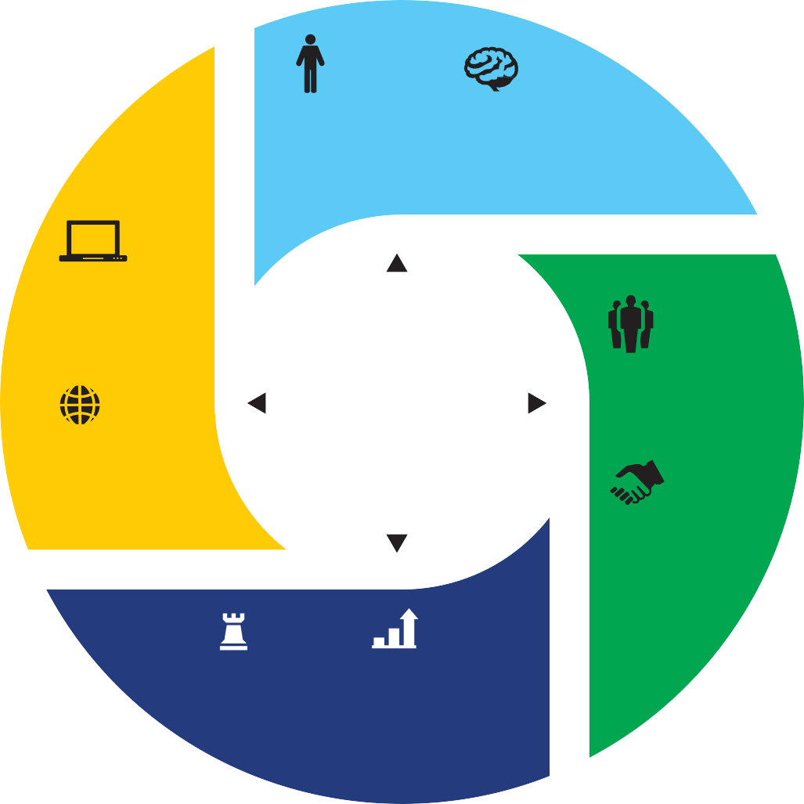What will I learn?
EMBODIED NEURO LEADERSHIP LEADERSHIP
Leading through Applying the findings
self-management, of neuroscience to physical awareness, mindful the work of leadership practice and creativity
DIGITAL LEADERSHIP
Leading with awareness of shifting technologies and leveraging the best of the new digital era
EFP
Leadership Framework and Toolkit
AUTHENTIC LEADERSHIP
Leading with a clear sense of self and purpose
SYSTEMS LEADERSHIP
Leading in the context of complex interactions, interdependencies
and interests
COMMUNITY LEADERSHIP
Leading through engagement, influence and connection
ADAPTIVE PUBLIC VALUE LEADERSHIP LEADERSHIP
Leading in the face of Leading in order to create volatility and uncertainty public value with the support
of the authorizing environment
L

key leadership themes: leading the self and others (including neuroleadership), leading an organisation (including adaptive leadership) and systems leadership.
E
N
The EFP focuses on three
These themes are explored using contemporary issues as a focal point, including the COVID-19 crisis (and beyond), Black Lives Matter, the climate crisis, and the #metoo movement.
By exploring contemporary issues, participants will benefit from engaging and relevant learning opportunities with real-world application. The EFP leadership framework underpins the themes, content and teaching methods
I
of our program, highlighting the capabilities required of a successful leader.

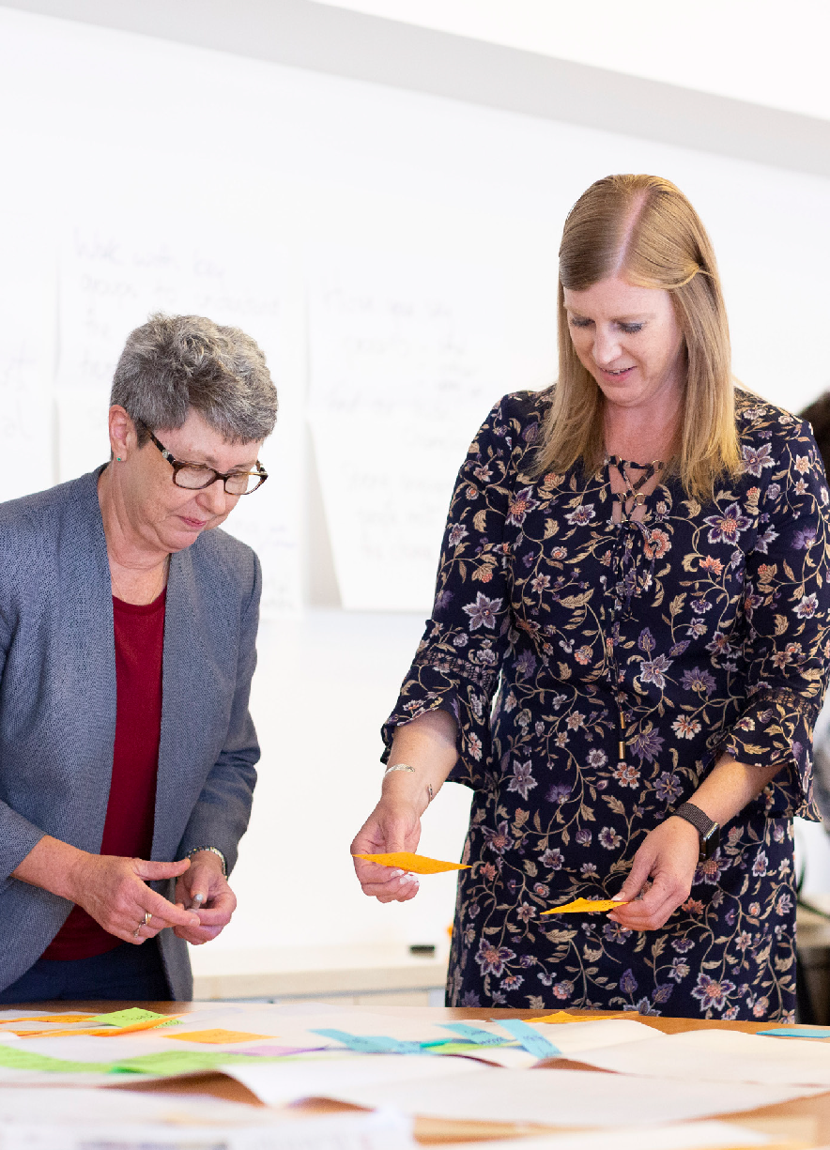
Outcomes

Throughout the program, you will explore the three leadership themes outlined above. Outcomes from these themes, include:
    - explore the latest thinking on leadership
    - discover leadership frameworks which can be applied immediately in your agency
    - develop a greater sense of self-as-a-leader
    - build skills to effectively lead across cultural boundaries in an increasingly complex operating environment
    - broaden and deepen your professional networks
    - gain deeper insights into the operating environment of the public service with particular attention to politics, the media, the international sphere and other sectors
    - increase capabilities in reading and shaping organisational cultures
    - find inspiration and opportunities to take your leadership to the next level
    - learn how to better communicate in your relationships with ministers, staff and stakeholders, to create and deliver public value.

“The networking opportunities the EFP gives you are priceless. If this was any other course I don’t feel I would have got the depth and the breadth of
information and participation that I had on the EFP.”
Sylvester Shamy, Divisional Manager, Audit and Risk, Ministry of Foreign Affairs and Trade NZ

Faculty

Our faculty include leading national and international academics who are experts in the public sector. We also
draw on the expertise of senior practitioners from the public, not-for-profit and private sectors.
Faculty includes:
- Professor Catherine Althaus, ANZSOG Deputy Dean (Teaching and Learning), and ANZSOG Chair

“We’re recognising that leadership is not just a professional activity – it’s
something that we need to embody, and it’s holistic – and we are very committed to that in the delivery of this program.”
Catherine Althaus

History of the EFP

in Public Service Leadership and Reform, University of New South Wales Canberra (Extraordinary Professor, University of Pretoria and Adjunct Professor, University of Victoria, British Columbia and Griffith University)
- Robin Ryde, former Chief Executive UK National School of Government, and leadership
and organisational development expert.

“People that join the EFP are very experienced public servants - they’re looking at a period of time in their career when they can really make a profound impact. The EFP provides them with an opportunity to soak up experience and knowledge, and to return to work with
a renewed energy.”
Robin Ryde

The EFP has been educating public sector executives since 2003 and continues to be one of ANZSOG’s highly-respected education offerings, attracting high performing leaders from across Australia and Aotearoa- New Zealand.
The EFP has continually evolved and in recent years has been delivered as an intensive and lively three-week residential program for senior executives to develop their capacity to lead. The three uninterrupted weeks provided a rare opportunity for focused learning and reflection for busy senior executives.
The program emphasised immersive and experiential learning, and was delivered in three cities across three countries by world-recognised academics and high-calibre practitioners.
Due to the impact of COVID-19 on travel and indoor group gatherings, EFP 2022 has
been revamped for the online environment. Importantly, the 2022 program emphasises the engaging elements of the previous version of the EFP, translating them into the online environment while factoring in participant wellbeing, for example online fatigue. 2022 EFP participants
will benefit from lively, interactive online sprints and offline reflection (which can be done at their own pace). These sessions are tailored to fit around the lives of busy public sector executives. The online delivery method of the 2022 EFP also provides access to renowned academics and senior public sector practitioners from Australia, Aotearoa-New Zealand and beyond.

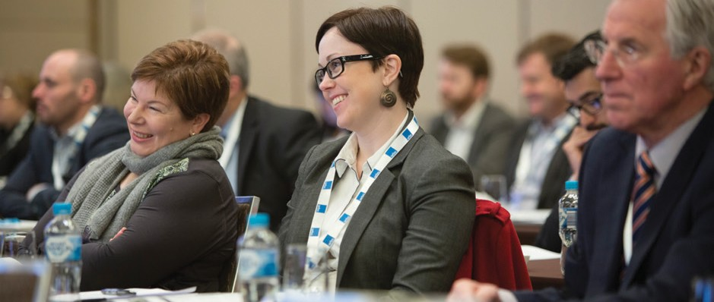
How do I apply?

Applications for 2022 are now open. For more information, submit an expression of interest or contact +61 3 8344 1909 or email: programs_team@anzsog.edu.au.
If you work for the governments of Western Australia, New South Wales
or Victoria, please contact your department or agency’s Human Resources or Learning and Development team about your application or expression of interest.
If you work for the Northern Territory government, please contact the Office of the Commissioner for Public Employment at

Information for managers and sponsoring agencies

swpd.ocpe@nt.gov.au about your application or expression of interest.
If you work for the Aotearoa-New Zealand government, please contact Lynn Evans at the Leadership Development Centre at LDCProgrammes@ ldc.govt.nz; about your application or expression of interest.
If you work for the Queensland government, your Public Sector Commission has a limited number of scholarships available for the program. If you would like to be considered for a scholarship via your jurisdiction’s Public Sector Commission, we encourage you to contact them for further information including dates for application submission.
Owned by and working for the governments of Australia and Aotearoa-New Zealand, ANZSOG creates and delivers education programs tailored to meet the needs of public sector leaders.
Our programs are designed with significant government input, for government, and led by renowned academics and respected practitioners.

Who should I nominate?
The EFP is designed for high performing senior public sector executives, from Deputy Chief Executive Officers (CEO), Deputy Director-Generals and Deputy Secretaries, and executives
two-levels below CEO, Director- General or Secretary.
Executives seeking to take the next step in their careers or further their leadership
capabilities will thrive in the EFP.
We encourage you to nominate Māori and Aboriginal and Torres Strait Islander peoples, people with disability and those from culturally and linguistically diverse backgrounds.
For more information about the suitability of your candidate/s, please complete the Expression of interest form or contact
+61 3 8344 1909 or email: programs_team@anzsog.edu.au

Investment
The sponsoring agency, jurisdiction or organisation pays the program costs, which includes tuition fee and program materials.

Shared learning
Participants will have opportunities to apply new insights immediately in their workplace and are encouraged to share what they learn with others. The module delivery provides opportunities for participants to apply their insights into their workplace while completing the program.
We encourage sponsoring managers to facilitate opportunities for participants to share and add further value as a result of their studies.

Frequently asked questions
Please see below for frequently asked questions relating to ANZSOG’s Executive Fellows Program.

What are the entry requirements?
The EFP is designed for high performing leaders and senior public sector executives, such as Deputy Chief Executive Officers (CEO), Deputy Director-Generals and Deputy Secretaries, and executives up to two levels below CEO, Director-General or Secretary. The program is also suitable for senior executives
in the not-for-profit sector, international equivalent levels and other experienced, high- performing senior leaders.

What is the registration process?
Applications are now open if you wish to apply for the next
iteration of the Executive Fellows Program. If you are seeking more information, contact +61 3 8344 1909 or email: programs_team@ anzsog.edu.au.
Applications are encouraged from Aboriginal, Torres Strait Islander, Māori and Pacific Peoples, and from people with disabilities or from culturally and linguistically diverse backgrounds.
Some jurisdictions have specific registration processes. If you work for the governments of Western Australia, New South
Wales or Victoria, please contact your department or agency’s Human Resources or Learning and Development team about your application or expression of interest.
If you work for the Northern Territory government, please contact the Office of the Commissioner for Public Employment at swpd.ocpe@ nt.gov.au about your application or expression of interest.
If you work for the Aotearoa- New Zealand government, please contact Lynn Evans at the Leadership Development Centre at LDCProgrammes@ldc.govt.
nz about your application or expression of interest.
If you work for the Queensland government, your Public Sector Commission has a limited number of scholarships available for the program. If you would like to be considered for a scholarship via your jurisdiction’s Public Sector Commission, we encourage
you to contact them for further information including dates for application submission. You are also welcome to make your own arrangements with your agency.
If you are a member of ANZSOG’s
alumni you can apply for the 15% ANZSOG alumni discount. Every person that completes ANZSOG’s Executive Master of Public Administration, Executive Fellows Program, Towards Strategic Leadership or an international program becomes part of our alumni. To register for the alumni discount for
this program, please see the registration form.

When do applications close?
Applications close on Friday, 18 March 2022

How much does the program cost?
The program costs $21,000 AUD
+ GST

When will I/my agency be invoiced?
Invoices will be emailed to you/your agency invoice contact once your registration has been finalised. Note that cancellation conditions are enforced after the date of acceptance into
the program.

What is covered in the Program fee?
Program fees cover program design and preparation, tuition fees and learning materials.

What is the program structure?
The EFP is a multi-module program, with an orientation session and two check in sessions. See below for dates. A further breakdown of the modules can
be found in the EFP brochure. For the upcoming program in May-July 2022, the program

will be delivered online due to restrictions on travel and large gatherings.
- Orientation: 3 and 6 May 2022 (90-minute session)
- Module 1: Leading Self and others: 23-25 May 2022
- Module 2: Leading the organisation: 21-23 June 2022
- Module 3: Systems leadership: 4-6 July 2022

Can I speak with a previous EFP participant?
If you are interested in applying for EFP, we encourage you to speak to our EFP alumni to get an insider’s perspective. Please contact our Alumni Coordinator via email at: alumni@anzsog.edu. au, to arrange an introduction.

Do I need to download any software to participate?
Yes, you will need Zoom installed on your device. It will do this automatically when you click on your first webinar so just login 5 minutes before and allow it.

What is the time commitment of the program?
Participants benefit from lively, interactive online sessions, including online sprints and offline reflection which can
be done at their own pace – which maximise the positive impact on their workplace.
Module 1 and 2 are three-day modules, module 3 is a two and a
half-day module.
Each module features some pre-work, and short and sharp online sessions.

Can I self-fund my participation if my agency won’t fund?
Yes.

What are the attendance requirements?
Participants are expected to attend all sessions to fully realise the benefits of the program.

How is the 2022 online EFP different to previous EFP iterations?
The EFP has continually evolved and in recent years has been delivered as an intensive and lively three-week residential program for senior executives to develop their capacity to lead.
Due to the impact of COVID-19 on travel and indoor group gatherings, EFP 2022 has
been revamped for the online environment.
Importantly, the 2022 program emphasises the engaging elements of the previous version of the EFP, translating them into the online environment while factoring in participant wellbeing, for example online fatigue.
2022 EFP participants will benefit from lively, interactive online sprints and offline reflection (which can be done at their own pace).

These sessions are tailored to fit around the lives of busy public sector executives.
The online delivery method of the 2022 EFP also provides access to renowned academics and senior public sector practitioners from Australia, Aotearoa-New Zealand and beyond.

Do I need managerial approval to attend the program?
Yes. In signing the application form, your manager agrees to support you to participate in the program and that your organisation assumes the full program fee.
Your nominated manager will also receive an
email indicating you have applied to the program.

How big is the cohort?
The EFP 2022 cohort will be approximately 50-60 participants from across Australia and Aotearoa-New Zealand (and possibly beyond).

What are the outcomes?
Throughout this program, you will explore three key leadership themes: leading the self and others, leading an organisation, and systems leadership.
Outcomes from these themes, include:
- Explore the latest thinking on leadership
- Discover leadership frameworks which can be applied immediately in your agency
- Develop a greater sense of self-as-a-leader

- Build skills to effectively lead across cultural boundaries in an increasingly complex operating environment
- Broaden and deepen your professional networks
- Gain deeper insights into the operating environment of the public service with particular attention to politics, the media, the international sphere and other sectors
- Increase capabilities in reading and shaping organisational cultures
- Find inspiration and opportunities to take your leadership to the next level

About ANZSOG

ANZSOG acknowledges the Traditional Custodians and First Peoples of Australia and Māori, as tangata whenua and Treaty of Waitangi partners
in Aotearoa-New Zealand.
The Australia and New Zealand School of Government (ANZSOG) is a global leader in education and government-focused research

What we do
Alumni community
The ANZSOG experience extends well beyond the classroom.
The national and international networks students gain access to will be invaluable throughout their career. Our Alumni Program helps students maintain and build peer- to-peer relationships, creating
a broad community of public sector managers. This provides an

relevant to the public sector. ANZSOG was created in 2002 by government, for government, with the active collaboration of our partner universities.
We have a deep and genuine commitment to strong public administration, reflecting
the aspirations of – and our close relationship with
– our government owners.
As a not-for-profit organisation with offices in Melbourne, Sydney, Canberra, Brisbane and Wellington, ANZSOG is uniquely placed to support
our government members.

We have a unique role in providing education and development opportunities
for people in the public sector, and a unique mission to create public value by lifting the quality of public sector leadership in Australia and Aotearoa-New Zealand.
  - We educate public sector leaders to improve their skills, capacity and management, and expose them to the
best thinking on public administration.
  - We enrich the discipline of public sector leadership through focused research,
which has a practical application and meets the needs of our owner governments.
- ANZSOG connects diverse people, cultures, institutions and jurisdictions – it is a meeting place where public sector leaders come together to be inspired, share, learn and debate accepted practice and new ideas. We also connect senior public service practitioners and academic, and provide a bridge between theory and practice.
- Ultimately, we inspire public servants to make a positive difference to the lives of people in Australia and Aotearoa-New Zealand.
Our activities deliver public value through better government and better outcomes for citizens.
Find out more at anzsog.edu.au
opportunity for ongoing learning
and support from peers and greater exposure to different perspectives.
Find out more
To register or submit an expression of interest, visit: anzsog.edu.au/education-events/executive-fellows-program or contact +61 3 8344 1909 or email: programs_team@anzsog.edu.au
WWW.ANZSOG.EDU.AU

