

Annual report to corporate members

1 July 2022 – 30 June 2023

Contents

Message from Chair, ANZSOG Board 3

Message from the NRCoP chair 4

Introduction 5

Timeline for the NRCoP 7

NRCoP summary 2022/23 9

NRCoP Jurisdictional Chapters 10

Connect 14

Inspire 19

Enrich 23

Educate 29

The three-year strategic plan 32

Thank you to our corporate members 34

Thank you to our national and chapter committees 37

Follow us 41

The Australia and New Zealand School of Government (ANZSOG) works for our government owners and with our university partners to lift the quality of public sector leadership across Australia and Aotearoa New Zealand. Our work inspires and connects people across agencies, sectors, jurisdictions and nations.

We acknowledge the Traditional Custodians and First Peoples of Australia and Māori, as tangata whenua and Treaty of Waitangi partners in Aotearoa New Zealand.

# Message from Chair, ANZSOG Board



I am very pleased to present this report to corporate members on the activities and achievements of the ANZSOG-auspiced National Regulators Community of Practice (NRCoP).

NRCoP exemplifies ANZSOG’s point of difference in the creation of public sector capability and public value through integration of academic rigor and practitioner expertise in its learning program and resource collection. By creating opportunities for public sector leaders, practitioners and academics to exchange ideas and learn together, NRCoP contributes to the extension of regulatory capability in Australia regardless of jurisdiction, sector or role.

ANZSOG is proud to have had a long and close association with NRCoP, supporting its evolution over the last decade from three independent locally based communities in VIC, QLD and WA to a national network, with active chapters across the country.

A thanks to all of our corporate sponsors for their support of NRCoP and ANZSOG. Industry and stakeholder trust and investment in the continuing development of the regulatory profession through NRCoP is visionary, with the result being a world-leading community of practice.

I would also like to congratulate all of the 6,500+ participants in the community of practice on their commitment to both their personal development and the development of the profession. Over the last 12 months, we have seen practitioners take up opportunities on an unprecedented scale, participating in events around the country, exploring curated online resources and signing up for professional learning opportunities.

This year has also seen the achievement of a major milestone with the launch of The Professional Regulator program, developed by NRCoP and ANZSOG in partnership with the Australian National University’s School of Regulation and Global Governance (RegNet). The Professional Regulator gives Australian regulators access to nationally recognised training with a focus on the common issues regulators face. It draws on practice from our Aotearoa New Zealand counterparts, leveraging ANZSOG’s cross-jurisdictional strengths.

I would like to acknowledge the leadership of the NRCoP Chair, Rose Webb, and all the members of the National Steering Committee. As a mix of regulatory leaders, practitioners and academics, this team is made up of hardworking volunteers, adding their vision and expertise to NRCoP in addition to their already busy day jobs.

In closing, I would like to recognise the NRCoP staff team, led by Director Dr Marion Frere. The commitment of team members and our volunteers ensures NRCoP remains relevant, useful and valued to regulators.

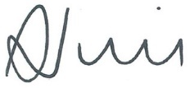

**Sharyn O’Neill  
Chair, ANZSOG Board**

# Message from the NRCoP chair



Over the last 12 months, the NRCoP has continued to go from strength to strength with a dynamic program of events and resources, informed by regular feedback from our 6,500+ participants.

This year we welcomed our 100th corporate member, now double the first 50 members who joined when we introduced our new corporate membership business model in 2020.

We rely on the support of our members, not just financially but also for their help in spreading the message and helping us ensure that we stay responsive and relevant.

I am frequently humbled (but never surprised!) by the degree of generosity of the regulatory community, where senior leaders and frontline staff are prepared time and time again to share their expertise to support their peers to learn and grow as regulators. This commitment to the regulatory profession is the foundation on which NRCoP is built and why it continues to flourish.

During the year, some valued members of the National Steering Committee departed and I would like to extend my heartfelt thanks to Christopher Ingham from VIC and Janet Schorer from NSW for their contributions over a long period to NRCoP. Stepping into their shoes, I am very pleased to be able to extend a warm welcome to new members Douglas Young from VIC and Tracy Mackey from NSW.

This year NRCoP has been engaged in implementing the work program set out in our 3-Year Plan. We continue to attract large numbers to our hybrid and online learning and networking events held around the country, the Regulation Policy and Practice Collection has seen a steady growth in use, and our Jobs Board continues to grow in popularity.

We have also focused over the last 12 months on embedding our new local chapters in SA and the ACT, supporting local events in WA, NSW and QLD and on building capability in culturally responsive regulation.

Our most significant achievement for the year was the launch of The Professional Regulator Program in February 2023. The inaugural cohort was made up of 100 participants drawn from the NRCoP corporate members. The response to the program has been overwhelmingly positive, representing an enormous vote of confidence in NRCoP, ANZSOG and the partnership with RegNet, ANU.

I would like to thank ANZSOG for its continued support of NRCoP, including the excellent contributions made by staff across the organisation. I would also like to thank the Regulatory Practice team, Dr Marion Frere, Dr Lorraine Cherney, Rosemary Vo and Shannon Tucker who work with great skill and enthusiasm to keep the NRCoP wheels turning.

I look forward to what the next near will bring as we continue to work together to build the regulatory profession and to promote the public value of regulation.

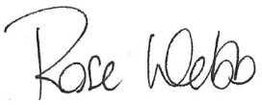

**Rose Webb  
Chair, NRCoP**

# Introduction

The National Regulators Community of Practice (NRCoP) is an active network of public sector regulators from all levels of government in Australia and from every regulatory sector, professional background, role and level of seniority, who are keen to learn from and with each other. Its objectives are to support participants to become more professional and capable regulators and to promote the public value and importance of regulation as a key function of government and thereby, to deliver better citizen outcomes

This report outlines the achievements of the NRCoP from July 2022 to June 2023. This was a period of intense activity, with growing membership, a diverse program of in-person and online events and the long-anticipated launch of The Professional Regulator self-paced online course. We became experts at the hybrid event, enabling local regulators to gather together in person and enjoy the networking opportunity, but also ensuring that our national audience was able to benefit from the high calibre presentations and panel discussions. For the 100 regulators that signed up to be part of the inaugural cohort for The Professional Regulator, and for the seminar leaders based at RegNet ANU, it was a year of strengthening and extending regulatory capability. Before the end of the financial year, over 700 individuals (from 30+ member organisations) had expressed interest in making The Professional Regulator part of their development plan in 2022-23. Read on to find out more on what has been happening in the community of practice.

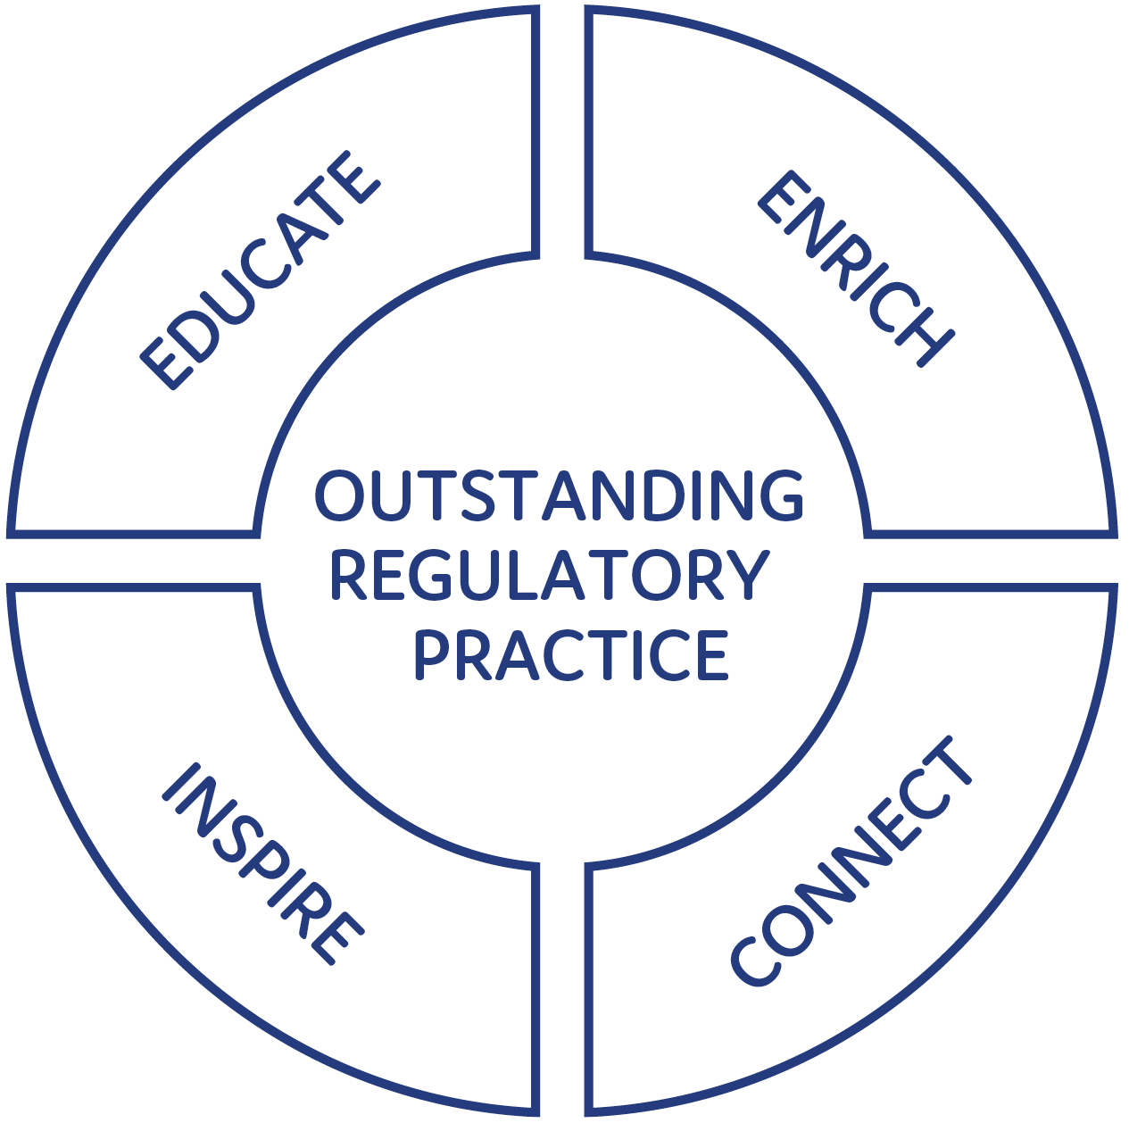



“The National Regulators Community of Practice is a rich community of conversation. The conversations are serious and helpful. NRCoP is well led to bring the most distinguished regulatory leaders from our region into dialogue with newcomers to regulatory agencies. And it gives home-grown regulatory scholars (like us) a chance to engage with ideas from master practitioners. We academics are proud of how our practitioners are leading the world in the quality of ideas exchanged among different kinds of regulators.”

Professors John and Valerie Braithwaite, founders of the School of Regulation and Global Governance (RegNet) at ANU.

Photo of Professor Allan Fels AO


“Decades ago when I first started studying public administration it was all about spending, raising revenue and accountability. On further close acquaintance with the public service via ANZSOG I discovered that most public servants in one way or another are involved in the devising, management and implementation of laws that use the coercive power of the state and need education in that sphere. The NRCoP has done a great job in bringing together literally thousands of regulators from across Australia covering an extraordinarily diverse range of regulatory challenges and finding that there are so many common elements. It is highly worthwhile bringing them together in NRCoP and its associated events.

Professor Allan Fels AO, Foundation Dean, Australia and New Zealand School of Government

# Timeline for the NRCoP

2013

* An informal network of ‘Sparrow alumni’ approaches ANZSOG to act as auspice
* ANZSOG and Institute of Public Administration Australia (Victoria) co-auspice Victorian Community of Practice

2014

* Inaugural annual forum with Professor Malcolm Sparrow

2015

* Second annual forum with Professor Gary Banks

2016

* Third annual forum with Professor Cary Coglianese

2017

* Fourth annual forum with Professor Alberto Alemanno
* Intention to take the CoP national announced at forum

2018

* WA chapter launched
* QLD chapter launched (building on existing Queensland Regulators Network)
* NSW chapter launched
* Fifth annual forum with Dr Femke de Vries

2019

* 14 seminars held across Australia, NRCoP reaches 2500 members
* Sixth annual forum with Bill Eggers

2020

* Pandemic transforms NRCoP’s deliveries, business model
* Launch of Regulation Policy and Practice collection on APO
* 50 departments and regulatory agencies become corporate members
* NRCoP delivers 17 webinars and 3 facilitated conversations

2021

* NRCoP reaches milestone of 25 successful webinars delivered
* APO Regulation Policy and Practice collection celebrates first birthday
* NRCoP launches free Jobs Board for corporate members

2022

* NRCoP launches new chapters in South Australia and the Australian Capital Territory
* NRCoP establishes hybrid events, with events held online and in-person
* 42 professional development working group sessions held, with 25 subject matter experts participating   
  in the development of content and case studies for the six-module professional development program
* NRCoP grew to a total number of 82 corporate members
* NRCoP appoints 3 new academic advisor positions to the board
* APO Jobs Board reaches 180+ advertised regulatory positions
* New Terms of Reference created along with improved governance structures for the NRCoP

2023

* NRCoP welcomes its 100th corporate member
* The Professional Regulator self-paced online course launched in partnership with RegNet ANU with 100 participants in the inaugural cohort
* NRCoP revitalises local in-person events which take place in WA, NSW, QLD, SA and ACT

# NRCoP summary 2022/23

28,000 registrations for 45 webinars with an average evaluation of 4.5 out of 5

21,000 additional views of the webinars on our YouTube channel

6,500+ subscribers from all levels of government in Australia and Aotearoa New Zealand

80% of our members this year found our webinars to be ‘Extremely useful’

332,415 page views of our APO Regulation Policy and Practice Collection, which holds over 1,900 regulatory resources

363 regulation jobs advertised on our free Jobs Board

22 monthly newsletters published with guest editorials written by senior regulatory practitioners

# NRCoP Jurisdictional Chapters

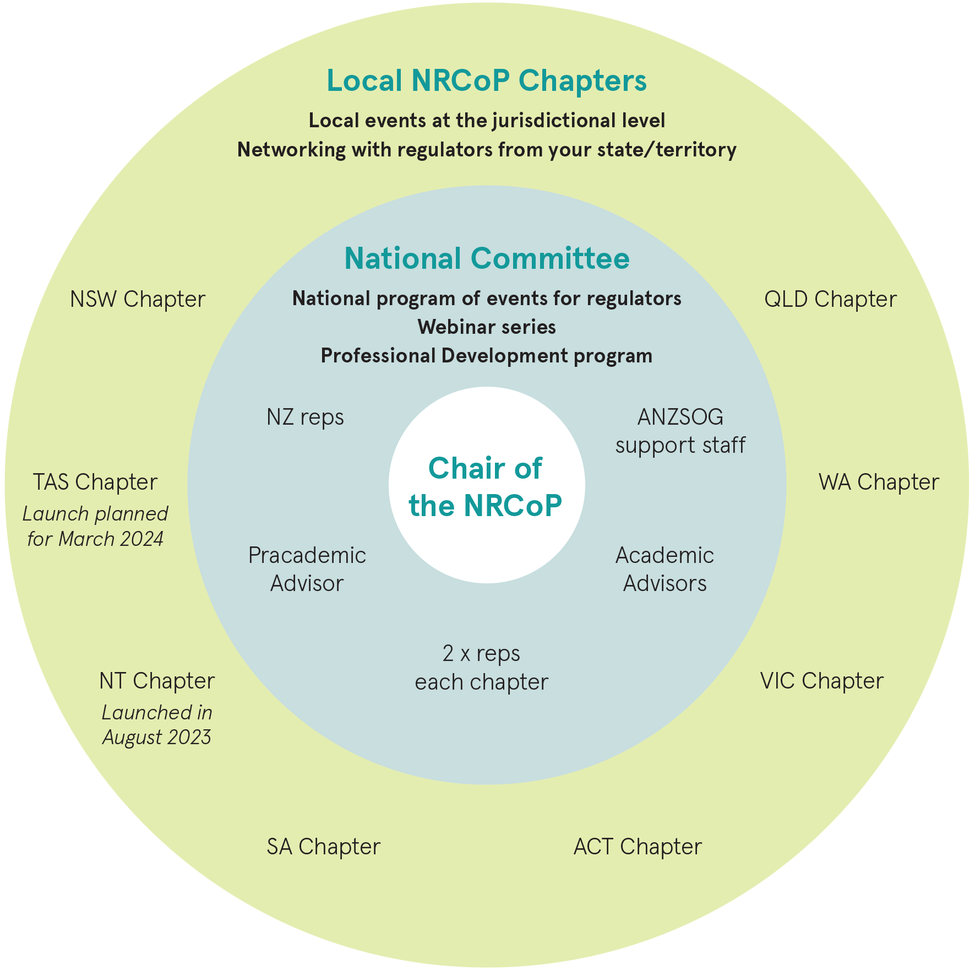

NRCoP is a proudly bottom-up community of practice, with active local chapters in Queensland, New South Wales, Australian Capital Territory, Victoria and South Australia. In next year’s report, we will be excited to add the Northern Territory and Tasmania to the list, making us a truly national organisation. Chapter committees bring local regulators together through a range of activities to build connection and grow capability, as well as contributing via the National Steering Committee to the national program of events. Meet some of our local leaders here.

ACT



“The thing I value most about NRCoP is the acknowledgment that being a professional ‘Regulator’ is an important job and it is a career to be proud of.“

Derise Cubin, Executive Branch Manager, Licensing and Registration, Access Canberra

NSW

Photo of Roxane Marcelle-Shaw


“It was exciting to put a focus on the regions in our NSW Chapter activities this year. We held sessions in Newcastle, with a ‘Regulating in the Regions’ event in March and a National Conference satellite event in September. These were wonderful opportunities to bring local regulators together to learn from and with each other.“

Roxane Marcelle-Shaw, CEO/Executive Director, The Professional Standards Authority

SA



“The best thing we did this year was to embed the SA Chapter and committee into the NRCoP family, to set ourselves up for future success.“

Kerry Leaver, Chief Executive and Registrar, Education Standards Board SA

QLD



“Regulation is a core function of Government and the NRCoP is an important part of lifting regulatory practice across the nation, we learn best practice, can seek advice from our peers, and improve outcomes for Australians everywhere.“

Jarrod Cowley-Grimmond, Acting Deputy Director-General, Water Resource Management Division

NT



“The NRCoP is a way for regulators in the Northern Territory to tap into and connect with the expertise that we need to deliver an excellent regulatory service in Australia’s most remote areas. We’re looking forward to growing the NT Chapter of NRCoP in the years ahead.“

Amy Dennison, Executive Director, Environmental Regulation Environment Division,   
Department of Environment, Parks and Water Security

VIC



“For me the NRCoP is a unique and vital forum that provides an opportunity to engage with other regulators through the lens of practice, insight and learning.“

Matt d’Abbs, Chief Quality Officer, EPA Victoria

WA



“It was great to recommence in-person events in WA with a hybrid seminar/webinar with current and former Chief Health Officers on the lessons learned during   
COVID-19.”

David MacLennan, Chief Executive Officer, City of Vincent

# Connect

To build a community of regulators across jurisdictions, sectors and roles, connecting practitioners with experts and leaders, to build regulatory expertise and improve outcomes

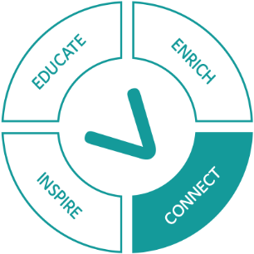

At its core, the NRCoP is about building connections between regulators. We support this by creating opportunities for people to get together and get to know each other and but also by creating a sense of shared purpose so that regulators feel part of a wider community. This year we have held 15 events around the country bringing together hundreds of regulators in person and thousands online. These events took place in our capital cities and our regional centres, and those who participated represented a very diverse range of regulatory spheres and included those working on the frontline to CEOs. In just a few examples, we talked about how to become a data-driven regulator in Queensland, in Western Australia we looked at the lessons from the Perth Casino Royal Commission, and in New South Wales we explored lessons from COVID on regulatory relaxation. Our photo gallery provides a snapshot of these local events as well as our national hybrid program.

Hear what participants have to say about **local events and webinars**:

“What I value most about the NRCoP is the opportunity to learn from my fellow regulators. Understanding how other entities approach similar challenges gives me confidence to try new strategies.”

Maggie Whitmore, Manager Complaints, Investigations and Compliance, Victorian Disability Worker Commission

## Local and Hybrid Events

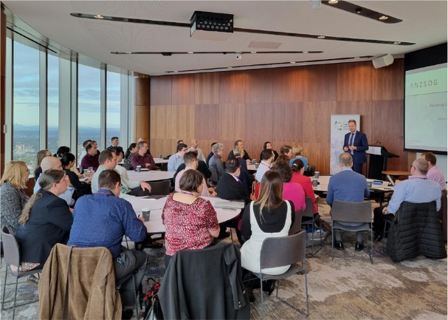

QLD – Becoming a data driven regulator **(20 July 22)**

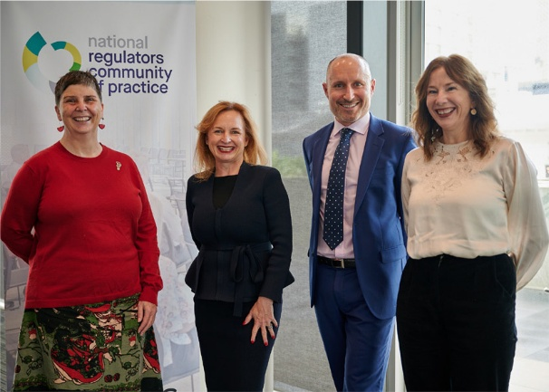

WA – Lessons for Regulators from the Perth Casino Royal Commission **(22 July 22)**

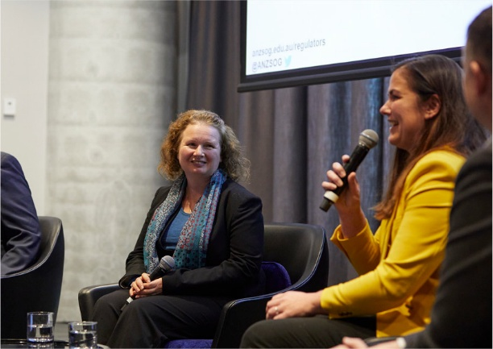

VIC – Telling their story once **(26 July 22)**



NSW – Solving problems, supporting staff **(21 September 22)**

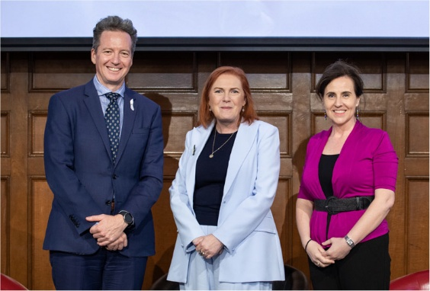

QLD – Having your say vs getting your way? Why good regulatory comms matter **(15 November 22)**

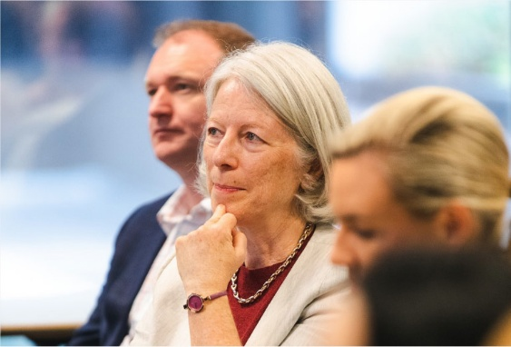

NSW – Regulatory relaxation and experimentation: lessons and leading practices **(6 December 22)**

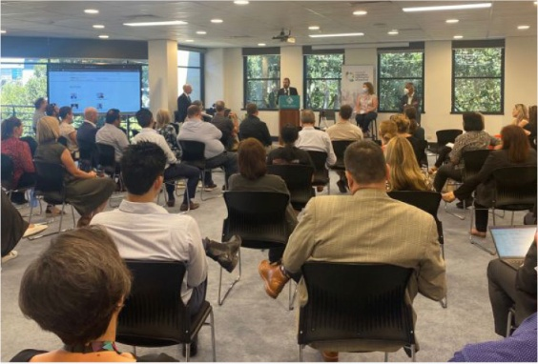

WA – COVID-19: Legitimacy, Trust and Compliance **(14 December 22)**

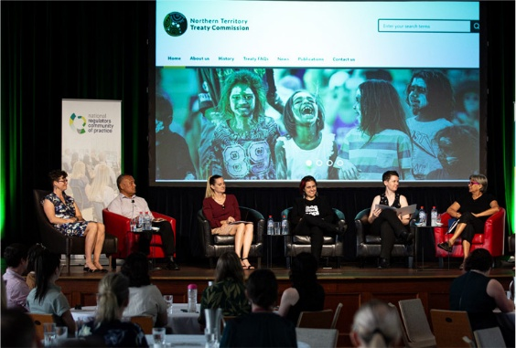

QLD – Indigenous knowledge, partnerships and shared decision making: culturally responsive regulation in action **(28 February 23)**

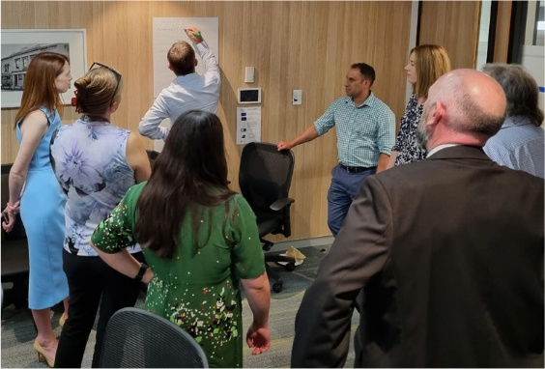

SA – Calling all South Australian Regulators! Come together, Connect, Collaborate Workshop with Grant Pink **(16 March 23)**

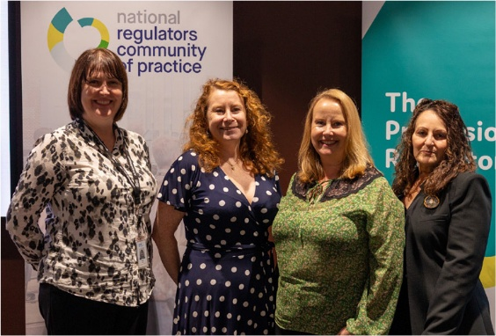

ACT – Are we OK? Co-design and the regulation of psycho-social hazards **(20 March 2023)**

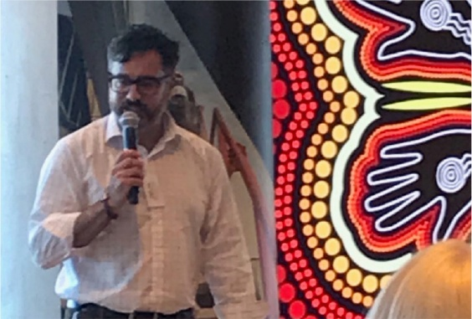

NSW Newcastle – Regulating in the Regions **(18 April 23)**

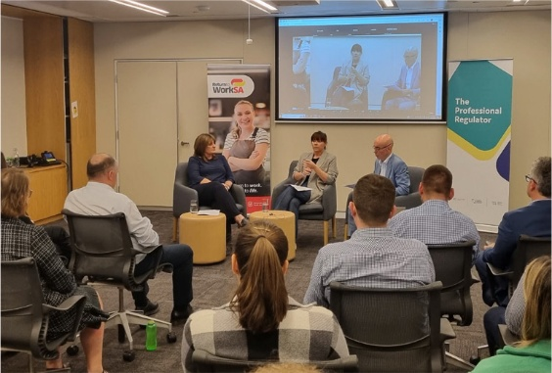

SA – Data, data everywhere: Challenges, lessons and opportunities for regulators **(15 May 23)**

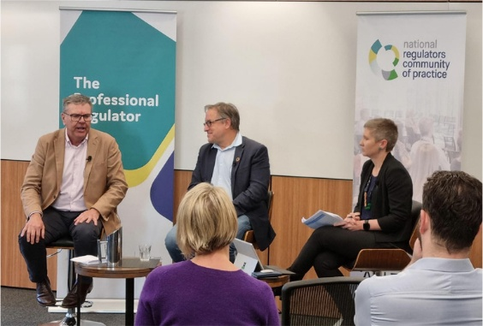

VIC – Incentivising compliance: using behavioural insights to encourage and persuade **(2 June 2023)**

Hear what participants have to say about **local events and webinars**:

“Regulators in the ACT love NRCoP because we get to network with each other and discuss regulatory theory and practical solutions. We are proud ‘regulatory nerds’.”

Derise Cubin, Executive Branch Manager, Licensing and Registration, Access Canberra

# Inspire

To inspire regulators that their work is intellectually, professionally and ethically worthwhile and the foundation for a rich and satisfying career

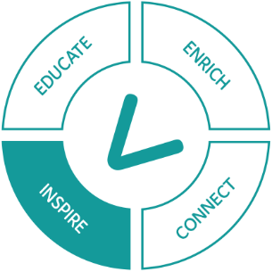

Our webinar program continues to be popular with the regulatory community. We try to keep this fresh and as relevant as possible by asking our members for their main take-aways from each session and suggestions for future topics. The level of feedback is always extensive, demonstrating commitment to the community of practice, with a wide range of ideas for future events. The average evaluation is 4.5 out of 5, with an all time high of 4.9 out of 5 being achieved for our webinar on AI earlier this year! As you can see from the full list of topics and speakers, we bring together practitioners and academics, organisational leaders and front-line regulatory officers to ensure topics explored are both thought-provoking and practical.

Table: Engagement in the NRCoP National Hybrid and Webinar Program

| Month | NRCoP Program of Events July 2022 – June 2023 | Registrations for event | YouTube views |
| --- | --- | --- | --- |
| July 2022 | Telling their story once: How digital technology can support regulators to provide streamlined services to citizens and businesses  Chris Ingham, Cassandra Meagher, Miriam Slattery & Craig Lloyd | Online - 367  Live - 12 | 235 |
| August 2022 | What is culturally responsive regulation? And how do we work with our Aboriginal and Torres Strait Islander partners to achieve it?  David MacLennan, Jacqueline McGowan-Jones, Richard Weston, & Dr Josephine Bourne | Online - 508 | 309 |
| September 2022 | Solving problems, supporting staff! Building an effective complaints handling culture  Liz Tydd, Nicole Lawless, Fiona Brown & Matt Press | Online - 408  Live - 10 | 204 |
| October 2022 | Guilty Corporate Minds: old and new approaches to regulating corporate (mis) conduct  Rowena Park, Dr Elise Bant FAAL  and Justice Ray Finkelstein AO KC | Online - 319 | 147 |
| November 2022 | Having your way vs getting your say?  Why good regulatory comms matters  Victoria Thomson, Jarrod Cowley-Grimmond, Jane Reid | Online - 542  Live - 68 | 224 |
| December 2022 | COVID-19: Legitimacy, Trust and Compliance  David MacLennan, Dr Andy Robertson,  Dr Kerryn Coleman, Professor Tarun Weeramanthri | Online - 195  Live - 26 | 113 |
| February 2023 | Indigenous knowledge, partnerships and shared decision making: Culturally responsive regulation in action  Lil Anderson, Ursula Raymond, Liz Costello, Dr Amanda Moffatt, Renee Henry, Ed Swann, Katrina Sanderson | Online - 829  Live - 77 | 237 |
| March 2023 | Are We Ok? Co-design and the regulation of psycho-social hazards  Grant Pink, Jacqueline Agius, Frances Crimmins, Sian Leathem, Tracey Harkness | Online - 368  Live - 58 | 111 |
| April 2023 | AI and ChatGPT: The latest fad, a useful tool, or something more nefarious?  Simon Corden, Dr Steven Lockey, Dr Caitlin Curtis | Online - 508 | 276 |
| May 2023 | Data, data everywhere: Challenges, lessons and opportunities for regulators  Steve Ronson, Samantha Jones, Kerin Montgomerie | Online - 400  Live - 24 | 112 |
| June 2023 | Incentivising compliance: using behavioural insights to encourage and persuade  Kate Gavens, Prof Liam Smith, John Merritt | Online - 777  Live - 32 | 188 |
|  | Total | 5528 | 2156 |

“Really valuable session, my entire team attended.”

“Interesting to hear the different approaches taken across the states, but also the similarities.”

“The speakers were extremely knowledgeable and provided so many ‘lightbulb’ moments for me.”

## Culturally Responsive Regulation

In 2022 the NRCoP identified building capability in culturally responsible regulation as a priority in its 3-Year Plan. To begin this journey, a panel of Indigenous regulators and leaders explored the question: What is culturally responsive regulation and how do we work with our Aboriginal and Torres Strait Islander partners to achieve it? This was followed up in February with an event in Brisbane where we heard from regulators and community members working together in culturally responsive ways, that honour Indigenous knowledge and build partnerships founded on shared decision making. NRCoP would like to acknowledge the support of the ANZSOG First Nations team in building this important program of work.



Lil Anderson, Chief Executive, of the Office for Māori Crown Relations

On February 14 this year, I challenged regulators in Aotearoa New Zealand and in Australia with a call to action – to continue to challenge ourselves and each other to be better, in a guest editorial I wrote for the NRCoP monthly newsletter. I challenged you to lead in culturally responsive ways and to lead by example in the way they that you work with communities in partnership and through sharing decision making. I hope that you are all on that journey, even if it is in a small way, as small steps end up making a huge difference to the journey.

Someone must have read the article (lol) because I was then invited to host an amazing NRCoP hybrid event entitled Indigenous knowledge, partnership and shared decision making: culturally responsive regulation in action in late February. It was a chance to hear from regulators working on the ground about their efforts and experiences in working differently with Aboriginal and Torres Strait Island communities and the knowledge they hold. It was so inspiring to hear some of the practical steps being taken in different regulatory contexts and the ways in which regulators are engaging differently. The amazing panellists ranged from working in the areas of gambling, biodiscovery, drinking water to Treaty pathways. I learned a lot from that session and if you haven’t already, I encourage you to watch this online. It may give you some ideas about what you could do in your own context.

I’ve loved watching NRCoP go from strength to strength and I congratulate you all on the forward momentum you have created in the First Nations space – both in your learning and from what you are already putting into practice. I wish you all the best as you endeavour to ensure that you hold people at the centre of your regulatory work as well look to improve outcomes in the daily lives of our two nations.



Tricia Stroud, Registrar, ORIC, Office of Registrar of Indigenous Organisations

ORIC joined NRCoP in May 2023, inspired after attending its February panel discussion exploring Indigenous knowledges and partnerships.

As the regulator of some 3386 Indigenous Corporations ORIC has much to offer other regulators, drawing on its 46 years’ experience in Indigenous Governance. Conversely, ORIC can greatly benefit from better understanding of and collaboration with the many regulators whom Indigenous corporations interact with. Regulation is a challenging and complex role – but it’s equally rewarding. It’s a role that ORIC does, committed to well-governed and self-determining Indigenous Corporations. And as Indigenous corporations evolve and mature, so should ORIC’s regulatory approach. What better opportunity to do so than by being part of a diverse and vibrant community of regulatory peers.

## Ahpra Indigenous Employment Strategy

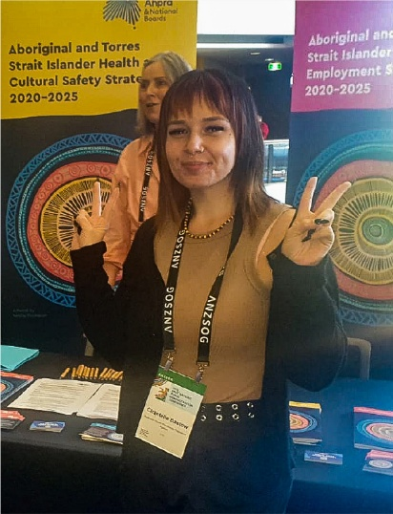

Ahpra aims to create a culturally safe working environment to increase Aboriginal and Torres Strait Islander employment, careers experiences and opportunities through its Employment Strategy.

The reform is driven by the National Scheme’s Aboriginal and Torres Strait Islander Health and Cultural Safety Strategy 2020-2025 which seeks to eliminate racism in Ahpra and healthcare as a matter of urgency. Ahpra is progressing work on an ‘Aboriginal and Torres Strait Islander Anti-Racism Policy’ to provide clear expectations and guidance on how to address and respond to racism for those within or accessing the National Scheme.

Targeted recruitment campaigns to ensure representation at the highest levels have resulted in the appointment of eight new Aboriginal and Torres Strait Islander Board and committee members, bringing the current total to 33. More than 1,500 Ahpra staff have participated in the Moong-moong-gak cultural safety training program since it began in 2021.

# Enrich

To enrich debate on the profession of regulation and to ensure enduring benefit for regulated entities and the public

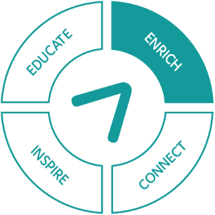

The NRCoP greatly values the partnership with Analysis & Policy Observatory (APO) which provides the regulatory community with excellent resources in the form of a curated research collection and jobs board, both of which are well utilised by our members.

The APO Regulation Policy and Practice Collection brings together a range of relevant resources from 532 publishing organisations including national, local and state and territory Australasian governments. In addition, monitoring, inquiries and reviews are contributed by regulatory agencies and external institutions, as well as from international bodies such as the OECD and the World Bank.

Content in the Collection is arranged around four topics in focus that include regulatory strategy, regulatory instruments, government regulatory policy and sector regulation. Last year, reports related to government regulatory policy were the most popular topics in focus.

Since the Collection was established in 2020, it has had 332,415 page views and now holds over 1,900 resources. The APO monthly guest editorials have continued to be an effective way to raise awareness of a wide range of issues faced by Australian regulators.

Since we launched the Regulators Jobs Board back in April 2021, it has continued to grow in popularity and our community has used it to advertise more than 540+ positions to our 6,500+ community. During the 2022-2023 reporting period, a total of 363 jobs were placed by 47 regulatory agencies. This indicates there is increasing diversity of organisations who are using this free service. The Jobs Board continues to be a popular resource for our members, with 2,300 page views during this reporting period. If you are yet to advertise your positions via the Jobs Board, you can do so at the [NRCoP Jobs Board](https://docs.google.com/forms/d/e/1FAIpQLSeVgcEIL4nLm2JOZDumPoCpPAGcGgp_mTPfEo6ze_BPLeOz7w/viewform) and know you will reach a “captured audience” of 6,500+ regulators, all ready to extend their professional regulatory career.

## APO Collection Guest Editorials

Table: Guest editorial readership numbers/NRCoP and ANZSOG clicks

| Month | Title | Article Reads |
| --- | --- | --- |
| July 2022 | Creating opportunities for regulators to collaborate – reflections from the COVID-19 frontline  By Chris Webb | 602 |
| August 2022 | Indigenous organisation leaders: balancing tensions between achieving political goals and regulatory requirements  By Dr Josephine Bourne | 329 |
| September 2022 | 10 tips for public sector complaints handling  By Fiona Brown | 713 |
| October 2022 | The Government Regulatory Technology Report 2022: optimism meets barriers to progress  By Simon Corden | 424 |
| November 2022 | Guilty Corporate Minds: regulating corporate (mis) conduct  By Dr Elise Bant FAAL | 162 |
| December 2022 | The key to regulatory communication success – Putting people at the centre  By Jane Reid | 582 |
| February 2023 | Building cultural intelligence to become a better regulator  By Lil Anderson | 860 |
| March 2023 | Psychosocial safety is everyone’s right and everyone’s responsibility  By Jacqueline Agius | 847 |
| April 2023 | Regulation is key to responsible AI, but what might this look like  By Dr Caitlin Curtis and Dr Steven Lockey | 488 |
| May 2023 | Provider Performance Analytics an important Regulatory Tool at ReturnToWorkSA  By Samantha Jones | 311 |
| June 2023 | Getting started with behavioural science  By Prof Liam Smith | 1233 |
|  | Total readership numbers | 5829 |

## Most Popular Reports in the RP&P Collection during 2022-2023

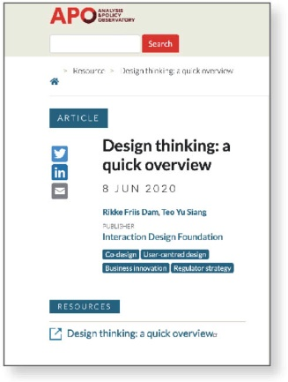

1 [Design thinking: a quick overview](https://apo.org.au/node/306478) (Number of reads 1,765)

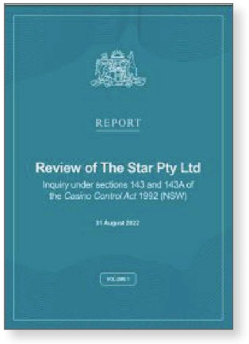

2 [Review of The Star Pty Ltd](https://apo.org.au/node/319488) (Number of reads 1,274)

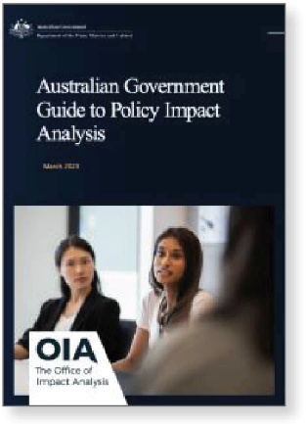

3 [Australian government guide to Policy Impact Analysis](https://apo.org.au/node/321584) (Number of reads 1,018)

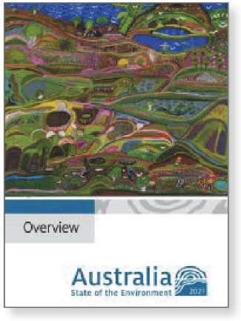

4 [Australia state of the environment 2021: overview](https://apo.org.au/node/318651) (Number of reads 969)

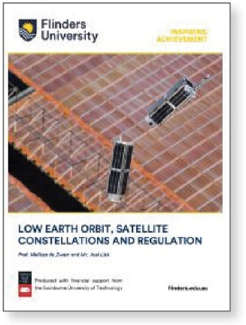

5 [Low Earth Orbit, satellite constellations and regulation](https://apo.org.au/node/318785) (Number of reads 937)



6 [Manifesto for sex-positive social media](https://apo.org.au/node/319110) (Number of reads 923)

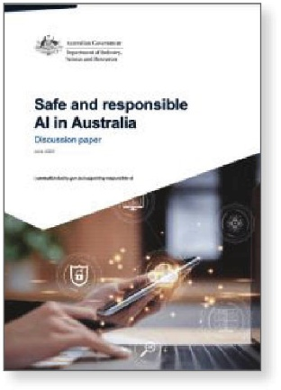

7 [Safe and responsible AI in Australia: discussion paper](https://apo.org.au/node/322938) (Number of reads 759)

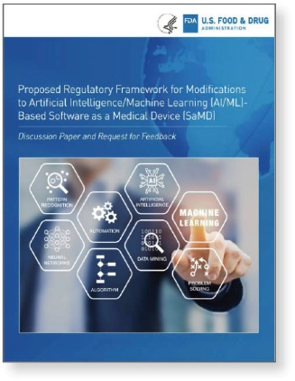

8 Proposed regulatory framework for modifications to Artificial Intelligence/Machine Learning (AI/ML)-based Software as a Medical Device (SaMD) (Number of reads 611)

## NRCoP Jobs Board

Table: NRCoP Jobs Board

|  | Total jobs posted | Total agencies posting jobs | Total page views |
| --- | --- | --- | --- |
| 2022 (July-Dec) | 176 | 26 | 1,426 |
| 2023 (Jan-Jun) | 187 | 21 | 890 |
| Totals | 363 Jobs posted | 47 Regulatory agencies | 2,316 Page views |

What our members are saying about the [Jobs Board](https://docs.google.com/forms/d/e/1FAIpQLSeVgcEIL4nLm2JOZDumPoCpPAGcGgp_mTPfEo6ze_BPLeOz7w/viewform):

“The jobs board offered to NRCOP members is a great means of attracting people who already have a passion for working in a regulatory environment and are looking for opportunities to expand their experience in this career sector. The quality of applicants we received was certainly noticeable in a recently advertised role.”

Glenn Farrell, Executive Director, SafeWork, SA

“Regulatory outcomes and regulator performance go hand in hand. Our access to deep and wide regulatory expertise through the Jobs Board helps us to attract those who are as committed as we are to the qualities of transparency, consistency, independence and accountability as well as efficiency in our regulatory work.”

Sue Dawson, Commissioner, Health Care Complaints Commission

“The National Regulators Community of Practice Jobs Board has been an invaluable resource to aid in our search for top talent. It’s provided a connection for Ahpra to a wider community of regulatory professionals, who understand the dynamic nature and demands of working with a regulator. We look forward to maintaining our continued partnership with NRCoP.”

Thomas Gregg, National Director Organisational Capability, Australian Health Practitioner Regulation Agency

# Educate

To educate regulators to improve their skills and expose them to best regulatory practice to support improved outcomes

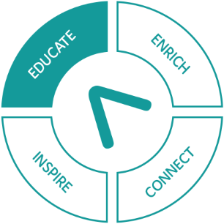

As the job of regulators has become more demanding, there has been an increased interest in professionalising practice and lifting skills of regulators at all levels. That’s why the NRCoP partnered this year with the Australian National University’s (ANU) School of Regulation and Global Governance (RegNet) to deliver a new self-paced online professional development program for regulators. The Professional Regulator program has been developed by regulators for regulators. The course fills a gap in Australia by providing accessible, high-quality training that has been designed with input from regulators across jurisdictions, and which focuses on their common challenges.

**The Professional Regulator program** focuses on key areas of best regulatory practice and is for all regulators, regardless of regulatory sphere or jurisdiction. The course is a combination of six self-paced online modules and six interactive seminars in small groups. It gives participants the opportunity to learn alongside colleagues from a range of regulatory spheres across the country and is designed to be accessible and flexible.

The six modules cover:

* Who Regulates and Why
* Licensing as Regulation
* Understanding and Achieving Compliance
* Using Information to Regulate
* Regulatory Communication
* Regulatory Professionalism and Ethics

Participants can also take part in a program of six seminars that extends on the topics and themes explored in the modules.

* Using our regulatory tools
* Frontline regulators and processes
* Understanding and achieving compliance
* Regulatory information and stakeholder engagement
* Regulatory communication
* Regulatory relationships, professionalism and ethics

The Professional Regulator program was launched in February 2023, with an inaugural cohort of 100 regulators from organisations which are part of the ANZSOG-auspiced NRCoP.

“Working with NRCoP experts has enabled us to create an innovative program that harnesses valuable academic and professional insights for application in real-world contexts. I am excited to see how The Professional Regulator will not only enrich NRCoP, ANZSOG and RegNet’s existing activities, but also enhance the capacity of regulators to think, learn and lead with integrity and wisdom.”

Professor Kate Henne, Director RegNet, Australian National University School of Regulation and Global Governance

“This training fills a gap and will allow organisations and individuals to lift their skills and build a stronger professional network across jurisdictions. It gives regulators access to the latest thinking about their craft and provides a common foundation of current, modern regulatory practice which will increase the professionalism and capacity of regulators around Australia. This work represents the best of regulators working together for the benefit of the wider regulatory community.”

Dr Lorraine Cherney, NRCoP Manager and lead author of The Professional Regulator

## The Professional Regulator

Testimonials from inaugural cohort participants:

“ANZSOG’s Professional Regulator Foundation course has solidified and built upon my knowledge and understanding of regulation. I will be able to apply my learnings in all aspects of my work to support the regulator and regulatory practitioners I work with daily. I would definitely recommend the course to other regulators. It is truly a great way to set the foundation!”

Lisa Schutz, Education Standards Board, South Australia

“I would recommend this course to newly appointed regulators and those who wish to refresh their knowledge. The value of the course to me was in the ability to step outside the agency where I work, and identify regulatory best practice across other agencies in Australia. In particular, I found the sessions on regulatory capture and the precautionary principle very useful. This course would also be very useful for regulatory officers who come from a law enforcement background and who have recently moved into a regulatory role.”

Robert Bates, NDIS Quality and Safeguarding Commission

“Despite having worked at the Victorian Building Authority for close to 17 years, I found the course to be highly relevant. While many of the topics I have already came across from work, I find it helpful that the course brings my different work experiences together, puts them into context, explains the reasons why we do or don’t do certain things, the pros and cons of choosing different tools/methods etc. As such, the course will help me become a more effective decision maker: more options to consider before making decisions, understand which decision better suits which circumstances and their pros and cons, and better able to articulate the decisions made. I would recommend this course to anyone working in the public sector in their first/second year.”

William Yap, Victorian Building Authority

“The case studies used throughout this course were really memorable. They reinforced the key learning areas from each module and really drilled home the key concepts across all six modules. I have recently stepped into a senior regulatory leadership role and this course has broadened my horizons across the regulatory sphere.”

Matthew Thurlby, Electoral Commission Queensland

# The three-year strategic plan

|  | Connect | Inspire | Enrich | Educate |
| --- | --- | --- | --- | --- |
| Objectives | To build a community of regulators across jurisdictions, sectors and roles, connecting practitioners with experts and leaders, to build regulatory expertise and improve outcomes | To inspire regulators that their work is intellectually, professionally and ethically worthwhile and the foundation for a rich and satisfying career | To enrich debate on the profession of regulation and to ensure enduring benefit for regulated entities and the public | To educate regulators to improve their skills and expose them to best regulatory practice to support improved outcomes |
| 2022 Actions | * Grow the NRCoP community by establishing new Chapters in SA and ACT * Re-establish local community face-to-face activities through national and local hybrid (online and in-person) events * Refresh the NRCoP website to improve member experience * Enhance our social media strategy * Encourage members to share learnings and ideas by including NRCoP activities on social media * Create strong links with regulatory agencies in each jurisdiction and at Commonwealth level * Build alliances with key networks of academics and regulators including RegNet and AELERT | * Bring regulatory practitioners and world-leading thinkers together to share knowledge through a national webinar series * Be responsive to members’ ideas in the design and programming of NRCoP events and activities through Annual Member Survey and stakeholder feedback * Increase the range and accessibility of outputs from the national webinar series, including short videos * Provide access to support material on key regulatory issues through the NRCoP website * Highlight ideas and opportunities for regulators through our monthly Regulator Email and monthly Australia Policy Observatory newsletter * Build capability in culturally responsible regulation in collaboration with the ANZSOG First Nations Team | * Draw on network of scholars and practitioners to inform developments in regulatory thinking * Develop the NRCoP Regulation Policy and Practice collection on APO, the Analysis and Policy Observatory * Add a new role of Academic Adviser (Early Career Researcher) to the NRCoP National Steering Committee to support the career development of regulatory academics * Build capability in media monitoring, ensuring that the NRCoP can respond to the needs of regulators on matters of public concern * Provide a Jobs Board, enabling regulatory policy and practice roles to be viewed by interested regulators across Australia and NZ | * Design a six-module program of regulatory professional development in collaboration with G: Reg NZ * Work with NRCoP members to ensure that the professional development program is innovative, contemporary and inclusive. and will meet the needs of regulators * Develop the online delivery mechanism for the roll-out of the professional development program * Identify options for locally based teaching support mechanisms to ensure online learning for regulators is further embedded on the job |
| 2023 Actions | * Grow the NRCoP community by establishing new Chapters in NT and TAS * Improve local government uptake of NRCoP through relevant content and opportunities * Design a regulatory professionals mentoring program to connect individuals across the career spectrum (early, mid, senior) * Embed new chapters, and continue to support existing chapters through a program of national hybrid events * Be responsive to members’ ideas in the design and delivery of a program of development activities | * Host a National Forum, bringing together regulatory practitioners, leading experts and researchers from across the country and internationally * Extend the National Forum into each jurisdiction by hosting local events featuring key speakers from the National Forum * Provide a range of innovative and accessible outputs from the National Forum to ensure maximum accessibility for all members * Continue to inspire through a national webinar series and associated resources that are responsive to members’ aspirations * Develop a program of curated conversations that support regulators to collaborate on common issue | * Bring together academics and practitioners to support the development of research which addresses contemporary issues in regulatory thinking * Prepare a monograph, co-authored by academics and practitioners on key developments in regulatory theory and practice * Build NRCoP as a thought leader through knowledge curation and translation that meets the needs of members * Develop a Regulatory Awards scheme to recognise and celebrate achievement and best practice in regulatory practice | * Launch regulatory professional development program in collaboration with G: Reg NZ * Deliver and continuously review implementation of professional development program |
| 2024 Actions | * Launch regulatory professional mentoring program * Deliver and continuously review implementation of professional mentoring program | * Host a National Speaking Tour of an international leader in regulatory thinking * Be responsive to member ideas in the development of new NRCoP offerings, including podcasts, master classes, facilitated conversations. | * Launch monograph key developments in regulatory theory and practice * Launch Regulatory Awards scheme * Undertake formal evaluation of NRCoP 2013-2023 | * Evaluate Year 1 of the regulatory professional development program * Explore demand for further professional development offerings (in line with G:Reg NZ) |

# Thank you to our corporate members

Australian Government

* Aged Care Quality and Safety Commission
* AUSTRAC
* Australian Charities and Not-for-profits Commission
* Australian Competition and Consumer Commission
* Australian Financial Security Authority
* Australian Pesticides and Veterinary Medicines Authority
* Australian Prudential Regulation Authority
* Australian Securities and Insurance Commission
* Australian Skills Quality Authority
* Australian Taxation Office
* Civil Aviation Authority
* Comcare
* Department of Agriculture, Water and the Environment
* Department of Education
* Department of Home Affairs
* Fair Work Ombudsman
* Inspector-General of Water Compliance Office
* National Offshore Petroleum Safety and Environmental Management Authority
* National Disability Insurance Scheme (NDIS) Quality and Safeguards Commission
* Office of the Registrar of Indigenous Corporations
* Tertiary Education Quality and Standards Agency
* Therapeutic Goods Administration
* Treasury

National

* Australian Health Practitioner Regulation Agency
* Professional Standards Authority

ACT Government

* Access Canberra
* WorkSafe ACT

New South Wales

* Department of Customer Service
* Department of Education
* Department of Planning, Industry and Environment
* Education Standards Authority
* Environment Protection Authority
* Independent Pricing and Regulatory Tribunal of NSW
* Information and Privacy Commission NSW
* Department of Enterprise, Investment and Trade
* Natural Resources Access Regulator
* NSW Electoral Commission
* NSW Ministry of Health
* NSW Environment Protection Authority
* NSW Treasury
* Office of the Children’s Guardian
* State Insurance Regulatory Authority

Transport for New South Wales

Northern Territory

* Department of Environment, Parks and Water Security

Queensland

* Brisbane City Council
* Department of Agriculture and Fisheries
* Department of Children, Youth Justice and Multicultural Affairs
* Department of Communities, Housing and Digital Economy
* Department of Education
* Department of Justice and Attorney-General
* Department of Regional Development, Manufacturing and Water
* Department of Resources
* Department of Transport and Main Roads
* Electoral Commission of Queensland
* Queensland Building and Construction Commission
* Queensland Fire and Emergency Services
* Queensland Health
* Queensland Police Service
* Queensland Treasury
* Resource Safety and Health Queensland

South Australia

* Attorney-General's Department
* Department for Energy and Mining
* Education Standards Board
* Essential Services Commission of SA
* Office of Health Protection and Licensing Services
* Return to Work SA
* SafeWork SA
* South Australian Skills Commission

Victoria

* Commission for Children and Young People
* Department of Education
* Department of Energy, Environment and Climate Action
* Department of Families, Fairness and Housing
* Department of Government Services
* Department of Health
* Department of Jobs, Skills, Industry and Regions
* Department of Transport and Planning
* Department of Treasury and Finance
* Environment Protection Authority
* Essential Services Commission
* Hobson's Bay City Council
* Portable Long Service Leave Authority
* Victoria Legal Aid
* Victorian Building Authority
* Victorian Disability Worker Commission
* Victorian Gambling and Casino Control Commission
* WorkSafe Victoria

Western Australia

* Department of Communities
* Department of Education
* Department of Health
* Department of Local Government, Sport and Cultural Industries
* Department of Mines, Industry Regulation and Safety
* Department of Planning, Lands and Heritage
* Department of Primary Industries and Regional Development
* Department of Transport
* Department of Treasury
* Department of Water and Environmental Regulation
* Economic Regulation Authority

# Thank you to our national and chapter committees

National committee

**Rose Webb, NRCoP Chair**

Derise Cubin, ACT Chapter Chair, Access Canberra

Amanda Grey, ACT Chapter, Office of the Work Health and Safety Commissioner

Matthew Campbell, NSW Chapter, Australian Department of Agriculture, Fisheries and Forestry

Roxane Marcelle-Shaw, NSW Chapter Chair, Professional Standards Authority

Tracy Mackey, NSW Deputy Chapter Chair, NDIS Quality and Safeguards Commission

Jarrod Cowley-Grimmond, QLD Chapter Chair, Department of Regional Development, Manufacturing and Water

Philip Halton, QLD Chapter, NDIS Quality and Safeguards Commission

Rowena Park, QLD Chapter, Australian Securities and Investment Commission

Dini Soulio, SA Chapter Co-Chair, Consumer and Business Services, Attorney-General’s Department

Kerry Leaver, SA Chapter Co-Chair, Education Standards SA

Matt D’Abbs, VIC Chapter Chair, Environment Protection Authority

Doug Young, VIC Deputy Chapter Chair, Department of Health

Adam Beaumont, VIC Chapter, With Purpose Consulting

Adam Watson, VIC Chapter, WorkSafe Victoria

Kate Maddern, VIC Chapter, Victorian Disability Workers Commission

Marianne Munro, VIC Chapter, VIC Department of Environment, Land, Water and Planning

David MacLennan, WA Chapter Chair, CEO City of Vincent

Alice Turnbull, WA Deputy Chapter Chair, National Offshore Petroleum and Environmental Safety Authority

Ian Caplin, NZ Government Regulatory Practice Initiative

Lisa Docherty, NZ Government Regulatory Practice Initiative

Dr Grant Pink, Pracademic Advisor, Recap Consultants

Professor Veronica Taylor, Academic Advisor, Australian National University

Dr Guzyal Hill, Academic Adviser - Early Career, Charles Darwin University

Dr Mitzi Bolton, Academic Adviser – Early Career, Monash University

James Green, Advisory Group, ANZSOG

**With thanks to previous members:**  
Ashley Bunce, Christopher Ingham, Janet Schorer, Martyn Campbell

Current Australian Capital Territory

**David Pryce, Head of Access Canberra (Chapter Sponsor)**

Derise Cubin, Access Canberra (Chapter Chair)

Amanda Grey, WorkSafe ACT

Matthew Campbell, Department of Agriculture, Fisheries and Forestry

Chris Howe, Australian Department of Industry, Science, Energy and Resource

Giuseppe Mangeruca, Fair Trading and Regulatory Strategy ACT Government

Dr Grant Pink, Recap Consultants

Josh Rynehart, Chief Minister Treasury Economic Development Directorate, ACT Government

Paul Baskys, Department of Home Affairs

Sally Gibson, Community Services Directorate

Sean Sloan, Transport Canberra City Services, ACT Government

Tracey Harkness, Department of Communities ACT

**With thanks to previous members:**  
Adam Pascoe, Michael Fritschy, Samantha Grundy

Current New South Wales

Roxane Marcelle-Shaw, Professional Standards Authority (Chapter Chair)

Tracy Mackey, NDIS Quality and Safeguards Commission (Deputy Chapter Chair)

Dr Christopher Walker, ANZSOG

Elizabeth Tydd, Information and Privacy Commission NSW

Jackie Walsh, Australian Securities and Investment Commission

Jane Eldridge, Australian Health Professional Regulation Authority

Matt Press, Department of Customer Service

Matthew Barrett, State Insurance Regulatory Agency

Merrin Hambley, Australian Competition and Consumer Commission

Sharife Rahmani, Coal Mining Industry (Long Service Leave Funding) Corporation

**With thanks to previous members:**  
Janet Schorer, Dr Maggie Hardy, Peter Dunphy, Scott Wheeler, Tony Kofkin

Current Northern Territory

**Paul Vogel, Environment Protection Authority (Chapter Sponsor)**

Amy Dennison, Department of Environment, Parks and Water Security (Co-Chapter Chair)

Duncan Poulson, Australian Securities and Investments Commission (Co-Chapter Chair)

Current Queensland

**David Mackie, Department of Justice and Attorney-General (Chapter Sponsor)**

Jarrod Cowley-Grimmond, Department of Regional Development, Manufacturing and Water (Chapter Chair)

Dean Barr, Resources Safety and Health Queensland

Erica McLuckie, Department of Education

Geoffrey Airo-Farulla, Queensland Building and Construction Commission

Jennifer Kenny, Department of Transport and Main Roads

Kellie Heran, Comcare

Nick Singh, Civil Aviation Safety Authority

Omar Ameer, Queensland Building and Construction Commission

Rachel Scalongne, Department of Regional Development, Manufacturing and Water

Rose Bovey, Public Health Regulatory Systems Unit, Queensland Health

Rowena Park, Australian Energy Regulator

Victoria Thomson, Department of Justice and Attorney-General

**With thanks to previous members:**  
Mark Stone, Philip Halton

Current South Australia

Dini Soulio, Consumer and Business Services (Chapter Co-Chair)

Kerry Leaver, Education Standards Board (Chapter Co-Chair)

Kate Turner, Department for Health and Wellbeing

Kerin Montgomerie, SA Health

Mark Stewart, Department of Energy and Mining

Samantha Jones, Return to Work SA

Scott Brown, SafeWork SA

Serena Turner, Department for Education

Steve Ronson, Fair Work Ombudsman

Steve Zaluski, City of Adelaide

**With thanks to previous members:**  
Alexandra Blood, Donna Barchiesi, Caroline Mealor, Joanna Gall, Martyn Campbell

Current Victoria

Matt d’Abbs, Environment Protection Authority (Chapter Chair)

Doug Young, Department of Health (Deputy Chapter Chair)

Adam Beaumont, With Purpose Consulting

Adam Watson, WorkSafe Victoria

Baethan Mullen, Australian Competition and Consumer Commission

Emily Sanders, Commission for Children and Young People

Kate Maddern, Victorian Disability Worker Commission

Marianne Munro, Department of Environment, Land, Water and Planning

Michael Mintrom, Monash University

Robert Kelly, WorkSafe Victoria

**With thanks to previous members:**  
Antonia Parkes, Ashley Bunce, Chris Ingham, Penelope Winslade

Current Western Australia

**Michelle Andrews, Department of Water and Environmental Regulation (Chapter Sponsor)**

David MacLennan, City of Vincent (Chapter Chair)

Alice Turnbull, National Offshore Petroleum Safety and Environmental Management Authority (Deputy Chapter Chair)

Allan Lantzke, Department of Mines, Industry Regulation and Safety

Anita Wyntje, Department of Primary Industries and Regional Development

Belinda Walker, Department of Water and Environmental Regulation

Chris Mather, Department of Transport

Erin Gauntlett, Department of Local Government, Sport and Cultural Industries

Germaine Larcombe, Department of Water and Environmental Regulation

Ian Munns, Department of Mines, Industry Regulation and Safety

Jennifer Shelton, Department of Local Government, Sport and Cultural Industries

Jenness Gardner, Economic Regulation Authority

Linda Murdoch, Department of Treasury

Lisa Barron, Department of Training and Workforce Development

Louise Oorschot, Department of Treasury

Lyn Anderson, Department of Communities

Matthew Lester, Department of Health

Philip Wyles, Department of Training and Workforce Development

Robert Kennedy, WA Electoral Commission

Tim Green, Department of Primary Industries and Regional Development

**With thanks to previous members:**  
Neil Sarti

# Follow us

[NRCoP website](https://anzsog.edu.au/partner-with-anzsog/regulators) <anzsog.edu.au/partner-with-anzsog/regulators>

X logo [NRCoP X page](https://twitter.com/RegulatorsOf)

[NRCoP LinkedIn page](https://www.linkedin.com/groups/8675632/)



[ANZSOG YouTube page](https://www.youtube.com/user/TheANZSOG)



[](https://anzsog.edu.au)