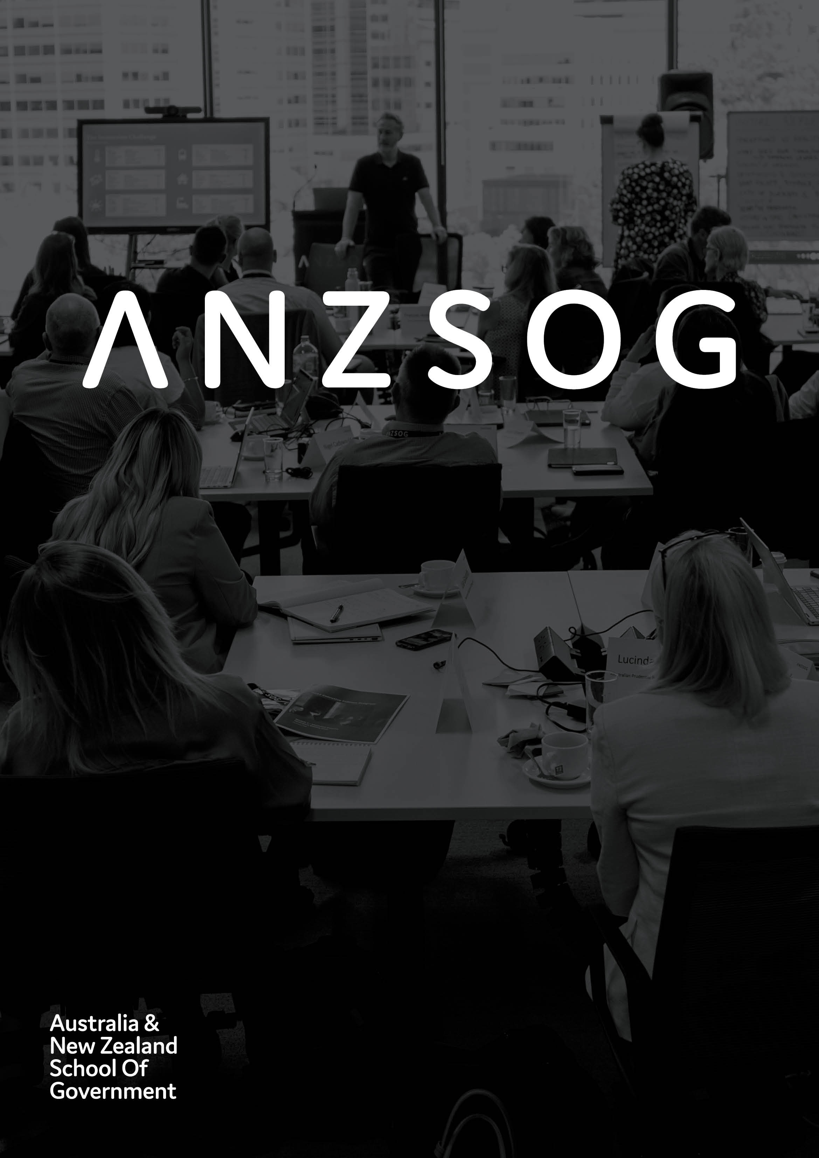

Impact Snapshot 2022

Owned by and working for the governments   
of Australia and Aotearoa New Zealand

Contents

ANZSOG 3

Message from the Dean and CEO 4

Key metrics for 2022 6

Educate 7

Inspire 11

Enrich 18

Connect 22

Finances 24

Our workforce 25

Who we are 27

Follow us 30

# ANZSOG

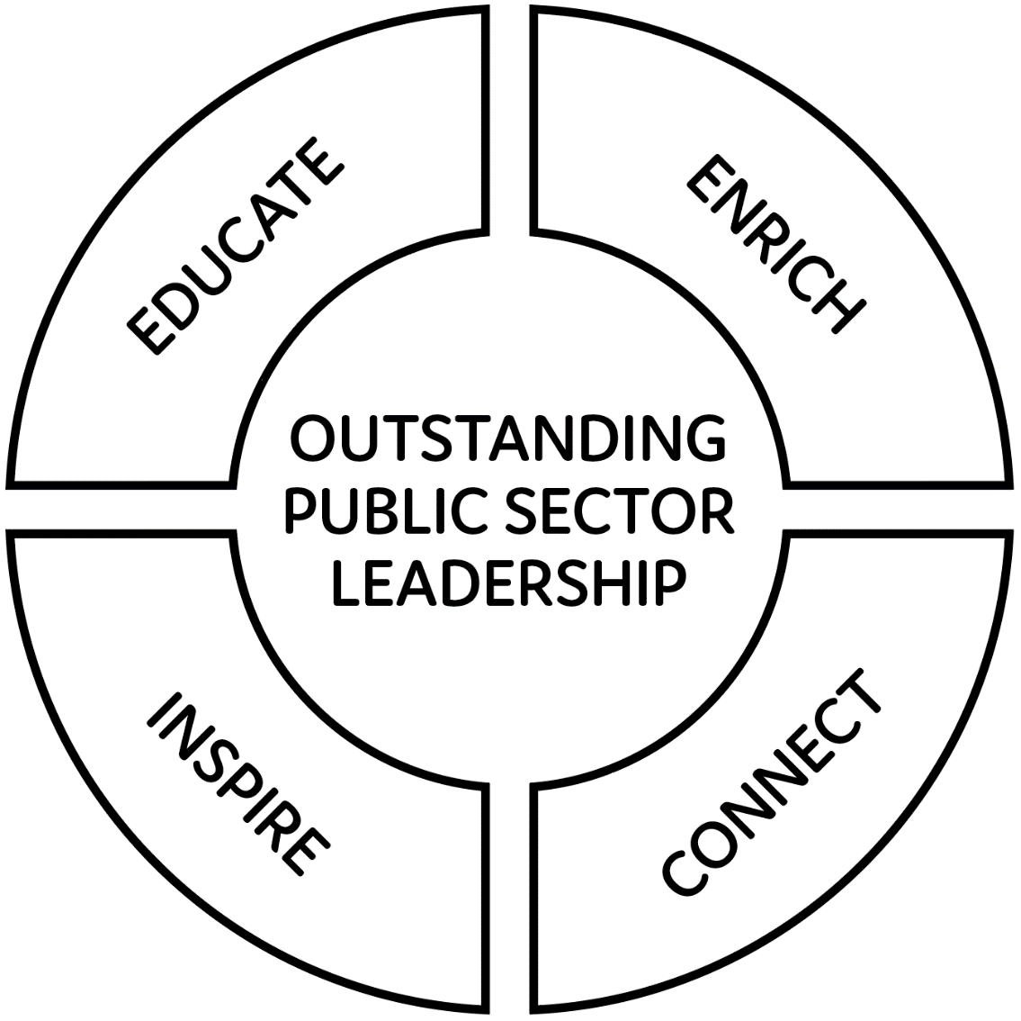

ANZSOG works for our government owners and with our university partners to lift the quality of public sector leadership across Australia and Aotearoa New Zealand. Our work inspires and connects people across agencies, sectors, jurisdictions and nations.

# Message from the Dean and CEO

Photo of Adam Fennessy PSM


It was my great privilege to be appointed as Dean and CEO of ANZSOG in October 2022 and begin steering an organisation with a strong reputation for its diverse and positive impact on governments in Australia and Aotearoa New Zealand.

I want to thank my predecessor Professor Ken Smith AO for his contribution in stewarding ANZSOG over the last five years, in particular his work during the COVID-19 pandemic which disrupted so many of ANZSOG’s core activities. He has left a resilient and flexible organisation that continues to deliver education, research and thought leadership programs which help governments address the extreme challenges posed by both the pandemic and general global uncertainty.

For ANZSOG, as for our owner governments, 2022 was something of a return to business-as-usual – we saw the return of face-to-face teaching in our key education programs, combined with the flexibility of online delivery, a return to international visits to Australia and the publication of two major ANZSOG-funded research reports dealing with the impact of the pandemic on services and the work of the public sector.

But, in other ways the year was a reminder that the long-term impact of COVID will be to intensify the ongoing increase in the demands on our public services. Public service work is complex, messy and it involves a set of ever-changing expectations. Public leaders are required to innovate in an environment of constrained resources, greater scrutiny and increasing politicisation.

The greater demands on the public sector mean strong leadership and culture are required making ANZSOG’s work more important than ever, as we try to provide education that equips public servants for today and tomorrow, create networks and opportunities for connection, as well as spaces to reflect and find inspiration

During 2022, we have seen a consistently strong demand for our education programs – the Executive Master of Public Administration, the Executive Fellows Program, Towards Strategic Leadership and the Deputies Leadership Program – highlighting the desire among public sector leaders for high-quality programs that address their current and future needs. We have also increased our work in providing Custom Education programs to individual agencies who want specific capability building.

As part of our Research Strategy, we have delivered two major research projects – on place-based and hybrid services, and on flexible work in the public sector – which brought together university research teams and governments to produce publicly available research into issues which are highly relevant to governments working to adapt services to the new public sector environment. We have worked to include First Nations perspectives in our curricula, and we will hold an in-person First Nations conference in Brisbane in 2023.

This report contains a snapshot of our activities across our ten jurisdictions and the positive impact they have had on our students, owner governments, university partners and the broader community.

I congratulate ANZSOG staff, faculty and board on what they have achieved, and look forward to working with you in 2023.



**Adam Fennessy PSM  
ANZSOG Dean and CEO**

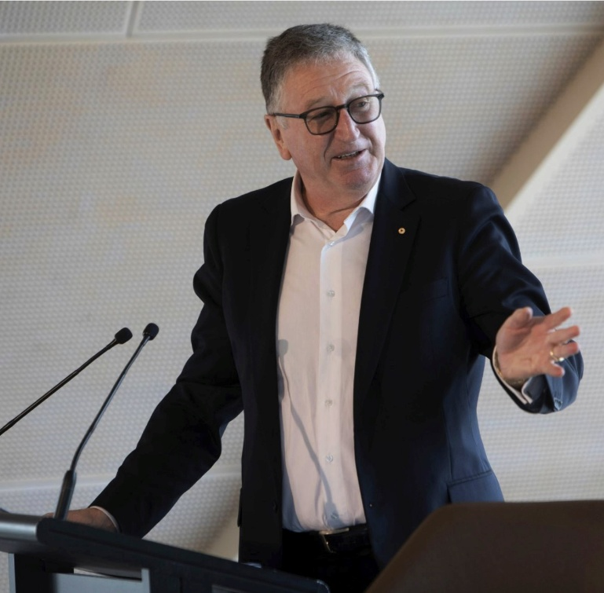

Ken Smith AO,   
Enterprise Professor,   
University of Melbourne

# Key metrics for 2022

* **3,747** Total enrolments/registrations in ANZSOG programs
* **941,892** ANZSOG Website Pageviews (up 22.16% on 2021)
* **18,694** E-news subscribers (up 2.18% on 2021)
* **463,157** Social Media Engagement (up 265% on 2022)

# Educate

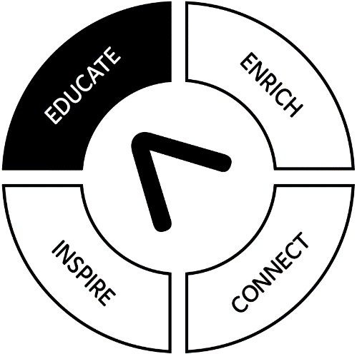

## ANZSOG’s EMPA returns to face-to-face delivery

After two years of successful online delivery ANZSOG’s flagship Executive Master of Public Administration (EMPA) program shifted to a blended format in 2022. Mixing the flexibility and global reach of online delivery with a return to face-to-face programs in Melbourne and Aotearoa New Zealand and an in-person graduation ceremony in Wellington. Demand for the EMPA has remained strong and participant satisfaction levels have remained high. ANZSOG is continually adapting the EMPA to ensure it meets the current and anticipated needs of public services while retaining its focus on public value. This year saw the publication of three reports from the independent EMPA Academic Program Review, on Program Quality, Strategic Alignment and value, and Sustainability. The reports found that the EMPA offered a ‘program of outstanding quality and world-leading stature’ and outlined ten key recommendations for improvement in the future.

“Evidence gathered from hundreds of current EMPA students and alumni, as well as government agencies themselves, highlights how the program provides emerging managers with new insights and knowledge and professional networks which greatly enhance leadership capability and practice across government.”

Professor Richard Eccleston (Chair), Director, Tasmanian Policy Exchange and Professor of Political Science, University of Tasmania

## How the EMPA creates value

A major focus of the EMPA throughout its history is to ensure that the course provides practical relevance not just for participants but their organisations and the broader public sector. Three of the EMPA’s subject leaders for 2022 explain how participants in their EMPA subjects create value across the public sector.

“Over the past 18 years, our student Work-Based Project teams, in conjunction with their academic advisors, have completed over 300 projects tackling the often wicked and complex problems faced by the public sector. Organisations who sponsor topics are offered a professional report that addresses concerns and offers guidance for remediation and forward action”

Dr Zina O’Leary – subject leader for Work-Based Project

“We worked with the New Zealand Attorney-General’s office, and workshopped the new integrity strategy they are developing for the NZ public sector. They have now released their latest draft and publicly thanked the EMPA participants workshop and the feedback they got.”

Professor Michael Macaulay – subject leader for Managing Public Sector Organisations

## Monash Pathways program boosting EMPA diversity

To create a more diverse and accessible EMPA, ANZSOG has worked with Monash University to create the Pathways program for EMPA applicants who have demonstrated leadership capabilities in their professional roles but lack university qualifications. The first cohort of Pathway students enrolled in Monash’s Graduate Certificate in Public Policy (GCPP). All nine students in the first cohort successfully completed the GCPP and transitioned into the EMPA in 2022.

## Participants praise the EMPA’s relevance to their work

Each year ANZSOG surveys the EMPA cohort to determine how relevant they find each subject to their work. Below are the 2022 responses to the statement: *‘the insights from the subject are transferable to my workplace and can be applied to my organisational context’*

**5 = strongly agree, 1 = strongly disagree**

|  |  |
| --- | --- |
| Decision Making Under Uncertainty | 4.56/5 |
| Delivering Public Value | 4.45/5 |
| Designing Public Policy and Programs | 4.40/5 |
| Governing by Regulation | 4.37/5 |
| Governing in a Market Economy | 4.17/5 |
| Leading Public Sector Change | 4.73/5 |
| Managing Public Sector Organisations | 4.36/5 |
| Public Financial Management | 4.58/5 |
| Work-Based Project | 4.46/5 |

“Public Financial Management has been designed with the idea that its content and its assessments contribute to practical impact. The exemplar of that is that the individual assignment that participants take is about evaluating and improving performance measurement of financial resource use in their own organisation. Many participants have used that as a basis for writing recommendations for change into their organisation’s executive.”

Suresh Cuganesan – subject leader for Public Financial Management

## Flexible Custom Education Programs helping agencies build capability

A growing part of ANZSOG’s work is the provision of Custom Education programs to organisations including the Australian Tax Office, and the Victorian Department of Health. Partnering with ANZSOG gives clients access to our networks of experts and knowledge of the broader public sector landscape. A custom program can bring an entire leadership team together for capability development that reflects the organisation’s challenges, priorities and contexts.

For example, the Office of Industrial Relations Queensland worked with ANZSOG to create customised capability training for senior and mid-level staff in its Work and Electrical Safety Policy Team to strengthen their capacity to collaborate with stakeholders and give them the deeper understanding they needed to navigate the ethical, strategic and political context of their work.

“What ANZSOG offered was a bespoke training course that was developed with us. Everyone in the team has done some generalist consultation or stakeholder relations training already, so we wanted something that would help us at a much higher level – and that’s what we got.”

Andrea Fox, Chief Policy Director Work and Electrical Safety Policy, Office of Industrial Relations Queensland

## Education programs strengthen current and future leaders

ANZSOG’s key education programs returned to blended delivery in 2022, with the Executive Fellow Program, Towards Strategic Leadership and the new Deputies Leadership Program offering a mix of online and face-to-face instruction. These programs cater to different levels of leadership but all provide a unique mix of exposure to expert perspectives from practitioners and academics, and a space to reflect on the qualities required for effective leadership.

“I was impressed at the high quality and seniority of the presenters and their level of experience, and at having the opportunity to be able to speak to them in small groups. It is a rare opportunity to talk to people who are leading Royal Commissions, who are auditor generals or former department heads, in a forum where they can be open and honest about the challenges we all face.”

2021/22 Deputies Leadership Program participant Judith Formston, Executive Director People and Corporate Services, SA Department for Infrastructure and Transport

# Inspire

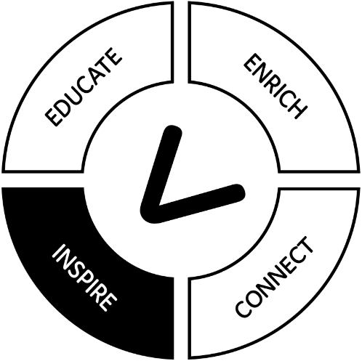

## ANZSOG Alumni honoured for contribution to community

ANZSOG’s Alumni are a 3000-strong network of passionate and committed people in every jurisdiction in Australia and Aotearoa New Zealand. Every year the value of some of our alumni’s contributions to their communities is recognised in the Australia Day and Queen’s Birthday Honours lists in Australia, and the State Service Commission Awards in Aotearoa New Zealand. Below are the ANZSOG alumni who received awards in 2022, a total which includes 15 recipients of the 100 Public Service Medals awarded this year.

### Order of Australia

**Wendy Steendam** – (Victoria Police Deputy Commissioner for Specialist Operations – Executive Master of Public Administration 2004) has been made a Member of the Order of Australia (AM) for significant service to the community through emergency response organisations.

### Public Service Medals

**Tracy Creech** – Executive Master of Public Administration 2016 (Australian Government) was recognised for outstanding public service in establishing survivor-focused support services for the National Redress Scheme and for guiding instrumental improvements.

**Alice Linacre** – Executive Master of Public Administration 2017 (Australian Government) was recognised for outstanding public service in the provision and management of legal services and resources to support the government’s response to critical events, including the COVID-19 pandemic (COVID honour roll).

**John Tansey** – Executive Fellows Program 2009 (NSW Government) was recognised for outstanding public service to building regulation in New South Wales.

**Lee Miezis** – Executive Fellows Program 2013 (Victorian Government) was recognised for outstanding public service to policy, regulation and service delivery in Victoria, particularly in the area of environmental sustainability.

**Sarah Stephen** – Towards Strategic Leadership 2016 (Victorian Government) was recognised for outstanding public service to strategic policy reform and delivery in Victoria, particularly in the areas of climate change and energy.

**Jasmina Joldic** – Deputies Leadership Program 2021 (Queensland Government) was recognised for outstanding public service through delivery of critical functions and health policies that have contributed to the successful COVID-19 response in Queensland.

**Kathleen Robinson** – Executive Fellows Program 2013 (Northern Territory Government) was recognised for outstanding public service to the Northern Territory Public Sector.

**Robert Patrick Bryson** – Towards Strategic Leadership 2018 (Commonwealth Government) for outstanding public service in his sustained role in the logistic and asset improvement and modernisation of Australia’s operational Antarctic program.

**Jacqueline Ann Curtis** – Executive Master of Public Administration 2006 (Commonwealth Government) for outstanding public service in driving change and building capability in the Australian Public Service as inaugural head of the APS Human Resources Profession.

**Danielle Joy Regeling** – Executive Master of Public Administration 2018 and Executive Fellows Program 2021 (Commonwealth Government) for outstanding public service to Service Australia’s support for Australians during the COVID-19 pandemic, navigating between Services Australia and primary partners including the Department of Health and national health providers.

**Caroline Farmer** – Executive Master of Public Administration 2018 (NSW Government) for outstanding public service to New South Wales Health, particularly during the COVID-19 pandemic.

**William James Murphy** – Executive Master of Public Administration 2007 and Executive Fellows Program 2016 (NSW Government) for outstanding public service to NSW, particularly during the COVID-19 pandemic.

**Argiri Alisandratos** – Executive Master of Public Administration 2006 (Victorian Government) for outstanding public service to the community, particularly to Victoria’s most vulnerable.

**Maree Ann Parker** – Deputies Leadership Program 2019 (Queensland Government) for outstanding public service in regional development, infrastructure planning and delivery and disaster economic recovery.

**Fiona Ward** – Deputies Leadership Program (2018 South Australian Government) for outstanding public service in child protection and community services for children and families in South Australia.

## Our alumni talk about how ANZSOG helped them deliver public value

### Manaia King

New Zealand

Executive Master of Public Administration 2019



Manaia trained as a lawyer but decided to make his career in the public service because of his passion for service and for helping people to achieve their own aspirations. Coming from a disadvantaged community, he now works to bridge the gaps between the ways governments make polices and deliver services, and the lived experience of the people and communities they are trying to support.

“As a manager I have approximately 50 staff under me all of whom had personal pressures and matters to deal with over COVID. The EMPA has helped me to be a more empathetic leader and to realise people are an extension of myself and my leadership responsibility.”

### Jacqui Curtis

Australia

Executive Master of Public Administration 2006

Photo of Jacqui Curtis


Jacqui is Chief Operating Officer at the Australian Taxation Office (ATO), and in recent years has played a key part in major cultural changes within the ATO. As the inaugural head of the Australian Public Service’s Human Resources Profession she leads efforts to raise the profile and capability of Human Resources across the APS. Her focus on people-centred leadership has driven a career which saw her awarded a Public Service Medal in 2022.

“I signed up for the Executive Master of Public Administration within a few months of shifting to the public sector. If you want to have a career in the public service, you need to know what it is, what its core functions are, what makes it different to other sectors and in particular, learn public sector craft. You need to look at the whole system, not just your role and your department’s remit.”

### Michelle Campbell

Australia

Executive Fellows Program 2020



Michelle made a purpose-driven decision to move from the private sector to the public service in mid-career because she wanted to serve the community and help the government deliver projects. Her role focuses on project system wide improvements, championing the state-wide, whole of government approach to understanding the relevant issues and facilitating the sharing of best practice advice between infrastructure delivery agencies.

“I’d completed my senior corporate MBA study and worked in the corporate sector for many decades. For me the EFP was like: ‘I get it now, there’s that other political dimension we don’t need to factor in in corporate’. It introduced concepts and theories to put into my day-to-day work, and ways to shape my thinking. It crystallised everything for me.”

### Chris Sarra

Australia

Executive Master of Public Administration 2003

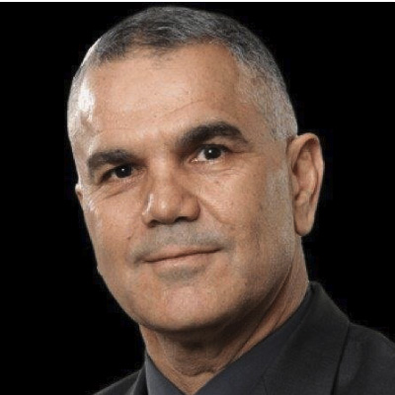

Chris is one of Australia’s most influential Aboriginal educators, pioneering the Stronger Smarter approach in his role as principal of Cherbourg Public School in Queensland. The Gurang Gurang/Taribelang man was also co-chair of the Indigenous Advisory Council until 2018 and is currently working to build partnerships between First Nations communities and government in Queensland with a focus on a strengths-based approach that recognises the value of Indigenous cultures.

“The EMPA helped me stretch my thinking and give me some confidence about being able to work in that broader policy space. My most profound learning from the EMPA is that ‘policy is policy’, and it was quite emancipating to realise that I could bring more to the public service and the world than just First Nations policy experience.”

## New ideas for uncertain times with Public Leadership Masterclasses

ANZSOG’s Future public sector leaders program began in 2020 and offered short masterclasses that gave participants exposure to new ideas and fresh thinking on the work of government. In 2022, the series was renamed Public Leadership Masterclasses and has continued to provide public leaders with new ideas and inspiration from leading domestic and international thinkers on leadership and public management, in a format that allows agencies to tailor packages for their staff and fit into a busy work day. The series has had high positive ratings since it began.

* **4.4/5** – Winter Series 2022 Average Evaluation
* **4.3/5** – Summer Series 2021-22 Average Evaluation
* **4.2/5** – Summer Series 2020-21 Average Evaluation

**(4 = good, 5 = excellent)**

* **90%** agreed topics were contemporary and relevant to their work
* **85%** agreed that the packages provided the flexibility they were looking for

“The topic areas, especially in relation to Indigenous content were attractive and aligned with my professional and cultural leadership”

quote from participant

“I have learnt something new from every masterclass I have attended”

quote from participant

## ANZSOG policy ‘hackathon’ gives Australian Public Service graduates tools and connections

ANZSOG brought together around 400 Australian Public Service graduates from different departments together to build connections, gain new tools for collaboration and generate new ideas in a two-day policy ‘hackathon’ in Canberra. The event, delivered for the Australian Public Service Commission in partnership with the ANU Futures Hub, supported graduates to channel their energy, enthusiasm and expertise to come up with specific proposals to tackle big-picture policy challenges in an innovative live-action format. The success of the event is evidenced by a request for ANZSOG to run a repeat in 2023 and expanding the cohort. Additionally, we are leveraging this event to inform ongoing research around public service craft.

# Enrich

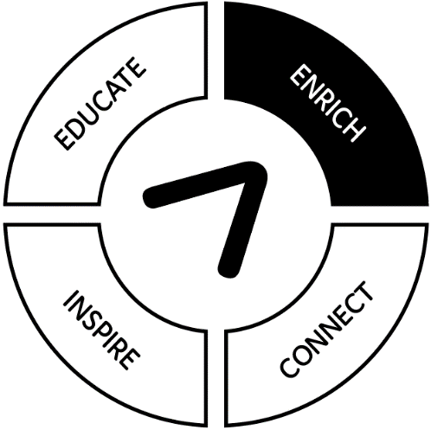

## ANZSOG-funded research shaping the post-pandemic public sector

ANZSOG uses our unique ability to connect academics and practitioners to fund and disseminate research that has broad, systemic impact on the practice of public administration. Two of our major co-funded research projects investigating pressing concerns in public policy and public administration delivered final reports in 2022. The first, on place-based and hybrid services, was undertaken by the University of NSW’s Social Policy Research Centre and co-funded with the NSW Government. The second, on flexible work in the public sector, was undertaken by the University of NSW’s Wales’s Public Service Research Group and co-funded in partnership with the ACTPS. These publications were followed by two implementation workshops which brought together senior public servants from multiple jurisdictions to consider how the findings would impact their own contexts. The flexible work report received positive coverage in The Mandarin, The Canberra Times and other media and helped shape debate on this key issue.

This was also the culmination of the inaugural Round of projects under our collaborative Research Model, with two new projects commissioned in late 2022. ANZSOG continues to receive requests to co-design research through this model, highlighting that our demand-led Model is offering real value, and that there is an appetite for focused collaboration with university-based research teams.

## Improving policy and bringing jurisdictions together

ANZSOG is working to build policy development capability by creating frameworks and models for better policy development and through its Advisory services.

ANZSOG brought representatives from three of these jurisdictions together for a ‘curated conversation’ about the challenges of improving policy development including building a policy advisory system and culture change within organisations, which has been published as part of our Research Insights series. We also held a curated conversation with several jurisdictions and Singapore on building foresight capability in government.

ANZSOG also works with individual departments to support their policy improvement programs. For example, we worked with the NSW Department for Education to design a policy model ‘The Way we do Policy’ and supporting toolkit.

“The Way We Do Policy has been extremely well received so far, both internally within the NSW Department of Education and more widely, with many other Department leaders commenting on its rigour and quality. We greatly appreciate the expertise and personal dedication ANZSOG brought to this work, which ensured it was fit-for-purpose and supported by the latest research into what works.”

Georgina Harrisson, Secretary NSW Department of Education

## Making research projects accessible with Research Insights



ANZSOG wants the research it funds to reach all those who could benefit from it. To help achieve this ANZSOG established the Research Insights series in late 2021 to share research outputs more broadly and offer conceptual and practical insights into the work of public administration and policymaking. In 2022 ANZSOG published six new Research Insights papers covering issues including: building policy capability, developing a way to implement an early intervention investment framework, to the governance of the Queensland Building and Construction Commission. ANZSOG also use Research Insights to publish a series of eight papers by Professor Brian Head outlining the history of SES governance in eight Australian jurisdictions.

## ANZSOG academics shaping public policy debates

**Professor Ariadne Vromen**, ANZSOG/ANU Sir John Bunting Chair of Public Administration continued to contribute material to a range of research and media outlets in 2022. Prof Vromen’s work included a book and two scholarly journal articles, and other short form pieces, concerning young people and political participation, the future of citizen engagement, and the future of work. An ANU Media release on Professor Vromen’s research on technology and the future of work in August 2022 generated almost 500 media items across TV, radio, print and online Additionally, Professor Vromen was an invited speaker/presenter to:

* Royal Society of NSW on Reshaping Australia: Communities in Action
* Academy of Social Sciences conference on Democracy: Risk, Relevance, Revival
* United Nations Dept. Economics and Social Affairs–UN Think Tank: Youth Digital Engagement

**Professor Catherine Althaus**, ANZSOG Chair of Public Service Leadership and Reform at UNSW Canberra and an internationally certified adaptive leadership facilitator and coach, launched the Academy of Adaptive Leadership at UNSW in collaboration with the Harvard Kennedy School and Kansas Leadership Center. She also continued as academic lead and contributing faculty for the Journey program being undertaken by UNSW and Nous with the Department of Defence, training 3500 personnel over 5 years. She co-authored the 7th edition of the Australian Policy Handbook with Professor Glyn Davis, Peter Bridgman, Dr Sarah Ball and David Threlfall.

Her publications on subjects including Indigenous public service leadership and using consultants to improve public sector policy capability featured in Tier 1 journals in the public administration, including Public Administration Review and Perspectives on Public Management and Governance. Professor Althaus accepted an invited role as International Advisory Board Member, for the John Templeton Foundation Islamic Public Value project, and continued her invited scholarly service as honorary member, South Asian Network of Public Administration and Extraordinary Professor with the University of Pretoria.

## New additions to ANZSOG’s Case Library

The John L. Alford Case Library is a freely-available trove of research-based case studies on public service decision making and critical incidents, underpinned by original fieldwork. Cases continue to attract new general readers as well as being incorporated into teaching programs. Six new cases were published in 2022, including a case detailing the Australian Bureau of Statistics response to failures of the 2016 Census has proven especially popular and was cited as the basis for a request to ANZSOG for a bespoke learning program. Two cases were published featuring First Nations perspectives on highly important issues: Closing the Gap Refresh: Incorporating First Nations Voices in Policy Design; Making up for Lost Time? First Peoples-State Treaty-Making in Victoria.

## The Bridge – sharing knowledge between academics and public servants



ANZSOG’s The Bridge research translation project delivers a fortnightly email to 15,000+ subscribers outlining recent research relevant to their work, as well as new Research Brief which summarises an academic article on public management. Since it’s launch in 2020 The Bridge has become highly popular with readers and delivered content relevant to their work. The 2022 survey of Bridge readers found that:

* **25% open rate** for Bridge emails in 2022
* **18,708 unique page views** for the 23 Research Briefs published in 2022
* **97%** of readers said they found Bridge **content engaging**
* **91%** said they found content **relevant to their work**
* **71%** of readers said they **shared content** with their colleagues or networks
* **35%** are **managers or senior** leaders in the public service

## Work across the Indo-Pacific

### Building policy capability through the Pacific Fale

ANZSOG partnered with the Public Service Fale in the Public Service Commission in Aotearoa New Zealand to develop and deliver a policy capability program for 16 Pacific jurisdictions. The Fale’s policy program began in April 2022 with the first of two webinars led by ANZSOG’s Executive Director for Aotearoa New Zealand, Sally Washington, who previously set up and led the Policy Project in Aotearoa’s Department of the Prime Minister and Cabinet.

The program draws on ANZSOG’s expertise and recent work on building policy capability and supports Pacific Public Service Commissions and public service leaders to assess and build policy capability through a series of interactive webinars – with the goal of improving the quality of their advice to decision makers.

### Strengthening governance in Papua New Guinea

ANZSOG worked with the Pacific Institute of Leadership and Governance (PILAG) throughout 2022 to design a high-level leadership and governance program for public servants in Papua New Guinea (PNG), as part of our work to improve governance in the Indo-Pacific region. The program was delivered to approximately 100 CEOs and provincial executives via online learning, with a focus on three themes: leading organisational culture, leading organisational performance and leading organisational change.

“We chose ANZSOG because it is an organisation that has delivered a lot of leadership programs for the Australian and New Zealand public service and we wanted to partner with an international organisation with that experience.”

Rebecca Gonapa, Manager Learning Development Research and Innovation, Pacific Institute of Leadership and Governance.

## Bringing regulators together and lifting capability

The ANZSOG-auspiced National Regulators Community of Practice (NRCoP) is an active network of public sector regulators from all three levels of government and from every regulatory sector, professional background, role and level of seniority, who are keen to learn from and with each other. The NRCoP delivers webinars and local events to connect regulators and expose them to new ideas about their craft.

As the job of regulators has become more demanding, there has been an increased interest in professionalising practice, and a focus on the similarities in the challenges facing regulators in different areas and agencies. Aotearoa New Zealand began the process of professionalising regulation in 2008, and the Government Regulatory Practice Initiative (G-Reg) was set up in 2015 to provide standardised training to regulators across agencies.

No similar system has existed until now in Australia, and NRCoP in partnership with ANU’s School of Regulation and Global Governance (RegNet) has created a program of training modules and seminars – the Professional Regulator Program (PRP) – to give Australian regulators access to training with a focus on the common issues regulators face. The PRP will commence in February 2023 and will provide an accessible way for regulatory agencies to lift capability.

## NRCoP activities for 2022

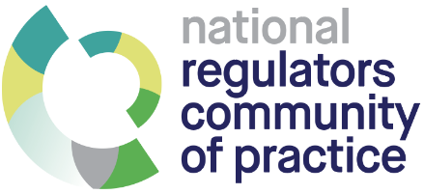

* **2,042** – Hosted 12 webinars with **2,042 participants**
* **4.6/5** – **Average evaluation** for webinars
* **6,697** – **Subscribers** to Regulators Update e-news
* **92** – **Corporate members**
* **SA & ACT** – **New chapters inaugurated** in SA and the ACT
* **347** – **jobs posted** on the NRCoP Jobs Board

# Connect

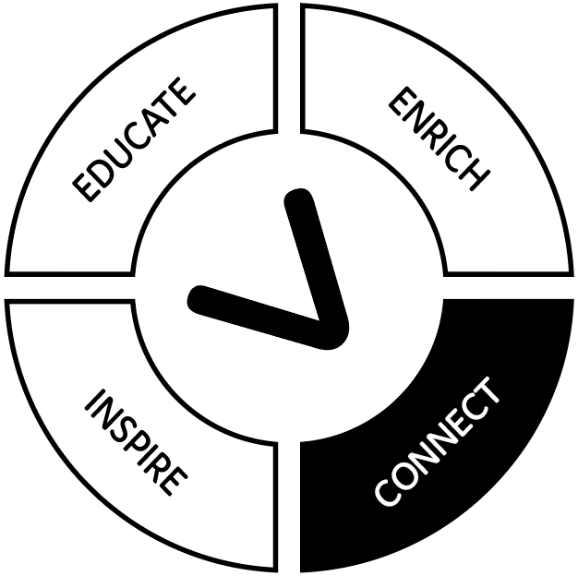

## Planning for 2023 First Nations Conference

After the successful online delivery of ANZSOG’s *Proud Partnerships* conference in 2021, we will hold a face-to-face conference in March 2023 in Brisbane – *First Peoples to All Peoples: partnerships, devolution, transformation and sharing* – with the support of the National Indigenous Australians Agency (NIAA). The conference will explore the transformation in the ways governments are working with First Nations and the need for public servants to develop new skills |and ways of thinking. The conference will feature an almost entirely First Nations line-up of speakers, including ten from Aotearoa New Zealand and will examine First Nations policy through the lenses of Australia’s National Agreement on Closing the Gap commitments, particularly the four Priority Reforms, as well as the New Zealand Public Service Act 2020, which now clearly sets out the responsibility of the public service, particularly its leadership, in supporting the Crown’s relationship with Māori under the Treaty of Waitangi. This will be the fourth ANZSOG First Nations public administration conference, and continue our unique role in bringing public servants, academics and First Nations community representatives together.

To support the conference ANZSOG has developed and distributed an Explainer for public servants on the National Agreement on Closing the Gap, win collaboration with the Closing the Gap Secretariat and the Coalition of Peaks Secretariat

## Embedding First Nations perspectives into education programs

In 2022, ANZSOG established a First Nations Reference Group to provide advice and guidance to ANZSOG on its First Nations priorities, programs and strategies as requested. There are seven members all of whom are First Nations. The Reference Group met twice in 2022 and provided advice on ANZSOG’s First Nations Curriculum Guide, a project to assist ANZSOG subject leaders and faculty to embed First Nations perspectives and values into our education programs.

## Return of international visits to Australia

### Singapore Civil Service College visits

In September 2022, ANZSOG welcomed a delegation of 30 mid-level public servants from the service delivery functions of over 20 Singapore ministries and agencies to Australia for a three-day visit to Sydney. They built connections and shared ideas with high-level NSW public servants from a range of agencies with a focus on technology and the digital transformation of government and service delivery. Patrick Lau, Singapore Civil Service College’s Assistant Chief Executive (Strategy & Transformation), Dean’s Office said ANZSOG had put together a well-curated program and participants had left with many valuable insights, particularly into inter-agency collaboration.

Later in the year ANZSOG hosted the 3rd Executive Leadership Programme (ELP) organised by the Civil Service College for senior leaders in the Singapore Public Service. The delegation of 30 senior leaders included Director-Generals, Senior Directors, and Divisional Directors in ministries, as well as Deputy Chief Executives and Assistant Chief Executives of statutory boards, who were interested to hear ANZSOG’s vision and priorities for public sector leadership and building leadership capabilities in Australia public sector.

### NZ Parliamentary Delegation

ANZSOG hosted Aotearoa New Zealand Members of Parliament visiting Australia as part of the Australian Political Exchange Council program, a program designed to develop young Australian political leaders by providing opportunities to gain insights into the political systems and cultures of participating counterpart countries. ANZSOG’s Dean and CEO was able to talk to the group about ANZSOG’s capability building and policy foresight work, and share his experience on building leadership capabilities in the Australian public sector.

# Finances

## 1 January 2022 – 31 December 2022

Figures covering revenue and expenditure across programs from Jan 1 – Dec 31, 2022.

## Income

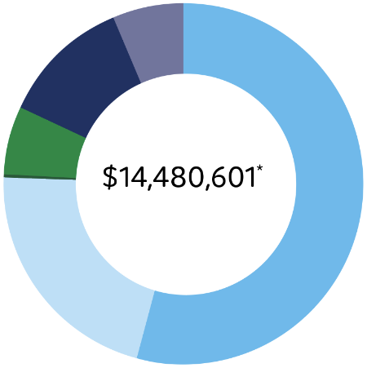

**Total:** $14,480,601

This figure does not include a $2,877,375 net loss on investments, made up of the combined investment income and net losses from realised investments

|  |  |
| --- | --- |
|  | Foundation Programs 54.4% |
|  | Executive Education 21.2% |
|  | International Programs 0.3% |
|  | Research & Academic 6.2% |
|  | Other Events 11.7% |
|  | Member Contributions 6.2% |
|  | Other Income Sources 0.0% |

Note:

* Foundation Programs is comprised of EMPA, EFP and TSL
* Other Income Sources previously included Jobkeeper grants

## Expenses

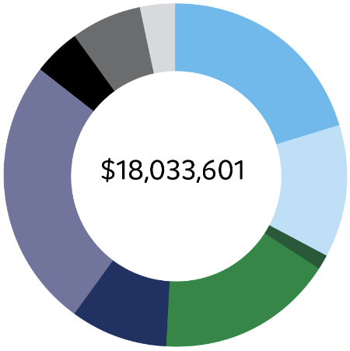

**Total:** $18,033,601

|  |  |
| --- | --- |
|  | Foundation Programs 21% |
|  | Executive Education 12% |
|  | International Programs 2% |
|  | Research & Academic 17% |
|  | Other Events 9% |
|  | Admin, Board & Governance 25% |
|  | Strategic Expenditure 4% |
|  | Marketing and Business Development Expenses 7% |
|  |
|  | Other Expenditure 3% |

Note:

* Research & Academic include expenditure related to Seconded Academics with Universities
* Admin, Board and Governance include expenditure related to governance and operational support such as Finance, ICT, HR
* Other Expenditure include expenditure related to Investment management and Office Facilities

# Our workforce

as of December 2022

## Gender

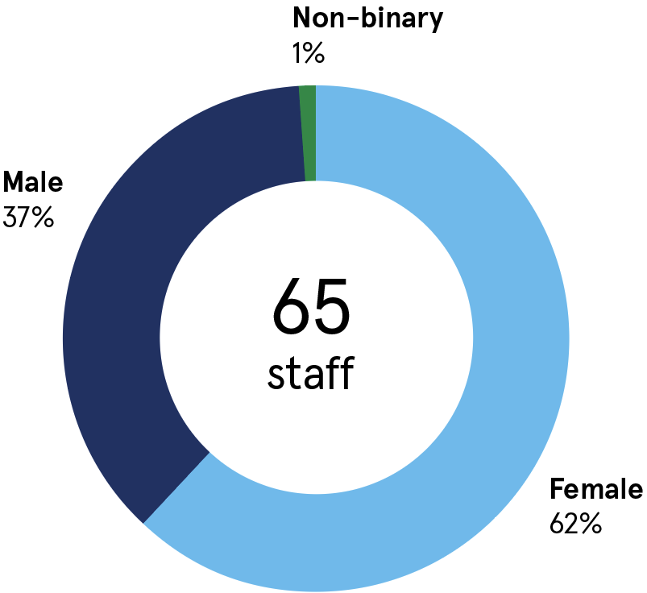

65 staff:

* Female 62%
* Male 37%
* Non-binary 1%

## Age

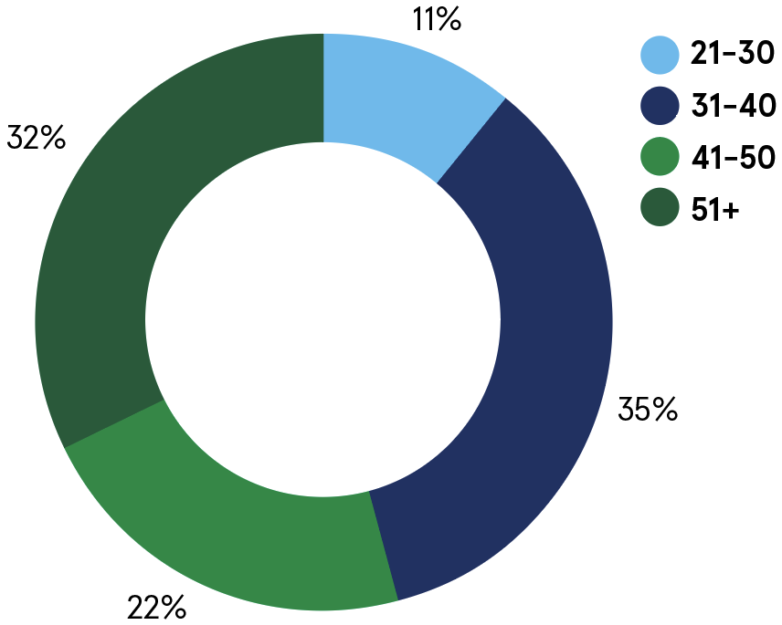

* Age 21-30: 11%
* Age 31-40: 35%
* Age 41-50: 22%
* Age 51+: 32%

## Years of service

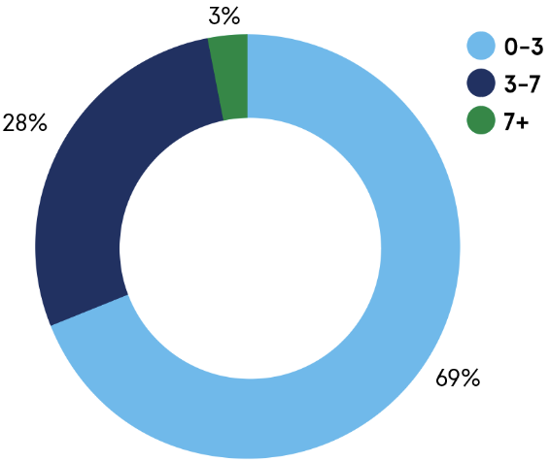

* 0-3 years: 69%
* 3-7 years: 28%
* 7+ years: 3%

## Staff Pay Band by Gender

(percentages are of total staff)

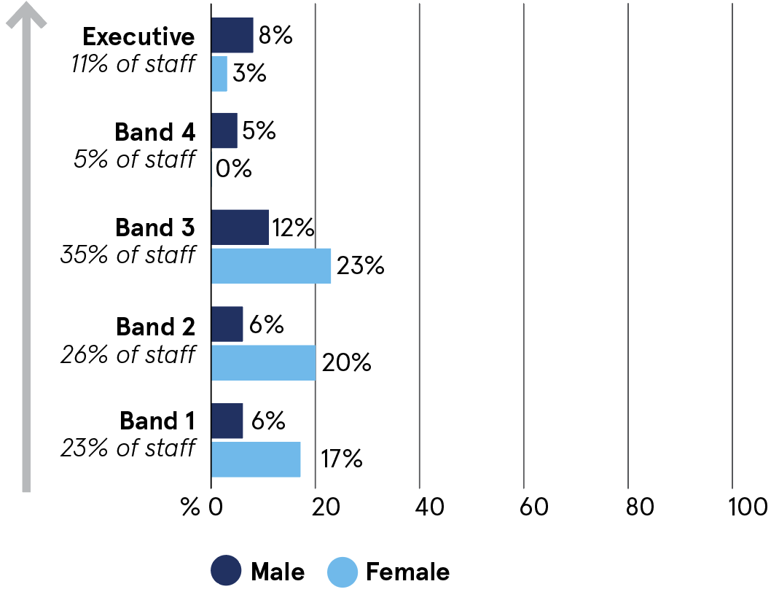

* Band 1 (23% of staff): Female 17%; Male 6%
* Band 2 (26% of staff): Female 20%; Male 6%
* Band 3 (35% of staff): Female 23%; Male 12%
* Band 4 (5% of staff): Female 0%; Male 5%
* Executive (11% of staff): Female 3%; Male 8%

## Highlights from Diversity Survey 2022

* **22%** of staff were born outside Australia and Aotearoa New Zealand
* **29%** spoke a language other than English with their family or community
* **4%** were First Nations
* **59%** have worked outside Australia and/or Aotearoa New Zealand

# Who we are

Created by government for government, ANZSOG works with our owner governments and partner universities to strengthen the quality of public sector leadership in Australia and Aotearoa New Zealand. We provide unique education programs, thought leadership and government-focused research that meet the contemporary challenges faced by public services. Our work inspires and connects people across agencies, sectors and jurisdictions. Everything we do is designed to deliver better government and better outcomes for the public.

## Our Board

The Board of Directors has overall responsibility for the organisation, setting direction and overseeing the effectiveness of delivery against strategy.

* [Mr Peter Woolcott AO (Chair)](https://www.anzsog.edu.au/about/contact-directory/peter-woolcott/?_content-type=Directory&_areas-of-expertise=&_directory-group=Board&searchword=&ordering=last_name_ordering+ASC&searchmodule=168&limitstart=): Australian Public Service Commissioner
* Adam Fennessy PSM: Dean and CEO, ANZSOG
* [Professor Margaret Gardner AC](https://www.anzsog.edu.au/about/contact-directory/professor-margaret-gardner/?_content-type=Directory&_areas-of-expertise=&_directory-group=Board&searchword=&ordering=last_name_ordering+ASC&searchmodule=168&limitstart=): President and Vice-Chancellor, Monash University
* [Mr Jeremi Moule](https://www.anzsog.edu.au/about/contact-directory/jeremi-moule): Secretary for the Victorian Department of Premier and Cabinet
* [Ms Kathrina Lo](https://www.anzsog.edu.au/about/contact-directory/kathrina-lo): NSW Public Service Commissioner
* [Ms Belinda Clark](https://www.anzsog.edu.au/about/contact-directory/belinda-clark-qso): Board member, ANZSOG
* [Professor Deborah Terry AO](https://www.anzsog.edu.au/about/contact-directory/professor-deborah-terry-ao/?_content-type=Directory&_areas-of-expertise=&_directory-group=Board&searchword=&ordering=last_name_ordering+ASC&searchmodule=168&limitstart=): Vice-Chancellor and President, The University of Queensland
* [Ms Erma Ranieri](https://anzsog.edu.au/about/contact-directory/erma-ranieri-psm): Commissioner for Public Sector Employment, SA
* [Ms Kathy Leigh](https://anzsog.edu.au/about/contact-directory/kathy-leigh): Head of Service and Director-General | Chief Minister, Treasury and Economic Development Directorate, ACT Government
* [Ms Jenny Gale](https://anzsog.edu.au/about/contact-directory/jenny-gale): Secretary of Tasmanian Department of Premier and Cabinet and Head of State Service
* [Ms Sharyn O’Neill](https://anzsog.edu.au/about/contact-directory/sharyn-o-neill): WA Public Sector Commissioner
* [Professor Mark Scott AO](https://anzsog.edu.au/about-us/contact-directory/professor-mark-scott-ao/): Vice-Chancellor and Principal, University of Sydney
* [Professor Mark Hickford](https://anzsog.edu.au/about-us/contact-directory/professor-mark-hickford/): Pro Vice-Chancellor of Government, Law and Business, Victoria University of Wellington
* [Ms Vicki Telfer PSM](https://anzsog.edu.au/about-us/contact-directory/vicki-telfer/): Commissioner for Public Employment, Northern Territory Government
* [Mike Kaiser](https://anzsog.edu.au/about-us/contact-directory/mike-kaiser/): Director-General of the Department of State Development, Infrastructure, Local Government and Planning, Queensland Government

## Our Executive Leadership Team

In 2022 the Executive Management Team (EMT) and the Academic Management Team (AMT) were amalgamated into a single forum – the Executive Leadership Team (ELT) – to avoid duplication between the EMT and the AMT and to provide a single management approach across ANZSOG.

The ELT is a consultative forum which provides advice to the Dean & CEO on strategic and operational matters. The ELT brings cross-organisational focus and perspective on a broad range of issues and its work program is aimed at developing and endorsing submissions for consideration by the Board and relevant sub-committees. The ELT conducts strategic discussions 6 weeks prior to Board meetings. It also assesses the organisational performance of ANZSOG on a monthly basis at meetings convened mid-month.

### ELT composition in 2022

* Professor Ken Smith (Dean/CEO) – Chair
* Professor Catherine Althaus (Deputy Dean, Teaching & Learning)
* Dr Subho Banerjee (Deputy CEO, Research and Advisory)
* Mr Simon Kent (Deputy CEO, Thought Leadership)
* Ms Radha Thomas (COO/Company Secretary)
* Professor Ariadne Vromen (Deputy Dean, Research)
* Dr Chris Walker (Deputy Dean, University Relations and Academic Director, EMPA)
* Ms Sally Washington (Director ANZSOG New Zealand)
* Prof Janine O’Flynn (Professor of Public Management)

## Our member universities

* Australian National University
* Carnegie Mellon University, Australia
* Charles Darwin University
* Curtin University
* Flinders University
* Griffith University
* Melbourne Business School
* Monash University
* University of Adelaide
* University of Melbourne
* University of New South Wales
* University of Queensland
* University of Sydney
* University of Canberra
* University of Tasmania
* Victoria University of Wellington

## Our affiliate partners

* Analysis & Policy Observatory (APO)
* China Executive Leadership Academy Pudong (CELAP)
* Department of Personnel and Training, Government of India
* Organisation for Economic Co-operation and Development (OECD)
* Singapore Civil Service College
* Lee Kuan Yew School of Public Policy
* Razak School of Government

## Our owner governments

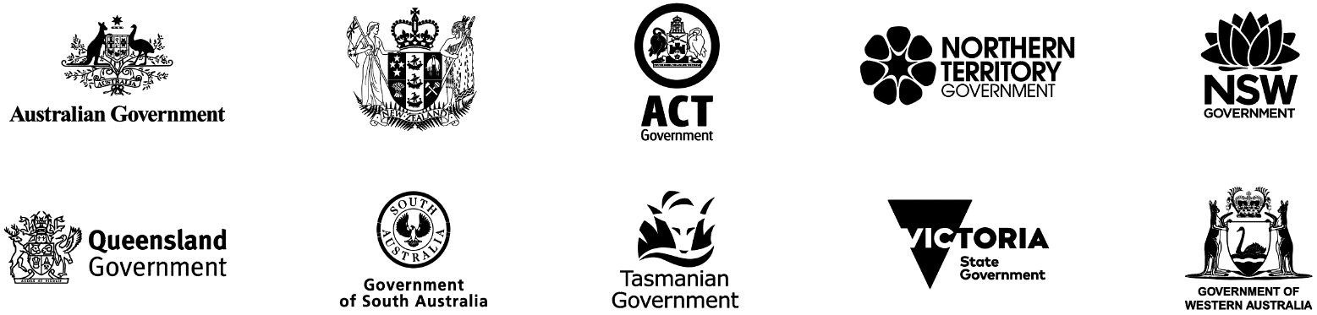

* Australian Government
* Aotearoa New Zealand Government
* Australian Capital Territory Government
* Northern Territory Government
* New South Wales Government
* Queensland Government
* Government of South Australia
* Tasmanian Government
* Victoria State Government
* Government of Western Australia

# Follow us

[ANZSOG website](https://www.anzsog.edu.au)

Facebook icon [ANZSOG Facebook page](https://www.facebook.com/ANZSOG)

Twitter icon [ANZSOG Twitter page](https://twitter.com/ANZSOG)

LinkedIn icon [ANZSOG LinkedIn page](https://www.linkedin.com/school/anzsog)

We acknowledge the Aboriginal and Torres Strait Islander peoples as Traditional Owners, Custodians and First Nations of Australia, and Māori as tangata whenua and Treaty of Waitangi partners in Aotearoa New Zealand.