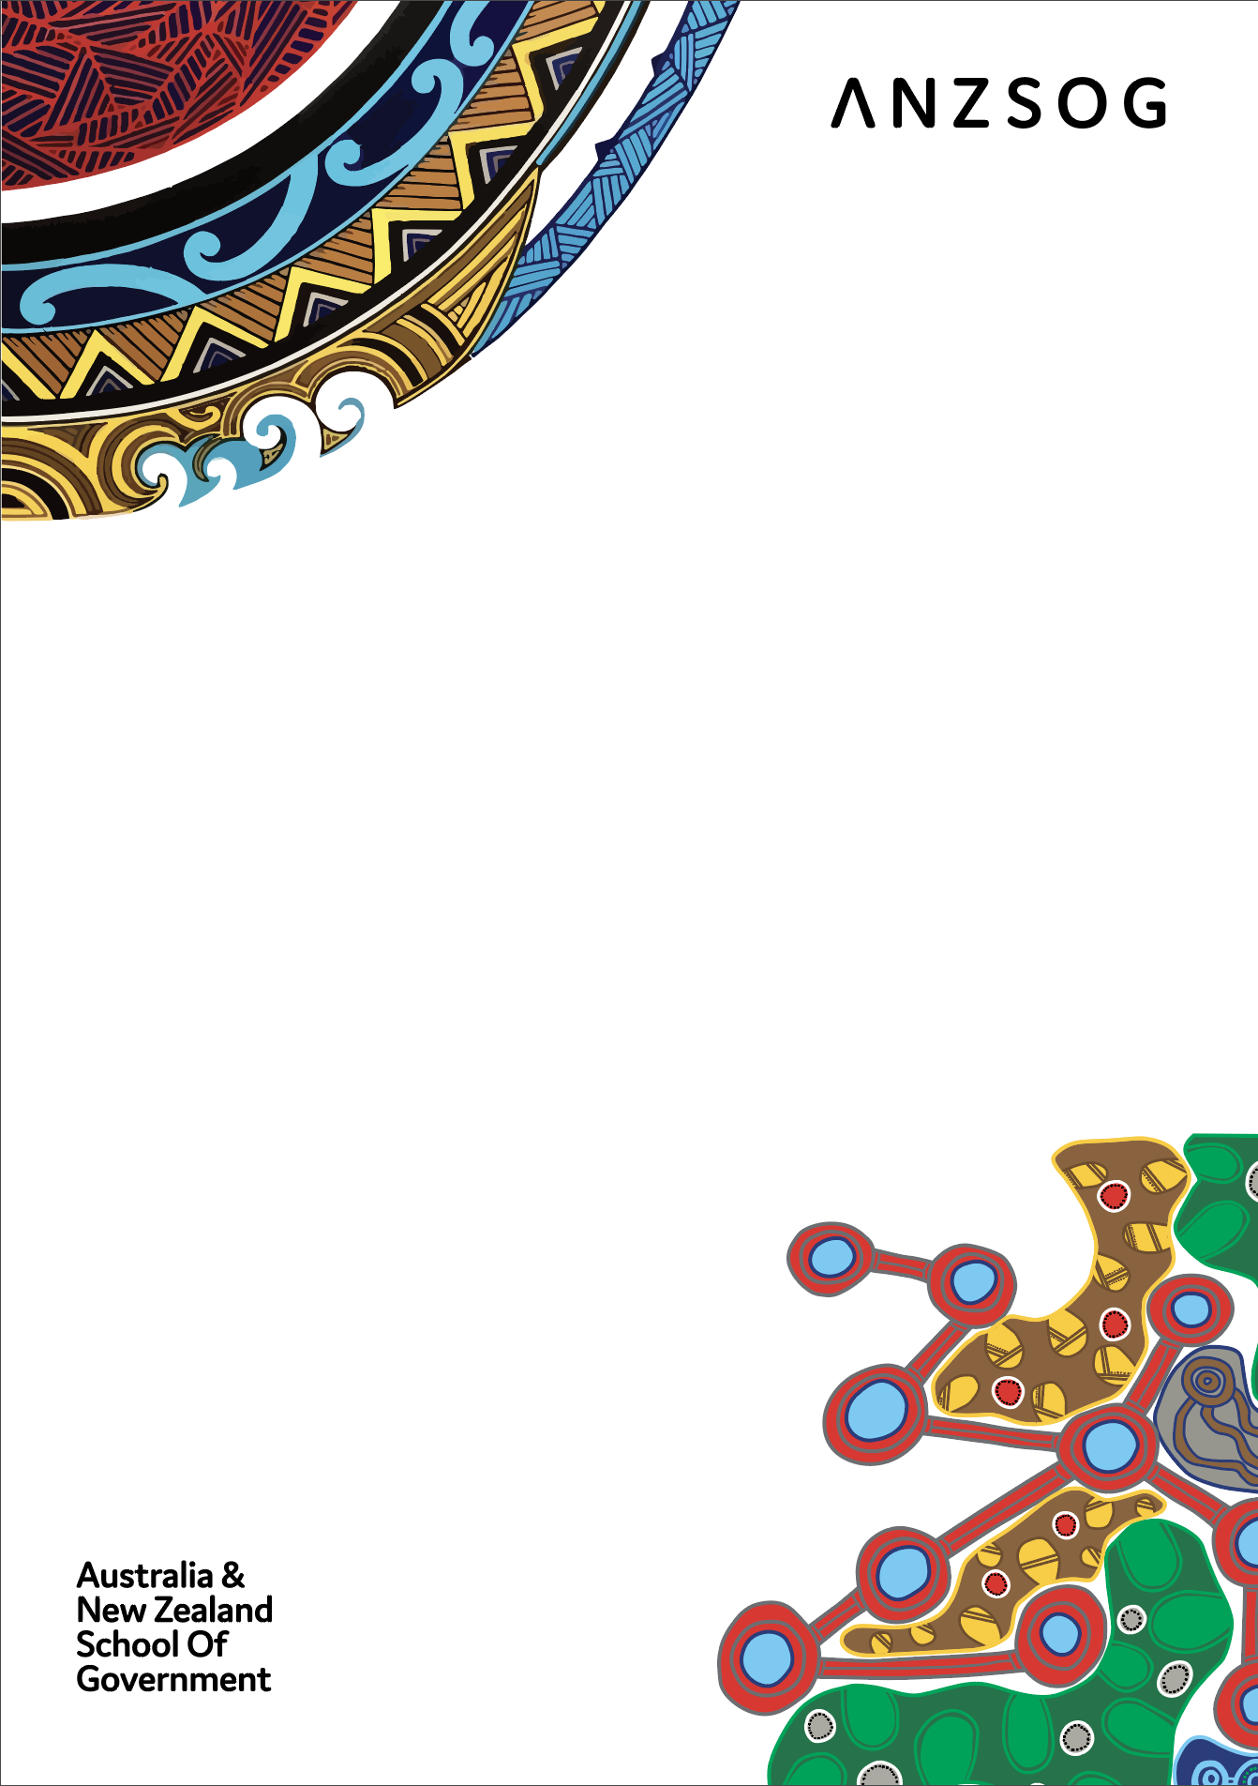
The National Agreement on Closing the Gap – and what it means for public servants

By Shane Hoffman, ANZSOG First Nations Senior Advisor, with assistance from the Closing the Gap Secretariat and the Coalition of Aboriginal and Torres Strait Islander Peak Organisation’s Secretariat
First published July 2022
Updated September 2022

Table of Contents
Executive Summary 1
Introduction to the National Agreement 2
Priority Reform One: Formal partnerships and shared decision-making 5
Priority Reform Two: Building the community-controlled sector 8
Priority Reform Three: Transforming government organisations 10
Priority Reform Four: Shared Access to data and information at a regional level 12
How will the parties know if they are making a difference? 14
Appendix – Priority Reform Outcomes and Targets 16
Follow us 17

Executive Summary
The purpose of this document is to provide public servants across Australia with a simple introduction to the National Agreement on Closing the Gap (National Agreement) and what it means for each of you.
It aims to explain the National Agreement, its objectives and how you might begin to work differently as public servants to meet the objectives outlined in it.
The Partnership Agreement on Closing the Gap 2019-2029 (Partnership Agreement) was signed in March 2019. Its signatories included First Ministers of: the Commonwealth Government (Prime Minister) and all state governments (Premiers) and territory governments (Chief Ministers) and the President of the Australian Local Government Association (ALGA) representing the then Council of Australian Governments (COAG) and the Coalition of Aboriginal and Torres Strait Islander Peak Organisations (Coalition of Peaks) representing the Aboriginal and Torres Strait Islander community-controlled sector.
It includes the governance arrangements and principles for negotiating a new national agreement to replace the former National Indigenous Reform Agreement (NIRA). This includes a new Joint Council on Closing the Gap made up of Ministerial representatives from each government and a representative from the ALGA and 12 representatives from the Coalition of Peaks selected by them.
The National Agreement on Closing the Gap (National Agreement) was signed by all government First Ministers and the ALGA and the Coalition of Peaks (the Parties to the Agreement) in July 2020. It includes the four Priority Reforms and an accountability framework which are outlined in this explainer.
Briefly the Priority Reforms are:
- One – Formal partnerships and shared decision-making (explained at chapter 3)
- Two – Building the community-controlled Sector (explained at chapter 4)
- Three – Transforming government organisations (explained at chapter 5)
- Four – Shared access to data and information at a regional level (explained at chapter 6)
All Parties are required, in partnership, to develop Implementation Plans (clauses 104-110) to show how they plan to meet the agreed outcomes and indicators for the priority reforms and the 17 socioeconomic targets (Tables A and B). All Parties completed their first Implementation Plans by mid-2021.
From the end of 2021-22, each Party is required to prepare annual public reports (clauses 118-120) to show progress on the Agreement and their implementation plans. The Productivity Commission provides a data repository from which a dashboard is drawn (clause 116). It also prepares an annual data compilation report (clause 117). Each Parties’ annual reports will include commentary on this data dashboard and compilation report and progress against their implementation plan.
There are to be two three-yearly reviews of progress of the National Agreement – one by the Productivity Commission (clauses 121-124) and an Aboriginal and Torres Strait Islander-led review (clauses 125-128). The first Productivity Commission review will be finalised in 2023 and the First Nations-led review one year later.

Introduction to the National Agreement
What you need to know

The new National Agreement on Closing the Gap replaced the former National Indigenous Reform Agreement (NIRA). It was signed by the First Ministers of all nine Australian Governments, the President of the Australian Local Government Association and the Coalition of Aboriginal and Torres Strait Islander Peak Organisations (the Coalition of Peaks) in July 2020. It is premised on a “new approach …where policy making that impacts the lives of Aboriginal and Torres Strait Islander people is done in full and genuine partnership … where [governments] listen to and change the way [they] work in response to the voices of Aboriginal and Torres Strait Islander people”. The embedded plan on a page prepared by the Coalition of Peaks is a diagrammatic representation of the National Agreement.

The full potential of the National Agreement cannot be realised unless and until all public servants familiarise themselves with it and understand and implement its contents and underlying principles. The Partnership Agreement on Closing the Gap 2019 to 2029 (Partnership Agreement) was negotiated and agreed (March 2019), and included the principles and framework for negotiating the final version of the National Agreement. See page on a page prepared by the Coalition of Peaks.

The Partnership Agreement established the governance architecture including a Ministerial Council on Closing the Gap, with Ministerial representation from all jurisdictions and at least equal representation from the Coalition of Peaks. This Ministerial Council (co-chaired by a Minister and the Lead Convener of the Coalition of Peaks) is known as the Joint Council on Closing the Gap (Joint Council) and its role is to oversee the implementation of the National Agreement (refer Joint Council Terms of Reference). The Joint Council established a Partnership Working Group made up of senior officials from all jurisdictions and representatives of the Coalition of Peaks. It too is co-chaired by a representative of each of the government Parties and the Coalition of Peaks, and decision making is by consensus.

The governance arrangements outlined here are critical to the success of the National Agreement in that they drive shared decision-making for the National Agreement itself, and also serve as exemplars of how shared decision-making works for adoption more broadly (refer next chapter).

The diagram at Fig 1, courtesy of the Coalition of Peaks, shows how the Partnership Agreement led to the National Agreement and the governance structures put in place to develop the National Agreement.

Parties outline their actions to achieve the outcomes of the National Agreement in their Implementation Plans. Each Jurisdiction has its own Implementation Plan, which is intended to be developed and delivered in partnership with their Aboriginal and Torres Strait Islander Partners. Implementation Plans are key delivery and accountability mechanisms, and it is critical that all agencies in all jurisdictions take responsibility for them.

Two annual independent health checks of the Partnership Agreement have been conducted, one in 2020 and another in 2021. Each health check was considered and responded to (2020 and 2021) by the Joint Council.
Figure 1

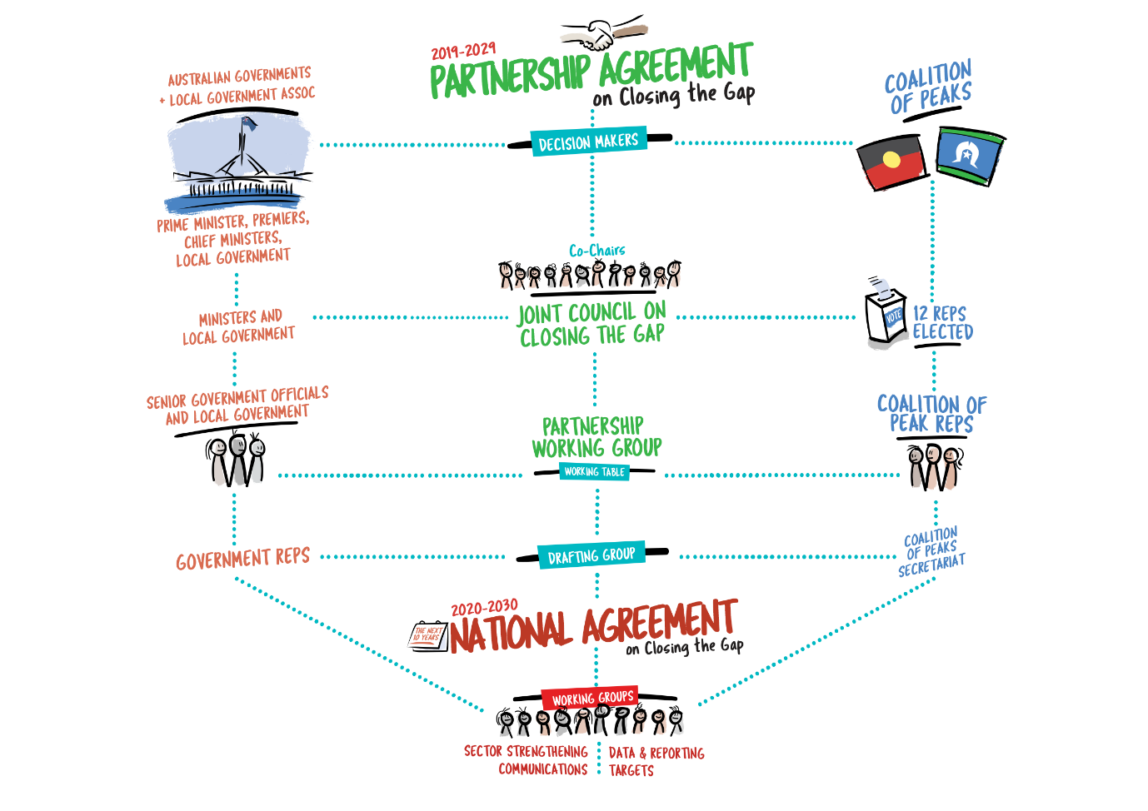

Critically, the National Agreement is premised on an acknowledgement that strong First Nations cultures are fundamental to improved life outcomes. The Parties have agreed that all activities should be implemented in a way that takes full account of, promotes, and does not diminish in any way First Nations cultures.

Four Priority Reforms and an enhanced accountability framework underpin the Agreement. These are explained in the following chapters. Together, they envisage a new way of working while holding the Parties to account for meeting the agreed Priority Reform and Socioeconomic outcomes and targets (Table A and Table B).

As governments retain control of almost all the resources (human, financial, policy, service provision) required to close the gaps, transformational change needs to occur within those systems to ensure accountability and responsiveness to First Nations and for the ambitions in the Agreement to be achieved.

The following chapters outline the Priority Reforms and the accountability framework.

What you can do

While these actions are sorted by levels of authority, you should seek guidance about your specific responsibilities from your agency‘s leadership. This is not an exhaustive list.

- Familiarise yourselves with the contents of the National Agreement and the commitments made by First Ministers. | All public servants, especially those in leadership positions
- Identify how these commitments impact on your jurisdiction and your agency. | All public servants in senior leadership positions
- Identify how these commitments impact on your work. | All public servants
- Familiarise yourself with the four Priority Reforms and consider how they can be given effect in your workplace. | All public servants in senior leadership and middle management positions
- Familiarise yourself with your jurisdiction’s implementation plan, the specific commitments made by your government, and the how your agency may need to engage in delivering them. | All public servants in senior leadership and middle management positions
- Familiarise yourself with the data in the PC dashboard and consider how policies and programs you are responsible for could improve the trajectory (i.e. evidence-based policy making). | All public servants developing policies and programs
- Understanding your jurisdiction’s Closing the Gap shared decision-making architecture, the processes that need to be followed, and the key organisations to engage with. | All public servants in senior leadership and middle management positions and all public servants working in areas covered by the socioeconomic outcomes and targets

Priority Reform One: Formal partnerships and shared decision-making

Diagram provided courtesy of the Coalition of Peaks
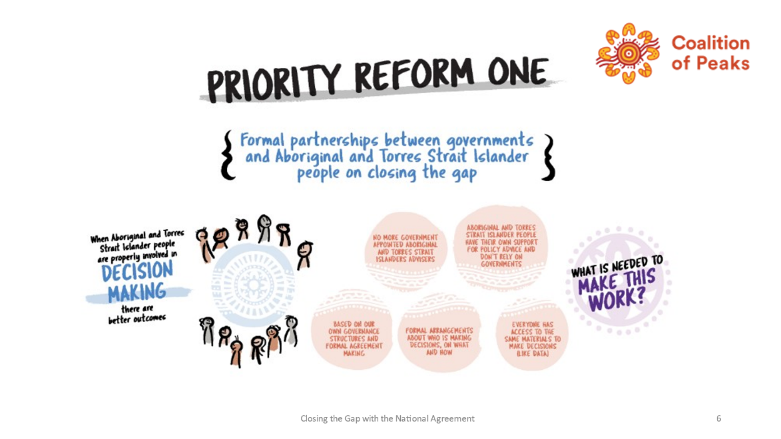
What you need to know

All Parties to the National Agreement committed to extending the principles in the Partnership Agreement (clause 14, pp4-5) to other partnerships between First Nations’ organisations and governments to accelerate policy and
place-based progress. This includes building and strengthening structures that empower First Nations to share decision-making with governments.

Critically, clauses 32 and 33 outline the strong partnership elements which should characterise these partnerships between First Nations and governments. These elements spell out that formal partnerships are the mechanism by which First Nations have greater authority to share decision-making with governments and influence policy directions; simple advisory or consultation approaches are no longer appropriate.

Briefly, these strong partnership elements are as follows:

- Partnerships are accountable and representative
- A formal agreement is in place and signed by all Parties
- Decision-making is shared between government and First Nations representatives
- Adequate funding is needed to support First Nations to be partners with governments in formal partnerships

Acknowledging that many partnerships between First Nations’ organisations and governments already exist, Government Parties, in accordance with clause 36 of the National Agreement, commit to reviewing all existing partnership arrangements to assess how they meet the strong partnership elements at clauses 32 and 33. Stocktakes of all existing partnerships in all jurisdictions are to be completed in 2022 (clause 36a.) and will be reviewed and strengthened by the end of 2023 (unless the First Nations partners choose not to pursue the stronger partnership elements). All governments are to report on their reviews to Joint Council once completed.

The National Agreement includes two types of partnership: policy and place based.

There are five prescribed policy priority areas for nationally joined up action:

- justice (adult and youth incarceration)
- social and emotional wellbeing (mental health)
- housing
- early childhood care and development
- Aboriginal and Torres Strait Islander languages.

The Justice Policy Partnership has already been established. It comprises representatives from all Australian governments, the Coalition of Peaks, and other First Nations with expertise and lived experience in this policy area. At its meeting in August 2022, Joint Council agreed to establish two policy partnerships – for Early Childhood Care and Development; and Social and Emotional Wellbeing (SEWB) – by the end of 2022.

Six place-based partnerships are to be established by 2024, with others to follow (clause 39). They will comprise all governments and First Nations representatives and be consistent with the strong partnership elements.

The Agreement does not limit the number of policy and place-based partnerships. In fact, a formal agreement was recently negotiated between the First Nations Heritage Protection Alliance (FNHPA) and the Commonwealth Government, represented by the Minister for the Environment, to inform the development of options for the modernisation of Aboriginal and Torres Strait Islander cultural heritage protection laws, in the wake of the Juukan George catastrophe. Formalised in writing, it provides for shared decision-making by the Joint Working Group of FNHPA and Department of Agriculture, Water and Environment (DAWE) representatives. The Minister, as a party to the Agreement, would take the partnerships’ recommendations to the state and territory ministers and Cabinet, and ultimately the Parliament.

However, given that proposals to the Minister are to be developed jointly by the Parties to that agreement, it would be expected that proposals put forward to Cabinet and Parliament are those recommended by the partnership.

Although the National Agreement requires that six place-based partnerships are established by 2024, others may be negotiated between First Nations communities and their organisations and relevant governments and included in their Implementation Plans.

Public servants can acquaint themselves with the strong partnership elements (clauses 32 – 33) and look for opportunities to partner with First Nations’ communities and their organisations to progress policy and place-based partnership arrangements. Funding agreements and contracts are not considered partnership agreements, given the nature of these is the delivery of a service by one party for payment.

What you can do

While these actions are sorted by levels of authority, you should seek guidance about your specific responsibilities from your agency‘s leadership. This is not an exhaustive list.

- Understand the commitments made by First Ministers. | All public servants, including police, school, hospital, corrections etc. staff
- Contribute to the review of all partnership arrangements between your agency and First Nations organisations. Do they meet the strong partnership elements at clauses 32 and 33? If not, what needs to be done to strengthen them? | All public servants with responsibility for handling partnership arrangements with First Nations organisations
- Consider how policy partnerships can be developed within your department/agencies’ area of policy with First Nations organisations. | Senior leadership of department and agencies
- Consider your agency’s role in place-based partnerships. What can you bring to the table to support First Nations’ community development? | Senior leadership of department and agencies.  All public servants with responsibility for handling place-based partnership arrangements
- Consider a departmental or agency partnership agreement template embedding the strong partnership elements to be used when developing new partnerships with First Nations. | Senior leadership of department and agencies
- Consider how representatives from First Nations organisations in your sector can be supported to improve their capability. | All public servants with responsibility for handling partnership arrangements with First Nations organisations
- Consider funding arrangements for Aboriginal and Torres Strait islander parties who are part of jurisdictional shared decision-making arrangements to be partners with governments (Cl 33)? | All public servants in senior leadership/middle management who enter into partnerships with First Nations communities and organisations

Priority Reform Two: Building the community-controlled sector
Diagram provided courtesy of the Coalition of Peaks
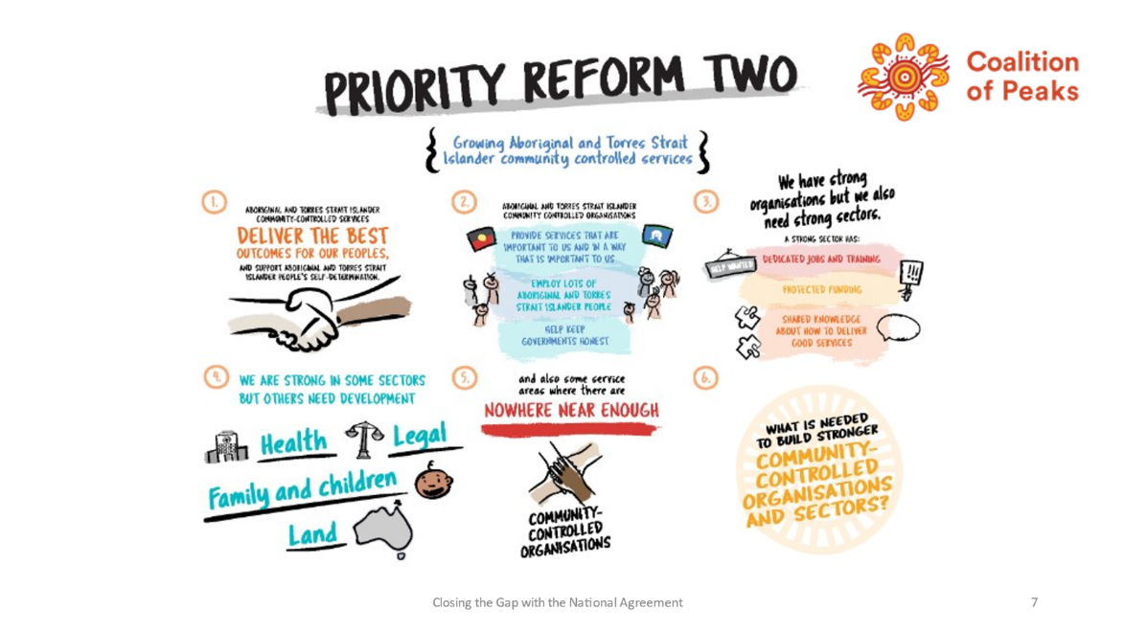
What you need to know

All Parties committed to building and strengthening First Nations’ community-controlled sectors to deliver services to support closing of the gaps – the socio-economic disparities between First Nations and other people in Australia.

Community-controlled organisations are controlled by elected members of the First Nations communities to whom they deliver services. They often join up to form state/territory-wide and/or national peak bodies. The National Aboriginal Community-Controlled Health Organisations (NACCHO) is an example of a national peak body, and there are many others.

Parties have agreed to develop Sector Strengthening Plans, initially in four key areas: early childhood care and development; housing; health; and disability. Sector Strengthening Plans for the early childhood care and development and the health sectors have been agreed by Joint Council. Plans for the housing and disability sectors were agreed in by Joint Council in August 2022.

Governments have also committed to take actions to increase the proportion of services delivered by First Nations organisations, especially their community-controlled organisations, across all Closing the Gap outcomes (clause 55). This requires significant structural change by governments to ensure that:

- First Nations organisations are preferred providers of these services; and
- existing First Nations organisations are strengthened, and others are developed, to deliver services in the sectors where they are underdeveloped or non-existent.

Notably, the Commonwealth Government is developing a grants connected policy to formalise these preference arrangements and other governments are considering similar policies. Once agreed and in place, reporting arrangements will show if it proves successful.

Actions are to be implemented progressively with completion by 2024 and included in Jurisdictional Action Plans.

What you can do

While these actions are sorted by levels of authority, you should seek guidance about your specific responsibilities from your agency‘s leadership. This is not an exhaustive list.

- Implement the specific actions for which your agency is responsible in the four sector strengthening plans. | Senior and middle level officials
- Contribute to your jurisdiction’s procedures aimed at preferencing First Nations organisations, especially community-controlled organisations, to deliver Closing the Gap services to their communities. | Senior and middle level officials, especially those with responsibility for service provider procurement
- Consider how Closing the Gap services delivered by your agency or non-Indigenous third Parties can be delivered by First Nations organisations. Is there a well-developed First Nations sector in your area of service? If not, what needs to be done to build the sector and develop their capability? | Senior and middle level officials, especially those with responsibility for policy development and service provider procurement
- Consider how representatives from First Nations organisations in your sector can be supported to improve their capability. | All public servants with responsibility for handling partnership arrangements with First People organisations

Priority Reform Three: Transforming government organisations
Diagram provided courtesy of the Coalition of Peaks

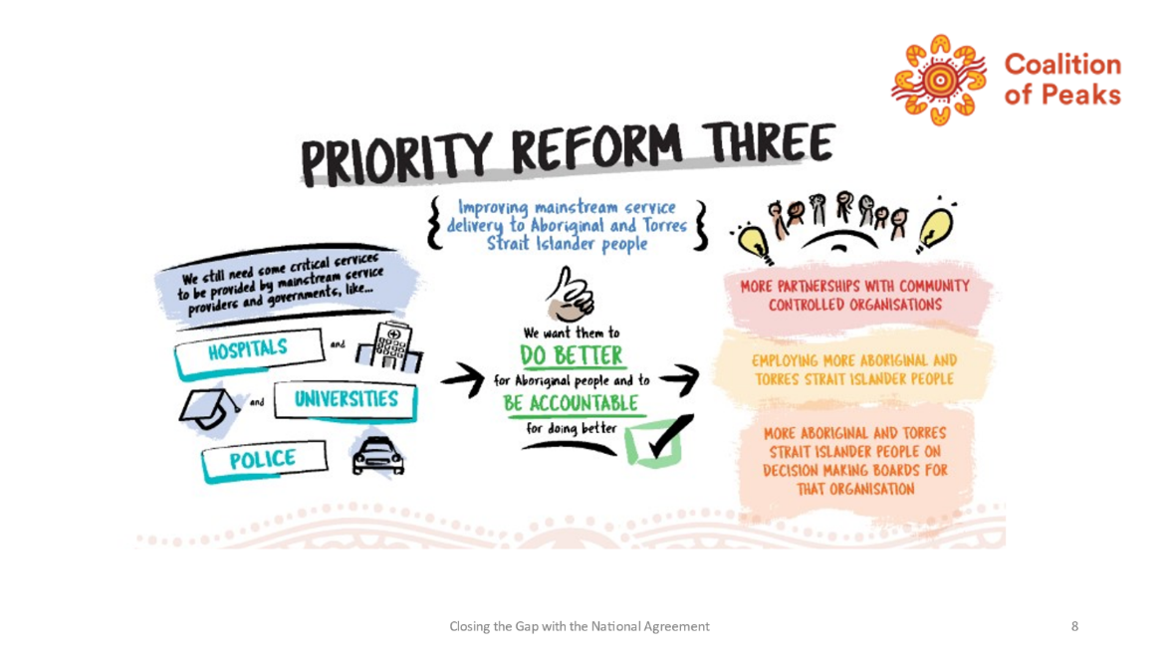
What you need to know

Parties have committed to systemic and structural transformation of mainstream government organisations to improve accountability and respond to the needs of First Nations. Governments agree to the following transformational elements (clause 59 a-f):

- Identify and eliminate racism within all institutions of government
- Embed and practice meaningful cultural safety
- Deliver services in partnership with First Nations and their organisations and communities
- Increase accountability through transparent funding allocations
- Support First Nations’ cultures
- Improve engagement with First Nations.

Significant transformation will be needed across all areas of government: police, courts, youth detention and prisons; hospitals and other health services; educational providers; child protection, early childhood, aged and disability care; and social services to name just a few.

This presents public servants with significant opportunities to review current working arrangements and capabilities. Are they consistent with both the content and spirit of the National Agreement? How can they be improved? What systemic reform is needed at all levels to embed the transformational elements?
Although fundamental change must be driven from the top, it is important that it is not just top down. While they need a strong authorising environment, all public servants have a role to play in ensuring they have or acquire the knowledge and skills to play their part.

The government Parties have agreed to establish, by 2023, an independent mechanism (clause 67) to support, monitor and report on the transformation of mainstream agencies and institutions. This is discussed later in the paper.

What you can do

While these actions are sorted by levels of authority, you should seek guidance about your specific responsibilities from your agency‘s leadership. This is not an exhaustive list.

- Become familiar with the transformational elements in the National Agreement. | All public servants, including police service, school, hospital, corrections etc. staff
- Consider how you can contribute to the implementation of these elements by your jurisdiction and your agency.  - What needs to be done to eliminate racism in your workplace?  - What needs to be done to make your workplace a culturally safe place for First Nations people to work and to access services?  - Are there opportunities to partner with First Nations organisations in the delivery of services? | Central agencies, departmental and agency heads and senior leadership teams.  All public servants, including police service, school, hospital, corrections etc. staff.
- Consider how your workplace can celebrate First Nations cultures and include their perspectives and values in your everyday work. | All workplaces in all departments and agencies. Senior leadership and People Teams to consider capability building needed to embed First Nations perspectives and values.
- Contribute to and implement your government and agency’s First Nations’ engagement strategy. Make suggestions for improvement as appropriate. | All public servants with opportunities provided by senior leadership.
- Consider what skills and capabilities you and your agency need to ensure improvement in these areas and how you and your agency attain these capabilities. | Senior leadership and People Teams to consider capability building needed to implement the transformation.

Priority Reform Four: Shared Access to data and information at a regional level
Diagram provided courtesy of the Coalition of Peaks

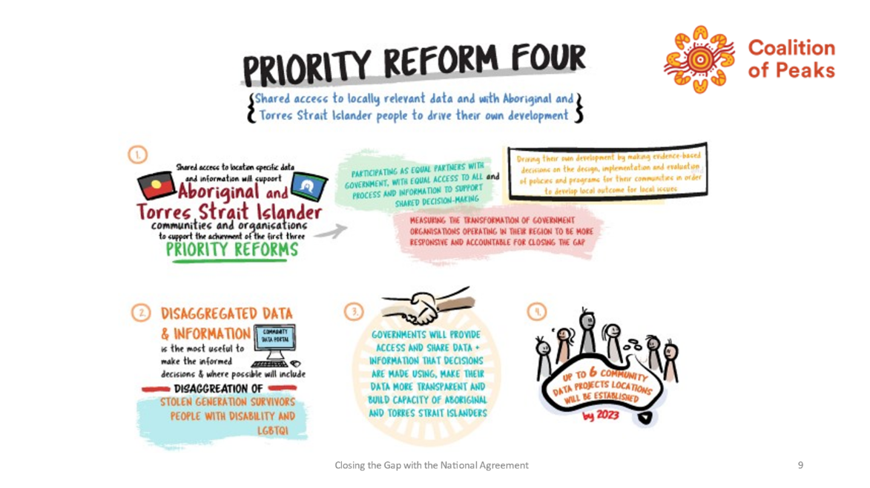

What you need to know

This reform is critical to the success of all other reforms. First Nations’ communities and their organisations require access to good quality data to build a comprehensive picture of their communities, and to inform their decision-making about their futures.

The Parties agree that data and information sharing elements should contain the following features (clause 71):

- There are formal partnerships in place
- Governments agree to provide First Nations communities with the same data and information they use to make decisions
- Governments collect, handle and report data and information in a timely manner and at such levels of disaggregation to empower First Nations to access, use and interpret data for local decision-making
- First Nations communities are supported to build capability and expertise in collecting and interpreting data and information.

Governments have committed to implement these data and information sharing elements and include information on action taken in their annual reports (clauses 72 & 73).

The Parties will establish data projects in six locations by 2023 (clause 74). The Australian Institute of Health and Welfare has been selected to develop community data portals for the six projects and assist communities to collate and interpret data to support local decision-making and their ongoing development.

What you can do

While these actions are sorted by levels of authority, you should seek guidance about your specific responsibilities from your agency‘s leadership. This is not an exhaustive list.

- Consider what data your agency collects on First Nations people and how it can be shared with their communities and organisations in your jurisdiction, at community, regional and jurisdiction-level. | Data and information managers in each department/agency.  Senior management to encourage sharing as the default position.
- Support First Nations communities and their organisations to build their capability and expertise in collecting and using data for their own decision-making. | Data and information managers in each department/agency.
- Establish formal partnerships with First Nations communities and their organisations for the provision of data and information held by your agency and support for capability building in collecting, using and interpreting data. | Public servants with responsibility for partnerships, data and information managers
- Contribute to the data development projects referred to in clause 74. | Data and information managers

How will the parties know if they are making a difference?
What you need to know

A relatively sophisticated approach has been agreed to monitor progress against the objective, the outcomes and the targets.

Objective, Outcomes and Targets

The National Agreement has a single objective and it’s very clear: “To overcome the entrenched inequality faced by too many Aboriginal and Torres Strait Islander people so that their life outcomes are equal to all Australians.”

The four Priority Reforms and the 17 socioeconomic areas each have a desired outcome, a target to be achieved by 2029 and indicators to measure progress against the target. The Priority Reform targets and indicators are outlined at Table A and the socioeconomic outcomes, targets and indicators are outlined at Table B. The National Agreement Partners agreed to amend the National Agreement to include a Community Infrastructure target at 9b and Joint Council has recommended they also agree an Inland Waters target.

Many of the targets are new and data development work is needed so that comprehensive data can be collected to measure progress. A Data Development Plan to finalise the data development items identified in the National Agreement was endorsed by Joint Council in August 2022 [link to be provided when plan uploaded to CTG website].

The Commonwealth, states and territories share accountability for the implementation of the National Agreement and are jointly accountable for its outcomes and targets. All Parties were required to prepare rigorous Implementation Plans to show how they will implement the National Agreement and achieve the agreed targets. All Parties’ Implementation Plans were submitted to Joint Council in mid-2021.

All Parties will prepare and publish annual reports to demonstrate their progress. The first annual reports are due after the first year of the Implementation Plans, i.e. 2021-22. All governments will table their annual reports in their respective Parliaments.

In addition, the Productivity Commission (an independent statutory authority) has been tasked with developing a publicly accessible dashboard to report on progress against the expanded targets in the Agreement. The dashboard was released in June 2021 and has been updated in June 2022. The data repository from which the dashboard is drawn is updated as more data becomes available, and dashboards are released regularly. Data development to facilitate collection and reporting is ongoing; the priority reforms and many of the new socioeconomic targets are still awaiting data development.

The Productivity Commission’s first Annual Data Compilation Report was released in July 2021 and subsequent reports are released annually in July.

The Productivity Commission will undertake a comprehensive review of progress every three years (clauses 121-124). The first one will be completed in 2023. A First Nations-led review will be conducted within 12 months of each Productivity Commission review to capture lived experiences of First Nations of the National Agreement’s implementation (clauses 125-128).

The Joint Council will respond publicly within six months and provide recommendations to amend the Agreement, comments on the progress of jurisdictions, and suggestions for future approaches (clauses 129-130).

What you can do

While these actions are sorted by levels of authority, you should seek guidance about your specific responsibilities from your agency‘s leadership. This is not an exhaustive list.

- Become familiar with the outcomes, targets and indicators in the National Agreement and consider how your agency can contribute to the data development work. | Senior leadership and middle managers of all departments and agencies.
- Become familiar with your government’s Jurisdictional Implementation Plan (JIP). | Senior leadership and middle managers of all departments and agencies.
- Identify how you and your agency can contribute to progressing the actions in the JIP. | Senior leadership and middle managers of all departments and agencies.
- Identify other actions for inclusion in the next iteration of your government’s JIP. | Senior leadership and middle managers of all departments and agencies.
- Subscribe to the Productivity Commission’s Data Dashboard and review updates. | Senior leadership and middle managers of all departments and agencies.
- Review the Productivity Commission’s annual data compilation report for implications for your jurisdiction and agency. | Senior leadership and middle managers of all departments and agencies.
- Contribute to your agency’s contribution to your government’s annual report. | Senior leadership and middle managers of all departments and agencies.
- Familiarise yourself with all four Priority Reforms and note their interdependence. | Senior leadership and middle managers of all departments and agencies.

Appendix – Priority Reform Outcomes and Targets
Priority Reform One – Formal partnerships and shared decision-making

Outcome
Aboriginal and Torres Strait Islander people are empowered to share decision-making authority with governments to accelerate policy and place-based progress on Closing the Gap through formal partnership arrangements.

Target
There will be formal partnership arrangements to support Closing the Gap in place between Aboriginal and Torres Strait Islander people and governments in place in each state and territory enshrining agreed joint decision-making roles and responsibilities and where Aboriginal and Torres Strait Islander people have chosen their own representatives.

Priority Reform Two – Building the community-controlled sector

Outcome
There is a strong and sustainable Aboriginal and Torres Strait Islander community-controlled sector delivering high quality services to meet the needs of Aboriginal and Torres Strait Islander people across the country.

Target
Increase the amount of government funding for Aboriginal and Torres Strait Islander programs and services going through Aboriginal and Torres Strait Islander community-controlled organisations.

Priority Reform Three – Transforming government organisations

Outcome
Governments, their organisations and their institutions are accountable for Closing the Gap and are culturally safe and responsive to the needs of Aboriginal and Torres Strait Islander people, including through the services they fund.

Target
Decrease in the proportion of Aboriginal and Torres Strait Islander people who have experiences of racism.

Priority Reform Four – Shared access to data and information at a regional level

Outcome
Aboriginal and Torres Strait Islander people have access to, and the capability to use, locally relevant data and information to set and monitor the implementation of efforts to close the gap, their priorities and drive their own development.

Target
Increase the number of regional data projects to support Aboriginal and Torres Strait Islander communities to make decisions about Closing the Gap and their development.

Follow us
ANZSOG website <https://www.anzsog.edu.au>
ANZSOG Facebook page <https://www.facebook.com/ANZSOG>
ANZSOG Twitter page <https://twitter.com/ANZSOG>
ANZSOG LinkedIn page <https://www.linkedin.com/school/anzsog>

COAG was replaced by the National Federation Reform Council and National Cabinet in May 2020.
The Coalition of Aboriginal and Torres Strait Islander Peaks is comprised of more than 70 Peak bodies representing First Nations community-controlled organisations and some independent statutory organisations.
Together, they are referred to as the Parties to the National Agreement.
Throughout both the Partnership Agreement and the National Agreement, the term Aboriginal and Torres Strait Islander is used. In this paper, the term First Nations is used unless quoting from either Agreement or other sources.
Partnership Agreement, clauses 17-25, pp 7 & 8.
The National Indigenous Australians Agency (NIAA) provides the Secretariat for the Closing the Gap Partnership. It sits in the Closing the Gap Branch in the National Indigenous Australians Agency (NIAA). NIAA also maintains the official Closing the Gap website. The Coalition of Peaks also has a small Secretariat to support their active involvement in the Agreements. The Coalition of Peaks also maintains a website for its members.
Clauses 28 and 29 of the National Agreement.
Nationally joined up action refers to all levels of government (commonwealth, state / territory and local) working together with First Nations people to address complex areas of policy, identifying the issues and recommending solutions.
Subsequently changed to the Department of Environment and Water after the 2022 Federal election.
All areas for which priority reform and socio-economic targets have been developed.

