Second annual report to corporate members
1 July 2021 – 30 June 2022

Contents
Message from the Dean 3
Message from the NRCoP Chair 4
Introduction 6
Timeline for the NRCoP 7
NRCoP summary 2021/22 9
The NRCoP national committee and jurisdictional chapters 10
Connect 12
Inspire 16
Enrich 20
Educate 25
The 3-Year Plan 28
Thank you to our corporate members 30
Thank you to our national and chapter committees 33
Follow us 36

Owned by and working for Australian and New Zealand governments. We acknowledge the Traditional Custodians and First Peoples of Australia and Māori, as tangata whenua and Treaty of Waitangi partners in Aotearoa New Zealand.

Message from the Dean
Over the last 12 months, ANZSOG has been very proud to auspice the work of the National Regulators Community of Practice (NRCoP) which has continued to mature as a relevant, vibrant and highly effective body.
The relationship between ANZSOG and NRCoP is strong and committed, highlighted in the last year by our joint re-set of the Terms of Reference, and the signing of an MOU between the two organisations that supports the partnership and will ensure stability and the sustainability of the relationship going forward.
ANZSOG is increasingly engaged in the regulatory space through our education, thought leadership and research and advisory functions, at home and internationally, highlighting the excellent synergies between our two organisations and the importance of linking regulatory work from practice, through policy and to performance and leadership.
Professor Malcolm Sparrow continues to work with us in the delivery of Managing Regulation Enforcement and Compliance (MREC) and The Modern Regulator (TMR). We hope to bring both programs led by Malcolm back to a face-to-face format in the year ahead. I also acknowledge the massive contribution to the Executive Masters in Public Administration's core subject, Governing by the Rules, of the inimitable Professor Arie Freiberg. Arie also provided great support as Academic Adviser to the NRCoP.
This year has seen the appointment of Rose Webb, and the new Director, Regulatory Practice, Dr Marion Frere who joins Dr Lorraine Cherney and Beth Morrison. I would also like to acknowledge again the previous Chair, Simon Corden and ANZSOG long term Director, Monica Pfeffer for the establishment of the initial model which has further developed in response to ongoing changes in regulatory practice.
There have also been new appointees at the National and Jurisdictional Chapter levels. I thank all of the many volunteers who commit their time and expertise to strengthen regulatory practice through the NRCoP, and I also thank the ANZSOG staff who work hard behind the scenes to support the community of practice, by bringing all the events and activities to fruition.
The 3-Year Plan signals exciting times ahead for the regulatory community, showcasing the vision and ambition of the NRCoP National Steering Committee. I note with particular enthusiasm, the forthcoming launch of the professional development program which has such strong support and interest from regulators across all domains and jurisdictions. I am sure that everyone will welcome the return of the National Forum in 2023, an event that I know has been sorely missed by so many in the regulatory community.
To all of our corporate agency members, congratulations on your vision for your regulatory staff and the broader regulatory community and thank you for your continuing support of ANZSOG and the NRCoP.
Ken Smith
Dean and CEO

Message from the NRCoP Chair
I was very pleased to step into the role of NRCoP Chair in the second half of 2021, knowing that it would give me an opportunity to continue to work with an organisation that was highly collegiate, strong and innovative.
Not only had the NRCoP successfully navigated the pandemic years, it had done so in a way that saw growth in both individual member participation and corporate commitment.
This success was due in large part to the contributions of my predecessor, Simon Corden and the former Director, Monica Pfeffer. I would like to acknowledge and thank them for their insight and hard work, which gave us such a solid platform on which to build our future NRCoP endeavours.
I would also like to thank those members of the National Committee who finished their terms over the last 12 months – Arie Frieberg, Jeroen Van der Heijden, Cassandra Meagher and Chris Mather – for their outstanding contributions to the NRCoP. And to the vast number of NRCoP volunteers – those of you who sat on working groups, presented at webinars, wrote guest editorials - a heartfelt thank you to you all. Many hands make light work, especially in such a large and diverse community. Your expertise, knowledge and generosity are much appreciated by your colleagues. Thank you also to our corporate agency members whose financial contribution ensure the sustainability of the NRCoP.
I am very pleased to extend a sincere welcome to our three new National Committee members, Professor Veronica Taylor (ANU) who has been appointed to the role of Academic Adviser, as well as Dr Guzyal Hill (Charles Darwin University) and Dr Mitzi Bolton (Monash University) who have been appointed to the new Academic Adviser – Early Career Researcher positions. We are thrilled to have them on board and look forward to their contributions in strengthening the links between academic knowledge and regulatory practice.
Since joining as Chair, we have seen the launch of two new NRCoP Chapters in South Australia and the ACT, marking our first “hybrid” events, with in-person attendees and a live-stream online audience. Congratulations to our regulatory colleagues in these two states and welcome aboard! This is an important milestone for the NRCoP, which will have national coverage in 2023 with the planned launch of chapters in the NT and Tasmania.
None of this would have been possible without the significant logistical, communications and secretariat assistance of the ANZSOG team. I would particularly like to acknowledge the support provided by ANZSOG Dean and CEO, Ken Smith, Deputy CEO Thought Leadership Simon Kent, and Dr Marion Frere and Dr Lorraine Cherney.
I am particularly pleased to present to you as part of this annual report, our forward 3-Year Plan.
Going forward, we intend to retain the best of both worlds, with a national program of online and hybrid events that are accessible to large numbers of members, and the re-instigation of local networking events to build skills and cement relationships on the ground.
Alongside the regular program of activities and events, our 3-Year Plan also sets out a number of exciting flagship initiatives. First on the horizon is the launch of the professional development program, due to start taking enrolments in February next year, and the design of a mentoring program intended to support regulators across their career.
I look forward to continuing to work closely with you all on the implementation of our 3-Year Plan. The NRCoP has always been and will continue to be a bottom-up community of practice, responsive to the needs of the regulator community across sector and jurisdictions. This report marks your success in working together to strengthen the professionalisation of the regulatory sector.
Rose Webb
Chair, NRCoP

Introduction
This report outlines the NRCoP’s activities and achievements during the period July 2021 – June 2022. This period saw an easing of COVID restrictions with many of us starting to return to the office. For NRCoP, this meant a move away from the fully online format that had been the norm in 2020. As the world has ‘opened up’, NRCoP has again sought to adapt by offering a return to COVID-safe in-person events, while listening to our community’s requests to continue with our online webinars. We have continued to build our existing chapters in Western Australia, Queensland, New South Wales, and Victoria, launched new chapters in South Australia and the ACT, and deepened our relationship with G-Reg in New Zealand. This report outlines the activities and achievements of NRCoP over the last 12 months and demonstrates our progress against the ANZSOG strategic priorities of Connect, Inspire, Enrich and Educate.
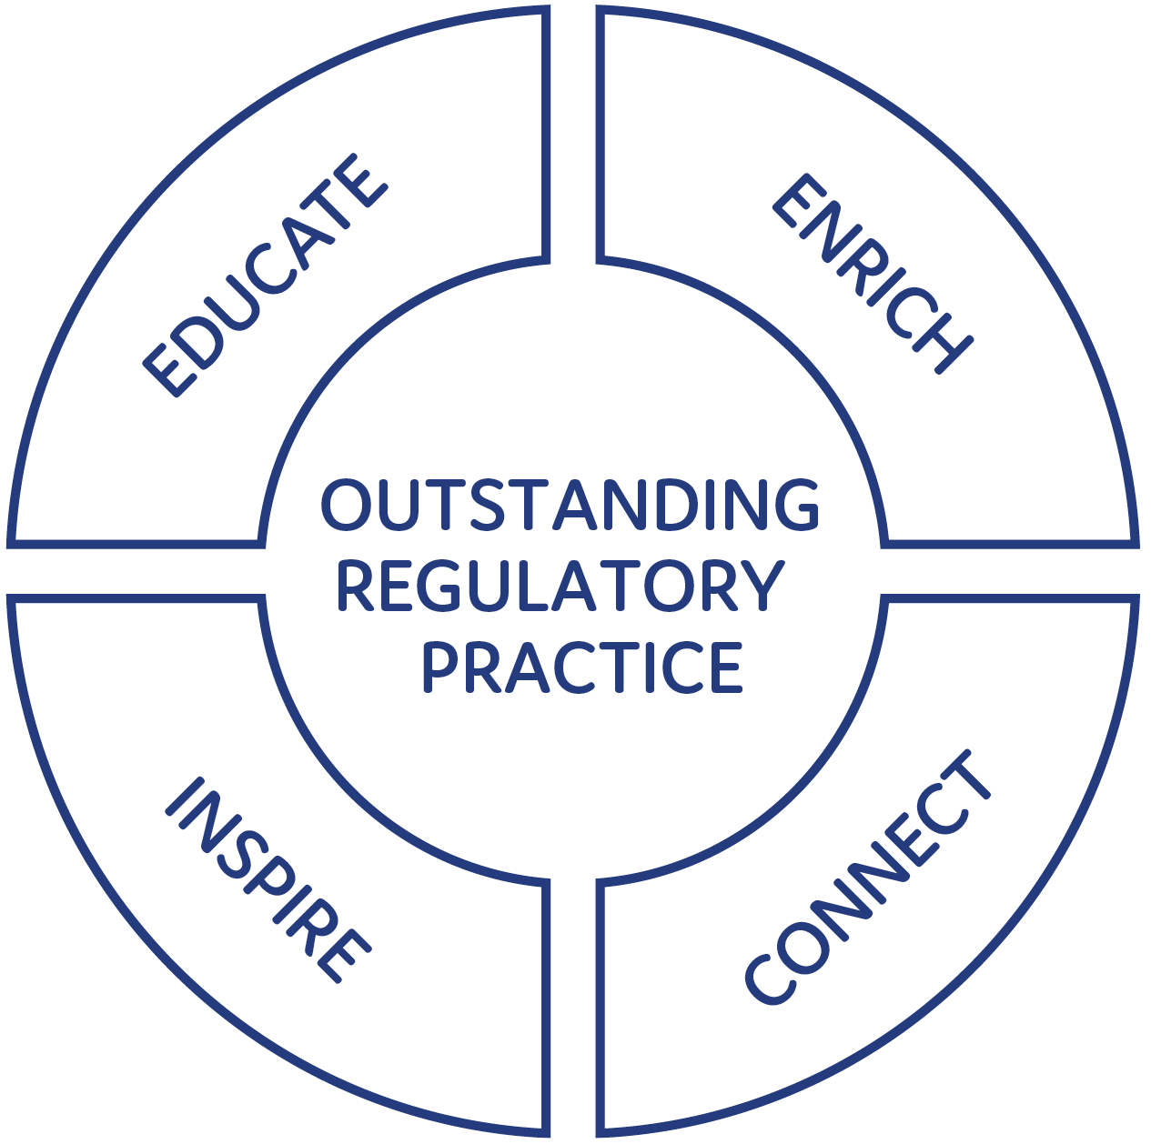
“I am completely thrilled to be able to hang out with the regulators community of practice because as far as I can tell, there is no such thing anywhere else on earth and so the energy that has gone into this and the commitment to the cross-domain learning that you've been able to derive from this, I think is a dream come true.”
Malcolm K. Sparrow, Professor of the Practice of Public Management, Harvard Kennedy School
“To achieve excellence, regulators must constantly be learning, adapting, and adopting best practices. The ANZSOG National Regulators Community of Practice provides an extensive and insightful array of opportunities for regulators to exchange ideas and share lessons learned. The National Regulators Community of Practice provides a model of a professional learning environment for regulators. It is a vital resource that should be emulated by other countries.”
Cary Coglianese, Professor of Law and Political Science, University of Pennsylvania

Timeline for the NRCoP

2013
- An informal network of ‘Sparrow alumni’ approaches ANZSOG to act as auspice
- ANZSOG and Institute of Public Administration Australia (Victoria) co-auspice Victorian Community of Practice

2014
- Inaugural annual forum with Professor Malcolm Sparrow

2015
- Second annual forum with Professor Gary Banks

2016
- Third annual forum with Professor Cary Coglianese

2017
- Fourth annual forum with Professor Alberto Alemanno
- Intention to take the CoP national announced at forum

2018
- WA chapter launched
- QLD chapter launched (building on existing Queensland Regulators Network)
- NSW chapter launched
- Fifth annual forum with Dr Femke de Vries

2019
- 14 seminars held across Australia, NRCoP reaches 2500 members
- Sixth annual forum with Bill Eggers

2020
- Pandemic transforms NRCoP’s deliveries, business model
- Launch of Regulation Policy and Practice collection on APO
- 50 departments and regulatory agencies become corporate members
- NRCoP delivers 17 webinars and 3 facilitated conversations

2021
- NRCoP reaches milestone of 25 successful webinars delivered
- NRCoP launches partnership with G:Reg to deliver online professional development for Australian regulators
- APO Regulation Policy and Practice collection celebrates first birthday
- NRCoP launches free Jobs Board for corporate members

2022
- NRCoP launches new chapters in South Australia and the Australian Capital Territory
- NRCoP establishes hybrid events, with events held online and in-person
- 42 professional development working group sessions held, with 25 subject matter experts participating in the development of content and case studies for the six-module professional development program
- NRCoP grew to a total number of 82 corporate members
- NRCoP appoints 3 new academic advisor positions to the board
- APO Jobs Board reaches 180+ advertised regulatory positions
- New Terms of Reference created along with improved governance structures for the NRCoP

NRCoP summary 2021/22
23,000+ registrations for webinars, plus 82 registrations for 3 facilitated conversations, with an average evaluation of 4.5 out 5
18,000: almost 18,000 additional views of the webinars on our YouTube channel
6,500+ subscribers from all levels of government in Australia and Aotearoa New Zealand
80% of our members found our webinars to be ‘Extremely Useful’ and would ‘recommend joining the NRCoP to their colleagues’
246,428 page views of our APO Regulation Policy and Practice collection and 44,107 downloads of the resources in the Collection,
1,600: the Collection holds almost 1,600 regulatory resources
180+ regulation jobs advertised on our free Jobs Board
2 new chapters of the NRCoP launched in the Australian Capital Territory and South Australia in 2022
24 monthly newsletters published with guest editorial written by senior regulatory practitioners and leading scholars from the field

The NRCoP national committee and jurisdictional chapters
The National Regulators Community of Practice (NRCoP) is an active network of public sector regulators from all levels of government in Australia and Aotearoa New Zealand and from every regulatory sector, professional background, role and level of seniority, who are keen to learn from and with each other.
Its objectives are to support participants to become more professional and capable regulators and to promote the public value and importance of regulation as a key function of government and thereby, to deliver better citizen outcomes.
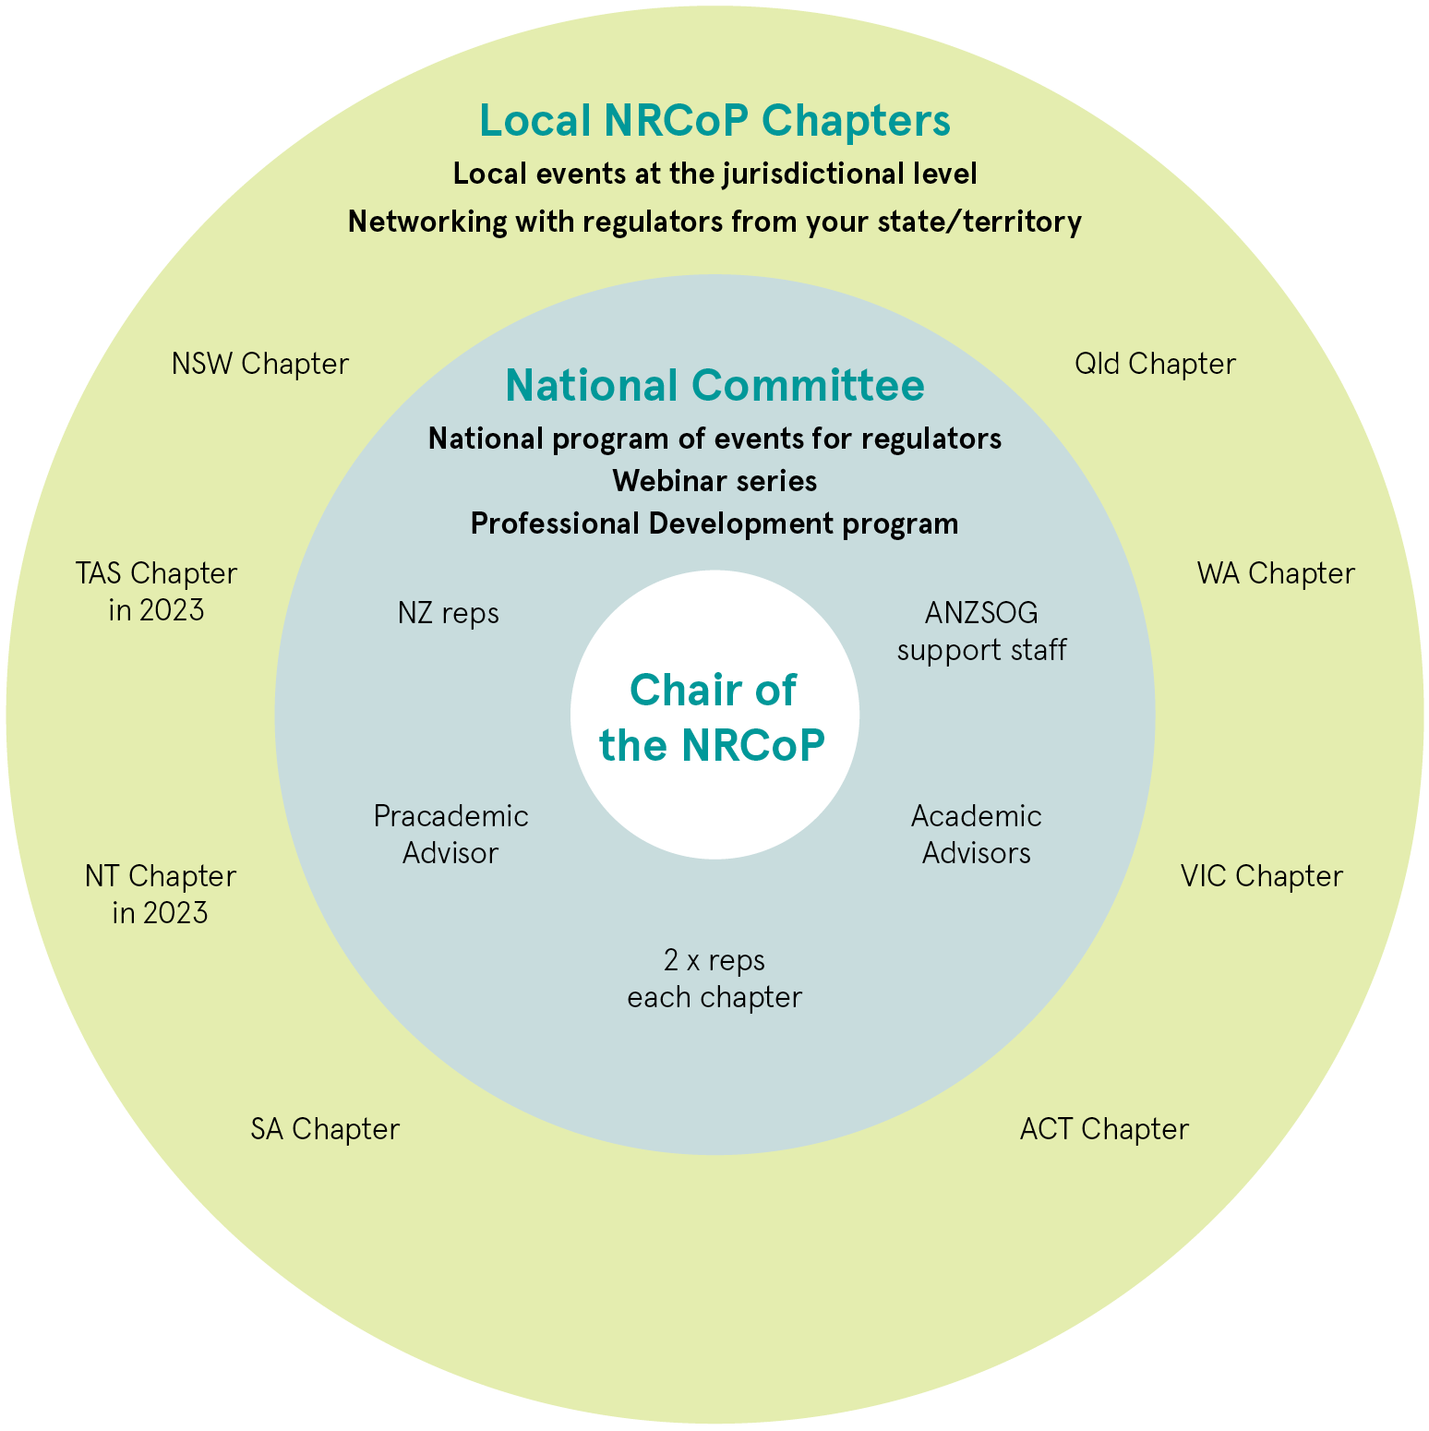

Composition of the National Steering Committee
The National Steering Committee comprises the Chair, academic advisors, a pracademic advisor, the ANZSOG staff supporting the NRCoP, the ANZSOG Deputy CEO – Thought Leadership and two representatives from each of the chapter committees, including the Chair of each chapter.

State and Territory Chapter Committees
Each jurisdiction is represented both on the National Steering Committee and has their own local jurisdictional Chapter. Chapter Committees engage with regulators at the local level, building local networks of regulatory practitioners and engage in a range of activities for the benefit of their members. Examples include, running networking breakfasts, workshops and seminars. State and Territory chapter committees also support the work of the National Steering Committee.

Pracademic and Academic Advisors
The work of the NRCoP is supported through one pracademic advisor and three academic advisor positions, two of which are designated as early career research (ECR) positions. These regulatory scholars ensure that the overall program of work for the NRCoP is rigorous, and that academic knowledge supports the National Steering Committee to make evidence-based decisions that will see the NRCoP continue to grow and flourish.

The role of ANZSOG
The NRCoP is auspiced by ANZSOG, whose staff support the work of the NRCoP. ANZSOG has a position on the National Steering Committee and provides a range of expert inputs to the development, promotion and delivery of face-to-face and online events for NRCoP, as well as contributing to ongoing stakeholder communication and engagement and providing access to its international network of leading regulatory scholars, public intellectuals and senior practitioners.

Corporate membership
Australian public sector departments and regulatory agencies can become regulatory agency or department participants. These participants make a yearly contribution of $5,000, $10,000 or $15,000 (plus GST) to ANZSOG as the auspicing body for the NRCoP depending on their size and level of participation in NRCoP activities.

Tasmania and the Northern Territory
Over the next 12 months we will continue work to develop local Chapters in both Tasmania and the Northern Territory, ensuring that all jurisdictions have representation.

Connect
To build a community of regulators across jurisdictions, sectors and roles, connecting practitioners with experts and leaders, to build regulatory expertise and improve outcomes
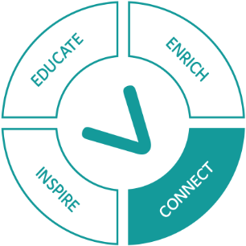
This last 12 months has taught us the importance of connection, especially at times when we have been isolated from colleagues and peers. During this time, the NRCoP has continued to bring our regulatory community together whilst we have remained physically apart. We have made inroads to resuming face-to-face networking events whilst maintaining the all-important online presence we have benefited from over this last couple of years. As COVID restrictions continue to ease and our members are eager to resume attendance at events, you will see more hybrid and in-person events throughout the remainder of the year. We have successfully completed two hybrid events in Adelaide and Canberra and have more planned for the other jurisdictions. This is a great opportunity for some networking and information sharing amongst peers, whilst maintaining accessibility for our online community.

Launch of the South Australia chapter
On March 17th 2022, the NRCoP launched its South Australian Chapter. This event was particularly exciting, as it was the first in-person networking event held since we were launched into pandemic mode back in 2020. We had 261 online registrations, and 56 in-person attendees. The chapter launch was held in hybrid format, with a live-streamed webinar on Emerging regulatory trends and the role of regulation in preventing and responding to sexual harassment and sexual assault also being presented for the benefit of the broader community of practice. The community was incredibly fortunate to hear insights from Kate Jenkins, Sex Discrimination Commissioner for the Australian Human Rights Commission, and Sarah Court, Deputy Chair at Australian Securities and Investments Commission. The webinar was facilitated by Martyn Campbell, who is the South Australian Chapter Convenor. Caroline Mealer, Chief Executive, Attorney-General's Department is the South Australian chapter sponsor.
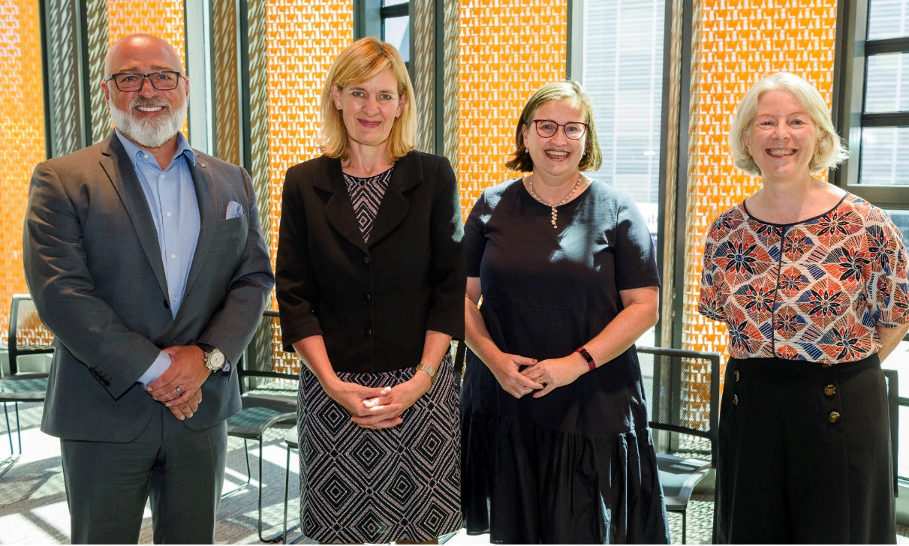
L-R: Martyn Campbell, Sarah Court, Kate Jenkins & Rose Webb
Hear what our audience said about the South Australian Chapter Launch & Webinar:
“Excellent to hear the collective challenges faced by regulators.”
“So good to catch up with other regulators – some familiar faces and some new ones.”
“Reassurance that the work being done in this field is being endorsed at a high level.”
“Fantastic speakers. I really enjoyed listening to and thinking about the bigger structural challenges that affect regulators (e.g., barriers to collaboration between agencies).”

Launch of the Australian Capital Territory chapter
On May 20th 2022, the NRCoP expanded for the second time this year, with the launch of the ACT chapter. This was held in a similar format to the SA chapter launch, with an in-person networking event for 44 attendees, and the live webinar streamed for the benefit of the broader community. A further 383 participants registered to watch the webinar online. The webinar consisted of a panel discussion on the Four Ps (policy, performance, practice and professionalisation) and how they contribute to the creation of public value in Australian regulation today. The distinguished panellists were: Jacqueline Agius, Work Health and Safety Commissioner and Labour Hire License Commissioner, David Parker, Chair and CEO of Clean Energy Regulator, Rona Mellor, Deputy Auditor-General at the Australian National Audit Office, Derise Cubin, Executive Branch Manager Licensing and Registrations at Access Canberra, and Professor Veronica Taylor, Professor of Law and Regulation at the School of Regulation and Global Governance. The event was facilitated by the NRCoP’s pracademic advisor, Dr Grant Pink. Derise Cubin will be the ACT chapter convenor and the chapter is sponsored by David Pryce, head of Access Canberra.
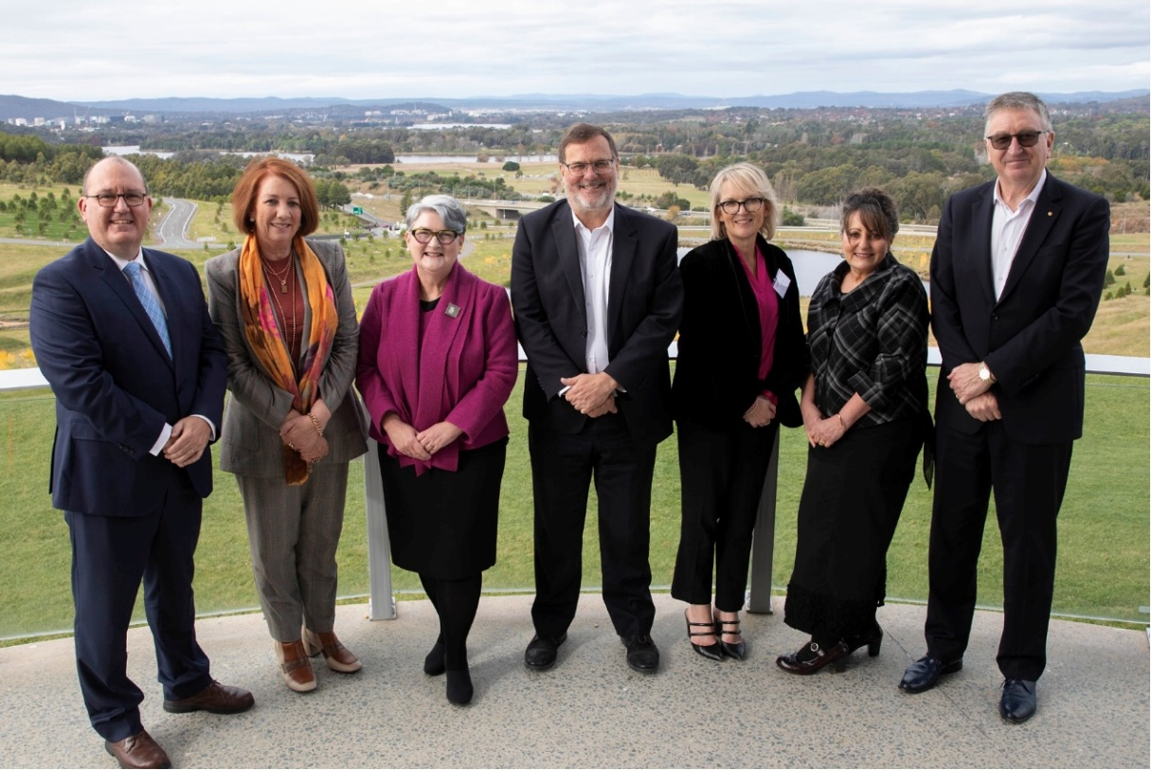
L-R: Dr Grant Pink, Rona Mellor, Prof Veronica Taylor, David Parker, Derise Cubin, Jacqueline Agius, & Ken Smith

ACT Planning Workshop
Following the successful launch of the ACT Chapter and webinar on the Four Ps, a group of 20 participants attended an afternoon planning workshop to discuss how the ACT NRCoP Chapter would operate, the topics and issues of interest to ACT regulators, and a range of ideas for knowledge sharing through proposed training and workshops.
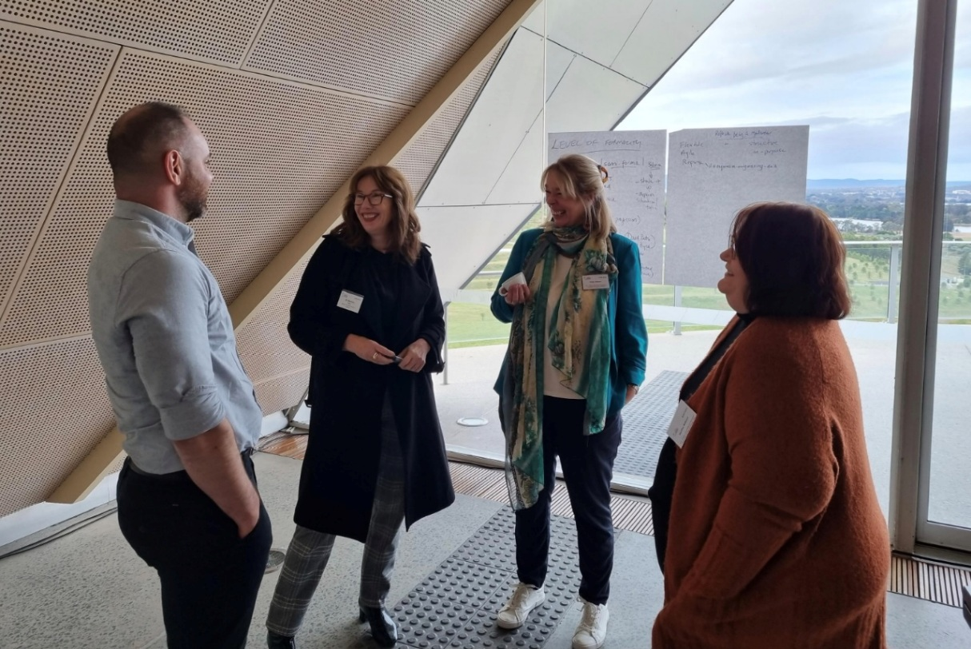
Hear what our audience said about the Australian Capital Territory Chapter Launch & Webinar:
“I thought it was interesting to observe that across the panel there was such a consistency of themes and ideas, even when the panellists all had different responsibilities.”
“I enjoyed hearing the different perspectives from the panel members which showcases how everyone needs to work together to make it happen”
“Speakers were great and shared some really valuable insights. I could have listened for longer”
“A top class panel. More like these, please”

Inspire
To inspire regulators that their work is intellectually, professionally and ethically worthwhile and the foundation for a rich and satisfying career
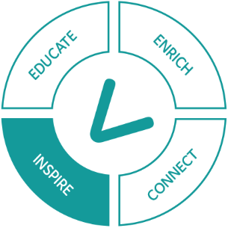
As regulators, we can inspire others through sharing both our success stories and our failures. The NRCoP webinar program seeks to showcase learnings and case studies from our community in order to inspire other practitioners to learn with and from each other and encourage innovation in thinking and practice. The NRCoP webinar program continues to be highly regarded by the wider regulatory community with 80% of respondents to the annual member survey reporting the webinars as ‘extremely’ or ‘very’ useful to them in their role as regulators. Findings from the annual survey continue to guide our overall program of work, ensuring that we continue to be responsive to and accommodate the needs of our wider community.

Table: Engagement in the NRCoP Program of Events
Month | NRCoP Program of Events July 2021 – June 2022 | Registrations for event | YouTube views
July 2021 | Is regulatory failure a good teacher?  Simon Corden, Bronwyn Weir, David Chandler OAM | 627 | 214
 | Learning from success? Doing safety differently  Dr Maggie Hardy, Professor Sidney Dekker, Martyn Campbell | 656 | 326
Aug 2021 | RegTech: the good, the bad and the seriously scary  A/Prof Rob Nicholls, Anne Lenz, Monika Sarder, Katie Miller | 754 | 385
Nov 2021 | The Challenge of leading a regulator  Adam Beaumont, Cheryl Batagol, John Merritt | 634 | 501
Dec 2021 | Professional Development training for regulators: what can the Aussies learn from the Kiwi experience?  Dr Rebecca Foley, Ian Caplin, Keith Manch, Sally Washington, Tony McKenna, Wendy Kale, Dr Lorraine Cherney | 271 | 233
Feb 2022 | Compliance Planning  Adam Beaumont, Rachel Scalongne, Andrew Wilson, Nick Heys | 812 | 300
Mar 2022 | OECD: Agile Regulation and Innovation  Rose Webb, Miguel Amaral, Anna Brakey, Florent Gomez | 284 | 175
 | Emerging regulatory trends and the role of regulation in preventing and responding to sexual harassment and sexual assault [Official Launch of South Australian Chapter of the NRCoP] Martyn Campbell, Kate Jenkins, Sarah Court | 261 Online  48 In-person | 290
April 2022 | From Cairns to Margaret River (and everywhere in between): Regulating in the Regions  Marian Prete, Iain Dainty, Shelley Tofilau, Matt Cuthbert | 165 | 33
May 2022 | Regulation and the Creation of Public Value: Exploring the Four Ps [Official Launch of Australian Capital Territory Chapter of the NRCoP] Dr Grant Pink, David Parker, Jacqueline Agius, Derise Cubin, Rona Mellor, Prof Veronica L. Taylor | 383 Online  44 In-person | 154
June 2022 | Setting regulatory practice at the speed of a pandemic: up-cycling other regulators tools and approaches to avoid reinventing the wheel  Adam Beaumont, Chris Webb, Leanne Hughson | 346 | N/A
 | TOTAL | 5285 | 2452
What our members are saying about the Webinar Program:
“I think the format and offering is great as I’m no longer in the city and often working from home, so webinar format is perfect”
“... I always leave the seminar with some ideas for how things could be approached differently or areas I had not previously considered that were worthy of a more in–depth analysis”

Report on the 2021 Annual Survey of the NRCoP
80% of respondents found our webinars to be ‘extremely’ or ‘very’ useful
67% of respondents have ‘applied insights’ gained from the NRCoP resources to their work as regulators. Respondents described the ‘insights’ they gained from participating in the NRCoP in the following ways:
- Gained specific, useful, regulatory knowledge
- Developed, learned, and shared best practices
- Gained broad foundational regulatory knowledge
- Informed their thinking in their roles as regulators
80% of respondents said they would recommend joining the NRCoP to their colleagues
61% of respondents reported that participating in the NRCoP has been ‘extremely valuable’ or ‘definitely valuable’ in developing capability and professionalism as a regulator (a further 29% stated this was ‘somewhat valuable’)

Celebrating and recognising our women regulatory leaders
To mark International Women’s Day in 2022, ANZSOG spoke to two women regulators: Rowena Park, General Manager, Compliance and Enforcement, Australian Energy Regulator and Victoria Thomson, Deputy-Director General Liquor Gaming and Fair Trading, Queensland Department of Justice and Attorney-General, both of whom are members of the NRCoP.
The two women took different paths into regulation but were united on the satisfaction to be gained from working in a field that was intellectually challenging and delivered positive outcomes for the community.
“If you don’t have women in your leadership team you don’t have a representative sample of the people you are regulating for.”
Rowena Park, General Manager, Compliance and Enforcement, Australian Energy Regulator
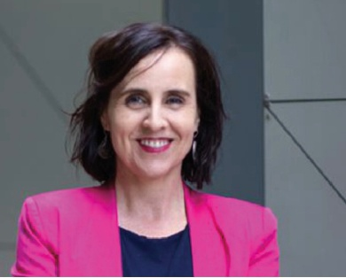
“Women don’t need more mentoring - we need people to invest and sponsor us into senior levels.”
Victoria Thomson, Deputy-Director General, Liquor Gaming and Fair Trading, Queensland Department of Justice and Attorney-General
Read the full article: Women in regulation talk about challenges, barriers and why it’s a great career

Enrich
To enrich debate on the profession of regulation and to ensure enduring benefit for regulated entities and the public
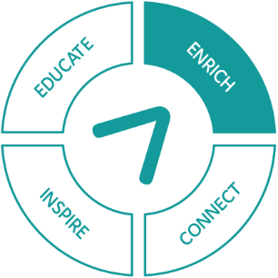
The NRCoP has at its core, the objective of supporting participants to become more professional and capable regulators. In so doing, it aims to promote the public value and importance of regulation as a key function of government and thereby, to ensure enduring benefit for regulated entities and the public. To support the achievement of this objective, the NRCoP offers a wide range of regulatory resources for its members to access. These resources are available on a diverse range of platforms and can support regulators at early, mid and senior stages of their career, across all sectors.
It has been wonderful to see the NRCoP help sustain regulatory practitioners through the disruptions of COVID-19, particularly with the online resources that have kept us connected and informed on developments in regulatory practice. I have especially valued the APO Regulation Policy & Practice Monthly newsletter. It lands in my inbox as a treasure trove of curated, useable research in regulation. Plus it provides a jobs board for regulators looking for their next career step. It is a great example of the practical benefits offered to members of this thriving community of practice throughout the year.
Roxane Marcelle-Shaw, NSW Chapter Chair

Table: Regulatory resources
Resource | Description
Webinar program | We offer a monthly educational webinar series where leading regulatory practitioners discuss their experience and offer advice on contemporary regulatory issues
YouTube Channel | All NRCoP webinars are recorded and available on the ANZSOG YouTube channel after the event. You can view the full back catalogue here ANZSOG - YouTube
APO Regulation Policy & Practice Collection | Here you can find approximately 1600 regulatory resources, which are catalogued by regulatory strategy, regulatory instruments, government regulatory policy, and sector regulation. You can view the collection at the APO Regulation Policy and Practice webpage
APO Regulation Policy & Practice Newsletter | This is a monthly newsletter with a guest editorial written by a senior scholar or leading regulatory practitioner. Subscribe to the APO Regulation Policy & Practice Newsletter
APO Jobs Board | We offer a free Jobs Board, where our corporate members can advertise current jobs in regulation. We have advertised over 180+ positions. You can access the Jobs Board here Regulation job board | APO
Video snippets | For those who are too time-poor to watch the full webinar, we provide short video snippets of key moments from the webinar.
Regulators email | We send a monthly email communication to our subscribers to advise them on upcoming events, as well as providing links to previous webinars and resources, and current regulatory jobs listed on the APO Jobs Board. Subscribe to the NRCoP here to receive these communications
LinkedIn Group | The NRCoP LinkedIn group provides a great opportunity for you to connect with your fellow regulators across Australia. Give a shout out about success, seek help with a challenge or recommend some useful research you've found in your travels. Join the group at Groups | LinkedIn
Regulators Webpage | The dedicated regulators webpage on the ANZSOG website provides a rich array of regulatory resources. It also includes key information on our National Steering Committee and jurisdictional Chapters.
Twitter | Follow the NRCoP Twitter page and use #NRCoP when engaging with the regulators’ community on twitter

A focus on the NRCoP Jobs Board
Since we launched the Regulators Jobs Board back in April 2021, it has become a popular avenue for our community to advertise and view regulatory positions on offer across the sector. To date we have advertised 180+ positions to our 6,500+ community. The Jobs Board has received almost 6,500 page views.
Table: Jobs Board data
 | Total jobs posted | Total agencies posting jobs | Total page views
2021 (Apr-Dec) | 95 | 35 | 3,926
2022 (Jan-Jun) | 88 | 28 | 2,503
Totals | 183 Jobs posted | 63 Regulatory agencies | 6,429 Page views
Many of our regulators utilise the Jobs Board on an ongoing basis, knowing they can reach a “captured audience” of 6,500+ regulators who are ready to extend their professional regulatory career.
- New South Wales Customer Service 16 positions advertised
- NSW Department of Education 13 positions advertised
- Essential Services Commission Victoria 9 positions advertised
- SafeWork SA 11 positions advertised
- TEQSA 6 positions advertised
- Queensland Office of Liquor and Gaming Regulation 9 positions advertised
- NSW Department of Planning and Environment 11 positions advertised
Results from the annual NRCoP Annual Survey indicated raising awareness of the Jobs Board is a priority area for the NRCoP.
- Corporate members can advertise regulatory positions free of charge
- Members complete an online form with the APO and submit the listing
- Job listings are posted to the Jobs Board
- The NRCoP promotes the Jobs Board listings in two publications each month: APO Regulation Policy & Practice Newsletter and the Regulators Email.
- Regulators seeking new opportunities and challenges can review the Jobs Board listings to connect with new employment opportunities

What our members are saying about the Jobs Board:
“SafeWork SA regularly uses the APO Jobs Board to advertise our vacancies. We look for skilled, knowledgeable and experienced regulatory professionals to join our team and the APO Jobs Board is a great conduit to find those people. The APO Jobs Board is now a firm part of our recruitment strategy and I’d encourage all Regulators to use it and for all regulatory professionals to check it out.”
Martyn Campbell, WHS Regulator for South Australia Chair of Heads of Workplace Safety Authorities for Australia & New Zealand.
“The Tertiary Education Quality and Standards Agency (TEQSA) has recently commenced using the APO Jobs Board to advertise a number of regulatory and non-regulatory roles in our agency and we are pleased with the initial results. Our aim is to increase the reach of our recruitment advertising within the broader policy community, and the APO Jobs Board gives us a valuable opportunity to share information about our agency, culture and roles across the community of practice. We look forward to continuing with this approach.
Susan Rodrigues, Assistant Director People and Capability, Tertiary Education Quality and Standards Agency
“Our applications when using the jobs board for a recent role were double our usual response. I found it easy to use and would definitely encourage others looking to tap into the regulatory job market to use this platform. We were able to target relevant skills and overall were happy with the range of applicants received.
Matthew Sargeant, Manager Enforcement, Essential Services Commission, Victoria.

A focus on the APO Regulation Policy & Practice Collection
The Regulation Policy and Practice collection holds around 1,600 resources, curated for practising regulators across Australia and Aotearoa New Zealand. The collection assists regulators in the following ways:
- Gaining an understanding of the context in which you operate
- Providing timely, curated access to reports that are directly relevant to your daily work
- Learning from other regulators’ successes, failures, challenges and innovations.
The Regulation Policy and Practice collection is organised around four categories:
Table: Top 3 Reports in the RP&P Collection During 2021-2022
Rank | 1 | 2 | 3
Regulatory Strategy | Design thinking: a quick overview | Australia as a space power: combining civil, defence and diplomatic efforts | Impacts of new and emerging assistive technologies for ageing and disabled housing
Regulatory Instruments | The Digital Services Act, the Digital Markets Act, and the new competition tool: European initiatives to hobble U.S. tech companies | Proposed regulatory framework for modifications to Artificial Intelligence/Machine Learning (AI/ML)-based Software as a Medical Device (SaMD) | Royal Commission into the Casino Operator and Licence: report
Government Regulatory Policy | Ransomware action plan | Human rights and technology: final report | 2021 Australian infrastructure plan: Reforms to meet Australia’s future infrastructure needs
Sector Regulation | Artificial Intelligence: solving problems, growing the economy and improving our quality of life | COVID-19: rental housing and homelessness impacts in Australia | Digital Platforms Inquiry: preliminary report
What our members are saying about the NRCoP suite of resources:
“I would read emails and articles etc and that would help my thinking, discussions and decision making.”
“The APO newsletter is extremely helpful for background information on policies we are developing and implementing general insights into how regulators work”
“[The APO] Newsletter provides excellent updates on literature and significant reports and regulatory matters.”
“I am finding the short blogs and articles the most convenient and engaging way of receiving information”

Educate
To educate regulators to improve their skills and expose them to best regulatory practice to support improved outcomes
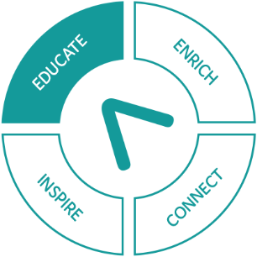
The Foundations of Regulatory Practice program is a six-module online professional development program for Australian regulators. The program is suitable for all regulators, regardless of discipline or jurisdiction, and provides a common foundation of current, modern regulatory practice, increasing the professionalism and capacity of regulators around Australia. The program of work is being led by Dr Lorraine Cherney, Manager NRCoP-ANZSOG in collaboration with G:Reg NZ and supported by a group of Subject Matter Experts drawn from our regulatory community.
The Foundations of Regulatory Practice program will start taking enrolments in February 2023.

Subject Matter Experts

New South Wales
Ashika Kumar
Steve Orr
Lesley Corkill
Michael Howat
Matthew Barrett
Melissa Bell
Lesley Corkill
James Goodwin

Queensland
Dean Barr
Jack Farry
Abhilash Dev
Tod Campbell
Trevor Brown
Rose Bovey

Victoria
Katrina Harrison
Roberta Campbell
Holly Watson-Reeves
Brian Wearne

Commonwealth/National
Jane Eldridge
Maggie Hardy
Alice Turnbull
Prue Oxford
Roxane Marcelle-Shaw

Other
Dr Guzyal Hil
Neil Quarmby

I commend NRCoP for investing in this important initiative. While all regulators are in the business of risk management and can readily obtain and apply established frameworks and methods, little exists to support the development of those in the regulatory profession. It is here that the NRCoP Professional Development program provides a body of knowledge, developed by experienced regulators from a range of agencies, sectors, and harms. I’m grateful of the opportunity for my colleagues at Resources Safety and Health Queensland to participate in working groups, offer their knowledge and build their appreciation for the challenges and opportunities that face other regulators. Together we are more effective, for the benefit of society. I commend the program to our regulatory community.
Mark Stone, CEO, Resource Safety and Health Queensland
I want to thank the NRCoP for the vital work it does in support of regulators in NSW. The community of practice is just that - a fantastic network that builds capabilities and fosters the profession and art of being a regulator. It continues to challenge and inspire us all to lift our game and be our best through the provision of thought-provoking topics and information at webinars, forums and by other channels. It also performs very useful services such as the jobs board and bringing people together through its networks. We all look forward to the new offerings through work underway on a professional development program. Well done!
Peter Dunphy, Head of Transport Safety, Transport for New South Wales

The Foundations of Regulatory Practice six-module program

Module One: Regulation 101
Module One is a broad introductory module covering the ‘basics’ of regulation: what regulation is, who regulates, approaches to and styles of regulation. It provides some ‘context’ to the Australian regulatory landscape (Commonwealth, States/Territories, Local Gov regulators). The module aims to let students ‘see themselves’ and the job that they do, reflected in the course and in the larger regulatory landscape. It teases out the differences between the job of a regulator and that of other public service roles. This module also starts the conversation about how difficult it is to define what ‘good regulation’ looks like.

Module Two: Regulatory – Tasks and Functions (Part A - Authorising)
Module Two introduces the broad tasks and functions of a regulator at the authorising level. The module covers licensing, permitting and accrediting. The module provides a broad working definition of ‘licensing’ to allow students to orientate their thinking and learning around a common language and terms, in order to appreciate the important role and function that licensing plays in the broader regulatory environment. The module then makes the case for ‘why we license’ (the value of licensing to the wider regulatory environment) and ‘how we license’. Through the use of a number of contemporary case studies, students will understand how licensing works in practice, demonstrating that this regulatory function applies to people, products, places and environments.

Module Three: Understanding and achieving Compliance
Module Three is framed using concepts and language about compliance that resonates with Australian regulators. This module introduces the concept of compliance to the student, prompting the student to think about: “what does it mean to be compliant?”. Topics covered include: understanding what motivates regulated entities to comply; exploring reasons why regulated entities may not comply; examining the role that inspections and site visits play in achieving compliance; regulatory tools that are used to achieve compliance; and a look at additional compliance concepts that can have an impact on our regulatory environment and regulatory actors.

Module Four: Regulatory – Tasks and Functions (Part B – Monitoring)
Module Four introduces the broad tasks and functions of a regulator at the monitoring level. The module covers regulatory intelligence, campaigning, auditing, inspecting, investigating, complaints handling, dispute resolution and the ever-present role of education and communication which flows throughout these tasks.

Module Five: Effective Regulatory Communication
Module Five is comprised of two (2) sections: the first part equips students with an understanding of the importance of regulatory communication. The second part provides students with an understanding that regulation and regulatory tasks are carried out within a ‘context’ that includes other people/groups of people and factors that may have an impact upon how they conduct their job.

Module Six: Knowing your legal environment and maintaining ethical standards
Module Six provides a broad introduction to the legal environment in which regulation is conducted in Australia. The module covers the separation of powers, how legislation and regulation is made and administered, provides practical guidance and skills to students on how to access and refer to legal documents (e.g., Legislation), and includes a broad introductory topic on ethics and ethical decision-making for regulators.

Case studies examined in the program:
- The A to Z of an inspection
- The use of education and engagement with stakeholders to shift their thinking around ‘onerous, technical and excessive’ compliance activities.
- Mine dust lung disease
- Wildlife crime
- The functions of an intelligence team
- Vaping
- Complaints handling & dispute resolution (local council)
- Toxic soil dumping
- The control of pollution (water, air, noise, land and waste) from industrial activities
- The use of discretion
- Classification & disposal of medical waste (PPE) during the COVID-19 pandemic
- How regulators use licensing as a tool

The 3-Year Plan
National Regulators Community of Practice: 3-Year Plan
 | Connect | Inspire | Enrich | Educate
Objectives | To build a community of regulators across jurisdictions, sectors and roles, connecting practitioners with experts and leaders, to build regulatory expertise and improve outcomes | To inspire regulators that their work is intellectually, professionally and ethically worthwhile and the foundation for a rich and satisfying career | To enrich debate on the profession of regulation and to ensure enduring benefit for regulated entities and the public | To educate regulators to improve their skills and expose them to best regulatory practice to support improved outcomes
2022 Actions | - Grow the NRCoP community by establishing new Chapters in SA and ACT  - Re-establish local community face-to-face activities through national and local hybrid (online and in-person) events  - Refresh the NRCoP website to improve member experience  - Enhance our social media strategy  - Encourage members to share learnings and ideas by including NRCoP activities on social media  - Create strong links with regulatory agencies in each jurisdiction and at Commonwealth level  - Build alliances with key networks of academics and regulators including RegNet and AELERT | - Bring regulatory practitioners and world-leading thinkers together to share knowledge through a national webinar series  - Be responsive to members’ ideas in the design and programming of NRCoP events and activities through Annual Member Survey and stakeholder feedback  - Increase the range and accessibility of outputs from the national webinar series, including short videos  - Provide access to support material on key regulatory issues through the NRCoP website  - Highlight ideas and opportunities for regulators through our monthly Regulator Email and monthly Australia Policy Observatory newsletter  - Build capability in culturally responsible regulation in collaboration with the ANZSOG First Nations team | - Draw on network of scholars and practitioners to inform developments in regulatory thinking  - Develop the NRCoP Regulation Policy and Practice collection on APO, the Analysis and Policy Observatory  - Add a new role of Academic Adviser (Early Career Researcher) to the NRCoP National Steering Committee to support the career development of regulatory academics  - Build capability in media monitoring, ensuring that the NRCoP can respond to the needs of regulators on matters of public concern  - Provide a Jobs Board, enabling regulatory policy and practice roles to be viewed by interested regulators across Australia and NZ | - Design a six-module program of regulatory professional development in collaboration with G: Reg NZ  - Work with NRCoP members to ensure that the professional development program is innovative, contemporary and inclusive. and will meet the needs of regulators  - Develop the online delivery mechanism for the roll-out of the professional development program  - Identify options for locally based teaching support mechanisms to ensure online learning for regulators is further embedded on the job
2023 Actions | - Grow the NRCoP community by establishing new Chapters in NT and TAS  - Improve local government uptake of NRCoP through relevant content and opportunities  - Design a regulatory professionals mentoring program to connect individuals across the career spectrum (early, mid, senior)  - Embed new chapters, and continue to support existing chapters through a program of national hybrid events  - Be responsive to members’ ideas in the design and delivery of a program of development activities | - Host a National Forum, bringing together regulatory practitioners, leading experts and researchers from across the country and internationally  - Extend the National Forum into each jurisdiction by hosting local events featuring key speakers from the National Forum  - Provide a range of innovative and accessible outputs from the National Forum to ensure maximum accessibility for all members  - Continue to inspire through a national webinar series and associated resources that are responsive to members’ aspirations  - Develop a program of curated conversations that support regulators to collaborate on common issue | - Bring together academics and practitioners to support the development of research which addresses contemporary issues in regulatory thinking  - Prepare a monograph, co-authored by academics and practitioners on key developments in regulatory theory and practice  - Build NRCoP as a thought leader through knowledge curation and translation that meets the needs of members  - Develop a Regulatory Awards scheme to recognise and celebrate achievement and best practice in regulatory practice | - Launch regulatory professional development program in collaboration with G: Reg NZ  - Deliver and continuously review implementation of professional development program
2024 Actions | - Launch regulatory professional mentoring program  - Deliver and continuously review implementation of professional mentoring program | - Host a National Speaking Tour of an international leader in regulatory thinking  - Be responsive to member ideas in the development of new NRCoP offerings, including podcasts, master classes, facilitated conversations. | - Launch monograph key developments in regulatory theory and practice  - Launch Regulatory Awards scheme  - Undertake formal evaluation of NRCoP 2013-2023 | - Evaluate Year 1 of the regulatory professional development program  - Explore demand for further professional development offerings (in line with G:Reg NZ)

Thank you to our corporate members

Australian Government
Australian Competition and Consumer Commission
Australian Financial Security Authority
Australian Pesticides and Veterinary Medicines Authority
Australian Prudential Regulation Authority
Australian Securities and Insurance Commission
Australian Skills Quality Authority
Comcare
Department of Agriculture, Water and the Environment
Fair Work Ombudsman
National Disability Insurance Scheme (NDIS) Quality and Safeguards Commission
National Offshore Petroleum Safety and Environmental Management Authority
Tertiary Education Quality and Standards Agency
Fair Work Commission
Australian Charities & Not-for-profits Commission
Aged Care Quality and Safety Commission
Australian Taxation Office
AUSTRAC
Civil Aviation Safety Authority
Clean Energy Regulator
Department of Education, Skills and Employment
Therapeutic Goods Administration

National
Australian Health Practitioner Regulation Agency
Professional Standards Authority

ACT Government
Access Canberra

New South Wales
Department of Industry
Department of Customer Service
Department of Planning and Environment
NSW Ministry of Health
Environment Protection Authority
Treasury
Office of the Children’s Guardian
Transport for New South Wales
Department of Enterprise, Investment and Trade
Department of Education
NSW Electoral Commission
NSW Education Standards Authority (NESA)
Natural Resources Access Regulator

Queensland
Brisbane City Council
Department of Agriculture and Fisheries
Department of Education
Department of Environment and Science
Queensland Health
Department of Justice and Attorney-General
Department of Resources
Department of Transport and Main Roads
Queensland Treasury
Resource Safety and Health Queensland
Department of Energy and Public Works
Queensland Police Service
Department of Children, Youth Justice and Multicultural Affairs
Department of Fire and Emergency Services
Department of Regional Development, Manufacturing and Water

Victoria
Department of Environment, Land, Water and Planning
Department of Education and Training
Department of Health
Department of Jobs, Precincts and Regions
Department of Justice and Community Safety
Department of Premier and Cabinet
Department of Transport
Department of Treasury and Finance
Essential Services Commission
Victorian Building Authority
Victorian Commission for Gambling and Liquor Regulation
WorkSafe Victoria
Commercial Passenger Vehicles Victoria
Victoria Legal Aid
Disability Worker Commission
Department of Families, Fairness and Housing
Environment Protection Authority

Western Australia
Department of Planning, Lands and Heritage
Department of Communities
Department of Local Government, Sport and Cultural Industries
Department of Mines, Industry Regulation and Safety
Department of Primary Industries and Regional Development
Department of Treasury
Department of Water and Environmental Regulation
Department of Education
Department of Transport
Department of Health

South Australia
Department for Energy and Mining

Thank you to our national and chapter committees
In 2021 the national committee was restructured to better reflect the more equitable distribution of NRCoP corporate members and engaged participants since COVID.

National committee
Rose Webb, NRCoP Chair
David MacLennan, CEO City of Vincent
Alice Turnbull, WA member, National Offshore Petroleum and Environmental Safety Authority
Roxane Marcelle-Shaw, NSW convenor, Professional Standards Authority
Janet Schorer, NSW Children’s Guardian
Jarrod Cowley-Grimmond, QLD convenor, Department of Regional Development, Manufacturing and Water
Philip Halton, QLD member, NDIS Quality and Safeguards Commission
Rowena Park, QLD member, Australian Securities and Investment Commission
Marianne Munro, VIC Department of Environment, Land, Water and Planning
Christopher Ingham, Victorian chapter convenor, Victorian Registration and Qualifications Authority
Adam Beaumont, With Purpose Consulting
Adam Watson, VIC WorkSafe
Ashley Bunce, VIC Conservation Regulator
Kate Maddern, Victorian Disability Workers Commission
Matt D’Abbs, VIC Environment Protection Authority
Derise Cubin, Access Canberra
Martyn Campbell, SA convenor, SafeWork SA
Ian Caplin, NZ Government Regulatory Practice Initiative
Lisa Docherty, Director, NZ Government Regulatory Practice Initiative
Grant Pink, Pracademic Advisor, Recap Consultants
With thanks to previous members:
Simon Corden, Monica Pfeffer, Arie Freiberg, Jeroen Van Der Heijden, Cassandra Meagher & Chris Mather

South Australia
Caroline Mealor, SafeWork SA (chapter sponsor)
Martyn Campbell, SafeWork SA (chapter chair)

Australian Capital Territory
David Pryce, Head of Access Canberra (chapter sponsor)
Derise Cubin, Licensing and Registrations (chapter chair)

New South Wales
Peter Dunphy, Head of Transport Safety, Transport for New South Wales (chapter sponsor)
Roxane Marcelle-Shaw, CEO, Professional Standards Authority (chapter chair)
Matthew Barrett, Manager Policy & Governance, Department of Planning Industry & Environment
Jane Eldridge, NSW State Director, Australian Health Professional Regulation Authority
Merrin Hambley, A/Director Platforms Branch, Australian Competition and Consumer Commission
Tony Kofkin, A/Director Complaints Operations, NSW Health Care Complaints Commission
Tracy Mackey, NDIS Quality and Safeguards Commissioner
Janet Schorer, NSW Childrens Guardian
Dr Chris Walker, Deputy Dean University Relations ANZSOG
Jackie Walsh, Manager People and Development, Australian Securities and Investment Commission
With thanks to previous members:
Scott Wheeler, Dr Maggie Hardy

Queensland
David Mackie, Department of Justice and Attorney-General (chapter sponsor)
Jarrod Cowley-Grimmond, Department of Regional Development, Manufacturing and Water (chapter chair)
Omar Ameer, Queensland Building and Construction Commission
Rose Bovey, Public Health Regulatory Systems Unit, Queensland Health
Philip Halton, NDIS Quality and Safeguards Commission
Erica McLuckie, Department of Education
Rowena Park, Australian Energy Regulator
Rachel Scalongne, Department of Regional Development, Manufacturing and Water
Mark Stone, Resource Safety and Health Queensland
Victoria Thomson, Department of Justice and Attorney-General
With thanks to previous members:
Brian Bauer, Mary Doolan, Jennifer Kenny, Anne Lenz

Victoria
Chris Ingham, Victorian Registration and Qualifications Authority (chapter chair)
Ashley Bunce, Department of Environment, Land, Water and Planning
Adam Beaumont, With Purpose Consulting
Matt d’Abbs, Environment Protection Authority
Kate Maddern, Victorian Disability Worker Commission
Baethan Mullen, Australian Competition and Consumer Commission
Marianne Munro, Department of Environment, Land, Water and Planning
Antonia Parkes, Fair Work Ombudsman
Emily Sanders, Commission for Children and Young People
Adam Watson, WorkSafe Victoria
Penelope Winslade, Hobsons Bay City Council
Douglas Young, Manager Regulatory Practice Improvement, Department of Health
Robert Kelly, Deputy Commander Field Operations, WorkSafe Victoria
With thanks to previous members:
Simon Corden, Cassandra Meagher

Western Australia
Michelle Andrews, Department of Water and Environmental Regulation (chapter sponsor)
David MacLennan, City of Vincent (chapter chair)
Lyn Anderson, Department of Communities
Jenness Gardner, Economic Regulation Authority (chapter convenor on leave of absence)
Germaine Larcombe, Department of Water and Environmental Regulation
Chris Mather, Department of Transport
Ian Munns, Department of Mines, Industry Regulation and Safety
Alice Turnbull, National Offshore Petroleum Safety and Environmental Management Authority
Neil Sarti, Department Primary Industries and Regional Development
Philip Wyles, Department of Training and Workforce Development
Tim Green, Department of Primary Industries & Regional Development
Shaun Hodges, Regulatory Capability
Erin Gauntlett, Department of Local Government, Sport & Cultural Industries
Jennifer Shelton, Racing Gaming and Liquor
Andrew Dolling, Better Regulation Unit
Matthew Lester, Public and Aboriginal Health Division
Robert Kennedy, Electoral Commissioner
With thanks to previous members:
Lanie Chopping, Benjamin Ford, Nicola Perry

Follow us
NRCoP website <https://anzsog.edu.au/partner-with-anzsog/regulators>
NRCoP Twitter page
NRCoP LinkedIn page
ANZSOG YouTube page

