Table of Contents

Executive Summary 3
Introduction 3
Executive Master of Public Administration 4
Core Program Policies Overview 4
1. Representation 8
1.1. Information for prospective students 9
1.2. Summary of Channels used to present information to prospective students 9
2. Admission 10
2.1. Process, including timelines and information given to students, and how students select admission 10
2.2. Outline of any recruitment strategies in place for Aboriginal and Torres Strait Islander and low SES students 13
3. Facilities and Infrastructure 14
3.1. ANZSOG teaching facilities, including library and digital resource facilities 14
3.2. IT support provide to students and faculty members 15
4. Student Support 17
4.1. Orientation activities, including training and information provided on academic integrity and respectful relationships 17
4.2. Student support offered (academic and non-academic), including the process for dealing with student complaints 18
4.3. Annual collation of student complaints, including number and nature of complaints, resolutions and time to resolution. Data should be deidentified and presented for the entire EMPA cohort across all university partners 20
4.4. Annual collation of data relating to breaches of academic integrity. Data should be deidentified and presented for the entire EMPA cohort across all university partners 20
4.5. Support for identified cohorts, specifically Aboriginal and Torres Strait Islander students and low SES students 20
4.6. Student satisfaction survey monitoring and results, including how results are looped back into course provision 22
5. EMPA 24
5.1 Course Outline 25
5.2 Review activities for current year 37

5.3 Graduate attributes 38
6 Units 39
6.1. List of all units offered 39
6.2 Improvement activities 40
7 Students 42
7.1. EMPA Cohort profile 43
7.2. Student success profile 45
8 Staff 46
8.1. Teaching staff for each unit including degree and teaching experience. 47
9 Governance 71
9.1. Report of EMPA Academic Board: 71
9.2. Other EMPA internal governance functions 73
9.3. New Governance Arrangements 2020 onwards 73

Executive Summary

Introduction

Welcome to the ANZSOG Executive Master of Public Administration (EMPA) Annual Academic Governance Report. This report provides government owners and ANZSOG university partners conferring the EMPA degree a quality assurance assessment on underpinning academic practice and the impact of ANZSOG’s teaching, operation and delivery of the EMPA program core subjects. This information covers program structure and design, subject details, teaching staff, student performance, governance processes, policies and administration.
The information has been provided across nine reporting fields. These have been identified by ANZSOG’s conferring university partners as necessary for demonstrating and evidencing quality assurance approaches relevant to the Australian Higher Education Standards Framework (HESF) 2015.
Each section of this report relates to data accessible to conferring university partners through ANZSOG’s Canvas online portal and aligns to the information and data needs identified by ANZSOG conferring university partners mapped to HESF Standards. Each of these fields is supported by relevant ANZSOG policies as follows:

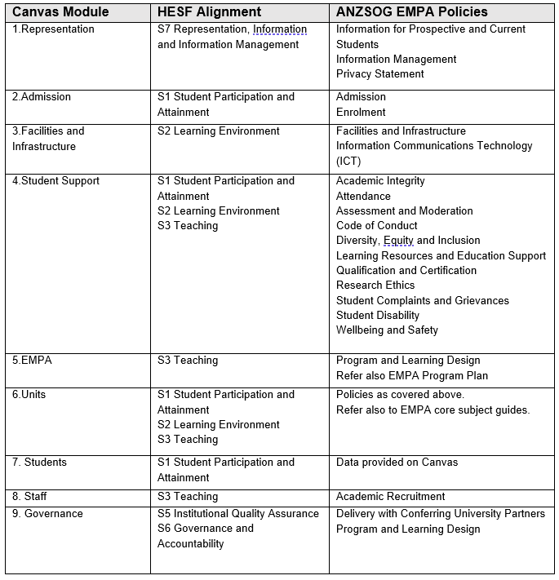

Executive Master of Public Administration

Core Program Policies Overview
ANZSOG has developed 24 policies that guide the design and delivery of the Executive Master of Public Administration program core subject units. These policies align to corresponding standards across the domains of the Australian Higher Education Standards Framework (HESF) 2015 and reflect ANZSOG’s guiding principles and approach to best practice in program delivery as a third-party provider working in collaboration with its conferring university partners. As a bi-country program, ANZSOG also considers the requirements of the New Zealand Quality Authority in its program and learning design.
The Tertiary Education Quality and Standards Agency (TEQSA) advises that ANZSOG’s policies, while needing to align with the HESF 2015 standards and the quality assurance expectations of university partners, must also be fit-for-purpose to ANZSOG as a smaller organisation with limited resources and a focused delivery on the core subjects of the EMPA program. This organisational focus and delivery capacity is significantly different to the broader university sector for which the HESF was developed. Nevertheless, ANZSOG recognises the quality focus provided by the HESF standards for the design and delivery of quality education. ANZSOG’s supporting policies are therefore appropriate for ANZSOG’s operational capabilities and facilitate its commitment to provide EMPA students with a quality learning experience in the core program equivalent to what they could expect in their conferring university’s elective subject units.
ANZSOG’s 24 EMPA policies are categorised against five operational areas (refer to ANZSOG EMPA Policy Map below):
- Program Structure
- Program Administration
- Student Engagement and Participation
- Academic Standards
- Academic Attainment

The objectives of ANZSOG’s EMPA policies are to:
- form a coherent policy framework that aligns core program design and delivery functions with national standards and university partners’ expectations
- map the EMPA program lifecycle for students from admission and enrolment through to assessment and qualification
- differentiate ANZSOG’s core program responsibilities from those of conferring universities
- formalise ANZSOG’s EMPA governance and quality assurance framework in policy
- frame and underpin operational procedures for program delivery
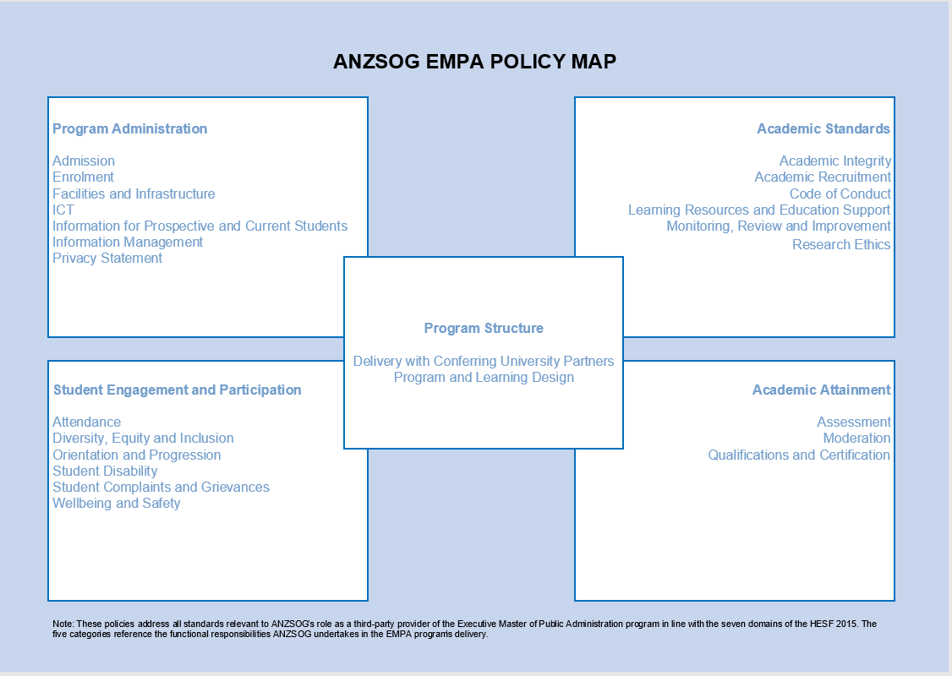

- Program Structure
There are two core policies that together define the arrangements between ANZSOG and its conferring university partners, and then the EMPA core program design:
- Delivery with Conferring University Partners - outlines ANZSOG’s commitment to fulfilling its responsibilities as a provider of the EMPA core program in line with third-party arrangements.
- Program Design and Delivery - describes the program and learning design of the EMPA and identifies the role of policies and procedures in the administration and governance of the program.

- Program Administration

There are seven core policies that underpin all of the logistical, student administrative and information provision and management requirements of the EMPA core program:
- Admission - outlines the requirements for student admission into ANZSOG’s EMPA program
- Enrolment - outlines the requirements for students enrolling in the EMPA program
- Facilities and Infrastructure - outlines ANZSOG’s approach to facilitating onsite classes using venues and supporting infrastructure of conferring university partners or other organisations for the delivery of the EMPA program.
- Information Communications Technology - aligns authorised student use of the EMPA Learning Management System (LMS) and supporting network facilities with ANZSOG’s Information Security Policy and Provision and Acceptable Use of ICT Policy.
- Information for Prospective and Current Students - outlines ANZSOG’s standards and approach to providing current and prospective students in the EMPA program with clear and timely program information to enable informed decision-making.
- Information Management - outlines ANZSOG’s approach to ensure the secure and effective management of information and documents related to the EMPA program in line with ANZSOG’s Information Security Policy.
- Privacy Statement Policy - outlines the information to be provided in an ANZSOG privacy statement to students enrolled in the EMPA program.

- Student Engagement and Participation

An inherent learning requirement of the EMPA program is the opportunity for students drawn from senior public administration leadership roles across multiple jurisdictions to fully participate in all aspects of the program, including the development of professional peer networks and interactions with leading academics and practitioners from relevant fields.
EMPA students contribute to the diversity of the Australian and New Zealand public sector workforce and ANZSOG is committed to recruitment into the program that is inclusive and as far as possible addresses equity challenges through program progression. ANZSOG also fosters a supportive and safe learning environment that is responsive to students’ needs and concerns.
The six ANZSOG EMPA policies supporting these objectives in relation to student engagement and participation are:
- Attendance - outlines the expectations for student attendance in core subjects of the EMPA program
- Diversity, Equity and Inclusion - outlines ANZSOG’s commitment to support and promote diversity and inclusion for students enrolled in the EMPA program
- Orientation and Progression - outlines ANZSOG’s approach to student orientation and academic progression in the EMPA program
- Student Complaints and Grievances - outlines requirements for the submission, management and resolution of student complaints and grievances regarding any aspect of their experience in the EMPA
- Student Disability - outlines ANZSOG’s approach to supporting EMPA students with a disability to achieve the inherent core program requirements.
- Wellbeing and Safety - outlines ANZSOG’s commitment to providing a safe learning environment that supports the wellbeing of all students enrolled in the EMPA program.

- Academic Standards

The EMPA program is a leading international program in the public administration field. ANZSOG seeks to maintain and continuously improve the academic quality of the core program through the following six policies, aligned to the EMPA quality assurance framework:
- Academic Integrity - outlines ANZSOG’s academic integrity standards and approach to dealing with student academic misconduct in relation to core subjects in the EMPA) program
- Academic Recruitment - outlines ANZSOG’s approach to academic recruitment and responsibilities for core subject leaders in the EMPA program
- Code of Conduct - aligns to the ANZSOG Code of Conduct Policy and expands on the ethical standards and expectations for students enrolled in the EMPA program, particularly in relation to the requirements of the HESF 2015.
- Learning Resources and Education Support - outlines ANZSOG’s approach to ensure access to quality learning resources and education support relevant to the needs of students enrolled in the EMPA program.
- Monitoring, Review and Improvement - outlines ANZSOG’s approach to ongoing cyclical review, monitoring and improvement of the EMPA program including external referencing and benchmarking.
- Research Ethics - outlines ethical standards for research conducted by or under the auspices of ANZSOG in the delivery of core subjects of the EMPA program.

- Academic Attainment

ANZSOG has rigorous standards for designing and conducting assessments to evaluate student performance and achievement across the EMPA core subjects in line with conferring university partners’ assessment and moderation practice in the elective program. The following three policies outline ANZSOG’s approach to academic attainment in the core program, and its relationship to the overall program completion:
- Assessment - outlines the requirements for the design and delivery of student assessments in core subjects of the EMPA program
- Moderation - outlines requirements for the moderation of core subject assessments submitted by students in theEMPA program to promote quality and ensure consistency.
- Qualification and Certification - outlines ANZSOG’s role regarding certification for students of the EMPA program in being awarded a Master level qualification accredited under the HESF and awarded by conferring university partners.

- Representation
______________________________________________________________
Introduction
ANZSOG promotes the Executive Master of Public Administration (EMPA) via a number of communication channels with tailored messaging for specific audiences and various channel-specific content types. The audience includes our government owners in Australia and New Zealand (CEOs of agencies, Learning and Development contacts and Public Sector Commissions); prospective students (current and future public sector leaders); and alumni (EMPA graduates who act as message multipliers and encourage others to apply). The EMPA program requires students to study core subjects delivered by ANZSOG and elective subjects offered by the student’s conferring university. This combination of subject delivery defines the nature and timing of the program of study and the fees and charges that are applied.
Approximately 100 students across all jurisdictions in Australia and New Zealand enrol in the EMPA annually. The EMPA program is designed for future Australian and New Zealand public sector leaders who are sponsored through the government agencies in which they are employed. These agencies nominate prospective students with management experience and at least five years of relevant work experience. Students are identified as high potential future leaders exhibiting a strong commitment to public service.
Applicants should meet the Master’s degree entry requirements of the conferring universities, which typically requires previous completion of an undergraduate degree. Agencies are also encouraged to nominate Māori and Aboriginal and Torres Strait Islander peoples, people with disability and those from culturally and linguistically diverse backgrounds. See Chapter 2. Admission for more detail in the application and admission process.
TEQSA Guidance
The remainder of this chapter provides a range of data related to the content and delivery of information for prospective EMPA students. The evidence provided demonstrates alignment with core elements of the Higher Education Standards and guidance notes specific to accuracy, relevancy and timeliness, including:
- whether the providers’ representations (whether directly or through other parties) about themselves and the course(s) of study they offer are accurate, ethical and not misleading in their claims (HESF 7.1)
- whether there is sufficient publicly available information to assist students in making informed choices about selecting a course of study, to enable effective and informed participation in a chosen course of study and to resolve grievances if necessary, including the particular needs of international students studying in Australia (HESF 7.2)
- the existence of a readily accessible public description of the provider and its operations
- the requirement that the provider’s information management system meets certain critical requirements concerning content, security and integrity (HESF 7.3).

1.1. Information for prospective students

ANZSOG Policy
The EMPA Information for Prospective and Current Students Policy outlines ANZSOG’s standards and approach to providing students enrolled or seeking enrolment in the EMPA with clear and timely program information to facilitate informed decision-making. It directs:
- The types and purpose of the information to be provided
- How prospective students can access the information online or through emails
- Quality control on currency and accuracy including regular review and reasonable notice

HESF Alignment: ANZSOG’s policies and processes address HESF Standard 7.2 by ensuring regular internal review of information and promotional material provided to students to ensure that its content is accurate and informs prospective students’ decision-making in relation to the relevance and quality of the EMPA program to fulfill their professional learning goals and to guide their application and enrolment process.

ANZSOG EMPA Program Promotion
In the lead up to the program applications and admissions process, ANZSOG undertakes an annual communications campaign tailored to the specific needs of the target EMPA audience. The information shared is consistent with standards outlined in HESF Domain 7, providing students and government sponsors with access to reliable and accurate information concerning the EMPA program structure, eligibility requirements, the applications process and a link to the applications template.
Other content to inform prospective students about the EMPA program’s value include:
- news stories and articles (e.g. alumni and faculty profiles)
- images and videos
- advertising
- brochures and fact sheets

  - Summary of Channels used to present information to prospective students
ANZSOG EMPA communication channels include:
- briefings with Public Service Commissions
- ANZSOG website
- ANZSOG social media channels (Facebook, Twitter, LinkedIn and YouTube)
- electronic direct mail (EDM)
- partnerships (e.g. with the Analysis and Policy Observatory)

- Admission
_________________________________________________________

Introduction

The EMPA is managed as a partnership between the government, which funds, nominates and supports their employees as EMPA students; the conferring university that administers, enrolls, teaches into and confers the degree; and ANZSOG, which delivers 75% of the subjects (9 out of 12 subjects) in the degree and providing the conduit between all parties in the arrangement.
The EMPA is a prestigious, internationally respected and highly valued professional development opportunity offered by governments to their high performing, emerging leaders. Each of ANZSOG’s 10 member governments nominates students for program entry. Students do not apply directly to ANZSOG without being nominated and sponsored by their government employer. The number of students from individual agencies and governments changes each year depending on government budgets and the quality of applications for the places offered. Students remain employed full time by their sponsoring agency while undertaking the degree.

TEQSA Guidance

This chapter provides an overview of ANZSOG’s administrative practices, policies and information that relates to student admission. The evidence provided demonstrates alignment with core elements of the Higher Education Standards and guidance notes. In this chapter evidence covers Domain 1 of the TEQSA HESF addressing the importance of institutions providing fair and consistent processes of admission where students are informed of their rights and obligations, fees and charges and are informed of policies and other relevant matters impacting on their participation in the program of study.

2.1. Process, including timelines and information given to students, and how students select admission

ANZSOG Policy
The EMPA Admission Policy outlines the requirements for student admission into ANZSOG’s EMPA program. It directs:
- Mandatory and other eligibility requirements
- Information sought in program applications
- The application process and notification of outcome
HESF Alignment: The student intake for the EMPA is very specific to the needs of senior public sector leaders across jurisdictions and departments in Australia and New Zealand and therefore have high expectations of the quality and relevancy of the program. As such, ANZSOG’s policies and processes address HESF Standard 1.1 by ensuring that provision of all relevant information guiding a prospective student to apply is accurate and timely, and that processes for progressing applications across three stakeholder parties are clear to the applicant and fair and transparent.

EMPA Admission

Admission to the ANZSOG EMPA involves a tri-party, three-staged process:

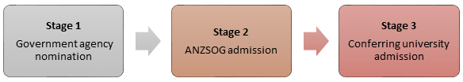

ANZSOG’s admission policy covers Stage 2. Each government/government agency stipulates their own selection processes for nomination (Stage 1). Each university has its own admission policy and processes (Stage 3).

ANZSOG’s admission policy describes the mandatory and other requirements for provisional acceptance into the EMPA, the information required for an application and the process followed to confirm or otherwise an application for admission.

Admission Information and Application Form

In addition to the Admission Policy, students obtain formal information about the EMPA and application timelines from ANZSOG and their own agency.

Additional information is provided to students in response to queries received via email and phone interactions.

All information captured at the application stage complies with the Privacy Act 1988 (Cth).

Admission timelines

Application March to September
The EMPA commences in Semester 1 each calendar year. Applications are accepted from March onwards in the previous calendar year, closing in September.
Late applications continue to be received up to and including 30 November.

ANZSOG provisional acceptance August to October
Applications for admission to the degree are reviewed on a rolling basis by the EMPA Academic Director.
Applicants receive a notification of their provisional acceptance or non-acceptance into the degree via email by mid-October.

University acceptance November-January
Applications which have been provisionally accepted by ANZSOG are provided to the university in one batch in early November. Late applications are subsequently provided as soon as they are provisionally accepted by ANZSOG.
The university then manages its own process for admitting students to the degree and advises students of the outcome independently of ANZSOG.
ANZSOG is advised by the university about which applicants have been admitted to the degree in line with their general admission processes and timelines.

The following diagram summarises the Admission timeline:

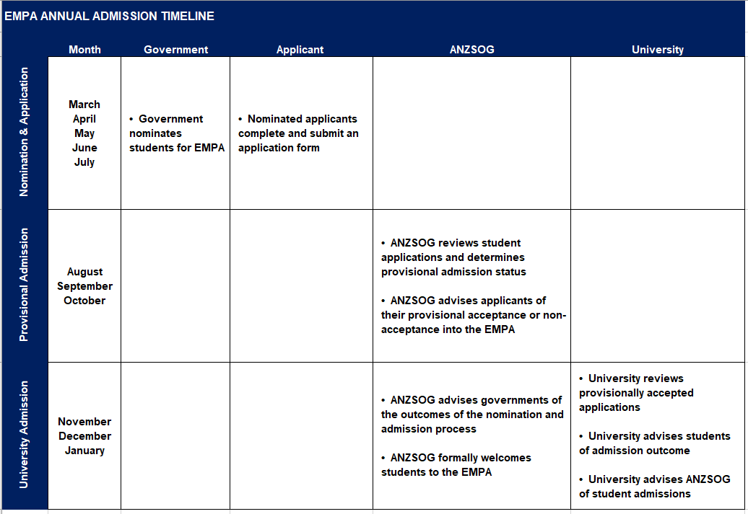

University Selection by Students

ANZSOG values its relationship with all conferring university partners. The overall number of students enrolling each year depends, as noted above, on sponsoring government budgets and priorities.

Applicants must satisfy the eligibility and enrolment requirements of their preferred university, and therefore ANZSOG cannot guarantee enrolment into the program at any participating university. ANZSOG endeavours to progress applicant’s first preference university where possible. ANZSOG welcomes opportunities to discuss strategies for increasing student enrolments for all partners.

2.2. Outline of any recruitment strategies in place for Aboriginal and Torres Strait Islander and low SES students

ANZSOG Policy
The EMPA Diversity, Equity and Inclusion Policy outlines ANZSOG’s commitment to support and promote diversity and inclusion for nominations from member governments and sponsoring agencies and for students enrolled in the EMPA program.
While this policy covers ANZSOG’s commitments to inclusion and participation of EMPA students from all diversity and underrepresented cohorts, it acknowledges ANZSOG’s special responsibility to advance the priorities of its government and university partners to encourage the nomination and recruitment of students of Aboriginal, Torres Strait Islander and Māori backgrounds.
Recruitment Strategies
As student selection is the responsibility of sponsoring government agencies, ANZSOG does not have authority to formally direct recruitment and nominations for Aboriginal,Torres Strait Islander and Māori prospective students and low SES students to enter into the EMPA. ANZSOG does, however, continue to promote and encourage applications from students from these backgrounds in line with its EMPA Diversity, Equity and Inclusion policy, and through broader engagement arising from its First Peoples Strategy.
ANZSOG has previously participated in initiatives that some jurisdictions have implemented to actively recruit Indigenous students into the EMPA. This has included, for example, the funding by the Department of Prime Minister and Cabinet of specific scholarships for Aboriginal and Torres Strait Islander students to participate in the EMPA.
Furthermore, ANZSOG has pursued a number of informal processes that support a pathway model for encouraging student recruitment from Māori, Aboriginal, Torres Strait Islander and low SES students. For example:
- ANZSOG’s pathbreaking establishment of the Senior Indigenous Public Servant Forum facilitates discussion of how to embed student recruitment into ANZSOG programs

- ANZSOG’s employment of First Peoples advisers within its own organisation models employment targets and prioritises First Peoples leadership within ANZSOG

- ANZSOG’s research and curriculum review processes help enable ANZSOG to bring Māori and Indigenous speakers, topics, knowledges and initiatives into focus and into the mainstream of ANZSOG activities

- ANZSOG’s focused outreach to First Peoples networks (formally through its Indigenous newsletter and informally through multiple relationships built over time by ANZSOG staff with First Peoples communities in various locations throughout Australia and Aotearoa-New Zealand) is building trust and credibility for First Peoples students to contemplate ANZSOG as a place of cultural safety for learning and leadership growth opportunities

- Facilities and Infrastructure
_________________________________________________________

Introduction
ANZSOG delivers 75% of the subjects within the EMPA in a combination of online, blended and face to face modes.
This chapter outlines ANZSOG’s approach to utilising facilities and infrastructure for the delivery of the core EMPA subjects, and how students and faculty are provided IT tools and support enabling their successful program completion.
TEQSA Guidance
This chapter provides an overview of ANZSOG’s administrative practices, policies and information that relates to Facilities and Infrastructure. The evidence provided demonstrates alignment with core elements of the Higher Education Standards and guidance notes. In this chapter evidence aligns with HESF Standard 3.3 Learning Resources and Educational Support which addresses the importance of institutions providing appropriate learning infrastructure and resources to support student learning.

3.1. ANZSOG teaching facilities, including library and digital resource facilities

ANZSOG Policy
The EMPA Facilities and Infrastructure Policy outlines ANZSOG’s approach to facilitating onsite classes using venues and supporting infrastructure of conferring university partners or other organisations for the delivery of the EMPA program. It directs:
- The use of external facilities for a range of core subject learning activities
- Expected student compliance with conditions of the facility owner
- The types of facilities and supporting infrastructure utilised
- Quality and safety issues related to class capacity, accessibility and suitability
HESF Alignment: ANZSOG’s policy and processes address HESF Standard 2.1.1 regarding use of fit-for-purpose venues that have normally been conducted onsite at conferring university partner campuses. On occasion where other venues have been used the ANZSOG EMPA Delivery Team has ensured that these venues comply with the above requirements. The types of learning activities undertaken at external venues are outlined in the core subject guides with venue chosen to support these activities and student interaction as required by HESF Standard 2.1.3. Through arrangements with conferring university partners, and EMPA students have access to the library and digital resource facilities at their conferring university for undertaking both core and elective EMPA subjects.

3.1.1 Background and Context
While completing the EMPA, regardless of whether subjects are being delivered by ANZSOG or their conferring university, all university facilities are available to their students. Therefore, students are expected to access their conferring university library and digital resource facilities, as necessary.
ANZSOG delivers its subjects in a variety of modes, including online, blended and face to face. Where subjects are delivered face to face, ANZSOG sources external facilities in the delivery location that meet the required standards, as outlined in the Facilities and Infrastructure Policy.

3.2. IT support provide to students and faculty members

ANZSOG Policy
The EMPA ICT Policy aligns authorised student use of the EMPA Learning Management System (LMS) and supporting network facilities with ANZSOG’s Information Security Policy and Provision and Acceptable Use of ICT Policy. Together, these policies direct:

- The accessibility and use of the EMPA LMS, which is the same Canvas site through which this report is accessed
- Standards for information management and acceptable use that also align with ANZSOG’s Privacy policies and the EMPA Code of Conduct policy

HESF Alignment: ANZSOG’s policies and processes address HESF Standard 2.1.2 regarding secure access to electronic information. In addition to the ANZSOG ICT policy related to use of the EMPA LMS, ANZSOG’s broader organisational policies Information Security, and Provision and Acceptable Use of ICT, overseen by ANZSOG’s Chief Information Officer frame IT security for the whole organisation including IT support for the EMPA. The EMPA Facilities and Infrastructure policy addresses use of external digital networks and learning support.

Background and context
Regardless of the delivery mode for the EMPA core subjects, every subject utilises the ANZSOG LMS to convey information, resources and to generally support student learning. All students have access to the ANZSOG LMS free of charge for the duration of their EMPA studies.
Whilst using IT, all students and faculty are bound by the ICT policy and Code of Conduct policy.

IT Support for students
There are a range of mechanisms available to support students to use the LMS technology in their EMPA studies, including:
- A ‘Welcome to the EMPA’ orientation module in the LMS
- A ‘how to’ module for using the LMS more generally
- During online deliveries, immediate technology support to triage technology connection issues experienced by individual students via a dedicated email account for students only
- Email and phone support to students during their studies

IT Support for Faculty
ANZSOG works directly with subject leaders (faculty) to support their development and capacity to teach in the required format. For online learning and teaching, this includes a faculty support model comprising:
- A self-paced program available in the LMS to build awareness of the range of options available to faculty in a blended learning space, including advice about what options work best to achieve different learning outcomes
- Coaching from an experienced blended and online learning designer
- Dedicated learning designer and technologist to support subject design, development of digital learning resources and delivery
- Technology support during delivery to enable the faculty to focus on teaching and fostering student engagement and collaboration
- Peer support through subject leader meetings, discussions of best practice and showcasing innovation by individual faculty
- Rehearsal/piloting of new technology and approaches to identify those that best fit their learning and program objectives, and to refine their practice.

- Student Support
_________________________________________________________

Introduction
On completion of admission and enrolment to the EMPA program students are regarded as students of both ANZSOG and their conferring university. The EMPA core subjects constitute 75% of the program content and are delivered by ANZSOG through a combination of online, blended and face to face modes. A range of learning resources, and academic and other support is made available to EMPA students through the program. Concurrently, each conferring university has complementary practices the EMPA student is encouraged to participate in or access, as per their individual requirements. Where appropriate students may also be directed to speak to their sponsoring agencies regarding employment entitlements.
This chapter outlines ANZSOG’s approach to student support for the subjects delivered by ANZSOG.
TEQSA Guidance
Evidence provided demonstrates alignment with core elements of the Higher Education Standards and guidance notes. In particular, the data provided demonstrates the policies, practices and systems ANZSOG has in place align with relevant requirements of Domains 1, 2 and 3 of the HESF.
This specifically concerns issues of student orientation; policy guidance for academic integrity; student code of conduct and arrangements; and data related to student grievances and complaints. In addition, these ANZSOG policies and practices address students from diversity cohorts and how student feedback and measures of satisfaction are obtained. This chapter sets out how this information informs ongoing processes of learning and teaching improvement.

4.1. Orientation activities, including training and information provided on academic integrity and respectful relationships

Following enrolment and prior to commencing studies, all students are provided a range of information and guidance to support their success in the ANZSOG EMPA core program.
ANZSOG Policy
The EMPA Orientation and Progression Policy outlines ANZSOG’s approach to student orientation and academic progression in the EMPA program. It directs:
- The type of information provided to students during orientation at program commencement and how this is delivered
- Advice to students on obtaining information from their conferring university in relation to the university’s expectations, policies and elective subject requirements
- Core subject and program progression requirements

HESF Alignment: ANZSOG’s policies and processes address all subsections of HESF Standard 1.3 through strategies to transition and support students into the EMPA course program, and ongoing academic and other support provided through their program progression. ANZSOG seeks to implement strategies to support program orientation and transition for students from diverse and lower SES cohorts, and students with a disability. ANZSOG monitors student cohort trends in relation to retention, progression and completion.

At commencement, all students are invited to undertake a purpose-built EMPA Orientation and Information portal accessible through ANZSOG’s Canvas LMS. This module is both an orientation and a reference point for students for the duration of their studies with ANZSOG. It includes:
- Information about all ANZSOG core subjects and the structure of the degree
- Information to support effective learning at ANZSOG, with reference to synchronous and asynchronous components of education
- Statement of learning Objectives aims and graduate attributes
- A statement on Academic Integrity with reference to the associated policy
- All EMPA related policies relevant to students, including Code of Conduct.
- A ‘how to’ module for using and navigating the LMS and use of Turnitin for assessment submission
- Information about technology requirements for completing the EMPA
In addition to the online orientation module, the first subject of the EMPA includes a “Welcome to the EMPA” session, where students meet relevant faculty and staff at ANZSOG, and are able to engage with experts in relation to specific subject content, policies and practices, and to resolve any outstanding queries regarding program enrolment and progression.
Students are clearly informed on expectations regarding the program’s academic and personal standards through the Academic Integrity Policy and Code of Conduct Policy.

4.2. Student support offered (academic and non-academic), including the process for dealing with student complaints

Student Support Offered
General EMPA support is available on demand to students through the ANZSOG EMPA team via email and phone. All support queries are acknowledged and/or responded to within 24 hours. Academic support for particular subjects is available through each subject leader, via email or the LMS for initial contact. Subject leaders are available for individual guidance and advice about learning content, assessment pieces, or additional support requirements. In addition to the support offered by ANZSOG, students have access to the support resources available through their conferring university.

ANZSOG Policy
The EMPA Learning Resources and Education Support Policy outlines ANZSOG’s approach to ensure access to quality learning resources and education support relevant to the needs of students enrolled in the EMPA) program. It directs the:

- Academic quality, rigour, relevance and currency of learning texts and support materials to be used in EMPA core subject delivery
- Availability and accessibility of support materials and services
- Removal of barriers to accessing support
- Types of learning resources and support and how they are accessed
- Regular review of learning resources and support to keep them relevant and current
- Information to students encouraging them to seek academic advice from their core subject leaders or conferring university as appropriate

HESF Alignment: ANZSOG policies and processes address standards in relation to HESF 3.3 by planning, delivering, monitoring and reviewing the quality and types of academic support and resources provided to EMPA students.

Managing Student Complaints
ANZSOG seeks to address student complaints and grievances through a mechanism that is impartial and fair, transparent and consistent, and respects the privacy of all parties.
ANZSOG Policy
The EMPA Student Complaints and Grievances policy outlines requirements for the submission, management and resolution of student complaints and grievances regarding any aspect of their experience in the EMPA. It directs:
- When and how to lodge a complaint and grievance
- Caution on vexatious complaints
- Process on lodging a complaint or grievance from investigation to notification of outcome
- Withdrawal of complaints
- Other avenues of feedback
- Record keeping on complaints in line with ANZSOG responsibilities to protect privacy of complainants

HESF Alignment: ANZSOG addresses HESF Standard 2.4 by recognising a student’s right to make a complaint or lodge a grievance about any aspect of the EMPA and facilitating an impartial process to do so. ANZSOG provides clear guidance and reference to associated procedures and articulates what students can expect in relation to communication and responses about their issues.

4.3. Annual collation of student complaints, including number and nature of complaints, resolutions and time to resolution. Data should be deidentified and presented for the entire EMPA cohort across all university partners

ANZSOG highly values student feedback and is committed to addressing student complaints in a timely and fair manner. ANZSOG actively and regularly engages students to ensure they are satisfied with all aspects of program delivery. In 2019, there were no complaints or grievances lodged with ANZSOG about the EMPA or specific subject content.

4.4. Annual collation of data relating to breaches of academic integrity. Data should be deidentified and presented for the entire EMPA cohort across all university partners

In line with the EMPA Academic Integrity Policy and EMPA Breaches in Ethical Standards Procedures, ANZSOG applies an educative approach to instances of academic misconduct where this is appropriate and possible. ANZSOG’s EMPA policies and procedures provide appropriate mechanisms to report and investigate serious or persistent breaches. There is no data to report in 2019 in regard to breaches.

4.5. Support for identified cohorts, specifically Aboriginal and Torres Strait Islander students and low SES students

ANZSOG’s 10 member governments nominate students for admission to the EMPA. (Refer to Chapter 2 for more information about Admissions.) ANZSOG does not directly influence the nomination process, government agencies are encouraged to nominate students from Māori and Aboriginal and Torres Strait Islander people’s backgrounds for admission into the EMPA program, as well as prospective students from a range of diversity cohorts.
ANZSOG Policy
The EMPA Diversity, Equity and Inclusion Policy outlines ANZSOG’s commitment to support and promote diversity and inclusion of nominations from member governments and sponsoring agencies and for students enrolled in ANZSOG’s EMPA program. It directs:
- ANZSOG’s commitment to equity, fairness and inclusiveness
- Promotion of admission opportunities to students representing diverse background via their sponsoring agencies
- Removal of barriers to participation and clarity of information of students’ rights and responsibilities
- Incorporation and valuing of diverse perspectives in curriculum and learning activities
- How ANZSOG promptly addresses complaints related to discrimination and/or harassment
- Students to familiarise themselves with equivalent support services available through their sponsoring agencies and conferring universities

HESF Alignment: ANZSOG has responsibilities to its government owners to advance their priorities for promoting opportunities for students from Aboriginal and Torres Strait Islander, and lower SES backgrounds. These responsibilities also align to the HESF Standard 2.2. ANZSOG works within both frameworks and is continually seeking to improve its support for these cohorts. ANZSOG staff have undertaken cultural competency training in relation to First Peoples to a higher level of sensitivity and support for students. Cultural competency in relation to First Peoples is also available and encouraged for subject leaders. To support the learning and teaching context ANZSOG has created a Learning Action Protocol that draws attention to the manner in which Indigenous knowledge and understanding can be linked to subject content.

Additional Strategies for Broad Engagement and Support in ANZSOG Programs
Student support for Aboriginal and Torres Strait Islander students and low SES students has traditionally been subsumed under general policies applying to all ANZSOG students.
In 2017, ANZSOG engaged in a Listening Tour across all its member jurisdictions which actively pursued the formation of relationships with ANZSOG stakeholders, alumni and its communities to seek out how ANZSOG should start to engage and demonstrate leadership on First Peoples issues, including in student support issues (such as cultural safety and embedding First Peoples content into programming).
This led to the development of a number of initiatives within ANZSOG including specific Indigenous Public Administration conference and senior public servant forums to begin to serve First Peoples communities, and to develop an internal agenda of cultural competency and confidence. ANZSOG is currently revitalising its activities and seeking to prioritise First Peoples perspectives across all that it does.
ANZSOG features faculty who actively supervise and examine Higher Degree by Research (HDR) students who are Aboriginal, Torres Strait Islander and Māori. This includes students supervised by
Dr Chris Walker, ANZSOG Deputy Dean University Relations and EMPA Academic Director, and Professor Catherine Althaus, ANZSOG Deputy Dean Teaching and Learning.
The following lists the activities that ANZSOG has pursued since the Listening Tour of 2017, in an effort to demonstrate explicit and substantive commitment to prioritising First Peoples knowledges and perspectives. ANZSOG is on an ongoing journey to improve cultural confidence and ensure student support for Aboriginal and Torres Strait Islander and Māori students and lower SES students:
Indirect recruitment and support initiatives
- successful establishment of the Indigenous Senior Public Servant Leadership Forum
- development of the ANZSOG Learning and Action Protocol
- curriculum review work in EFP in pilot form to potentially roll out to EMPA (e.g. curriculum review, commitments to content and speakers pertinent to First Peoples knowledges, development of new learning engagement principles and attention to cultural safety and support matters)
- development and inclusion of the Learning and Action Protocol in the Orientation program for the EMPA
- changes to the HREC committee to prioritise First Peoples ethics issues into deliberations including with respect to ethics approvals for Work Based Projects in the EMPA that address First Peoples issues
- development of the ANZSOG Cultural Integrity Scorecard
- development and inclusion of First Peoples materials and perspectives (including cultural safety) in the soon-to-be released(3rd quarter of 2020) Teaching Induction program
- the cultural competency training undertaken by ANZSOG staff (see Arrilla and Mãori cultural competency materials listed below)
- the Indigenous Public Administration conference with ANZSOG providing travel, accommodation and conference bursaries to 15 Aboriginal and Torres Strait Islander participants
- Thought Leadership and the National Regulators Community of Practice (CoP) events that address First Peoples topics
- the First Peoples newsletter and network coordinated by ANZSOG’s Stakeholder Relations and Communications team
- prioritisation of First Peoples issues in ANZSOG’s impact workshop and the shifting of some of our evaluation questions in program evaluation and reviews to address cultural competency, safety and confidence issues as well as First Peoples content
- past scholarships into some of the bespoke programs we delivered as well as the EMPA
- establishment and partial funding (along with the Chartered Accountants of Australia and New Zealand) of the First Peoples video case competition
- a variety of research initiatives we have either completed (the Indigenous Values for the APS- APS Review Submission, the Australian Journal of Public Administration special issue, support for the Griffith Review special issue, Leading from Between book, pieces we have written for the Mandarin, Canberra Times, etc), Partnerships with First Peoples need to start with healing project, or have underway (e.g. the Indigenous public servant statistics dashboard project)
- development of specific strengths-based Indigenous case studies including the Indigenous leadership case (interview with Ian Hamm) and the ‘Healing from the Centre’ case, Circle Sentencing, Responding to a call for help, Chris Sarra;
- funding and establishment of the First Peoples collection with the Analysis Policy Observatory
- establishment and funding contribution for the ANZSOG/Churchill Memorial Trust Fellowships (x2) for Indigenous public servants
- development of the First Peoples online series
- Bespoke program activities such as: developed First Peoples Leadership Program in conjunction with Western Australia and developed and delivered program for Victorian Aboriginal delegation to Aotearoa
- ANZSOG/ VPSC organised a delegation of senior Aboriginal public servants to visit Wellington and learn from the New Zealand experience.

4.6. Student satisfaction survey monitoring and results, including how results are looped back into course provision

The EMPA Monitoring, Review and Improvement Policy outlines ANZSOG’s approach to ongoing cyclical review, monitoring and improvement of the Executive Master of Public Administration (EMPA) program including external referencing and benchmarking. It directs the annual program and review process.
HESF Alignment: ANZSOG’s policies and procedures address HESF Standard 5.3. through governance arrangements as outlined in Chapter 9 covering mechanisms for oversight of academic quality and administration of the EMPA within ANZSOG.

Additional Context
A range of qualitative and quantitative feedback is formally collected from students at the conclusion of every subject delivered by ANZSOG. This feedback is collected through an electronic survey system that facilitates analysis of a range of factors, both within and across subjects and faculty. All student feedback informs the annual subject review, following completion of assessments and marking.
Specifically, Subject and Academic Review meetings enable a holistic approach in which student feedback is discussed in the context of subject learning outcomes, assessment activities, student grades, subject materials, issues of academic integrity and other relevant matters. This feedback and analysis is then used to identify subject improvement actions and any other relevant actions across the program delivery that may assist in progressing learning and enhancing the student experience. Subject leaders and the EMPA Academic Director are then encouraged to draw on this feedback and analysis at the annual EMPA Subject Leaders’ meeting, which generally takes place during the first quarter of each year.

- EMPA
_________________________________________________________

Introduction

This chapter provides an overview of the rationale and structure of the EMPA, along with articulation of the learning outcomes and graduate attributes intended for students.
TEQSA Guidance

This chapter provides a range of data related to the rationale and structure of the EMPA. The evidence provided demonstrates alignment with core elements of the Higher Education Standards and guidance notes. In particular this chapter addresses elements of Domain 3 and 5 that concern processes of course design, learning outcomes and program review activities. Relevant elements from these domains include:
Domain 3
Specific requirements for the specification of the course design and requirements for engagement with advanced knowledge and enquiry, current knowledge, theoretical frameworks and concepts, related scholarship and emerging ideas coherent achievement of learning outcomes and professional accreditation of a course of study if applicable.
Domain 5
Whether the provider has a credible and effective process for internal approval of all courses of study that is applied consistently and involves competent academic oversight and scrutiny independent of those directly involved in the delivery of the courses of study (5.1)
The effectiveness of the policy framework and processes that are applied to maintain academic integrity throughout the provider’s academic activities (including arrangements with other parties) and to address and prevent lapses in academic integrity (5.2)
The mechanisms for regular review of the quality of higher education activities and how the findings of such reviews are used to bring about improvements (5.3)

5.1 Course Outline

5.1.1 Rationale
The EMPA engages and nurtures leaders and managers in the public sector in Australia and New Zealand to develop and enhance their critical thinking abilities in public management and public sector leadership. The degree is a prestigious and highly valued professional development opportunity offered by governments to their high performing and emerging leaders. A significant number of EMPA alumni have subsequently achieved appointments as Chief Executive Officers across a number of public sector organisations. Inherent in program expectations is the continuous development of senior leaders serving the Australian and New Zealand public service.
The original and ongoing purpose for establishing ANZSOG is to meet the requirement for quality leadership of the complex and multi-disciplinary nature of the public sector. With an estimated workforce of 2.4M people across Australia and New Zealand and with estimated government expenditure accounting for almost 25% of national GDP (OECD), quality leadership and effective management is essential for successful and competent public services for all governments. This, in turn, assures effective and efficient stewardship of public resources and the delivery of quality services to communities.
ANZSOG’s vision is to be a world-leading organisation for public sector education, research and knowledge exchange. The purpose of the EMPA program stems from the broader strategic goals that underpin ANZSOG’s operation: to Educate, Enrich, Connect and Inspire.

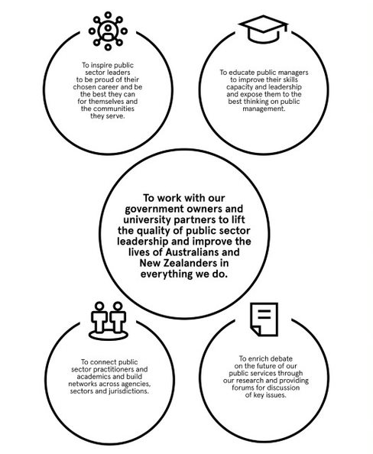

The EMPA welcomes students already exhibiting high potential as leaders so that they can be nurtured through the program and develop the skills necessary to improve the lives of people in Australia and New Zealand. It is this combination of matching the vision of ANZSOG with the specific elements of the EMPA that lifts the quality of public sector management and leadership. With a cohort drawn from all 10 governments of Australia and New Zealand, students develop cross-jurisdictional networks of peers who become a professional network that sustains and supports students throughout their program of study and across the duration of their professional careers.

5.1.2 About the EMPA
The EMPA is a two-year postgraduate qualification developed and delivered by ANZSOG exclusively for high-performing public sector managers and leaders.
The EMPA program is specifically designed to incorporate the range of skills required of an exceptional leader and manager, tailored to the unique and broad context of the public purpose sector. Unlike business degrees, the EMPA centres on the concept of leading and managing for public value, taking into account the nature of working in government in Australia and New Zealand and the challenges faced by leaders around policy, integrity, economics, regulation and public problem solving within a democratic society.
ANZSOG is governed by current and former public sector leaders, who play an active role in shaping and contributing to the content delivered through the EMPA. A significant focus of the degree is learning from practice, success and failures, as well as drawing on leading academic theories, concepts and the underpinnings of what determines best practice. In this way ANZSOG’s EMPA bridges the gap between academic theory and the world of practice, allowing students to benefit from both leading academic research and the pragmatic realities of working with the complexity of governance and delivering public value.
The blended EMPA delivery mode allows for the time and space so that students can become reflective practitioners. Following periods of intensive study students return to their professional roles refreshed and energised having delved deep into scholarly material as well as learning from experienced and expert practitioners. The program aims to stimulate conceptual thinking and also build on applied management and leadership skills.
Attention is drawn to the student’s experience within the public sector and linking this to conceptual and analytical frames that help guide the analysis of applied public policy problems. Learning is interactive, student-led and ANZSOG’s broader network of international partners is drawn on to enhance the experience for students beyond the domestic contexts. This may involve for example subject delivery in partnership with ANZSOG associates at the Lee Kwan Yew School of Public Policy in Singapore and subject delivery by our world leading international faculty.

5.1.3 The ANZSOG Model
The ANZSOG model is to Educate, Enrich, Connect and Inspire to create outstanding public sector leadership that includes Indigenous and diverse voices of local communities, with 10 member governments and 15 partner universities. ANZSOG has both a global reach and regional focus.
The partnerships strengthen understanding of the changing needs of governments across Australia and New Zealand so that teaching and learning has both academic rigour and also presents contemporary practices and approaches to public sector policy, management and service delivery challenges. Our government owners are actively engaged in the program, so that there is a mutual understanding of the current and future capability requirements of public sector employees and leadership across a diverse range of governmental structures.
Member governments | Partner universities
New Zealand | Victoria University of Wellington
Australia | Australian National University
Australian Capital Territory | University of Canberra
South Australia | Flinders University  Carnegie Mellon University H. John Heinz III School of Public Policy and Management, Adelaide.
Northern Territory | Charles Darwin University
Western Australia | Curtin University of Technology
Queensland | Griffith University  The University of Queensland
Victoria | Melbourne Business School  The University of Melbourne.  Monash University
New South Wales | The University of Sydney  The University of New South Wales
Tasmania | The University of Tasmania

5.1.4 Program structure
The core EMPA subjects (75%) are delivered by ANZSOG, as shown in the following table. The remaining 25% of the degree comprises three electives chosen by students from their conferring university, and this combined completes the degree. The aim of the electives is to provide a more individualised and tailored program of study that reflects each student’s interest, expertise and career trajectory. For example, a student who works in the Department of Health may choose a public health elective at their conferring university. Electives are therefore drawn from a diverse range of faculties at the conferring university.

ANZSOG core subjects | Acronym | Year
Delivering Public Value | DPV | 1
Government in a Market Economy | GME | 1
Designing Public Policies and Programs | DPPP | 1
Decision Making Under Uncertainty | DMUU | 1
Managing Public Sector Organisations | MPSO | 1
Governing by the Rules | GTR | 2
Public Financial Management | PFM | 2
Leading Public Sector Change | LPSC | 2
Work Based Project | WBP | 2

5.1.5 Subject Overview
Delivering Public Value (DPV) Year 1
About | Learning Outcomes
In this subject, core principles of public sector management are explored. Students consider the value their organisation creates, the impact of their authorising environment on operations and the capabilities involved in delivering value to stakeholders. | Appreciate the trends shaping public sector action and what they mean for contemporary leaders and managers.  Understand the theory and practice of strategic thinking and value creation in the public sector.  Appreciate the importance of values, how they shape action, and connect to value creation.  Be cognisant of the changing role of technology in value creation.  Recognise how strategy and value are shaped by the authorising environment and appreciate the importance of political astuteness.  Comprehend the importance of place and community in shaping notions of value.  Be able to apply these ideas, in real time, to challenges faced in practice.

Government in a Market Economy (GME) Year 1
About | Learning Outcomes
In this subject, students examine key economic principles and their application to public sector activities in supporting resource allocation, pricing and delivering goods and services. Students will explore how government intervention, through both private sector regulation, and the public provision of services, can be used to achieve the best outcomes for citizens. | Understand how market forces operate and how government policies influence, and are influenced by, market forces.  Understand why unfettered private markets can sometimes fail to deliver efficient and fair outcomes for society.  Identify particular examples of market failure and apply economic principles to designing government interventions to prevent or reduce the costs of market failure.  Apply the economic toolkit to decisions facing public sector managers about delivery and pricing of public services apply the key principles of cost-benefit analysis to public sector projects and appreciate the importance and role of the public sector in promoting national productivity.

Designing Public Policies and Programs (DPPP) Year 1
About | Learning Outcomes
In this subject, students will be offered a framework for considering government responses to contemporary public problems. They are encouraged to think analytically about problems, identify alternative ways of tackling them, and assess the likely results of changes in current policies and programs. Emphasis is given to the role of effective teamwork and clear communication in any well-functioning advisory system. | Bring an investment perspective to all policy and program design work.  Characterise existing programs and appreciate their relationship to specific valued outcomes or perceived public problems.  Design policies and programs that are likely to produce ongoing public benefits and appreciate the value of teamwork in policy analysis.  Help politicians, stakeholders, and citizens achieve realistic expectations about the potential and the limitations of government actions.

Decision Making Under Uncertainty (DMUU) Year 1
About | Learning Outcomes
In this subject, students will unpack how informed decision-making requires a critical appraisal of the available evidence. They will learn to dissect evidence to assess its quality and usefulness. | Show greater awareness of the uncertainties in a policy or management decision context and how it affects decisions.  Understand the role of evidence and its usefulness for guiding complex decision-making.  Critically appraise data and evaluate evidence.  Contribute to better informed decision-making in specific contexts using knowledge of evidence types and evidence-handling methods.  Think explicitly about decisions and choices and the evidence needed to make a good decision.  Judge evidence according to its methodological qualities, and its appropriateness and relevance in informing decisions.  Work systematically with evidence with explicit attention to reasons for each step in the process.

Managing Public Sector Organisations (MPSO) Year 1
About | Learning Outcomes
In this subject, students will focus on the internal and external factors that influence the successful management of public sector organisations. Students will examine the distinction between routine problems and crises or ‘wicked problems’. They will explore techniques that enhance efficacy, system-thinking and contextual awareness in public sector managers. | Logically and systematically make sense of their role as public service manager and leader, and to create positive sensemaking in their work teams and organisation.  Identify the building blocks of trustworthiness and apply them across a number of internal and external integrity interventions .  Develop a leadership perspective for inclusivity in the workplace.  Evaluate and respond to key technological developments of relevance to client relationship management and the achievement of ongoing organisational efficiency gains.  Develop an innovation orientation within their organisation, and identify new forms of cross-cutting issues as a means of knowledge transfer and organisational learning.  Assess ethics fault-lines in innovation and manage its associated risks.

Governing By The Rules (GBR) Year 2
About | Learning Outcomes
In this subject, students will develop their capacity to operate effectively and appropriately within a democracy governed by the rule of law. They will do this through exploring the web of ‘rules’, stretching from ethics to the constitution to international law and human rights. Students will learn how to read the law, understand how it works, how it can fail, the conditions for reasonable performance and how to successfully navigate through the complexities of the legal system. | Understand the nature, form, complexity and limits to rules as tools of government.  Understand the interrelationship of legal rules, administrative. processes, and policy outcomes  Understand the role, uses and control of discretion.  Analyse problems and seek solutions in a setting governed by public law and other rules of public administration.  Evaluate how regulation, more broadly, can and should work to solve problems.  Interact with each other, particularly in using the resources of the group for developing arguments about particular issues or problems.

Public Financial Management (PFM) Year 2
About | Learning Outcomes
In this subject, students will explore the range of resource management practices that underpin policy-making in contemporary government, including fiscal rules to guide government spending and borrowing, multi-year expenditure frameworks that capture the longer-term impacts of current policy decisions, and performance-based budgeting to inform the level and relative priority of funding allocations. In addition, it will expose students to the practical realities of public financial management, equipping them with key conceptual and practical knowledge to integrate financial and non-financial performance in the public sector, and to apply it to generate public value. | To organize the major theoretical frameworks and concepts that underpin contemporary public sector budget and financial management processes.  Explain how government is financed  Evaluate the applications of finance principles to the evaluation of public sector projects.  Demonstrate the skills applicable to designing and working with budgets.

Leading Public Sector Change (LPSC) Year 2
About | Learning Outcomes
In this subject, students will explore the work of ‘leadership’ in the public sector and examine competing perspectives on the  complex nexus between leadership and change. Students will be encouraged to apply these perspectives as analytical tools  for understanding the drives and styles of public sector leaders, the dynamics of leader-follower relations, and their  implications for leading policy and organisational change in the public sector. | Enhanced ability to discriminate between myths and realities of public leadership discourse and practice.  Deep understanding of the institutional, contextual and (inter) personal factors shaping the behaviour of political and public service leaders, as well as the interaction between them.  Enhanced strategic capability, particularly in diagnosing, instigating or adapting to policy and organisational change in the public sector  Ability to discern, reflect upon and cope with ethical dimensions of exercising leadership.  Enhanced ability to work in collaborative teams on strategic assignments in the context of time pressure.

Work Based Project (WBP) Year 2
About | Learning Outcomes
The capstone of the EMPA, in this subject, students will practically apply the skills and knowledge gained throughout the degree. Designed to replicate specific aspects of the workplace environment in government, the work-based project requires students to bring a complex task to a successful conclusion within a team that spans working backgrounds, disciplines, organisations and jurisdictions. | Gain a greater appreciation of how concepts and practices introduced in the EMPA relate to one another and how they can be applied to policy and management situations in the workplace.  Experience with undertaking primary research and an understanding of the importance of conducting research in accordance with ethical principles  In-depth understanding of a public policy or public management issue in Australia and/or New Zealand  Enhanced capacity to apply skills in evidence-based analysis and policy design  Enhanced capacity in written and verbal communication skills to concisely and persuasively convey the significance of research and research findings

5.1.6 Curriculum map – Course Learning Outcomes and Subjects
The following table maps the EMPA program learning outcomes across each of the core subject delivered by ANZSOG. The table identifies subjects that contribute in a primary and secondary way to the achievement of the EMPA learning outcomes.

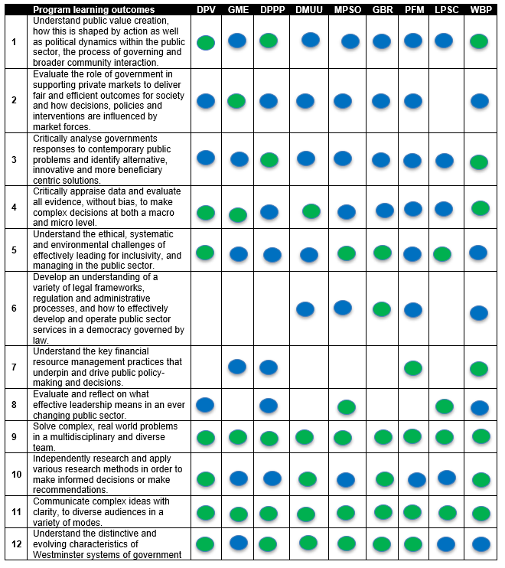
Primary Secondary

5.1.7 Program pedagogy
The ANZSOG EMPA is a leading program that addresses the current complexity of public administration and leadership.
What is particularly unique is this blend of both academic rigour and working directly on cases with public sector practitioners. This provides professionals with the knowledge and skills required by contemporary leaders who need to navigate complex and dynamic decisions for diverse communities taking care of issues at both a local, region and national level, whilst always maintaining the dynamic between these seemingly disparate parts.
In these challenging times ANZSOG provides a safe space in which students can explore some of the most pressing concerns that professionals face. It is in these spaces that there can be focused collaboration with fellow students and high level leaders in the public sector to problem solve and explore practicable solutions.
Teaching staff draw on current and historical public sector cases available in the ANZSOG Case Library. With the combination of practical work projects, blended delivery and a unique, intensive residential that has students iterating ideas that they have learnt in the incubation of the program give professionals a fully holistic experience with ANZSOG. Online and blended delivery allows flexibility, as professionals are able to balance the demands of studying the EMPA program into their daily working lives. As well as studying and having residential intensives locally, it is also possible to undertake learning in international locations including Singapore and Wellington, New Zealand.
ANZSOG applies innovation and design-thinking principles to the EMPA which place the learner at the centre of education design decisions. Through the blended model, students experience greater flexibility and autonomy as it affords even greater connectivity with peers and subject leads, as well as opportunities for collaboration that enhance digital communication and learning capabilities.

Blended learning in the EMPA consists of:
Synchronous learning – real-time interaction in a shared virtual or face to face space. This includes live online webinars and group activities.
Asynchronous learning – assessment instructions, readings, teaching videos and other materials are provided in ANZSOG’s LMS (Canvas) for students to complete in their own time.
Through this blended approach, ANZSOG continues to support reflective, collaborative practice and authentic work while remaining committed to providing a safe, respectful environment for all students, faculty and staff.

5.1.8 Group work
Throughout the core of the program there is an emphasis on group work for assessments and learning. ANZSOG understands the value of social learning and therefore embraces opportunities to create a community of practice.

5.1.9 Assessments at ANZSOG
Throughout the EMPA, these assessment types can be found.
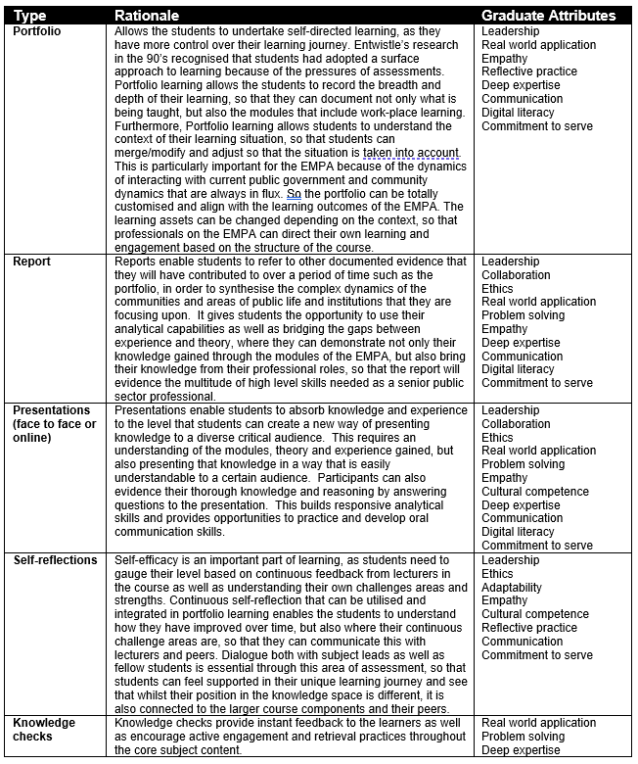

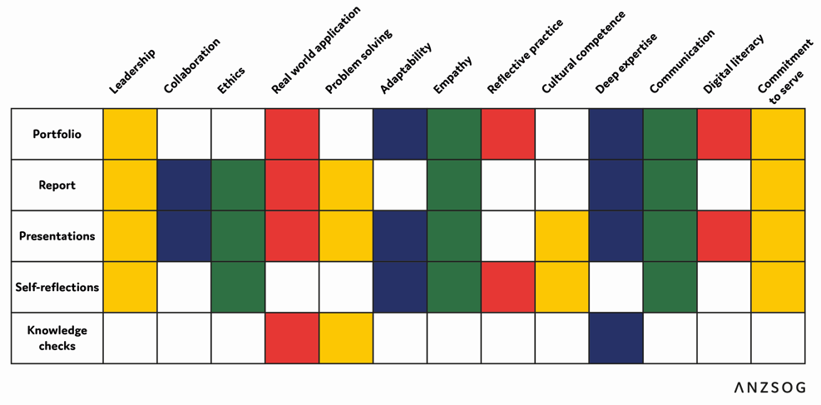

5.2 Review activities for current year

At the conclusion of all assessment and marking, each subject undergoes a Subject and Academic Review where student feedback is discussed in the context of subject learning outcomes, assessment activities, student grades, subject materials, issues of academic integrity and other relevant matters. This review and analysis is then used to identify subject improvement actions and any other relevant actions across the EMPA program delivery that may assist in progressing student learning and enhancing the student experience.
Subject leaders and the EMPA Academic Director are then encouraged to draw on this feedback and analysis at the annual EMPA subject leaders’ meeting, which generally takes place during the first quarter of each year. At the annual meeting all subject leaders convene for a full day to discuss and review their experience, critique the coherence of the program and report on innovations and aspects of quality teaching that will enhance the student experience. The subject leaders also review EMPA policies, procedures and administrative practices and program support resources. Refer to Chapter 6.8 Improvement Activities for examples of student feedback surveys and more detail about how they are used in Subject and Academic Review meetings.
Across the individual Subject reviews and the annual subject leader’s meeting in 2019, the following directions for revision and reform were identified:

- Consider the opportunity to incorporate regional perspectives in course content
- Seek to incorporate a higher component of First Peoples’ related content in subjects
- Explicitly refresh the subject content for three subjects: Government in a Market Economy (GME), Decision Making Under Uncertainty (DMUU) and Design Public Policies and Programs (DPPP)
- Seeki opportunities to embed blended learning into the degree to expand flexible study options for students
- Commission world leading research to underpin any future subject content revision.

Graduate attributes

The following table presents the EMPA Graduate Attributes.
Leadership | Lead strategically, with innovation and confidence across a range of public sector issues, communities and organisations
Collaboration | Embody collaboration, foster inclusivity and exercise humility when working with individuals, professions and communities
Ethics | Appreciate the importance of ethics and values in driving individuals and organisations to create public value and positively impact society
Real world application | Apply complex public policy theory and evidence to solve real-world problems, of diverse and disparate communities
Problem solving | Embody a solutions focused mindset, appreciating the role of data, diverse sources of evidence and the impact of changing social, economic and political contexts at a local, national and international level
Adaptability | Operate comfortably and strategically within an ever changing and somewhat ambiguous public sector and shifting demands
Empathy | Demonstrate empathy and compassion by understanding the power of perspectives in all interactions
Reflective practice | Look inward for answers to personal and professional challenges, with an understanding that reflection is one of the key ingredients for insight and growth
Cultural competence | Ethically, respectfully and effectively engage across and between cultures
Deep expertise | Deep knowledge and refined analytical capabilities to manage and lead in a complex public sector and changing political environment
Communication | Clear, concise and balanced verbal, written, visual and digital communication that is appropriate to the audience and context
Digital literacy | Apply, integrate and promote technologies as an enabler for success in the 21st Century
Commitment to serve | Embody a commitment to serve the public good and recognise the value and responsibility for stewardship that accompanies public service

- Units
_________________________________________________________

Introduction
This chapter outlines the EMPA core subjects delivered by ANZSOG and explains subject review and improvement processes.
TEQSA Guidance
The evidence provided in this chapter demonstrates alignment with core elements of the Higher Education Standards and guidance notes. In particular this chapter addresses elements of Domain 1 (1.4, Learning Outcomes and Assessment), Domain 3 (3.1 Course Design) and Domain 5 (5.3, Monitoring, Review and Improvement).
ANZSOG Policy
The EMPA Program Design and Delivery Policy describes the program and learning design of the Executive Master of Public Administration (EMPA) and identifies the role of policies and procedures in the administration and governance of the program. In relation to core subject unit management and quality it directs:
- Core and elective subject arrangements, hours of instruction and learning activities
- Responsibilities of core subject leaders
- Administrative responsibilities of the ANZSOG EMPA Delivery Team
- Student engagement and participation
- Academic standards and assessment (outlined in Assessment Policy)
HESF Alignment: ANZSOG’s policies and procedures support core subject unit design and delivery addressing HESF Standard 3 and these are demonstrated in the unit structure detail provided in the core subject guides.

6.1. List of all units offered

Delivering Public Value (DPV)
Government in a Market Economy (GME)
Designing Public Policies and Programs (DPPP)
Decision Making Under Uncertainty (DMUU)
Managing Public Sector Organisations (MPSO)
Governing by the Rules (GBR)
Leading Public Sector Change (LPSC)
Public Financial Management (PFM)
Work Based Project (WBP)

6.2 Improvement activities

6.2.1. Examiners Committee Meeting
Once all assessment pieces have been graded, the Examiners’ Committee is convened to discuss and confirm the final marks for the subject. Discussion items include distribution of grades, academic integrity issues and student progression and outliers. The committee members include the Subject Leader, EMPA Academic Director, Team Leader and EMPA Coordinator(s). Marks may be moderated if necessary, to ensure consistency of results across the cohort.
Once agreement has been met, results are finalised and issued to students and their conferring universities.

6.2.2. Academic Debrief Meeting
ANZSOG is involved in a number of improvement activities to consistently refine and ensure the quality of the EMPA and its core subjects. At the conclusion of each core subject, ANZSOG sends out a detailed subject evaluation, asking students to give detailed feedback on academic content, assessment and presenters. This feedback is collated into an evaluation report, which is circulated and presented as part of an academic debrief meeting, which occurs once all assessments for the subject have been marked and grading has been finalised.
The debrief involves the following personnel:
- EMPA Academic Director
- Subject Leader
- Team Leader
- Senior Program Coordinator
- Program Coordinator
During the debrief, the subject is reviewed, and student feedback is discussed to ensure that teaching aligns with learning outcomes and student expectations. Grades and assessment are reviewed for academic integrity purposes, as well as the list of learning materials provided and any other issues that may have arisen, such as student complaints, grievances, or issues surrounding plagiarism. Feedback on individual guest presenters is assessed and discussed, to ensure that presentations are well-received and informative to students, or to reassess if presentations are received negatively.
The outcome of the debrief is a set of improvement actions to be completed by various attendees in a timely manner, in order to maintain subject standards for the next cohort. Ongoing improvements may consist of revision of assessment tasks, realigning presentations with learning outcomes, and restructuring the subject timetable. This process is being strengthened in 2020, with the below debrief materials for Delivering Public Value available to view as part of this process:

6.2.3. Ethics, Monitoring and Research Review Process - ANZSOG Human Research Ethics Committee (HREC)
Project based research undertaken by ANZSOG students as part of their capstone subject, the Work Based Project, is assessed and reviewed through the ANZSOG Human Research Ethics Committee (HREC). The primary function of ANZSOG’s Human Research Ethics Committee (HREC) is to review and approve the research projects involving human subjects being conducted at ANZSOG. The HREC ensures that ethical standards are maintained in research projects in order to address and minimise any risks to research subjects, researchers, chief investigators and ANZSOG itself. These standards are primarily set out in the National Statement on Ethical Conduct in Research involving Humans 2007 (Updated 2018) (the National Statement). The HREC reviews ethics applications to ensure that they adhere to the National Statement, privacy requirements and other relevant standards and guidelines.
The HREC provides a central ethics review process for the cross-jurisdictional teams enrolled in the EMPA capstone subject Work Based Project (WBP). Each WBP team conducts primary research on a topic proposed by a sponsoring agency, under the supervision of an academic advisor who acts as chief investigator for the research project. Academic supervisors are drawn from ANZSOG partner universities or other recognised universities across Australia and New Zealand. Each WBP team submits an ethics application for their research project in mid-April of each year, for review by the HREC in early May. The HREC has the authority to approve these proposals or to request revisions and resubmission.
The HREC is appointed by, and reports to, the Dean of ANZSOG. The composition of the committee is based on the recommended composition set out in the National Statement (at least eight members comprising a chair; at least two lay persons, including at least one male and one female; at least two persons with current experience in the areas of research; a professional in counselling or treatment of people; at least one person who performs a pastoral role in the community; and a lawyer), plus an additional committee member.
The current membership of the HREC includes an independent chair who is an academic at one of ANZSOG’s partner universities; two senior public servants in New Zealand; four senior public servants in various jurisdictions within Australia; and two academics with expertise in areas of research relevant to the WBP. ANZSOG staff provide Secretariat support for the HREC.

- Students
_________________________________________________________

Introduction
The ANZSOG EMPA is delivered over two years, with one main student intake each year in Semester 1. This means that at any point in time there are two concurrent cohorts completing the EMPA – one completing first year subjects and one completing second year subjects.
ANZSOG collects a range of data about each student intake for the EMPA. This chapter provides a summary of significant student data for each intake year of the EMPA; where possible, information is provided for a five-year period to 2019.

TEQSA Guidance
This chapter provides a range of data related to the profile and progression of EMPA student cohorts. The evidence provided demonstrates alignment with core elements of the Higher Education Standards and guidance notes, including Domain 1, Student Participation and Attainment and Domain 2, Learning Environment.

ANZSOG Policy
The following ANZSOG EMPA policies address specific support related to student cohort needs:
- Diversity, Equity and Inclusion Policy
- Learning Resources and Education Support Policy
- Orientation and Progression Policy
- Student Disability Policy
- Wellbeing and Safety Policy

7.1. EMPA Cohort profile

A range of analytical and cohort-level information is provided on the student cohorts. In the majority of sections, data is provided on each intake year (cohort) of the EMPA from 2015 to 2019.
7.1.1. Age Profile
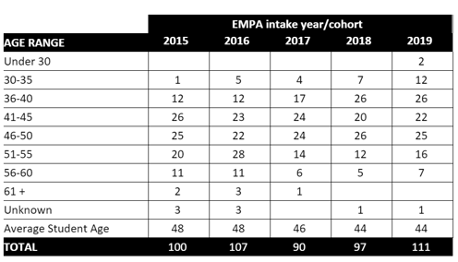

7.1.2. Gender Profile
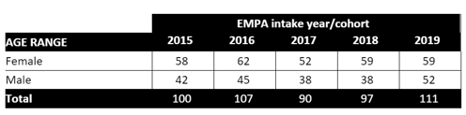

7.1.3. Years professional experience
Given that the ANZSOG EMPA is focused on the public sector, the relevant data captured for this section is Years in the Public Sector.
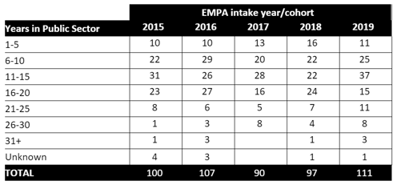

7.1.4. Primary degree
The following data provides a summary of the highest education qualification on entry to the EMPA for each cohort year 2016 – 2019.
Note that data for 2015 is not available.
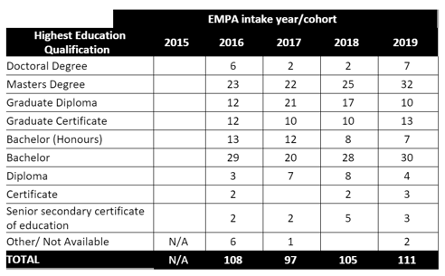
** Please note, highest education information is collected at time of application. The variation in students’ numbers is due to students withdrawing from the program after this time.

7.1.5. Identified cohorts – Aboriginal and Torres Strait Islander, low SES
ANZSOG captures Aboriginal and Torres Strait Islander (ATSI) status from applicants. SES status information is not captured by ANZSOG due to the way in which students are nominated by their employer before being considered for admission but may be captured through university enrolment processes.
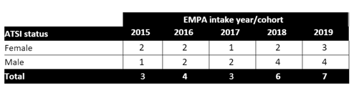

7.2. Student success profile

7.2.1. Progression
ANZSOG monitors completion of ANZSOG core subjects. Across the entire cohort, the following statistics apply:
80% of students complete all ANZSOG core subjects within 2 years.
90% of students complete all ANZSOG core subjects within 3 years.
97% of students complete all ANZSOG core subjects within 4 years.
3% of students require an extension to complete the ANZSOG core subjects in 4+ years.

7.2.2. Completion rates
The following data provides a summary of the completion of the EMPA, for intakes 2015 to 2019.
Data is current as of June 2020.
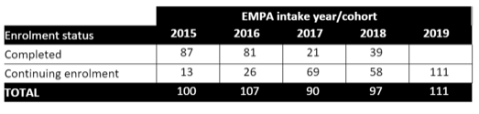

- Staff
_________________________________________________________

Introduction
ANZSOG recruits academics who are world leaders in their fields of expertise and who have extensive experience and demonstrable leadership in learning and teaching. Our faculty are drawn from our partner universities and leading international institutions involved in the teaching of public sector leadership, administration and public policy.
As ANZSOG does not engage teaching staff who do not have a PhD, this report only addresses 8.1 below and therefore is not required to respond to matters related to evidencing professional experience or supervision which is covered by the core subject leaders employing universities.
TEQSA Guidance
This chapter provides a range of data related to the EMPA staffing academic profile. This includes reference to some of the expert contributors from industry, government and the community sector. The evidence provided demonstrates alignment with core elements of the Higher Education Standards and guidance notes with particular reference to Domain 3 Teaching (3.2 Staffing).
ANZSOG Policy
The EMPA Academic Recruitment Policy outlines ANZSOG’s approach to academic recruitment and responsibilities for core subject leaders in the EMPA program. It directs recruitment decisions related to:
- Subject leader qualifications and experience relevant to their EMPA core subject theme
- Academic engagement ratio in relation to student numbers
- Occasional participation of leading practitioners invited to facilitate relevant topic components under the supervision of the EMPA Subject Leader
- ANZSOG vetting processes of academics not engaged on a full-time continuing contract by a university
- Expectations on availability of subject leaders for student academic advice and support

HESF Alignment: The table below in section 8.1 identifies the staffing complement for each EMPA course of study, the academic profile including teaching and research expertise of faculty engaged to deliver the EMPA core subjects, and evidence of experienced practitioners who contribute to the contemporary content and expertise of subjects. This evidences ANZSOG’s commitment to meeting all subsections of the HESF Standard 3.2 Staffing.

8.1. Teaching staff for each unit including degree and teaching experience.

The EMPA covers a broader range of topics informing best practice public sector leadership, management, policy analysis and financial management. The faculty we engage to deliver our core subjects are world-leading scholars who demonstrate significant records of achievement in research as well as learning and teaching. Many of the faculty engaged by ANZSOG have significant leadership experience in learning and teaching, often recognised by institutional and national awards. To the maximum extent possible, ANZSOG seeks to engage senior professorial staff in the design, development and delivery of the core EMPA subjects.

Professor Janine O’Flynn
The University of Melbourne
PhD (Melb)
BCom, Hons 1st Class (Melb)
Subject Lead: Delivering Public Value
Areas of expertise

- Performance management
- Public service delivery
- Public sector reform

Highlights

- Previous Director of Education, Melbourne School of Government​, University of Melbourne; and Director of Education, Crawford School of Public Policy, Australian national University
- Previous program director of the Master of Public Administration and the Master of Public Policy and Management at the University of Melbourne
- College of Asia and the Pacific Award for teaching Excellence (ANU); Vice Chancellors Award for Teaching Excellence (ANU); Citation for Outstanding Contribution to Student Learning (Australian Learning and Teaching Council); Nominee for Teaching Excellence Award (Office of Learning and Teaching)
- Fellow, Institute of Public Administration Australia​
- Approximately $1M in research income​
- Best Book Award, American Academy of Management (2013) ​
- Best article award Public Administration Review (2017) ​
- Best article award Review of Public Personnel Administration (2019) ​
- Multiple best paper awards/nominations at the Academy of Management (2013, 2013, 2014, 2020) ​
- Editor, Australian Journal of Public Administration​
- Editorial Board memberships - Public Administration Review; Public Administration; Public Management Review; Global Public Policy and Governance; International Journal of Public Administration; Policy Design and Practice; Halduskultuur.
- Former elected member of the International Research Society for Public Management Executive Board
- Former board member of the Australian Public Service Centre for Leadership and Learning
- Expert adviser to government in several countries
- Co-author of research report informing the Independent Review of the Australian Public Service

Overview

Janine is Professor of Public Management at ANZSOG and the University of Melbourne. Her expertise is in public management, with particular focus on reform and relationships. This covers topics as diverse as the creation and evolution of public service markets to the design of performance management systems. Her latest work explores the intersection of public service markets and morality.

Since 2015 she has been an editor of the Australian Journal of Public Administration and she sits on the editorial boards of several journals in the field including: Public Administration Review; Public Administration; International Journal of Public Administration; Public Management Review; Policy Design and Practice; Global Public Policy and Governance; and Halduskultuur: The Estonian Journal of Administrative Culture and Digital Governance. In 2018, she joined the Apolitical Future of Government Editorial Board. Previously she was a member of the editorial boards of Journal of Management & Organisation, Teaching Public Administration and Canadian Journal of Public Administration.
Janine is a Fellow of the Institute of Public Administration Australia (Victoria) and has previously been an elected member on the executive board of the International Research Society for Public Management. In 2018 she joined the Advisory Board of the Australian Public Service Centre for Leadership and Learning and in 2019 became a member of the Infrastructure Victoria Expert Panel on the Role of Infrastructure in Addressing Regional Disadvantage. As a keen observer of international practice in public management, she has had the opportunity to provide expert advice to a range of policy makers including in Australia, Chile, Bhutan, the United States, and Singapore. In 2020 she joined a network of practitioners and academics developing as part of the Agile Government Center, sponsored by the United States National Academy of Public Administration and the IBM Center for the Business of Government. In 2019, she co-authored a major research paper to inform the work of the Independent Review of the Australian Public Service: 2030 and Beyond: Getting the Work of Government Done.
She is a regular commentator in the media as well as producing columns for outlets such as The Conversation and The Mandarin.

Teaching Experience and Awards

Janine's teaching focuses on management issues in the public sector and the challenges faced by contemporary leaders in pursuit of public purpose. She has extensive experience working with experienced professionals from across the world in both executive education and postgraduate programs. She is an award-winning teacher and researcher having been the recipient of a national teaching prize (Australian Learning and Teaching Council) as well as University and College level awards for teaching excellence. She has several awards for academic innovation and contribution. This includes being part of the team awarded the Louis Brownlow Award (2017) for best paper published in Public Administration Review the best article published in Review of Public Personnel Administration (2019). As part of the same team she received the Carlo Mansini Award (2013), the Charles H. Levine Award (2013) and was nominated for the Carolyn Dexter Award (2014) from the Academy of Management. She also received the 2013 Academy of Management best book (public and non-profit) award with John Alford.

Professor O’Flynn’s postgraduate teaching experience and roles in teaching leadership includes:

- Former Director of Education, Crawford School of Public Policy, Australian National University and at the Melbourne School of Government, University of Melbourne
- Former Director Master of Public Administration and the Master of Public Policy and Management, University of Melbourne
- Former member and chair of the Melbourne School of Government/School of Social and Political Science Graduate Studies Committee; former member Faculty of Arts Graduate Studies Committee, University of Melbourne
- Current Member of Academic Board, University of Melbourne
- Former member University Education Committee, College of Asia and the Pacific Education Committee, Crawford School of Public Policy Education Committee (chair), Australian National University
- I have undertaken reviews of university programs including the London School of Economics and Political Science Executive Master of Public Policy (2020) and chair of the review of Flinders University Public Administration programs (2015)
- Postgraduate teaching at the University of Melbourne (subject leader, design and delivery): Public Management; International Public Management; World of Public Administration.
- Postgraduate teaching at the Australian National University (subject leader, design and delivery): Case Studies in Public Sector Management; Government, Markets and Global Change; People and Performance in Public Organisations.
- Postgraduate teaching at the University of Canberra (subject leader, design and delivery): Public Administration; Public Administration at the Interface.
- She has supervised numerous minor theses at the postgraduate level; eight PhD’s to completion and is currently supervising three PhD students (as at June 2020).

Professor Ross Guest
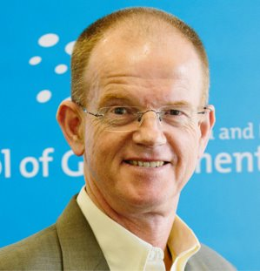
Griffith University
PhD (Melb)
M.Higher Ed (Griffith)
Grad dip Ed (UNE)
BA (Macq.)

Subject Lead: Government in a Market Economy

Areas of expertise

- Economics and finance
- Education

Highlights

- Former Dean, Learning and Teaching, Griffith Business School​
- Principal Fellow with the Higher Education Academy (Advance HE)
- National Senior Teaching Fellow with the former Australian Government Office for Learning and Teaching​
- Editor-In-Chief of the International Review of Economics Education (Elsevier)​
- Four ARC Discovery Grants as Principal Investigator

Overview

Ross Guest is Professor of Economics in the Griffith Business School at Griffith University, a Principal Fellow with the Higher Education Academy, and an adjunct professor at the Australia and New Zealand School of Government. Prof Guest holds a PhD in Economics from the University of Melbourne.

His primary field of research is population economics, on which he has published many articles in, for example, the Journal of Macroeconomics, the Economic Record, the Journal of Population Economics, and Oxford Economic Papers. He has received four Australian Research Council grants for his work on population economics, which has informed public policy through consultancies (e.g. New Zealand Treasury and Queensland Treasury) and citations in Productivity Commission reports. He received the Dean’s award for Best Mid-Career Researcher in the Griffith Business School in 2010.

Teaching Experience and Awards

Prof Guest has taught a range of economics subjects at Griffith University and formerly at Monash University. He was appointed a Principal Fellow with the Higher Education Academy in 2018, awarded a National Senior Teaching Fellowship in 2012 by the Australian Government and a Citation for Outstanding Contributions to Student Learning in 2006 by the former Carrick Institute for Learning and Teaching in Higher Education. He is Editor in Chief of the International Review of Economics Education.

Prof Guest’s postgraduate teaching experience and roles in teaching leadership includes:
- Dean (Learning and Teaching) in the Griffith Business School at Griffith University,
- Principal Fellow with the Higher Education Academy,
- Postgraduate teaching of Economics in the MBA at Griffith University and of Government in a Market Economy in the EMPA at ANZSOG.

Professor Suresh Cuganesan

University of Sydney
GAICD
FCPA
PhD
MCom (Hon)
BCom (Hon)
Subject Lead: Public Financial Management

Areas of expertise

- Strategy
- Organisational design
- Strategic financial management
- Performance measurement and reporting

Highlights

- Associate Dean (Student Success & Mobility), Business School, University of Sydney​
- CEO, John Grill Centre for Project Leadership, University of Sydney. ​
- Fellow, CPA Australia​
- Approximately $2.5M in grant income​
- Extensive consulting experience across business and government sectors

Overview

Suresh Cuganesan is Associate Dean (Student Success & Mobility) and Professor in the Discipline of Strategy, Innovation and Entrepreneurship at the University of Sydney Business School. Suresh specialises in the areas of strategy, organisational design and strategic financial management. He is also passionate about education that is fit-for-purpose and impactful given our changing society and workplace. Suresh’s current research areas investigate how technology and data innovations impact work and organisations; and, how organisations can achieve better outcomes through being more open, collaborative and transparent.

Prior to his academic career, Suresh worked in institutional banking and management consulting. He is also a Fellow of CPA Australia and a member of AICD. More recently, Suresh was CEO of the John Grill Centre for Project Leadership at the University of Sydney. He has advised and consulted for organisations in financial services, energy, law enforcement, transport, government and recruitment services. Suresh has published numerous academic research articles in leading international and national journals and has been successful in generating over $2.5 million in external funding (including Australian Research Council Grants) for his research.

Teaching Experience and Awards

- Over 25 years’ experience teaching at undergraduate and postgraduate levels. The latter includes Masters, MBA, and DBA levels.
- Has received Dean's Citations for Teaching for Post-Graduate Teaching at University of Sydney Business School and Macquarie Graduate School of Management

Professor Cuganesan’s experience in postgraduate teaching and roles in teaching leadership includes:

- Post-experience Masters: Units delivered include Strategies for Growth at University of Sydney, Accounting for Management, Financial Management, and Business Performance Measurement and Management at MGSM, Macquarie University. In addition, I have taught in international settings (Singapore and Hong Kong).
- Pre-experience master’s units: Units delivered comprise Accounting and Financial Management and Advanced Management Applications at University of Sydney and Managerial Accounting and Strategic Cost Management at Swinburne University.

Professor Paul t’Hart
PhD Leiden University Netherlands
MA Erasmus University Rotterdam Netherlands

Subject Lead: Leading Public Sector Change

Areas of expertise

- Crisis management
- Evaluation
- Public leadership
- Reform/change management

Highlights

- Professor of Public Administration, School of Government, Utrecht University​
- Associate Dean of the Netherlands School of Public Administration, The Hague, Netherlands​
- Past Professor of Political Science, ANU​
- Member of the Royal Dutch Academy of Arts and Sciences​
- Numerous consultancies and advisory roles with governments of Australia, Sweden and The Netherlands​
- Extensive research and publications in the fields of public sector leadership, policy evaluation, public accountability and crisis management.

Overview

Paul 't Hart is a Professor of Public Administration at Utrecht University and Associate Dean of the Netherlands School of Public Administration in The Hague. He resumed both positions in mid-2011, after spending five years as Professor of Political Science at the Australian National University. Paul’s research, teaching and consulting covers political and public sector leadership, policy evaluation, public accountability and crisis management. His books include Framing the Global Meltdown: Crisis Rhetoric and the Politics of Recession (ANU Press 2009), The Real World of EU Accountability: Which Deficit? (Oxford University Press 2010), How Power Changes Hands: Transition and Succession in Government (Palgrave 2011), Understanding Prime-Ministerial Performance (Oxford University Press 2013), The Oxford Handbook of Political Leadership (Oxford University Press 2014), and Understanding Public Leadership (Palgrave 2014). Prof 't Hart was elected a member of the Royal Dutch Academy of Arts and Sciences in 2014.

Teaching Experience and Awards

Prof 't Hart has extensive training and consulting experience within government, primarily in Holland, Sweden and Australia, including secondments at the Dutch Intelligence Service and Public Prosecutors Office. He recently completed two consultancy reports on the institutional reputation and the corporate governance of the Dutch judiciary, advised the Swedish cabinet on crisis management, and is currently a member of a government-appointed committee evaluating the Dutch police law of 2012, which in the largest reorganisation in the history of Dutch government saw the creation of a single, national police force out of 25 regional forces.

A selection of Professor Paul t’Hart​’s experience in postgraduate teaching and roles in teaching leadership includes:

- 1986 – present Ongoing lecturing, training and consulting practitioners/professionals/executives in crisis management, particularly in Sweden (up to Cabinet level), the Netherlands and Australia. Significant volume of work in this vein triggered by the Covid19 crisis.
- 1989-present Associate dean and core faculty of the executive MPA program of the Netherlands School of Public Administration (NSOB), which is very similar to ANZSOG’s, but at a smaller scale (average 15-20 students). During this time I have co-designed and redesigned its curriculum, navigated through accreditation processes, and developed and taught several courses, including on leadership, crisis management, public service craftwork.
- 2007-present Core faculty of ANZSOG’s EMPA program, teaching Leading Public Sector Change subject for 14 years consecutively. Approx 100 students
- 2009-present Co-architect and co-facilitator of ANZSOG’s Towards Strategic Leadership program for EL2’s/Band 1’s and their state/NZ equivalents. Aprox 40 students.
- 2012-present Associate dean of the ‘Learning Network’ program for top executives of NSOB. This involves designing and facilitating 3-year by invitation only programs for up to 15 secretaries, DG’s and equivalents across the Dutch public service.
- 2013-2017 Founding Dean of NSOB’s ‘Director’s Program’ for the equivalents of assistant secretaries in the Dutch public service. This is a 10-month program, in which I currently still teach the Leadership module. Approx 10-15 students.
- 2017-present Core faculty of NSOB’s ‘Interdepartmental Executive Course’, a 15-month program for people aspiring to SES roles, co-owned by the Dutch Board of Secretaries. Approx 25 students, twice yearly.

Professor Kimberley Isett

PhD University of Arizona USA
MPA University of Arizona USA
BA Ursinus College Collegeville Pennsylvania USA

Subject Lead: Decision Making Under Uncertainty

Areas of expertise

- Organization theory
- Evidence-based services/policy
- Systems Change
- Interorganizational Networks

Highlights

- Approximately $13 million in research grants​
- Director Master of Public Health, Health Policy and Management, University of Delaware, Newark, USA ​
- Past Director of Graduate Studies, School of Public Policy, Georgia Institute of Technology, Atlanta.​
- Extensive research, policy and advisory work with government agencies at state and federal level.​
- Chair, National Research Council on Poverty Alleviation (2015-2019)​
- Numerous Best Paper awards: Public Management Review, American Review of Public Administration, American Academy of Management​
- Extensive editorial board service in leading international journals of public administration

Overview

Kimberley Roussin Isett earned a Ph.D. (Management, Organization Theory) and M.P.A. (Health and Human Services, Policy) from the University of Arizona’s Eller College of Management. Her research focuses on institutional pressures and dynamics in implementing government services, with a particular interest in the delivery of services to vulnerable populations, and the use of evidence in public decision-making. Her goal is to do research that aids government organizations to find their optimal system design given their political, policy, regulatory, and financial constraints. To date, Dr. Isett has been the PI or co-PI on grants totalling over $13m. She was recognized by the Academy of Management in both 2001 and 2002 for excellence in research and participated in the John D. and Catherine T. MacArthur Foundation’s Mental Health Policy Research Network from 2002 until 2008. Isett has worked with elected officials and policymakers at all levels of government on a variety of issues. Prior to joining the Biden School, Dr. Isett was on faculty at Georgia Tech, Columbia University, and Texas A&M, and completed a NIMH sponsored post doc at UNC-Chapel Hill’s Sheps Center for Health Services Research.

Teaching Experience and Awards

Faculty Appointments

- University of Delaware, Newark, Delaware
Joseph R. Biden, Jr. School of Public Policy and Administration
- Georgia Institute of Technology, Atlanta, Georgia
School of Public Policy
- Columbia University, New York, New York
Department of Health Policy and Management
- Texas A&M University, College Station, Texas
George Bush School of Government and Public Service

Honors and Awards (Teaching)

- Teachnology Faculty Fellow, Columbia University MSPH 2010
- Georgia Tech Center for Teaching and Learning Student nominated accolade, 2016
- Outstanding Professor recognition, 2013

Professor Arie Freiberg
​

Monash University
LLD (Melb)
LLM (Mon)
Dip Crim (Melb)
LLB Hons (Melb)

Subject Lead: Governing by the Rules
Areas of expertise

- Regulation
- Sentencing
- Non-adversarial justice

Highlights

- Member of the Order of Australia for services to law​
- Fellow of the Academy of Social Sciences​
- Fellow of the Australia Academy of Law​
- Past Dean, Faculty Law, Monash University (2004-2012) ​
- Past Dean, Faculty of Arts, University of Melbourne ​
- Foundation Chair of Criminology at the University of Melbourne ​
- Past President of the Australian and New Zealand Society for Criminology. ​
- Consultant to Australian governments on sentencing matters, child sex abuse and drug courts​
- Over 170 publications covering the fields of sentencing, non-adversarial justice, criminology, regulatory practice and regulatory theory.

Overview

Professor Arie Freiberg AM holds an Adjunct Faculty appointment at ANZSOG and is a fellow of the Academy of Social Sciences in Australia and the Australian Academy of Law. He is one of Australia’s foremost experts on sentencing and the criminal justice system and has published widely from both a national and international perspective. He has been Chair of the Victorian Sentencing Advisory Council since 2004 and of the Tasmanian Sentencing Advisory Council since 2013.

His particular areas of expertise are sentencing, non-adversarial justice and regulation. He has been a Visiting Scholar at Harvard Law School (2014) and Tel Aviv University (2008) and has served as a consultant to the Federal, Victorian, South Australian and Western Australian governments on sentencing matters as well as the Australian and South African Law Reform Commissions. In 2015 he consulted to the Royal Commission on Child Sexual Abuse in Institutional Contexts on sentencing issues and in 2016 he was a consultant to the Queensland Department of Justice and Attorney-General on drug courts. He has also consulted for a number of state government agencies and departments on regulatory reform.

Professor Freiberg graduated from the University of Melbourne with an honours degree in Law and a Diploma in Criminology in 1972 and holds a Master of Laws degree from Monash University. He was awarded the degree of Doctor of Laws by the University of Melbourne in 2001 and is a fellow of the Academy of Social Sciences in Australia, the Australian Academy of Law and holds an Adjunct Faculty appointment in the Australia and New Zealand School of Government. Between 1996 and 1998, he was President of the Australian and New Zealand Society of Criminology. In 2009, he was made a Member of the Order of Australia (AM) for his service to law, particularly in the fields of criminology and reform related to sentencing, to legal education and academic leadership.

Arie Freiberg is an Emeritus Professor at Monash University. He was Dean of the Faculty of Law at Monash University between 2004 and 2012. Before this, he was Dean of the Faculty of Arts at the University of Melbourne in 2003. He was appointed to the Foundation Chair of Criminology at the University of Melbourne in January 1991 where he served as Head of the Department of Criminology between January 1992 and June 2002. In 2013 he was appointed an Emeritus Professor of Monash University.

Teaching Experience and Awards

Professor Freiberg’s experience in postgraduate teaching includes teaching into Masters degrees at both Monash and Melbourne universities since the 1990s in subjects relating to sentencing and regulation as well as teaching at the JD level at Harvard University in non-adversarial justice (2014). He has taught the ANZSOG EMPA subject Governing by the Rules since 2008. As dean, he led a curriculum review in the Faculty of Law, Monash University in 2010-11

Dr Christopher Walker

PhD, Social Sciences (UNSW), 2012
Graduate Certificate in University Learning and
Teaching (UNSW), 2007
Master of Public Policy (USYD), 1991
Bachelor of Heath Administration (Hons) (UNSW), 1984

Subject Lead: Delivering Public Policies and Programs

Areas of Expertise
- Policy theory and policy analysis
- Regulation theory, compliance and enforcement
- Public administration, management and leadership
- Public value

Highlights
- Approximately $270,000 in research grants, knowledge translation and commissioned works
- Outstanding record of academic leadership including the positions of;
  - Associate Dean University Relations and Academic Director, Executive Masters of Public Administration, Australia and New Zealand School of Government
  - Head of School, Social Sciences, University of New South Wales
  - Deputy Head of School, Learning and Teaching, Social Sciences, University of New South Wales
  - Program Director, Master of Public Policy, University of New South Wales
- Extensive research, policy and advisory work with government agencies, commissions and working groups at state, national and international level.
- Extensive domestic and international governance and advisory work including;
  - Governance Steering Committee Member, UNSW Centre for Law Markets and Regulation (2015 – 2019)
  - European Union AEROFLEX Project (Trucking innovation and regulatory reform working group) – Sounding Board Member, 2019 – current

  - Steering Committee Member- National Regulators Community of Practice (NSW), 2020 – current
  - Steering Committee Member- NSW Government, Customer Service, Better Regulation Division, Regulatory Practice Oversight Committee, 2020 - current
- Editorial board service with journals of public administration
- Visiting Research Fellow, University of Strasbourg Laboratory SAGE (Societies, Actors and Government in Europe). 2016/ 2017.
- Visiting Professor, Institut Barcelona Estudis Internacionals (IBEI), Barcelona, Spain. 2018.
- Erasmus Mundas MAPP Public Policy Visiting Scholar, Institute of Social Studies, Erasmus University, The Hague, The Netherlands. 2019.

Overview

Christopher Walker is the Associate Dean (University Relations) and Academic Director of the Executive Masters of Public Administration (EMPA) of the Australia and New Zealand School of Government (ANZSOG). Chris is a member of the ANZSOG executive leadership team and responsible for developing and maintaining relations with ANZSOG’s 15 partner universities across Australia and New Zealand. Chris also contributes to the development of strategic relations with other international centers of academic expertise in public sector management, leadership, regulation and public policy. As Academic Director, Chris leads the management and delivery of ANZSOG’s core program, the EMPA. This involves oversight of ongoing program development, review and input into quality learning and teaching. Chris is responsible for the oversight of student matters as well as liaison and negotiation with expert faculty engaged in subject delivery who are drawn from across Australia, New Zealand, Singapore, Europe and the US. Chris is also Subject Lead for the EMPA subject Delivery Public Policies and Programs.
Chris is a highly skilled teacher active in knowledge translation and contributes extensively to ANZSOG executive education programs, he also maintains an active program of research in public policy and regulation. Prior to joining ANZSOG Chris was the Head of the School of Social Sciences, University of New South Wales (UNSW), Australia (2012-2018). Chris’s work in academic leadership was preceded by a highly successful 20 year career in the New South Wales public service working in middle and senior executive positions in the departments of health, road transport, rail safety and the NSW Cabinet Office. Christopher has extensive research, teaching and leadership experience in the fields of strategic policy, public value, policy analysis, policy transfer, regulation and compliance.
Christopher’s PhD examined regulatory reform in the Australian trucking sector. Most recent research projects have examined policy transfer, the implications of digitization in social welfare service provision, and digital regulation and compliance in the transport sector. Christopher’s academic and practitioner experience means he is able to effectively bridge both the theoretical and applied understandings of public policy analysis and regulation in both his teaching and research. He is regularly engaged by public sector agencies in executive education and knowledge translation in the areas of public sector leadership, public value, strategic policy, policy analysis and regulatory reform. His work has been published in peer-reviewed journals such as Public Policy and Administration, Policy Studies, Australian Journal of Public Administration and Journal of Higher Education Policy and Management. His most recent book is a co-edited collection on policy circulation and transfer, Baker, T., & Walker, C. (Eds.). (2019), Public Policy Circulation: Arenas, Agents and Actions. Cheltenham, UK: Edward Elgar.

Teaching Experience and Awards
- Chris was awarded the Erasmus Mundas MAPP Public Policy Fellowship in 2019 in recognition of his outstanding teaching and research in public policy. He was a visiting scholar at the Institute of Social Studies, Erasmus University, The Hague, The Netherlands for the period May 2019 to June 2019.
- Postgraduate Council Supervision Award. In recognition of exemplary supervisory conduct of Higher degree research students. 2013
- Academic Director, Executive Masters of Public Administration, Australia and New Zealand School of Government.
- Program Director of the Masters of Public Policy, University of New South Wales
- Extensive teaching experience in postgraduate subjects including, Policy Analysis, Policy and Organisations, Policy Project, Delivering Public Policy and Programs, and supervision of over 100 major Masters level applied research projects. Extensive undergraduate teaching in public policy and social sciences covering Introduction to Social Sciences, Policy Case Studies and numerous Honours Thesis supervision.

Dr Jo Cribb

Victoria University, Wellington, New Zealand
Ph.D (Victoria University of Wellington)
MA Hons (Canterbury), DipMGMT (Cambridge)

Subject Lead: Managing Public Sector Organisations
Areas of expertise

- diversity
- gender
- governance
- social policy
- inclusive leadership
- community sector leadership
- public sector leadership

Highlights

- Former Chief Executive of the Ministry for Women, New Zealand​
- Former Deputy Children’s Commissioner​
- Director of Volunteer Service Abroad (VSA) advancing development in the Pacific​
- Finalist in the New Zealand Women of Influence Awards​
- Extensive experience in consulting and advising to government agencies on strategy, leadership, policy and gender projects.​
- Active in senior executive education and coaching.​
- Recent engagements include facilitating sessions at the Commonwealth Heads of Government Meeting in London, 2018, working with the leadership team of the New Zealand Defence Force to develop strategies to increase the gender diversity of the forces, and completing a gender analysis of immigration policy.​
- Board member of New Zealand Media Council, Royal New Zealand Navy Leadership Board and Institute of Public Administration of New Zealand (IPANZ)

Overview

Jo is a former Chief Executive of the Ministry for Women. One of the youngest Chief Executives ever appointed in the New Zealand Public Service, she has invested her time and energy in advancing the causes of the vulnerable in society, spearheading some of the most difficult issues of our time, including child abuse, child poverty, family violence, and vulnerable women.

Formerly the Deputy Children's Commissioner, and author of the Government's Green Paper on Vulnerable Children, she has a Doctorate in Public Policy and works internationally on advancing development in the Pacific as a director of Volunteer Service Abroad (VSA). She was a finalist in the New Zealand Women of Influence Awards.

She has a varied portfolio career which includes leading an NGO that works to improve literacy rates, directorships and consulting on policy, strategy and gender projects. Recent consulting assignments include facilitating sessions at the Women's Forum at the Commonwealth Heads of Government Meeting (CHOGM) in London in April.

Teaching Experience and Awards

Jo is an experienced facilitator of adult learning: including 3 years of facilitating governance development for the Institute of Directors in New Zealand.

Dr Cribb​’s experience in postgraduate teaching and roles in teaching leadership includes:

- Jo has taught in the MPSO for three years receiving excellent feedback, as well as delivering numerous guest lectures at the School of Government, Victoria University of Wellington.
- Jo has been a project advisor for the MPSO for two years

Professor Michael Macaulay

Victoria University, Wellington, New Zealand
Ph.D, Durham, UK
MSc, Management, Teeside University, UK
MA (Hons), University of Edinburgh, UK,
PGCert Higher Education, Teesside University, UK

Subject Lead: Managing Public Sector Organisations

Areas of expertise

- Integrity
- Public Ethics
- Public leadership
- Anti-Corruption

Highlights

- Professor of Public Administration, Victoria University, Wellington, NZ​
- 2010-2013 Professor of Public Management, Teesside University, UK
- Visiting Professorships held at University of Johannesburg (RSA), University of York St John (UK) and University of Sunderland (UK)
- Director of Institute for Governance and Policy Studies, NZ (2013-16)
- Has generated over $NZ 8.5 million in research income (as Principal or Associate Investigator)
- Regional Editor (Pacific Rim) for Public Management Review
- Co-chair, European Group of Public Administration a permanent study group on integrity and quality of governance. (2011-2019).
- Former judge (Teesside Bench, UK, 2005-2013).
- Advised and consulted international bodies including the United Nations Office on Drugs and Crime (UNODC) the Council of Europe and Transparency International.

Overview

Michael Macaulay is Professor of Public Administration at the School of Government at Victoria University of Wellington (Te Herenga Waka). He is currently a Visiting Professor at the Universities of Sunderland (UK) and York St John (UK), and is a former Visiting Professor at the University of Johannesburg (South Africa). He has published extensively in the fields of integrity, ethics and anti-corruption in leading international journals.

Whilst at VUW, Michael has held a number of senior roles including Associate Dean (Victoria Business School) and Director of the Institute for Governance and Policy Studies. During his tenure as Director of IGPS, Michael secured $NZ 7 million in research funding, generating nearly an extra $NZ 1 million in PBRF funding. He organised arranged over 200 roundtables and public events with speakers from all over the world, as well as overseeing publication of Policy Quarterly, NZ’s leading policy practitioner journal.

Professor Macaulay is currently Regional Editor (Pacific Rim) for Public Management Review and was previously co-editor (2013-16) of the International Journal of Public Administration. He has edited several special issues and currently sits on the editorial boards of several other journals. He was appointed co-chair of the European Group of Public Administration (EGPA) permanent study group on integrity and quality of governance in 2011, a position he gave up in 2019.
Michael was NZ lead for Whistling While They Work 2, an ARC-funded research project led by Griffith University into workplace misconduct and whistle-blower protections in Australia and New Zealand. Working in a consortium with numerous universities and public, private, and NFP agencies, the project is (to date) that largest piece of research of its kind undertaken.

Professor Macaulay’s experience in postgraduate teaching and roles in teaching leadership includes:

Senior Leadership

2020 Director, Doctoral Programmes, (School of Government, VUW)
2019- Chair of Masters of Public Management Nucleus Faculty (School of Government, VUW)
2016-19 Associate Dean Professional Programmes (Victoria Business School, VUW)

Programme leadership

2017-19 Programme Director MBA (VUW)
2010-12 Programme Director MSc Management (Teesside University)
2008-10 Programme Director MSc Organisational Leadership and Change
(Teesside University)

Course Leadership

ANZSOG: Delivering Public Value (EMPA)
(2016-current) Managing Public Sector Organisations (EMPA)

VUW: GOVT 514 Public Sector and Community Leadership (Master Public Management)
(2013-current) GOVT 565 The Future Facing Public Manager (Master Public Management)
MMBA 532 Business Research Project (MBA)
GBUS 512 Management Theory and Practice (Master Global Management)
GOVT 501 Governing and Governance (Master Public Management)
GOVT 534 Public Integrity (Master Public Management))
MMPM 528 Public Service Ethics (Master Public Management)

University of Teesside:
(2008-13) Current Issues in Management (MBA)
Organisational change (MBA)
Current Issues in Public Management (MBA Pub Mngt)
Public Management Strategy and Change (MBA Pub Mngt)
The Nature of Management Knowledge (DBA)
The Reflective Practitioner (DBA)
Ethical Leadership (DProf Clinical Psychology)

Dr Zina O’Leary

University of New South Wales
Ph.D, UNSW & UWS
MSc, University of Wisconsin, USA
BA, Rutgers University, NJ USA

Subject Lead: Work-Based Project

Areas of expertise

- Evaluation
- Communication
- Research Methodologies

Highlights

- Senior Research Fellow, ANZSOG​
- Held public policy and research methods academic positions at USYD, and University of Western Sydney.
- Extensive history as a consultant to both Government and the private sector and was the research coordinator for the Centre for Environmental Health Development at the World Health Organization Collaborating Centre​
- Author of numerous publications/ books including The Essential Guide to Doing Your Research Project 4e (in press 2020), Research Questions (2018), Research Proposals (2018) and Presentations that Motivate (2019). Workplace Research (2016), Researching Real World Problems (2005) and The Social Science Jargon Buster (2007).

Overview

Dr Zina O'Leary was awarded her PhD as a US National Science Foundation Fellow and is currently an adjunct senior lecturer at UNSW and an ANZSOG Senior Fellow. Dr O’Leary has over 25 years’ experience as an academic and public policy consultant and has taught research methods and communication courses in the US, Australia, Hong Kong, Fiji and Malaysia. She was also the coordinator of the Workplace Integrated Learning program at the University of Sydney Business

School, where she strived to help workplace-based students maximize the impact of their communication and conduct impactful applied research.
Zina also has an extensive history as a consultant to the World Health Organization, contributing to many projects on community engagement and community consultation across the Asia Pacific Region. She is the author of several books for Sage Publications including Workplace Research, Researching Real World Problems, The Essential Guide to Doing your Research Project and The Social Science Jargon Buster.

Teaching Experience and Awards

Prior to her engagement by the UNSW and ANZSOG, Dr O'Leary's teaching experience included courses on research methods, evaluation and professional development at the University of Sydney Business School (2013-2017), University of Sydney Graduate School of government (2011-2017), University of Western Sydney (1995-2010), Hong Kong Polytechnic University (1998-2008) and the International Medical University at Kuala Lumpur (2007-2010).

- 2019 Nominated for the Australian College of Education Quality Teaching Award
- 2017 Dean’s Citation for Excellence in Unit Coordination Sydney Business School
- 2016 Dean’s Citation for Excellence in Unit Coordination Sydney Business School
- 2015 Dean’s Citation for Excellence in Unit Coordination Sydney Business School
- 2014 Dean's Citation for Tutoring University of Sydney Business School
- 2008 Nominated for the Australian College of Education Quality Teaching Award
- 2002 Vice Chancellor’s Excellence Award commended for social justice
- 2002 Nominated for the Australian College of Education Quality Teaching Award
- 1999 UWS Teaching Excellence Award

Dr O’Leary’s experience in postgraduate teaching and roles in teaching leadership includes:

- Subject lead for ANZSOG’s capstone Work Based Project unit, which emphasize research communication as well as research design
- Developer/lecturer of several ANZSOG Executive Education Program
- Lead in the development of a whole of organization program on impactful communication City leader for EMPA core unit Decision Making Under Uncertainty (DMUU)
- Leader for curriculum review of Decision Making Under Uncertainty (DMUU)
- Led the development of a Sydney University multi-disciplinary and multi-school Industry and Community Placement Program
- Workplace Integrated Learning Academic Co-ordinator, responsible for overseeing academic integrity and consistency for 23 deliveries of Sydney University Business School's Industry and Community Placement Programs
- Unit Coordinator BUSS6500 Postgraduate Industry Placement Program (Sydney), and BUSS6510 Postgraduate Industry Placement Program (Chile)

8.1.1 Expert Practitioners
To support our expert faculty ANZSOG also involves leading expert practitioners from government, industry and the community sector from across Australia and New Zealand. The contribution of practitioner and community experts is managed in collaboration and under the guidance of the relevant EMPA Subject Leader.
Examples of some of the community and public sector leaders who contributed as guest speakers across the EMPA 2019/20 program include:
- Gillian Triggs - Former President of the Australian Human Rights Commission​
- Sally Capp - Lord Mayor of Melbourne ​
- The Hon Richard Wynne – MP, Victorian Minister for Planning, Minister for Housing, Minister for Multicultural Affairs
- John Thwaites - Former Deputy Premier of Victoria ​
- Brandi Hudson - CEO of the Independent Māori Statutory Board ​
- Christine Nixon - Former Chief Commissioner of Vitoria Police ​
- Di Grennell - Deputy Chief Executive – Te Puni Kōkiri, New Zealand
- Michelle Hippolite - Former Chief Executive – Te Puni Kōkiri, New Zealand
- Dame Karen Sewell – Former Secretary, Department of Education, New Zealand
- Gill Callister - Former Secretary of Department of Education, Victoria ​
- Glynn Davis – Former Vice-Chancellor, University of Melbourne
- Kym Peake - Secretary of Department of Health and Human Services (DHHS)
- Simon Phemister - Secretary of Department of Jobs, Precincts and Regions (DJPR)
- Ben Hubbard - Former Chief of Staff to Prime Minister Julia Gillard; former CEO Victorian Bushfire Reconstruction Authority
- Julian Hill - Member for Bruce, Parliament of Australia
- Grainne Moss - Chief Executive of Oranga Tamariki—Ministry for Children, New Zealand
- Bill Appleby - Chief Executive Officer at Jewish Care, Victoria
- Brendan Thomas - Chief Executive Officer, Legal Aid, NSW
- Peter Harris - Former Chairman Productivity Commission; former Secretary Commonwealth Department of Broadband and Communications

ANZSOG has in place administrative mechanisms that assist with the recruitment, retention and evaluation of teaching faculty and expert contributors. This includes the ANZSOG Academic Recruitment Policy.

- Governance
_________________________________________________________

Introduction
This chapter outlines the governance arrangements for the ANZSOG EMPA. ANZSOG has an ongoing commitment to continuous improvement and is currently exploring new arrangements, reporting systems and institutional committees that help extend the EMPA governance framework to strengthen representation from conferring partner universities. Both the current and future governance arrangements are described in this chapter.
TEQSA Guidance
Domain 6 (Governance and Accountability) is overarching in nature. It is concerned with ways in which a provider would ordinarily maintain oversight of its operations and be able to assure itself, in the normal course of its business, that quality and the maintenance of educational standards is assured. The evidence provided in this chapter outlines the systems and practices ANZSOG has in place that align with elements of Domain 6 of the Higher Education Standards and guidance notes.
ANZSOG Policy
The two EMPA policies that underpin program governance are the Delivery with Conferring University Partners Policy and the Program Design and Delivery Policy.
HESF Alignment: ANZSO’s policies and procedures address HESF Standards 6 and all subsections, and subsection 5.4 regarding institutional quality assurance. In particular, this governs the agreements, supporting schedules and annual reporting arrangements with conferring university partners, and university partner representation on the Academic Advisory Council advising on all EMPA program and subject unit quality review matters

9.1. Report of EMPA Academic Board:

Existing Governance Arrangements
The operational matters of the EMPA are managed by the EMPA Academic Director. The Director reports to the ANZSOG Dean and CEO. The operational matters are further supported by the EMPA subject leaders and ANZSOG professional staff.
ANZSOG currently has three management and/or advisory teams:
The Executive Management Team (EMT) is a decision-making forum for strategy and project implementation, marketing and communications, technology, programs and program delivery, human resources and finances and other organisational matters. This group meets once a month.

The Academic Management Team (AMT) is a forum to advise and make recommendations to the Dean/CEO and EMT on teaching and learning, research and related matters. The AMT is by chaired by the Deputy Dean (Teaching and Learning). This group meets once a month.
The Faculty Appointment Panel (FAP) provides advice to the Academic Management Team (AMT) on decisions regarding faculty appointments, faculty performance and changes to faculty across ANZSOG programs. This group meets once a quarter.

9.1.1. Unit and course review and improvements
Annually, there are two significant review points for each unit of study: An Examiners Committee meeting and an Academic Debrief meeting. In addition, there is an annual subject leaders’ meeting where the program plan is reviewed in relation to the next cohort.

9.1.2. Student grievance and complaint resolutions
ANZSOG has a comprehensive Student Complaints and Grievances Policy alongside all EMPA policies. For the period ending December 2019, ANZSOG has no formal student grievances or resolved complaints on record for the EMPA. Any issues raised by students are resolved promptly with the relevant people, and as such they have not required formal complaint processes, resolution and reporting.

9.1.3. Academic integrity issues and how they have been addressed
ANZSOG has a comprehensive Academic Integrity Policy alongside all EMPA policies. For the period ending December 2019, ANZSOG has no formal breaches of academic integrity for the core subjects of the EMPA. ANZSOG takes an educative approach to academic integrity, ensuring that students are made aware of academic standards and any unintentional breaches are addressed at the subject level with information and where appropriate, opportunities for revision and resubmission.

9.1.4. Student success
Evidence of student success profiles in relation to unit and degree completion are shown in Chapter 7.2. ANZSOG monitors several measures of student progression, including unit completion, grade range, pass/fail rate and degree completion rate.

9.2. Other EMPA internal governance functions

ANZSOG provides a range of mechanisms to oversee the delivery and quality of individual subjects and ensure consistency of practice. These are:
Examiners’ Committee Meeting is convened to discuss and confirm the final marks for the nine core EMPA subjects. Discussion items include, distribution of grades, academic integrity issues and student progression and outliers. The committee members include the Subject Leader, EMPA Academic Director, Team Leader and EMPA Coordinator(s). Marks may be moderated if necessary, to ensure consistency of results across the cohort.
Subject Review and Debrief Meeting occurs once all assessments for the subject have been marked and grading has been finalised. During the debrief, the subject is reviewed, and student feedback is discussed to ensure that teaching aligns with learning outcomes and student expectations. Grades and assessment are reviewed for academic integrity purposes, as well as the list of learning materials provided and any other issues that may have arisen, such as student complaints, grievances, or issues surrounding plagiarism. The debrief involves the following personnel: EMPA Academic Director, Subject Leader and ANZSOG EMPA delivery staff.
Subject Leader Meeting is an annual event that brings together the EMPA subjects leaders to discuss quality assurance matters, including discussions about improvements to teaching quality, consistency of practice, new policies/approaches, and showcase innovations to further improve the learning objectives of EMPA program.

9.3. New Governance Arrangements 2020 onwards

While ANZSOG currently has a robust governance and organisational management framework, discussions are underway with university partners to establish an EMPA Academic Advisory Council. This Council will be established to allow more direct engagement of university partners in the oversight of the academic quality of the EMPA subjects, review processes and the EMPA program. It will consist of rotating membership representing university partners. Terms of reference have been prepared in consultation with university partners on the role and functions of the Academic Advisory Council.
An important function of the new governance and quality assurance arrangements being developed by ANZSOG includes the production of an annual EMPA Quality Assurance Report. This report will be produced by ANZSOG and subsequently reviewed and signed off by the Academic Advisory Council. Quality assurance data will be provided to university partners though an online portal to allow timely and continuous access to data, and the collation of quality performance data will occur each year in the form of a report to university partners. This report represents the first draft of this process.

