ALUMNI PATHWAYS

The ANZSOG alumni is a community of public sector leaders from across Australia, New Zealand and the Indo-Pacific region. The alumni contributes to ANZSOG’s direction, plays a key role in educating current and future students and as individuals and a group, are a valuable asset to the broader public sector.

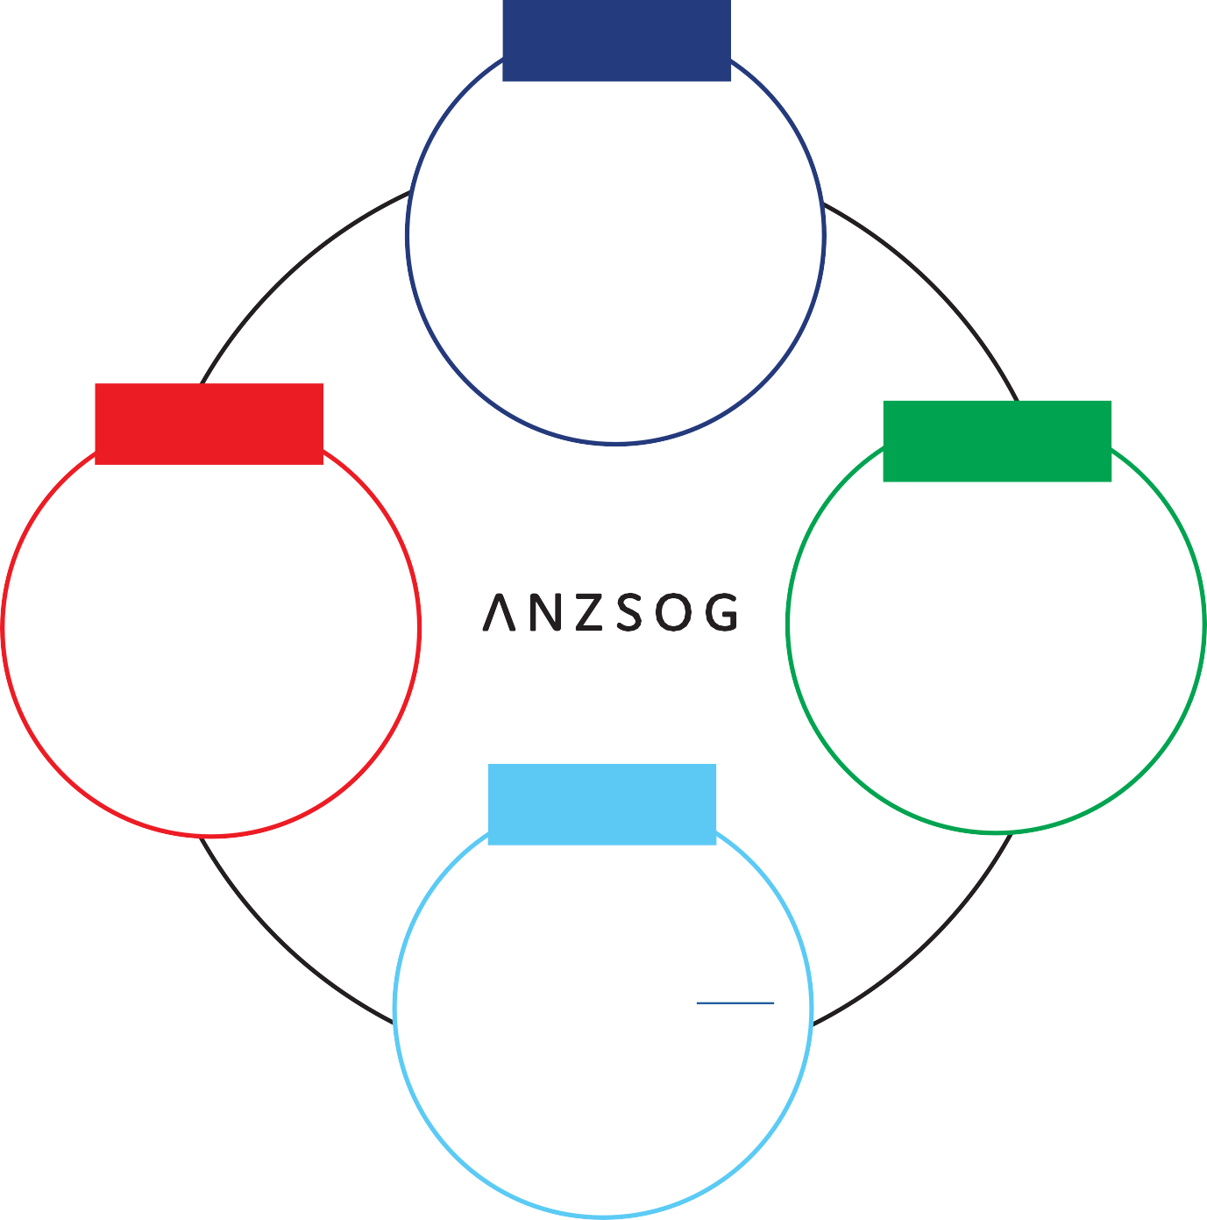
CONNECT

- Graduation pack
- Alumni e-newsletter
- LinkedIn Alumni Group
- Attend ANZSOG events in your jurisdiction

ENRICH

- Alumni Advisory Council
- Contribute to ANZSOG Research
- ANZSOG Alumni Tiger Team (Pilot)

INSPIRE

- ANZSOG course presenter
- Alumni Ambassador
- EMPA mentor

EDUCATE

  - Pilot ANZSOG programs
  - Further education: EMPA, TSL, EFP, International programs, Thought Leadership

ANZSOG alumni include graduates of:
- Executive Masters of Public Administration (EMPA)
- Executive Fellows Program (EFP)
- Towards Strategic Leadership (TSL)
- ANZSOG international programs

To find out more, visit the ANZSOG alumni website or contact Emma Rundle at: e.rundle@anzsog.edu.au

