How to add ANZSOG to your LinkedIn profle

You can now add ANZSOG and your course to the Education section on your LinkedIn profile.
To do this, please go to your LinkedIn profile, click ‘+’ in the Education section, and populate the fields. You can copy and paste details from the course relevant to you on page two. The example below is for Executive Master of Public Administration graduates. Once you’ve updated your profile, don’t forget to join the ANZSOG Alumni LinkedIn group (https://www.linkedin.com/ groups/152536/)

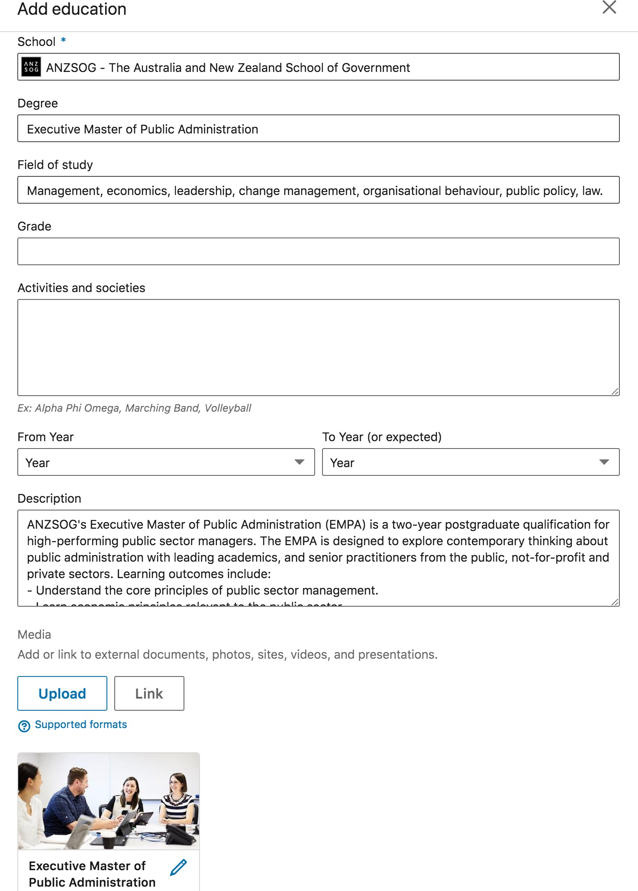

Education details (to copy and paste)

Degree: Executive Master of Public Administration

Fields of study: Management, economics, leadership, change management, organisational behaviour, public policy, law.

Description: ANZSOG’s Executive Master of Public Administration (EMPA) is a two-year postgraduate qualification for high-performing public sector managers. The EMPA is designed to explore contemporary thinking about public administration with leading academics, and senior practitioners from the public, not- for-profit and private sectors. Learning outcomes include:
- Understand the core principles of public sector management.
- Learn economic principles relevant to the public sector.
- Accurately use, interpret and draw inference from sources to support informed action.
- Examine the role of leadership in change.
- Ensure your organisational practices are fit-for-purpose and adaptive.
- Design policies and programs that yield ongoing public benefit.
- Understand relevant law, convention, practice and ethics.
- Find out how to use evidence-based analysis in policy design.

Link: https://www.anzsog.edu.au/masters Education details (to copy and paste) Degree: Executive Fellows Program
Fields of study: Leadership, public value, media and international relations, service delivery, organisation- al culture.

Description: ANZSOG’s Executive Fellows Program (EFP) is an intensive, three-week residential program for senior executives to develop their adaptive capacity to lead public sector organisations, providing a rare opportunity for focused learning and reflection. The EFP looks at the interactive dynamics faced by public sector leaders and explores how to better respond to competing requirements, including how to analyse concepts, frameworks and techniques to frame discussion, planning and strategic action.

Link: https://www.anzsog.edu.au/education-events/executive-fellows-program Education details (to copy and paste)
Degree: Towards Strategic Leadership

Fields of study: Strategic leadership, leadership development, innovation.

Description: ANZSOG’s Towards Strategic Leadership (TSL) program is a unique two-week program that helps emerging public service leaders develop the qualities needed to thrive in a senior executive role: a strategic outlook, political astuteness, personal resilience and the capacity to reflect and learn continuously. TSL encourages participants to identify personal and institutional strengths and weaknesses, understand their personal leadership styles, develop reflective and strategic thinking, and discover tools to discern and address the urgent and strategically important tasks, with an emphasis on integrating them into their every- day practices.

Link: https://www.anzsog.edu.au/education-events/towards-strategic-leadership

