Owned by and working for the governments
of Australia and New Zealand
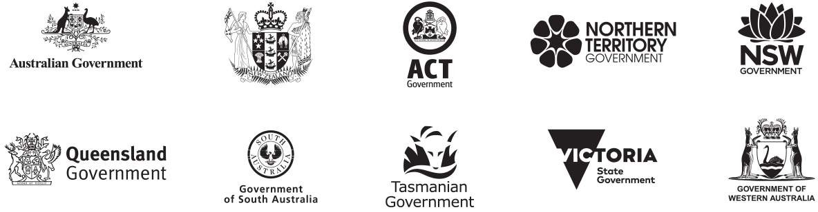

Member universities
- Australian National University
- Carnegie Mellon University, Australia
- Charles Darwin University
- Curtin University
- Flinders University
- Griffith University
- Melbourne Business School
- Monash University
- University of Melbourne
- University of New South Wales
- University of Queensland
- University of Sydney
- University of Canberra
- University of Tasmania
- Victoria University of Wellington

Affiliate partners
- Analysis & Policy Observatory (APO)
- China Executive Leadership Academy Pudong (CELAP)
- Department of Personnel and Training, Government of India
- Organisation for Economic Co-operation and Development (OECD)
- Party School of the Central Committee of C.P.C (National Academy of Governance)
- Singapore Civil Service College
- Lee Kuan Yew School of Public Policy
- Razak School of Government
We acknowledge Aboriginal and Torres Strait Islander peoples as the First Peoples of Australia and Maori, as tangata whenua and Treaty of Waitangi partners in Aotearoa-New Zealand.
Shaping your future
Contents
ANZSOG Strategy 2025 4
Our vision 4
Our purpose 4
Our values 4
Our approach 4
Our objectives & strategic priorities 5
Welcome from the Dean 6
The Changing Context 6
Who we are 7
Our purpose 7
Our values 8
Excellence 8
Collaboration 8
Integrity 8
Respect 8
Our objectives 9
Inspire 10
Educate 10
Connect 10
Enrich 10
Strategic Priorities 2019–2025 11
Educate 11
Inspire 12
Enrich 13
Connect 14
Guiding principles 15
Global reach, regional focus 15
Stewardship 15
Demand-led 16
Diversity and inclusion 16
Recognise First peoples 16

ANZSOG Strategy 2025

Our vision
Our vision is to be a world-leading organisation for public sector education, research and knowledge exchange.

Our purpose
Our purpose is to improve the lives of people in Australia and New Zealand by lifting the quality of public sector leadership.

Our values
- Excellence
- Collaboration
- Integrity
- Respect

Our approach
Founded by government for government. We work with our 10 owner governments and 15 university partners. We connect jurisdictions across Australia, New Zealand and the Indo-Pacific.

Our objectives & strategic priorities
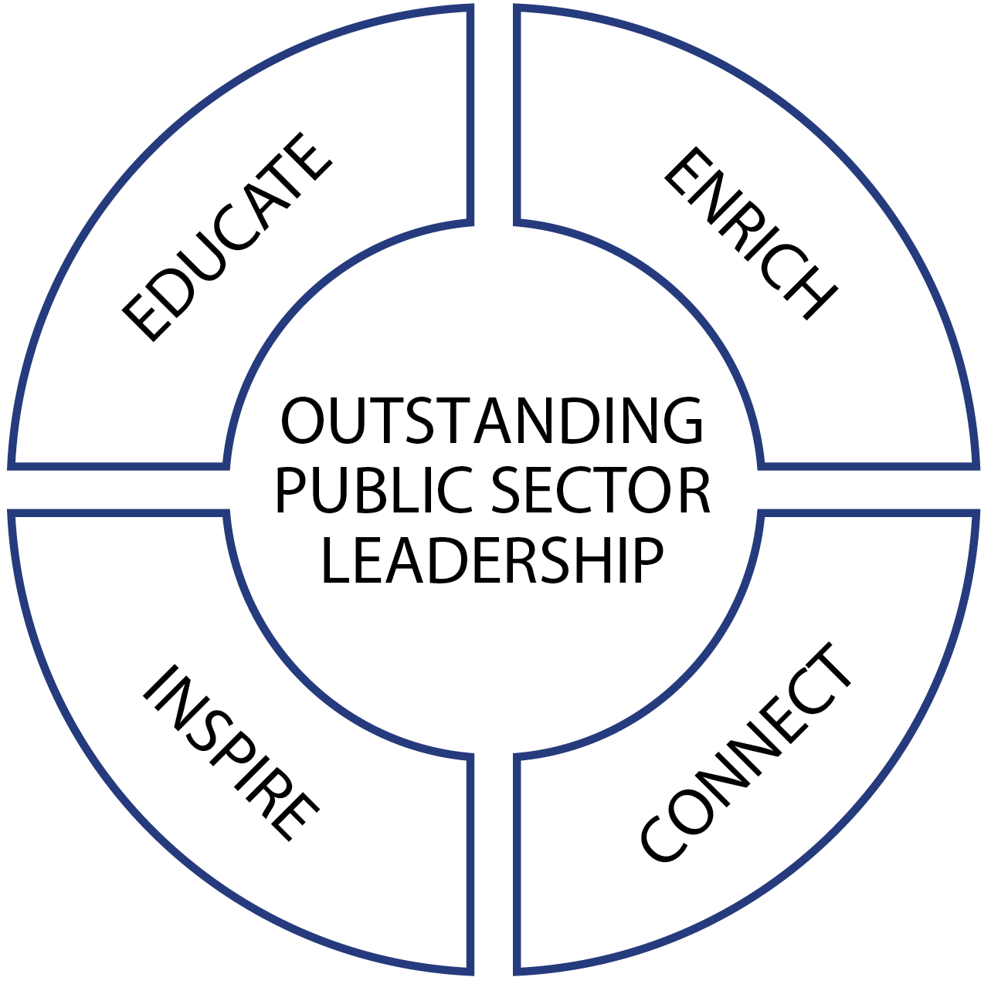
Our objectives and strategic priorities are:
Outstanding public sector leadership:
- Educate
- Inspire
- Enrich
- Connect
Read more about our strategic priorities from page 8.
All of our strategic priorities are underpinned by these five guiding principles
- Global reach, regional focus
- Inclusion and diversity
- Stewardship
- Demand-led
- Recognise First Peoples
Read more about our guiding principles from page 10.

Welcome from the Dean

Professor Ken Smith
Dean and Chief Executive Officer
‘This strategy outlines the direction that ANZSOG is taking to ensure that all our offerings continue to meet the needs of our owner governments and partner universities, and we can continue our purpose of helping to lift the quality of public sector leadership across Australia and New Zealand.’

The Changing Context
We all know the environment that public services operate in is becoming more complex and uncertain.
There is a global loss of trust in government and public and private institutions, more volatile politics, increasingly complex relationships with stakeholders, and a more diverse and empowered citizenry.
This makes it even more important that the public sector retains its core values of integrity and independence, and continues to build knowledge and expertise. By providing world-class education and research, creating public value and promoting the spirit of public service, ANZSOG is increasing the capability of public sector leaders to more effectively serve and support people and communities.
ANZSOG’s core offerings are more relevant now than ever, and we are working to update what we do to respond to rapid social, institutional and political change. This strategy outlines the direction that ANZSOG is taking to ensure that all our offerings continue to meet the needs of our owner governments and partner universities, and that we can continue our purpose of helping to lift the quality of public sector leadership across Australia and New Zealand.
Professor Ken Smith
Dean and Chief Executive Officer

Who we are
ANZSOG is a school of government created by government, for government. ANZSOG is owned by the Australian and New Zealand national governments and by all eight Australian state and territory governments. Our 15 partner universities contribute to our programs and give students access to world-leading academics. We provide education and research designed to meet the needs of public sector leaders and we have an extensive network of alumni serving in jurisdictions across Australia, New Zealand and the world.

Our purpose
To improve the lives of people in Australia and New Zealand by lifting the quality of public sector leadership.
Government touches all aspects of our lives. Improvements to the quality of the public sector, and the vital services it delivers, have broad social, economic and environmental benefits for the community.
ANZSOG was created almost 20 years ago to shape the future of public sector leadership, improve the quality of government in Australia and New Zealand, and deliver greater public value.
We do this through education and research focused explicitly on the knowledge and skills required by contemporary public sector leaders and by building links between jurisdictions across the Indo-Pacific, and between academics and senior practitioners.
While the external environment is constantly changing, our core mission remains the same: to provide education and research which helps the public sector better serve the community.

Our values

Excellence
We set and pursue the highest standards and strive to exceed expectations at all times.
We support our people with the resources, development opportunities and information to be successful in their roles.
We are prepared to lead the way in knowledge and practice in partnership with our owners and stakeholders.

Collaboration
We engage and empower our staff, clients and stakeholders.
We seek out, share and promote knowledge, ideas and innovation.
We seek to use our knowledge and capabilities to innovate and think creatively.
We draw on the diversity of people, skills and voices within and outside the organisation.
We evaluate what we do to continually learn and improve.

Integrity
We communicate clearly, honestly and sincerely.
We are accountable for our performance and behaviour.
We ensure the efficient and appropriate use of resources.
We are committed to delivering public value and promoting service for public purpose.
We apply our policies and practices consistently, fairly and transparently.
We build trusted relationships across and between the public sector and academia.

Respect
We treat each other with and expect to be treated professionally and with, courtesy and kindness.
We provide constructive and honest feedback.
We recognise and value the capabilities and contributions of those we work with and for.
We seek to understand and engage with diverse cultures, perspectives, experiences, ideas and knowledge.
We respect the confidentiality of personal and professional communication and data.

Our objectives
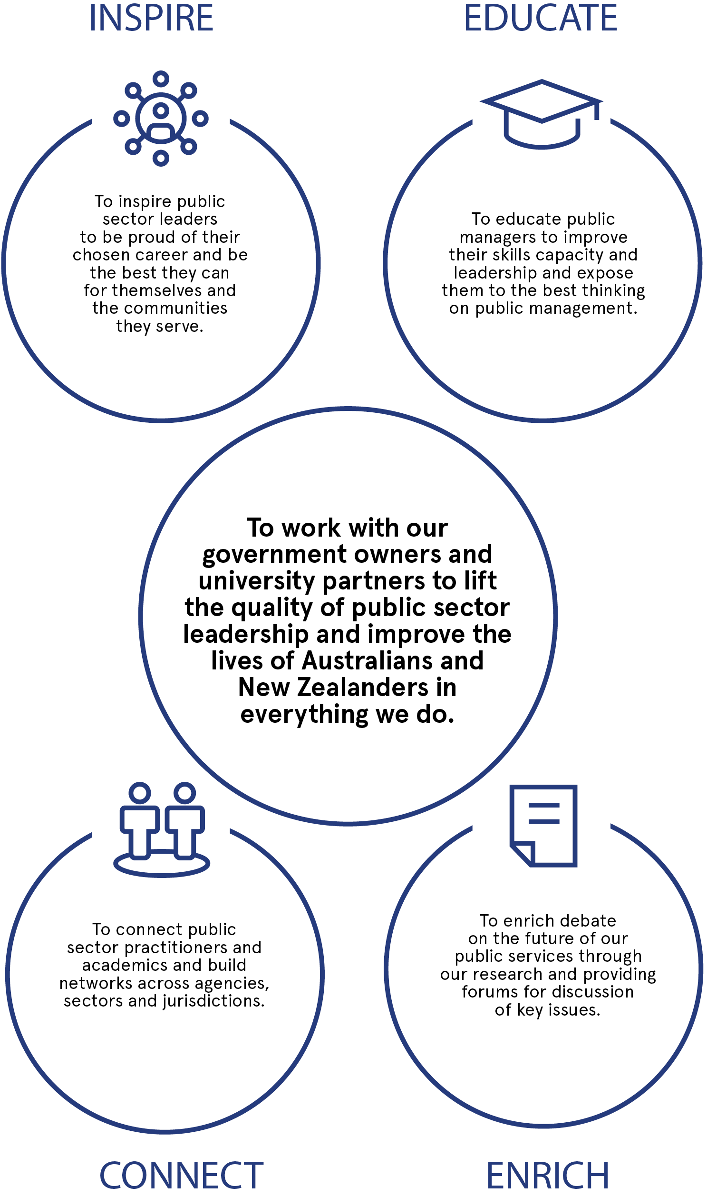
To work with our government owners and university partners to lift the quality of public sector leadership and improve the lives of Australians and New Zealanders in everything we do.

Inspire
To inspire public sector leaders to be proud of their chosen career and be the best they can for themselves and the communities they serve.

Educate
To educate public managers to improve their skills capacity and leadership and expose them to the best thinking on public management.

Connect
To connect public sector practitioners and academics and build networks across agencies, sectors and jurisdictions.

Enrich
To enrich debate on the future of our public services through our research and providing forums for discussion of key issues.

Strategic Priorities 2019–2025
We educate to deliver public value, enrich the discipline of public sector leadership through focused research, connect across jurisdictions and between scholarship and practice, and seek to inspire public sector leaders with new ideas and ground breaking innovations from around the world.

Educate
We develop public sector leaders who are confident, critical thinkers with the skills and capabilities required to manage the growing complexity of public sector challenges and deliver public value to the communities they serve. We create education programs for public managers at different stages of their careers, that meet the needs of public sector agencies.
Our first comprehensive Teaching and Learning Strategy will inform our approach to teaching and learning across all our education and related activities. It will guide development of innovative, contemporary and inclusive programs that meet the needs of governments and public sector leaders.
The strategy addresses the learning experiences desired by our owner governments, including blended learning opportunities. It sets out our approach to modularised and personalised learning pathways. Program participants will be introduced to academics and practitioners who are world-leading experts in their field. Our educational offerings will feature classic and recent academic contributions aimed at providing a contemporary offering tailored to the needs of modern public sector leaders.
The strategy establishes processes for selecting and recruiting academic and practitioner faculty and what we expect of them, with the goal of deepening and broadening our network of academics and practitioners. The faculty will reflect the diversity of our region and keep pace with contemporary thinking and issues.

Education programs
Our education programs are being reviewed to ensure they are fit-for-purpose, and remain at the forefront of the theory and practice on public management. This involves the renewal of our foundation principles, most notably the public value model will be extended to embrace different perspectives and major developments in theory and practice.
We will develop programs that respond to government needs, explore new opportunities in markets and program delivery, and which are continually reviewed and updated. Our programs will be broadened to include areas such as government and data, authentic leadership, 21st century public management and contemporary approaches to building ethics and institutional integrity.

EMPA reinvigoration
The Executive Masters of Public Administration (EMPA) is being progressively reinvigorated with a new suite of subjects to be delivered in 2022, aligned to ANZSOG’s mission and accepted as fit-for-purpose and forward looking by governments and participants. The completion of each individual subject will be of significant value to participants in their public sector role.

Inspire
We bring world-leading academics together with public sector leaders to share knowledge and create a dialogue which encourages learning, reflection and innovation. We work to spread new ideas across the public sector through seminars, workshops, conferences, digital media and communities-of-practice.
We will strengthen our partnerships to establish a research translation series, including regular summaries of the latest public sector thinking and research.
We will expand the ‘Thought Leadership’ program into additional jurisdictions.
We will establish a First Peoples’ public sector community-of-practice across Australia and New Zealand.
We will establish additional public sector communities-of-practice in consultation with public sector commissions in Australia and New Zealand and drawing on the experience of the National Regulators’ Community of Practice (NRCoP).

Enrich
We develop and distribute practical research that meets the needs of our owner governments. Our research programs bring together academics and practitioners with knowledge of public administration to do research which addresses contemporary issues in public sector management.

Research and problem solving
Our research strategy is shaped by government demand and addresses key contemporary issues in public management. The strategy will stimulate increased investment in our research program, and more research that is co-funded with governments and/or universities.
We will continue to draw on our network of scholars and practitioners to produce collaborative and comparative research. We will improve the dissemination of our research and its translation into formats that are accessible in meeting the needs of public servants.
We will tackle challenges of shared concern, by bringing together some or all our government owners to create a ‘safe space’ to share challenges, learn from each other and apply different problem-solving techniques. These workshops will deliver actionable outcomes which move issues forward and create cross- jurisdictional working communities.

Connect
We bring together public sector leaders from jurisdictions across Australia and New Zealand, to create links between academics and practitioners and build networks across the Indo-Pacific.

Alumni engagement
We will ensure the recently established Alumni Council fulfils its potential as a source of advice for ANZSOG and a vehicle to promote our activities. We will continue to work with our growing alumni to determine how we can help them increase their impact on their agencies and jurisdictions, and their ability to deliver public value.

Partnerships with governments
We will work to strengthen our understanding of the changing needs of governments across Australia and New Zealand. We will engage with our government owners to understand the current and future capability requirements of public sector employees and leadership across jurisdictions.
We will use insights from this engagement with government and alumni to identify opportunities for improvement including the possibility of creating new offerings. Part of this will involve a stakeholder relationship management system to support more effective engagement.
Our international programs are also being reviewed and potential new programs will be developed based on government need.

Partnerships with universities
We will review and revitalise our current university partnerships, and will investigate the possibility of expanding membership, as well as formally recognising international associate members.
We will continue to look at opportunities to work with universities to expand our geographic footprint across our member jurisdictions.
We will ensure we meet the quality requirements of accrediting institutions in Australia and New Zealand to strengthen our links with university partners and give us the opportunity to offer students more flexibility in how they engage with our courses through face to face and, online or blended learning opportunities.

Guiding principles

Global reach, regional focus
We will continue to access knowledge and learning from across the world and keep delivering programs that connect jurisdictions across the Indo-Pacific. We understand that the future of Australia and New Zealand will be shaped by events in the Indo-Pacific and recognise the importance of building links across the region.

Stewardship
We will maintain strong governance, ensure sustainable operations and strategic use of investment income on knowledge development, diffusion and innovation.
We will build internal capacity and capability to deliver programs and activities in a modern workplace with a mobile, flexible workforce. This includes strengthening our ICT systems to support new teaching and learning delivery tools, new ways to collaborate, streamlined administrative procedures, new stakeholder engagement and client management systems, and new technical controls for data protection.
We will invest in staff skills and capability, organisational culture, and review and implement changes to organisational arrangements, as required.

Demand-led
We will invest in deeply understanding our stakeholders and participants, their needs and expectations.
We will ensure an evidence-based, demand-led approach to all our operations, led by the needs of our owner governments and consistent with what we teach.

Diversity and inclusion
ANZSOG is on a mission to build and model the benefits of a diverse and inclusive workforce, and approach to teaching, learning and research. We are working to create an organisation where people can bring their unique viewpoints - informed by the identities they hold and the experiences they've had - and know that they're valued. We actively support the inclusion and contribution of First Peoples, women, LGBTQI people, people with a disability and people from culturally and linguistically diverse backgrounds. We will recognise, respect and support the strengths of all members of society.

Recognise First Peoples
ANZSOG is committed to working with communities across Australia and New Zealand to promote and prioritise the perspectives and contributions of First Peoples. We acknowledge the Aboriginal and Torres Strait Islander peoples as First Peoples of Australia, and Māori as tangata whenua and Treaty of Waitangi partners in Aotearoa-New Zealand. Our work includes action to: work closely with our member governments to support greater inclusion and representation of First Peoples at all levels of the public sector and broader public policy; strengthen cultural competency across our own organisation; include, respect and integrate Indigenous perspectives, cultures and knowledges in all of our work; and recruit and retain Indigenous staff and contractors in key positions across our education, research and thought leadership activities.
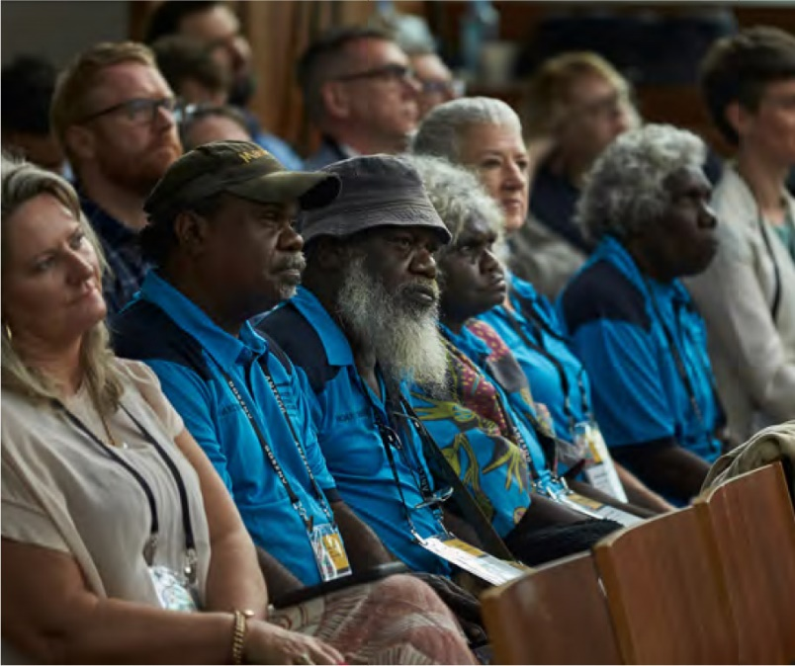
ANZSOG website <https://www.anzsog.edu.au>

Follow us
https://www.facebook.com/ANZSOG
https://twitter.com/ANZSOG
https://www.linkedin.com/school/anzsog

