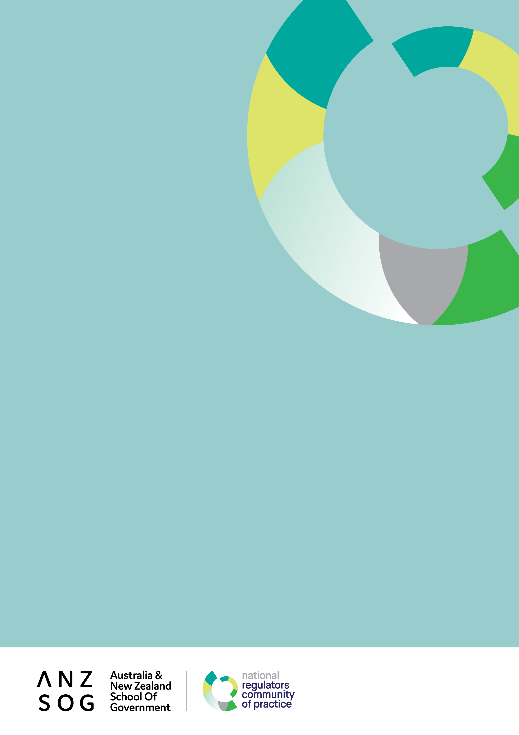
First annual report to corporate members
1 July 2020 – 30 June 2021

Contents
Message from the Dean 3
Message from the NRCoP Chair 4
Introduction 5
Timeline for the NRCoP 6
Connect 8
Inspire 12
Enrich 14
Educate 16
The year ahead: future plans and directions 17
Thank you to our corporate members 18
Thank you to our national and chapter committees 21
Follow us 24

ANZSOG works for our government owners and with our university partners to lift the quality of public sector leadership across Australia and Aotearoa-New Zealand. Our work inspires and connects people across agencies, sectors, jurisdictions and nations.

Message from the Dean
I have much pleasure in presenting this report to corporate members on the activities and achievements of the ANZSOG/National Regulators Community of Practice (NRCoP) and its impact on regulatory capability and professionalism.
While the NRCoP has grown to be the largest and most visible of ANZSOG’s contributions to better regulation in Australia and Aotearoa-New Zealand, with more than 6,000 subscribers, it is only one aspect of a long-standing commitment of which we are very proud.
Australasian regulators have long benefited from ANZSOG’s access to leading international and national regulatory scholars. These include world-renowned Harvard Kennedy School Professor Malcolm Sparrow, whose workshop alumni were inspired to create the original regulators community of practice, Emeritus Professor Arie Freiberg, who leads the highly regarded Governing by the Rules subject in our Executive Master of Public Administration (EMPA), and Dr. Chris Walker, the Academic Director of the EMPA. Many of Australia’s and Aotearoa-New Zealand’s regulatory leaders gained the knowledge and confidence to advance their careers by undertaking one of ANZSOG’s core offerings. Our leadership in building regulatory capability and professionalism has now been further recognised through our participation in the Australian Government’s Regulator Leadership Cohort and the policy performance framework and regulatory capability pilot led by the Department of the Prime Minister and Cabinet and the Australian Public Service Commission respectively.
As you will observe in the report, the NRCoP exemplifies ANZSOG’s unique remit to build bridges: between Australia and New Zealand, between academics, public sector leaders and practitioners, and all those in the public sector seeking to deliver public value regardless of jurisdiction, sector or role. Internally funded by ANZSOG in its initial years, ANZSOG and the NRCoP’s advisory committees have been delighted at its progress over this difficult period. The ANZSOG/NRCoP has gone from strength to strength, with invaluable financial and in-kind support from our corporate members, underpinned by the leadership of Simon Corden as national Chair, the enthusiasm of the national and four state chapter committees, and the continuing contribution of the dedicated ANZSOG team of Monica Pfeffer and Lorraine Cherney.
Professor Ken Smith, Dean and CEO, ANZSOG

Message from the NRCoP Chair
The NRCoP began calendar year 2020 expecting to deliver three or four large face-to-face seminars in each of Perth, Brisbane, Sydney and Melbourne, a major forum in Melbourne in October with an international keynote speaker, and, possibly, build towards new face-to-face chapters in South Australia and the ACT in the first half of 2021. Oh how wrong we were.
We never imagined we would find ourselves in June 2021 a stronger community of practice. By moving online we have doubled our subscribers and engaged an audience from every corner and regulatory sector of Australia and New Zealand. This includes regional and part-time staff attracted by the more flexible professional development opportunities we can now offer, including access to leading local and international regulators, without leaving their work stations.
The 25 webinars and three facilitated conversations we delivered on a rich array of regulatory topics have each drawn in hundreds of appreciative participants and, collectively, thousands of subsequent viewers on YouTube. We launched a Regulation Policy and Practice collection in partnership with APO with an accompanying newsletter which has rapidly made it the APO’s most popular collection. A recent development is a free Jobs Board on APO where our members can advertise regulatory policy and practice roles to an ever-growing audience of engaged members. Most excitingly, we have made real progress towards developing and delivering an online, relevant regulatory professional development program.
In introducing this report, I welcome the opportunity to acknowledge the three indispensable components of the NRCoP’s success in adapting so quickly to the new environment:
- The continuing support of ANZSOG’s Board, Dean and staff, particularly Monica Pfeffer, Lorraine Cherney and the Marketing and Communications team;
- The many senior regulators across Australia with demanding day jobs who volunteer their time and expertise for the NRCoP’s committees and who have been such able and enthusiastic advisers, advocates and ambassadors; and
- The 51 departments and regulatory agencies who heeded the plea to become corporate members in order to sustain and grow the NRCoP when the previous business model was rendered unviable by the pandemic.
As well as highlighting achievements to date, we have exciting plans for the future which are outlined on the following pages. We welcome your feedback on these as well as your continuing support and encouragement.
Simon Corden, Chair ANZSOG/NRCoP and Commissioner, Victorian Essential Services Commission

Introduction
This report outlines the NRCoP’s activities and achievements since COVID transformed the way we operate, and demonstrates our impact against the ANZSOG strategic priorities of Connect, Inspire, Enrich and Educate.
As a genuine community of regulatory practitioners from all levels of government, sectors, roles and levels of seniority in Australia and Aotearoa-New Zealand, we provide opportunities to learn from and with each other. We aim to build regulatory capability and professionalism and promote the public value of regulation. We seek to raise the profile of regulation as a valuable career path for ambitious and capable public servants.
Weathering the storm which was COVID-19, from April 2020 the NRCoP pivoted to online delivery and from 1 July 2020 to a widely distributed corporate membership model. We have built on our existing chapters in Western Australia, Queensland, New South Wales and Victoria, with a new chapter imminent in South Australia and a growing reciprocal relationship with G-Reg in New Zealand. Everyone associated with the NRCoP cares deeply about the regulatory craft and this broadly based ownership and commitment is evident in everything that has been achieved to date and is planned for the future.
“I am completely thrilled to be able to hang out with the regulators community of practice because as far as I can tell there is no such thing anywhere else on earth and so the energy that has gone into this and the commitment to the cross domain learning that you've been able to derive from this I think is a dream come true.
For more than 30 years I've been pressing the point in all of my teaching and writing that I think regulators share a huge number of frustrations, a huge number of aspirations, and that if only they would learn each other's vocabulary, they're dealing with very similar sets of concepts and there is merit and value in having them share across these lines. You have really done that with a vengeance.”
Professor Malcolm Sparrow, introduction to NRCoP webinar on Fundamentals of Regulatory Design, October 2020

Timeline for the NRCoP

2013
- An informal network of ‘Sparrow alumni’ approaches ANZSOG to act as auspice
- ANZSOG and Institute of Public Administration Australia (Victoria) co-auspice Victorian Community of Practice

2014
- Inaugural annual forum with Professor Malcolm Sparrow

2015
- Second annual forum with Professor Gary Banks

2016
- Third annual forum with Professor Cary Coglianese

2017
- Fourth annual forum with Professor Alberto Alemanno
- Intention to take the CoP national announced at forum

2018
- WA chapter launched
- QLD chapter launched (building on existing Queensland Regulators Network)
- NSW chapter launched
- Fifth annual forum with Dr Femke de Vries

2019
- 14 seminars held across Australia, NRCoP reaches 2500 members
- Sixth annual forum with Bill Eggers

2020
- Pandemic transforms NRCoP’s deliveries, business model
- Launch of Regulation Policy and Practice collection on APO
- 50 departments and regulatory agencies become corporate members
- NRCoP agrees on reciprocal arrangements with G-Reg in New Zealand
- NRCoP delivers 17 webinars and 3 facilitated conversations

2021
- NRCoP reaches milestone of 25 successful webinars delivered
- NRCoP launches partnership with SkillsNZ to design and deliver online professional development for Australian regulators
- APO Regulation Policy and Practice collection celebrates first birthday, launches free Jobs Board for corporate members
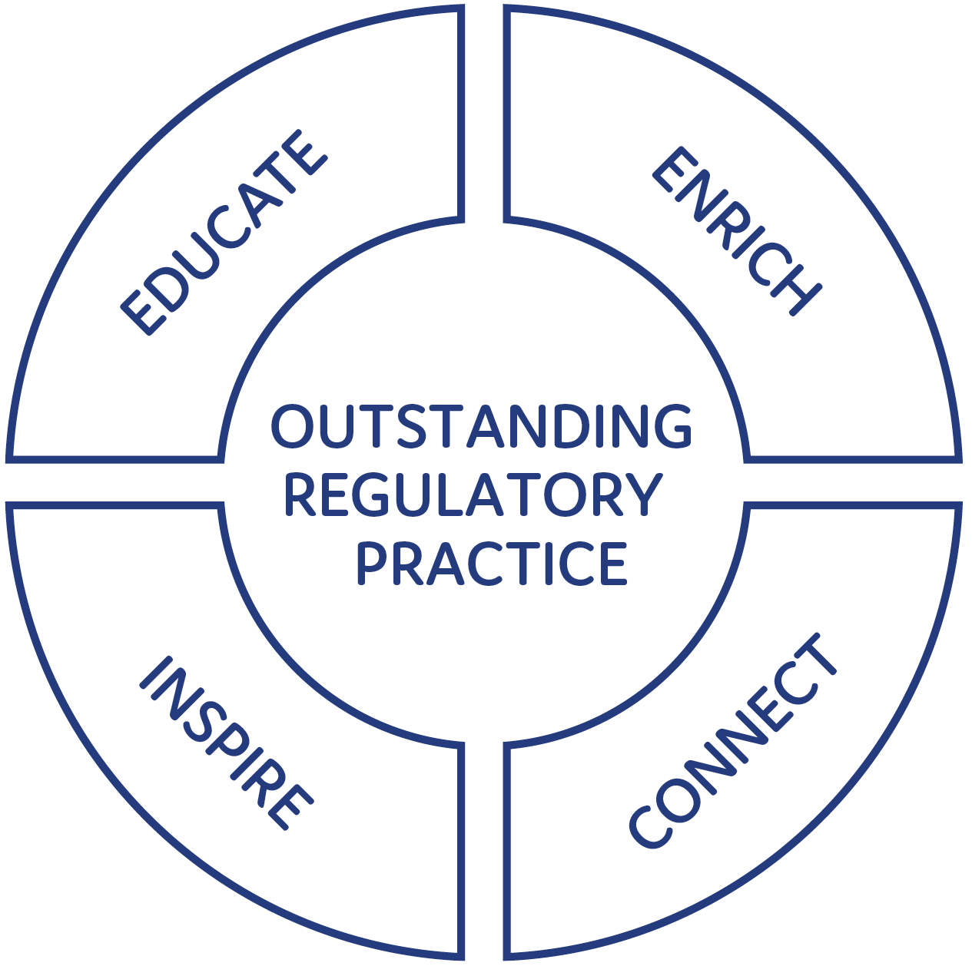
18,000: Approx 18,000 registrations for 25 webinars + 82 for three facilitated conversations, 10,000 YouTube views
82% of participants have shared insights from seminars/webinars with others in their workplace
6000: Nearly 6000 subscribers from all levels of government in Australia and Aotearoa-NZ
71,000 page views of APO Regulation Policy & Practice collection
71% of participants have been able to apply insights from seminars/webinars to their work as regulators
4.3/5: ‘I have found participating in the NRCoP valuable in developing my capability and professionalism as a regulator’: 4.3 out of possible 5.0

Connect
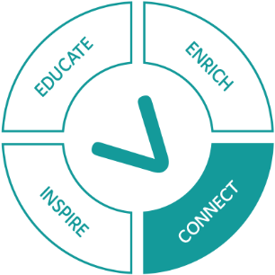
The foundation of the NRCoP is recognising how much all regulators have in common, and consequently the value of learning from their peers’ challenges, innovations, frameworks and experiences.
The NRCoP not only joins up regulators across jurisdictions, sectors and roles, we connect them with regulatory experts, including international and local scholars and past and present regulatory leaders.
As a consequence of COVID-19, we have needed to forego the ‘warm’ connections generated by face-to-face events and move online. Although this had its downsides, it has enabled us to bring into the community thousands more regulators who work outside capital cities, or part time, or in jurisdictions without NRCoP chapters. We could also connect directly and immediately with ANZSOG’s network of international regulatory scholars and the NRCoP has been the beneficiary of this opportunity.
As soon as the pandemic permits, we aim to combine the best of all worlds, with the resumption of face-to-face seminars and forums complemented by an ongoing program of webinars.
“As the Chief Executive Officer of Western Australia’s independent economic regulator, the National Regulators Community of Practice has provided me with a network of peers in regulatory agencies across the country with whom I can share ideas, news and support.
For regulatory agencies in Western Australia, NRCOP has enabled access to presentations and resources from leading practitioners across the country and plays an essential role fostering a culture of regulatory best practice in the State.”
Jenness Gardner, CEO WA Economic Regulation Authority

Table: Engagement in the NRCoP Program of Events
Month | NRCoP Program of Events | Registrations for event | YouTube views
April 2020 | Regulating the population  Cameron Stewart, Michael Eburn and Pauline Ireland | 339 | 464
 | Regulating at the border  Luke Wilson, Emma Watts and Simon Corden | 343 | 191
May 2020 | Learning to be better regulators, the G-Reg journey  Tony McKenna and Grant Pink | 565 | 374
 | Regulating the professions  Roxane Marcelle-Shaw, Jane Eldridge and Bronwyn Weir | 434 | 359
 | Why do people comply? COVID-19 compliance behaviours in international and local perspective  Benjamin van Rooij, Liam Smith and Jenness Gardner | 403 | 738
June 2020 | Measuring regulatory performance  Claire Noone and Gerard Brody | 948 | 581
 | RegX: Regulatory Excellence  Cary Coglianese, Kate Maddern and Simon Corden | 491 | 646
 | What would culturally responsive regulation of Aboriginal and Torres Strait Islanders organisations look like?  Brendan Thomas, Simone Jackson, Phillip Brooks and Janet Schorer | 792 | 424
July 2020 | Inside/Outside: the pros and cons of the independent versus the departmental regulator and does it matter?  Graeme Samuel, Peter Shergold and Fran Thorn | 702 | 693
 | Bias by design: when the design, implementation and enforcement of rules creates disadvantage  Donald Moynihan, Sarah McDowell and Janine O’Flynn | 494 | 402
August 2020 | Regulation, trust and social licence  Edward Langley, James Shipton and Marianne Munro | 574 | 462
Facilitated conversations: Windows of opportunity in a pandemic
Adam Beaumont, Grant Pink and Alice Turnbull
September 2020 | One space, many regulators  Rose Webb, Simon Cohen, Tracy Mackey and Simon Corden | 521 | 290
Facilitated conversations: Compliance in a crisis
Adam Beaumont, Grant Pink and Victoria Thomson
October 2020 | Defining and measuring our public value  Emily Sanders, Tony Keenan and Chris Walker | 927 | 527
 | Fundamentals of Regulatory Design  Malcolm Sparrow and Rose Webb | 1994 | 1103
Facilitated conversations: Regulatory laggards in a crisis
Adam Beaumont, Grant Pink and Chris Walker
November 2020 | Using Behavioural Science at the Bad End of Town  Femke de Vries, Will Day and Genene O’Neill | 929 | 417
December 2020 | Markets and Consumers in the Digital Age:  the ACCC and the Platforms  Kate Reader, Morag Bond and Rob Nicholls | 360 | 135
 | Regulating Unreason  Luke Cornelius, Sandro Demaio, Julie Inman Grant and Simon Corden | 542 | 272
January 2021 | Regulatory frameworks  Eric Kimmel, Alice Turnbull, Rob Scriven and Kate Maddern | 1084 | 480
February 2021 | Telling our story to the community: why good Comms matter  Michelle Bryne and Ian Caplin | 640 | 456
March 2021 | Learning to be virtual regulators: inspection and compliance in the age of COVID  Peter Dunphy, Samantha Taylor, Benjamin Noyen and Erica McLuckie | 776 | 257
 | ‘Regulatory Capability’: what does it mean and how do we acquire it?  Grant Pink, Victoria Thomson and Lorraine Cherney | 786 | 310
April 2021 | The struggle to regulate integrity: money and politics  Joo-Cheong Tham, Anne Twomey and Marlo Baragwanath | 548 | 114
May 2021 | Taking a new look at old tools: registering, licensing, permitting, accrediting, certifying, and so many more  Arie Freiberg, Jenness Gardner and Kerri Melkersson | 1071 | 186
 | Regulatory Stewardship: why and how the Kiwis manage regulation as an asset  Jeroen van der Heijden, Rebecca Foley and Lorraine Cherney | 645 | 60
June 2021 | Complain, complain, complain: how complaints can (and should) change regulatory practice  Nicole Lawless, Andrew Gavrielatos and Adam Beaumont | 1119
 | Total | 17,961 | 9,940

Connecting through the NRCoP: some examples
The NRCoP is delighted when regulators from different jurisdictions and sectors connect with each other and with us, as this is the true meaning of a ‘community’.
- Arising from our January 2021 webinar on Regulatory Frameworks <https://www.youtube.com/watch?v=INT5UqetA9Q>, presenter Alice Turnbull from NOPSEMA found herself featured in the Department of Prime Minister and Cabinet library of regulatory best practice <https://deregulation.pmc.gov.au/priorities/regulator-best-practice-and-performance/library> as well as being approached by other regulators seeking further information about NOPSEMA’s use of Malcolm Sparrow’s problem solving approach
- And from the same webinar, Rob Scriven from the New Zealand Civil Aviation Authority was invited to share details about their home-grown road map with regulatory colleagues from other organisations
- The March 2021 webinar on Regulatory Capability <https://www.youtube.com/watch?v=fkHoSJrPB50> resulted in a number of contacts for presenter Dr Grant Pink, from both national and state regulators, looking for more information about building capability. Grant was also able to alert a broader audience to the NRCoP’s environmental scan of regulatory professional development <https://www.anzsog.edu.au/preview-documents/publications-and-brochures/5623-nrcop-regulator-professional-development-march-2021-regulatory-professional-development/file>.
- ANZSOG staff have been informing and supporting a new Investigator Network (community of practice) in Queensland, sharing the knowledge and experience gained through the development and flourishing of the NRCoP
- ANZSOG staff have also ‘met’ on line with the Canadian Community of Federal Regulators and the fledgling UK Institute of Regulation to share insights about how communities of practice can inspire regulatory practitioners and sustain themselves

Inspire
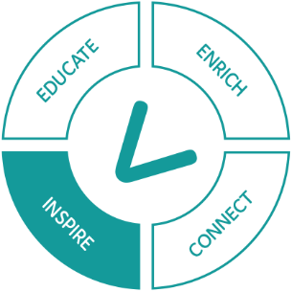
Regulation is a core and publicly valuable part of the work of government, but it is also complex, volatile and challenging. The NRCoP aims to inspire regulators that their work is intellectually, professionally and ethically worthwhile and the foundation for a rich and satisfying career. In its emotional dimension, the NRCoP works to give heart to regulators who find themselves constantly in the cross hairs of some or all of government, media, the community and duty holders.
“I passionately support the work of the NRCoP. As someone who has worked across many different regulators and regulatory areas – including agriculture, environment, forestry, transport and human services – many lessons and learnings can be shared with each other to improve skills and spark innovation, and also avoid reinventing the wheel. I particularly value that this community of practice covers the spectrum from technical and academic work to how it’s been applied in practice.”
Kate Maddern, Victorian Disability Worker Commission

Celebrating and recognising our female regulatory leaders:
For International Women’s Day 2021, ANZSOG turned to the NRCoP’s outstanding community of female regulatory leaders from every jurisdiction, sector and role to provide inspirational and wise advice <https://www.anzsog.edu.au/resource-library/news-media/women-in-regulation-three-leaders-talk-about-the-challenge> to the next generation. Sonya Stewart, CEO of the NSW Law Society, provides eloquent comment:
“As an Aboriginal woman I am part of the world’s oldest surviving culture and this has encouraged me to think long and hard about legacy; about the impact we can all make in the short time we are here.
The regulatory roles I have held – whether as the co-regulator of NSW’s 36000 solicitors as the CEO of The Law Society of NSW or as Executive Director of the then Department of Family and Community Services, where I led the regulation of 5,500 early education and care services across NSW - are ways for me to serve and deliver impact.
The advice that I give to women thinking about senior regulatory roles is that these are some of the most challenging and rewarding roles that you can have. In these roles, you have to keep the system “big picture” in mind while not neglecting the details; to be comfortable with complexity and constant problem solving all while focussing on delivering outcomes to individuals, organisations and communities.”
Sonya Stewart, CEO of the NSW Law Society

Enrich
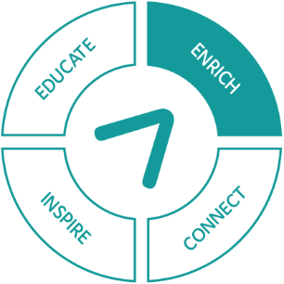
The NRCoP is committed to ensuring there is an enduring legacy from our learning opportunities for all regulators, whether or not they’ve been able to attend webinars and seminars. We do this in a number of ways.
The dedicated regulators webpage <https://www.anzsog.edu.au/regulators> on the ANZSOG site provides a rich array of resources from previous events, including slides, other relevant materials and links to recordings on ANZSOG’s YouTube channel. Regular communications alert our subscribers to the availability of these resources. The 2020 annual survey indicated that 82% shared insights and resources from NRCoP events with their colleagues and networks, by a range of means including letting others know, sending links to materials and following up on the presenter’s work.
The NRCoP Regulation Policy and Practice collection <https://apo.org.au/collection/302958/regulation-policy-practice> on APO, the Analysis and Policy Observatory, was launched in March 2020 and has quickly grown to be the most visited collection on APO. The collection includes 1,280 resources from 1,211 authors, hailing from 392 organisations. The site has received almost 71, 255 pageviews and 11,225 downloads since its inception.
Every NRCoP subscriber receives a monthly newsletter from the collection, highlighting the latest developments of relevance and interest to regulators. We commission a snappy guest editorial for each newsletter, spotlighting the work and challenges of our participants. Dr Liam Smith’s ‘Three steps for regulators to embrace behavioural science’ was the year’s most popular, with 2,200 unique web hits.
In April 2021 we provided extra value to our corporate members by introducing a free Jobs Board on APO, enabling regulatory policy and practice roles to be viewed by interested regulators across Australia and NZ. In its first fully operational week, the Jobs Board received almost 2,000 views and has become the third most-visited site on APO.
“The Regulators Community of Practice provides an invaluable network and resource for us as regulators of child safe practices. Regulation in complex areas such as out of home care and disability services, presents unique challenges. What we have found through the Community of Practice, is the opportunity to sit alongside other regulators, share the dilemmas, the wins and importantly, access a breadth of practical insight and support for practitioners. This is an excellent way to support the ongoing capability development for people working in regulatory bodies.”
Janet Schorer, NSW Children’s Guardian

Table: The NRCoP Regulation Policy and Practice collection
Month | Topic
May | Learning to be better regulators: the importance of training and development
June | COVID-19 and compliance: what makes people stick to the rules?
July | Good design leads to great digitisation for regulators
Aug | Three steps for regulators to embrace behavioural science
Sept | Regulation, trust and the professions
Oct | The role of artificial intelligence in regulatory decision-making
Nov | Regulatory stewardship: virtue, mechanism or both?
Dec | Performance reporting by regulators: are we measuring and reporting what matters?
Feb | What’s in a name? Does knowing you’re a regulator make a difference?
Mar | Regulatory Excellence
Apr | What can we learn from the regulation of sport?
May | Regulatory capability – some personal reflections on what makes a ‘good regulator’
June | 'Red tape’ and ‘beige tape’: what are they and why do they matter?
“I just wanted to thank you and the NRCoP team for the work you do in fostering and maintaining a vibrant community of practice for regulators in NSW. The range of topics and speakers has been fantastic and I know generated a great deal of discussion and insights which has translated into exemplary and credible regulatory services and approaches. Research often takes many years to translate into practice but the NRCoP has been a great way of accelerating this process by getting thought leaders and peers to share and embed learnings. I look forward to continuing this important network in 2021.”
Peter Dunphy, Head of Road, Maritime and Transport Safety, Transport for NSW

Educate
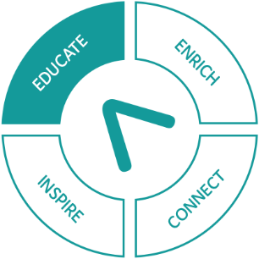
Inspired by the nested set of accredited qualifications for regulators in New Zealand developed and delivered by SKillsNZ, the NRCoP is well on its way to designing and piloting the first two of a 6-module program of regulatory professional development. We are cognisant of parallel investments in regulatory capability and professionalism by the Australian and Victorian Governments and many individual regulators, and are sharing our insights with them, confident that our work will complement those initiatives. Visit our environmental scan of existing Australian and international regulatory professional development programs <https://www.anzsog.edu.au/preview-documents/publications-and-brochures/5623-nrcop-regulator-professional-development-march-2021-regulatory-professional-development/file>.
Grounded in enthusiastic endorsement from a survey of NRCoP participants and consultation across the NRCoP national and chapter committees, the program’s development is based on the following agreed ‘problem statement’:
- The absence of shared and consistent professional development affects regulators’ capacity to develop regulatory careers, through which they can build a ‘regulatory mindset’, share knowledge and apply their skills and capabilities to different problems
- Many staff of regulators don’t fully understand the purpose and role of a regulator, and how it differs from other activities in the public or private sector, to the detriment of the culture and effectiveness of regulators
- There are knowledge, skills and capability gaps that are reducing the effectiveness of regulators
- The cost of individual regulators developing and delivering their own bespoke training and professional development wastes time and resources and reduces the overall supply
“ASIC’s engagement with the NRCoP complements our capability development strategy by providing hundreds of our team members access to free learning opportunities across a range of relevant topics and speakers. It also provides them with the opportunity to connect with other regulators across Australia, to share experiences and learn from each other. Participation in the NRCoP continues to be a key element of our capability development strategy at ASIC.”
Jackie Walsh, Manager – People and Development, ASIC

The year ahead: future plans and directions
The NRCoP has an active and ambitious workplan for the year ahead, including:
- Parallel program of online webinars and face-to-face deliveries
- Piloting and delivering a 6-module program of regulatory professional development in partnership with SkillsNZ
- Forums in Perth, Brisbane and Melbourne
- New chapters – South Australia and the ACT
- With an investment of corporate members’ funds from both 20-21 and 21-22, piloting, reviewing and delivering an online program of regulatory professional development relevant to regulators regardless of jurisdiction, sector and role
- Continuing a program of timely, thought provoking webinars on topics of interest and concern to regulatory practitioners
- As restrictions ease, resuming face-to-face seminars
- Again as restrictions ease, planning and delivering ‘satellite’ forums in Perth and Brisbane, in addition to a larger cross-jurisdictional annual forum in Melbourne
- Launching a South Australian chapter, followed by an ACT chapter
- Continuing to grow and develop the NRCoP/APO Regulation Policy and Practice collection
- Redeveloping the NRCoP website
- Supporting chapters to deliver small F2F work-in-progress and mentoring sessions for regulators in their jurisdiction

Thank you to our corporate members
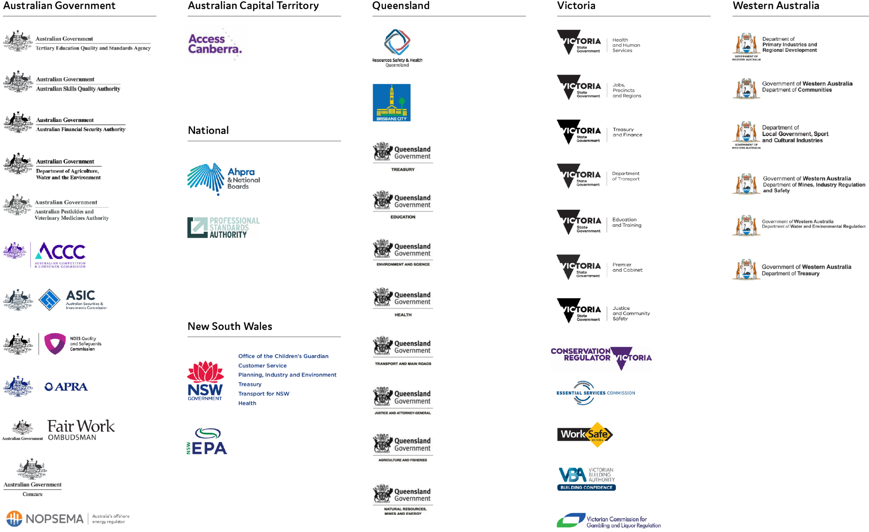

Australian Government
- Australian Competition and Consumer Commission
- Australian Financial Security Authority
- Australian Pesticides and Veterinary Medicines Authority
- Australian Prudential Regulation Authority
- Australian Securities and Insurance Commission
- Australian Skills Quality Authority
- Comcare
- Department of Agriculture, Water and the Environment
- Fair Work Ombudsman
- National Disability Insurance Scheme (NDIS) Quality and Safeguards Commission
- National Offshore Petroleum Safety and Environmental Management Authority
- Tertiary Education Quality and Standards Agency

National
- Australian Health Practitioner Regulation Agency
- Professional Standards Authority

ACT Government
- Access Canberra

New South Wales
- Department of Customer Service
- Department of Planning, Industry and Environment
- Ministry of Health
- NSW Environment Protection Authority
- NSW Treasury
- Office of the Children’s Guardian
- Transport for New South Wales

Queensland
- Brisbane City Council
- Department of Agriculture and Fisheries
- Department of Education
- Department of Environment and Science
- Department of Health
- Department of Justice and Attorney-General
- Department of Natural Resources, Mines and Energy
- Department of Transport and Main Roads
- Queensland Treasury
- Resources Safety and Health Queensland

Victoria
- Conservation Regulator Victoria
- Department of Education and Training
- Department of Health and Human Services
- Department of Jobs, Precincts and Regions
- Department of Justice and Community Safety
- Department of Premier and Cabinet
- Department of Transport
- Department of Treasury and Finance
- Essential Services Commission
- Victorian Building Authority
- Victorian Commission for Gambling and Liquor Regulation
- WorkSafe

Western Australia
- Department of Communities
- Department of Local Government, Sport and Cultural Industries
- Department of Mines, Industry Regulation and Safety
- Department of Primary Industries and Regional Development
- Department of Treasury
- Department of Water and Environmental Regulation

Thank you to our national and chapter committees
In 2021 the national committee was restructured to better reflect the more equitable distribution of NRCoP corporate members and engaged participants since COVID.

National committee
Simon Corden, Chair, VIC Essential Services Commission
Adam Beaumont, With_Purpose Consulting
Ashley Bunce, VIC Conservation Regulator
Martyn Campbell, incoming SA convenor, SafeWork SA
Ian Caplin, NZ Government Regulatory Practice Initiative
Lorraine Cherney, Secretariat, ANZSOG
Jarrod Cowley-Grimmond, QLD convenor, Department of Regional Development, Manufacturing and Water
Derise Cubin, Access Canberra
Matt D’Abbs, VIC Environment Protection Authority
Arie Freiberg, Academic Advisor, Monash University/ANZSOG
Philip Halton, QLD member, NDIS Quality and Safeguards Commission
Christopher Ingham, Victorian chapter convenor, Victorian Registration and Qualifications Authority
David MacLennan, interim WA convenor, City of Vincent
Kate Maddern, Victorian Disability Workers Commission
Roxane Marcelle-Shaw, NSW convenor, Professional Standards Authority
Chris Mather, WA member, WA Department of Transport
Cassandra Meagher, Service Victoria
Marianne Munro, VIC Department of Environment, Land, Water and Planning
Rowena Park, QLD member, Australian Securities and Investment Commission
Grant Pink, Pracademic Advisor, Recap Consultants
Monica Pfeffer, Secretariat, ANZSOG
Janet Schorer, NSW Children’s Guardian
Alice Turnbull, WA member, National Offshore Petroleum and Environmental Safety Authority
Jeroen van der Heijden, NZ Government Regulatory Practice Initiative, Victoria University of Wellington
Chris Walker, Deputy Dean ANZSOG
Adam Watson, VIC WorkSafe

New South Wales
Rose Webb, sponsor, NSW Department of Customer Service
Roxane Marcell-Shaw, convenor, Professional Standards Authority
Matthew Barrett, NSW State Insurance Regulatory Authority
Derise Cubin, Access Canberra
Peter Dunphy, Transport for NSW
Jane Eldridge, Australian Health Practitioner Regulation Agency
Maggie Hardy, Australian Pesticides and Veterinary Medicine Authority
Tony Kofkin, NSW Health Care Complaints Commission
Tracy Mackey, NSW Environment Protection Authority
Janet Schorer, NSW Children’s Guardian
Chris Walker, ANZSOG
Jackie Walsh, Australian Securities and Insurance Commission
Scott Wheeler, NSW Treasury

Queensland
David Mackie, sponsor, QLD Department of Justice and Attorney-General
Jarrod Cowley-Grimmond, convenor, Department of Regional Development, Manufacturing and Water
Omar Ameer, Queensland Building and Construction Commission
Brian Bauer, QLD Office of Fair Trading
Rose Bovey, QLD Health
Philip Halton, NDIS Quality and Safeguards Commission
Jennifer Kenny, QLD Department of Transport and Main Roads
Anne Lenz, Brisbane City Council
Erica McLuckie, QLD Department of Education and Training
Rowena Park, Australian Securities and Investment Commission
Rachel Scalongne, Department of Regional Development, Manufacturing and Water
Mark Stone, Resources Safety and Health QLD
Victoria Thomson, QLD Department of Justice and Attorney-General

Victoria
Simon Corden, sponsor, Essential Services Commission
Christopher Ingham, convenor, Victorian Registration and Qualifications Authority
Adam Beaumont, With_Purpose Consulting
Ashley Bunce, Conservation Regulator,
Matt d’Abbs, Environment Protection Authority
Kate Maddern, Victorian Disability Workers Commission
Cassandra Meagher, Service Victoria
Baethan Mullen, Australian Securities and Investment Commission
Marianne Munro, Department of Environment, Land, Water and Planning
Antonia Parkes, Fair Work Ombudsman
Emily Sanders, Commission for Children and Young People,
Adam Watson, WorkSafe
Penelope Winslade, City of Hobsons Bay
Douglas Young, Department of Health

Western Australia
Michelle Andrews, sponsor, WA Department of Water and Environmental Regulation
David MacLennan, interim convenor, City of Vincent
Lyn Anderson, WA Department of Communities
Lanie Chopping, WA Department of Local Government, Sport and Cultural Industries
Benjamin Ford, WA Treasury
Robert Kennedy, WA Electoral Commissioner
Germaine Larcombe, WA Department of Water and Environmental Regulation
Matthew, Lester, WA Health
Chris Mather, WA Department of Transport
Ian Munns, WA Department of Mines, Industrial Regulation and Safety
Phil Payne, Department of Communities
Nicola Perry, WA Department of Local Government, Sport and Cultural Industries
Neil Sarti, WA Department of Primary Industries and Regional Development
Alice Turnbull, National Offshore Petroleum Safety and Environmental Management Authority
Philip Wyles, WA Department of Training and Workforce Development

We acknowledge the Aboriginal and Torres Strait Islander peoples as First Peoples of Australia, and Māori as tangata whenua and Treaty of Waitangi partners in Aotearoa-New Zealand.

Follow us
ANZSOG website <https://www.anzsog.edu.au>
ANZSOG Facebook page <https://www.facebook.com/ANZSOG>
ANZSOG Twitter page <https://twitter.com/ANZSOG>
ANZSOG LinkedIn page <https://www.linkedin.com/school/anzsog>

