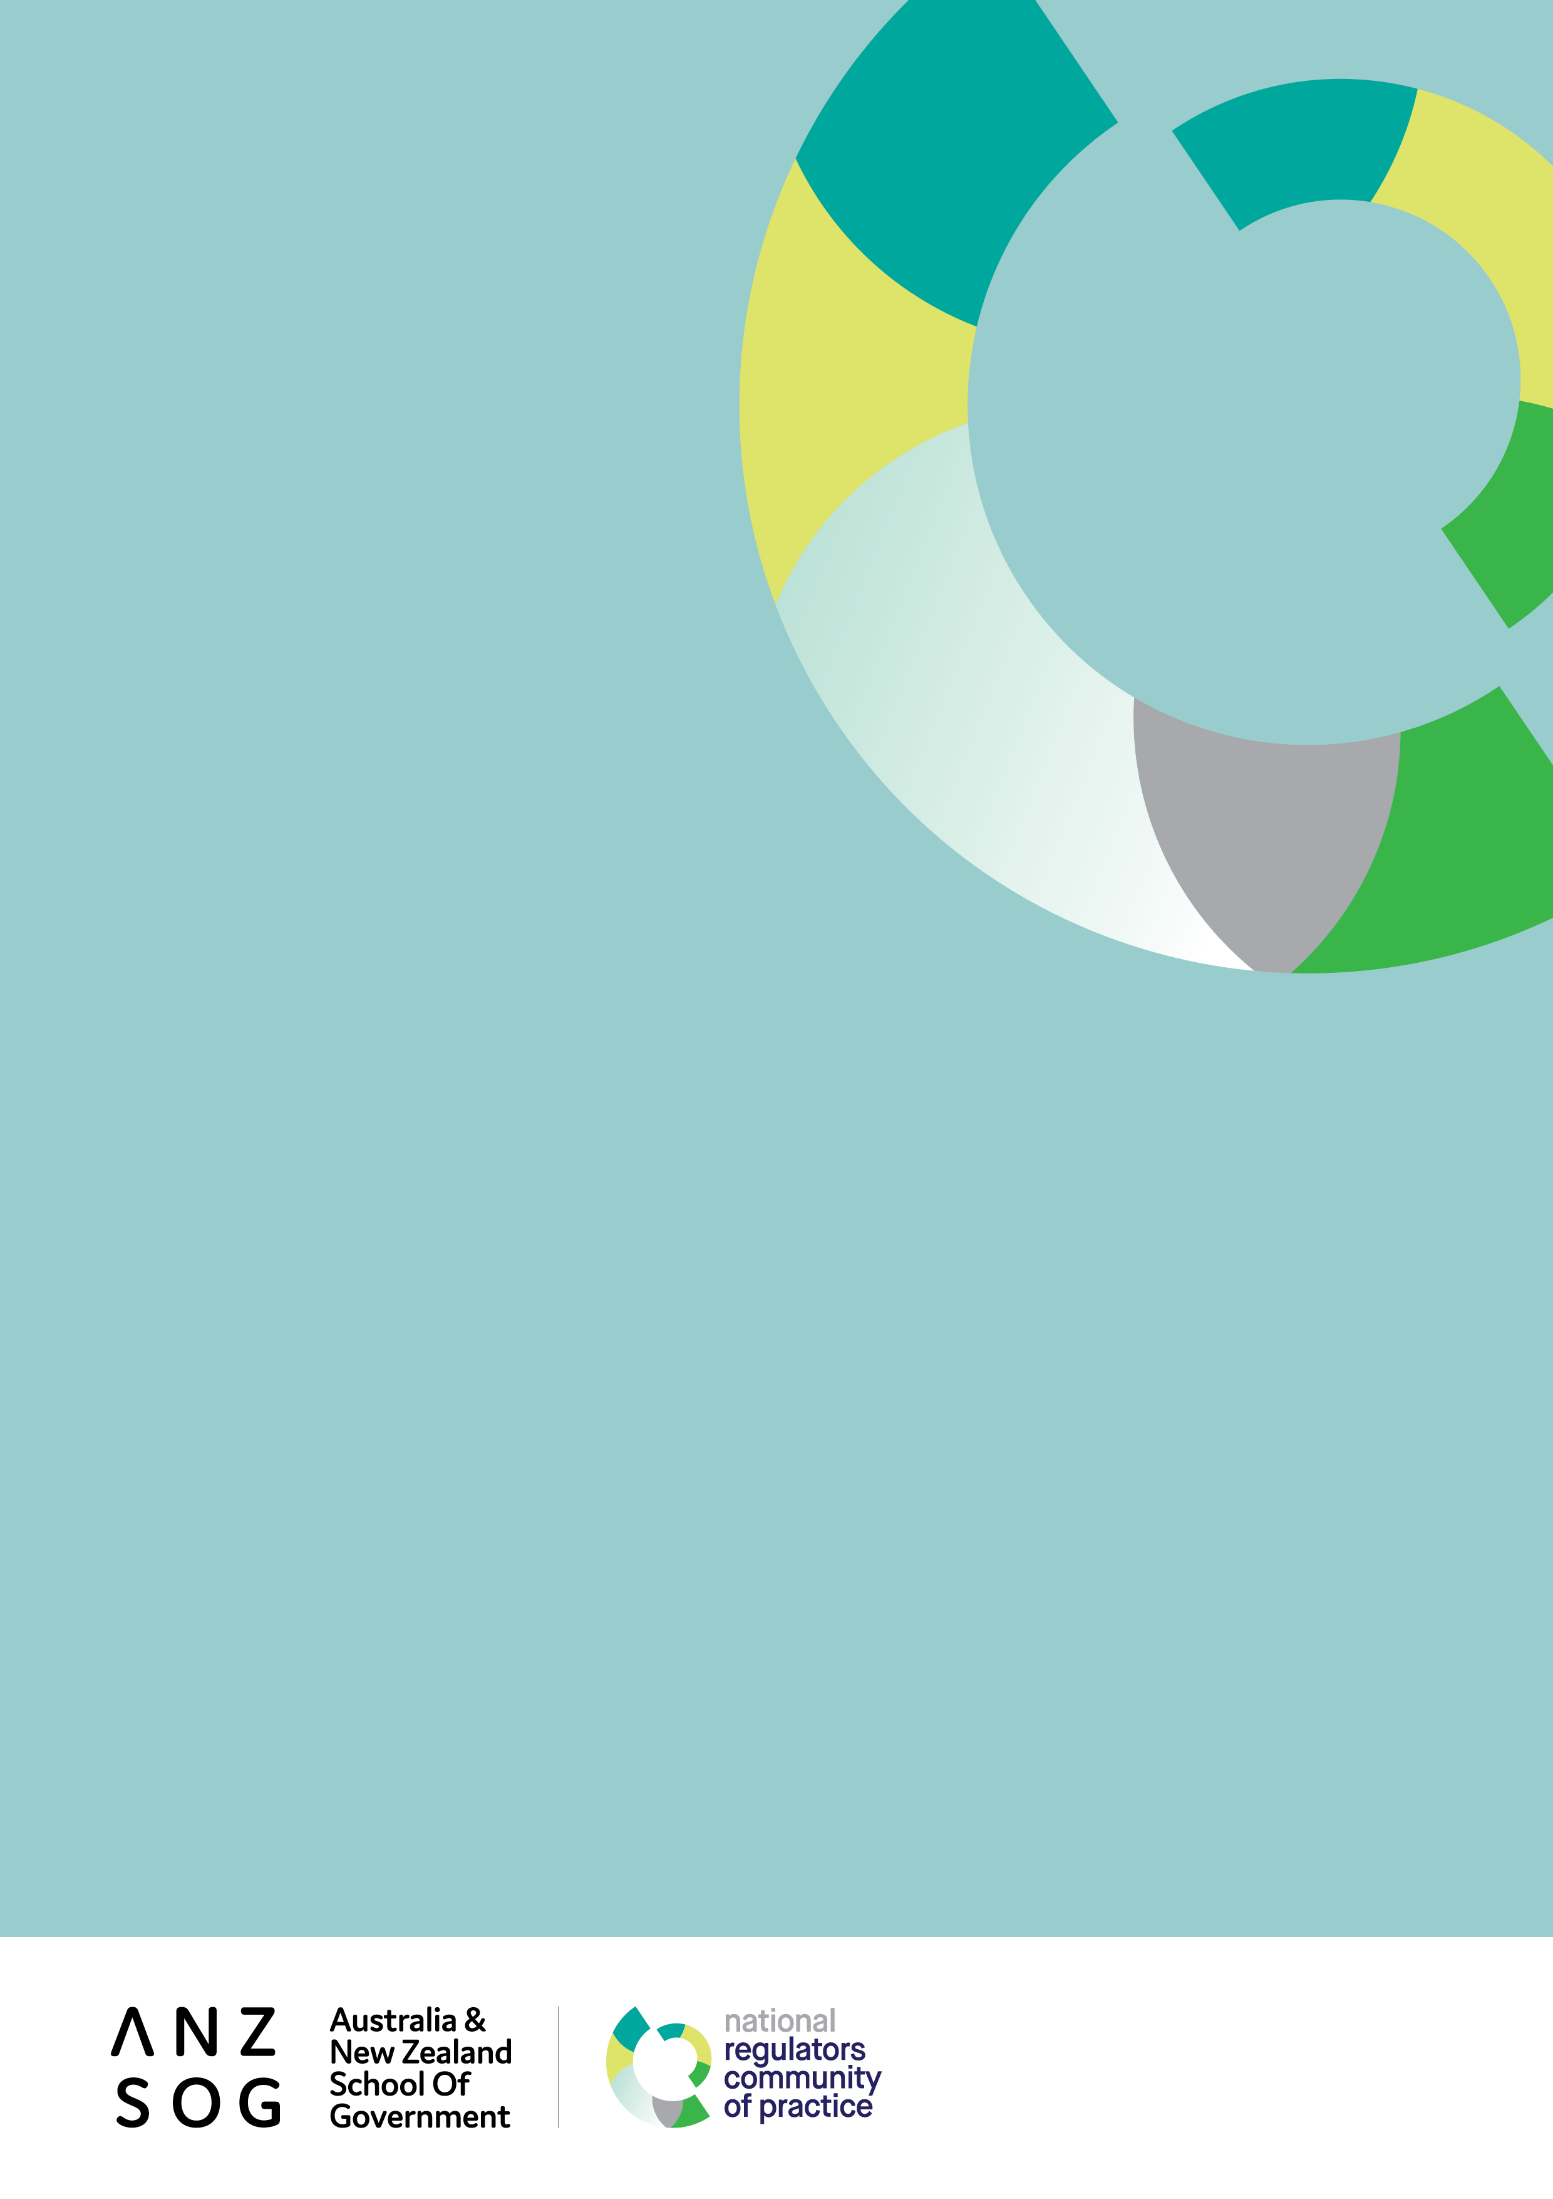
Six-monthly report to corporate members
December 2020

Contents
Message from the Dean 3
Message from the NRCoP Chair 4
Introduction 5
Timeline for the NRCoP 6
Connect 8
Inspire 11
Enrich 12
Educate 14
The year ahead: future plans and directions 15
Thank you to our corporate members 16
Thank you to our national and chapter committees 19
Follow us 21

ANZSOG works for our government owners and with our university partners to lift the quality of public sector leadership across Australia and Aotearoa-New Zealand. Our work inspires and connects people across agencies, sectors, jurisdictions and nations.

Message from the Dean
I have much pleasure in presenting this inaugural report to corporate members on the activities and achievements of the ANZSOG/National Regulators Community of Practice (NRCoP) and its impact on regulatory capability and professionalism.
While the NRCoP has grown to be the largest and most visible of ANZSOG’s contributions to better regulation in Australia and Aotearoa-New Zealand, with over 5000 subscribers, it is only one aspect of a long-standing commitment of which we are very proud.
My predecessors as Deans of ANZSOG, Professors Allan Fels and Gary Banks, are both giants on the Australian and international regulatory scenes. The highly regarded Governing by the Rules subject in our Executive Master of Public Administration, led by Emeritus Professor Arie Freiberg, has transformed successive cohorts of public sector leaders’ understanding of regulation and regulatory tools. Harvard Kennedy School Professor Malcolm Sparrow’s workshops for ANZSOG have virtually become compulsory for aspiring regulatory leaders and have created a common vocabulary and conceptual framework uniting thousands of Australasian regulators, regardless of jurisdiction or sector.
Many of Australia’s and New Zealand’s regulatory leaders gained the knowledge and confidence to advance their careers by undertaking one of ANZSOG’s core offerings. And ANZSOG’s research output has always encompassed regulatory matters, most recently featuring the work of ANZSOG’s Deputy Dean Dr Chris Walker.
As you will observe in the report, the NRCoP exemplifies ANZSOG’s unique remit to build bridges: between Australia and New Zealand, between academics, public leaders and practice, and between public managers seeking to deliver public value regardless of jurisdiction, sector or role. The NRCoP has gone from strength to strength over this difficult period, with your invaluable and generous support as corporate members underpinned by the leadership of Simon Corden and the NRCoP advisory committee and the contribution of the ANZSOG team led by Monica Pfeffer. I am sure you join me in looking forward to its continuing growth and development.
Professor Ken Smith, Dean and CEO, ANZSOG

Message from the NRCoP Chair
The NRCoP began 2020 expecting to deliver three or four large face-to-face seminars in each of Perth, Brisbane, Sydney and Melbourne, a major forum in Melbourne in October with an international keynote speaker, and, possibly, build towards new face-to-face chapters in South Australia and the ACT. Oh how wrong we were.
We never imagined we would find ourselves ending 2020 as a stronger community of practice. By moving online we have doubled our subscribers and engaged an audience from every corner and regulatory sector of Australia and New Zealand. This includes regional and part-time staff attracted by the more flexible professional development opportunities we can now offer, including access to leading local and international regulators, without leaving their work stations.
The 17 webinars and three facilitated conversations we delivered on a rich array of regulatory topics have each drawn in hundreds of appreciative participants and, collectively, thousands of subsequent viewers on YouTube. We launched a Regulation Policy and Practice collection in partnership with APO with an accompanying newsletter which has rapidly made it the APO’s most popular collection.
In introducing this report, I welcome the opportunity to acknowledge the three indispensable components of the NRCoP’s success in adapting so quickly to the new environment:
- The continuing support of ANZSOG’s Board, Dean and staff, particularly Monica Pfeffer, Lorraine Cherney and the Marketing and Communications team;
- The many senior regulators across Australia with demanding day jobs who volunteer their time and expertise for the NRCoP’s committees and who have been such able and enthusiastic advisers, advocates and ambassadors; and
- The 50 departments and regulatory agencies who heeded the plea to become corporate members in order to sustain and grow the NRCoP when the previous business model was rendered unviable by the pandemic.
As well as highlighting achievements to date, we have exciting plans for the future which are outlined on the following pages. We welcome your feedback on these as well as your continuing support and encouragement.
Simon Corden, Chair ANZSOG/NRCoP and Commissioner, Victorian Essential Services Commission

Introduction
This report outlines the NRCoP’s activities and achievements in 2020 and demonstrates our impact against the ANZSOG strategic priorities of Connect, Inspire, Enrich and Educate.
As a genuine community of regulatory practitioners from all levels of government, sectors, roles and levels of seniority in Australia and New Zealand, we provide opportunities to learn from and with each other. We aim to build regulatory capability and professionalism and promote the public value of regulation. We seek to raise the profile of regulation as a valuable career path for ambitious and capable public servants.
Weathering the storm which was COVID-19, in 2020 the NRCoP pivoted to online delivery and a widely distributed corporate membership model. We have built on our existing chapters in Western Australia, Queensland, New South Wales and Victoria, with a new chapter launching in early 2021 in South Australia and a growing reciprocal relationship with G-Reg in New Zealand. Everyone associated with the NRCoP cares deeply about the regulatory craft and this broadly based ownership and commitment is evident in everything that’s been achieved to date and is planned for the future.
“I am completely thrilled to be able to hang out with the regulators community of practice because as far as I can tell there is no such thing anywhere else on earth and so the energy that has gone into this and the commitment to the cross domain learning that you’ve been able to derive from this I think is a dream come true.
For more than 30 years I’ve been pressing the point in all of my teaching and writing that I think regulators share a huge number of frustrations, a huge number of aspirations, and that if only they would learn each other’s vocabulary, they’re dealing with very similar sets of concepts and there is merit and value in having them share across these lines. You have really done that with a vengeance.”
Professor Malcolm Sparrow, introduction to NRCoP webinar on Fundamentals of Regulatory Design, October 2020

Timeline for the NRCoP

2013
- An informal network of ‘Sparrow alumni’ approaches ANZSOG to act as auspice
- ANZSOG and Institute of Public Administration Australia (Victoria) co-auspice Victorian Community of Practice

2014
- Inaugural annual forum with Professor Malcolm Sparrow

2015
- Second annual forum with Professor Gary Banks

2016
- Third annual forum with Professor Cary Coglianese

2017
- Fourth annual forum with Professor Alberto Alemanno
- Intention to take the CoP national announced at forum

2018
- WA chapter launched
- QLD chapter launched (building on existing Queensland Regulators Network)
- NSW chapter launched
- Fifth annual forum with Dr Femke de Vries

2019
- 14 seminars held across Australia, NRCoP reaches 2500 members
- Sixth annual forum with Bill Eggers

2020
- Pandemic transforms NRCoP’s deliveries, business model
- Launch of Regulation Policy and Practice collection on APO
- 50 departments, regulatory agencies become corporate members
- NRCoP agrees on reciprocal arrangements with G-Reg in New Zealand
- NRCoP delivers 17 webinars and 3 facilitated conversations
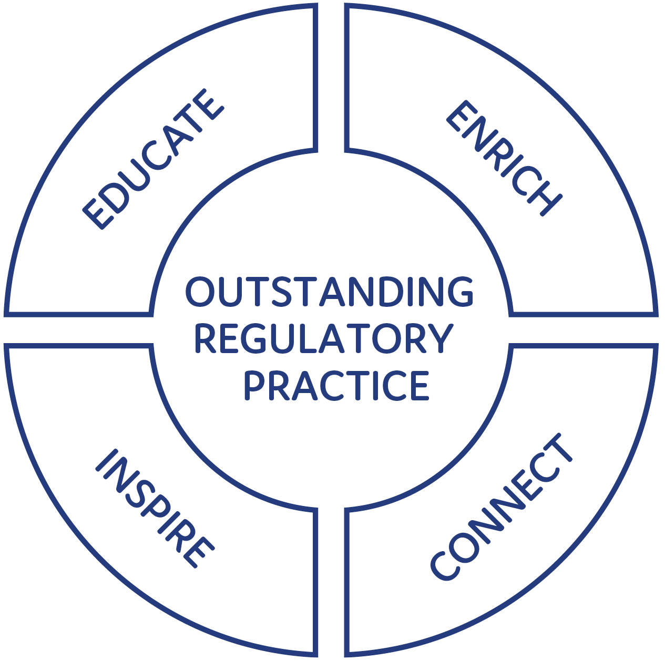
- 11,358 registrations for 17 webinars + 82 for three facilitated conversations, >5000 YouTube views
- 87% of participants have shared insights from seminars/webinars with others in their workplace
- 5000+ subscribers from every state and territory and the Australian and NZ Governments
- 6000+ page views of APO Regulation Policy & Practice collection
- 78% of participants have been able to apply insights from seminars/webinars to their work as regulators
- 4.3/5 ‘I have found participating in the NRCoP valuable in developing my capability and professionalism as a regulator’

Connect
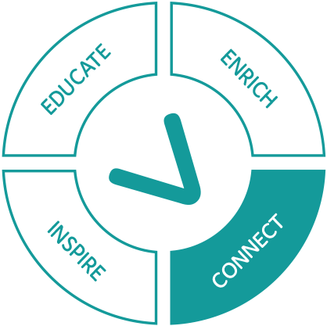
The foundation of the NRCoP is recognising how much all regulators have in common, and consequently the value of learning from their peers’ challenges, innovations, frameworks and experiences.
The NRCoP not only joins up regulators across jurisdictions, sectors and roles, we connect them with regulatory experts, including international and local scholars and past and present regulatory leaders.
In 2020 we needed to forego the ‘warm’ connections generated by face-to-face events and move online. Although this had its downsides, it has enabled us to bring into the community thousands more regulators who work outside capital cities, or part time, or in jurisdictions without NRCoP chapters. We could also connect directly and immediately with ANZSOG’s network of international regulatory scholars and the NRCoP has been the beneficiary of this opportunity.
In 2021 we aim to combine the best of all worlds, with the resumption of face-to-face seminars and forums complemented by an ongoing program of webinars.
“Too often we’re caught in the hurly-burly of day-to-day work, and don’t pause to reflect on the big questions confronted by all regulators. Do we deliver public value? How do we measure our impact? Do we communicate well? Have we taken sufficient advantage of new technology?
For me, this is the great benefit of NRCoP. It’s the chance to step away from the fray, to devote the time needed to reflect and learn, by discussing the big issues with regulatory practitioners and experts from the world of academia. And it’s not just an episodic, forum-to-forum experience. NRCoP builds your networks and helps you every working day. You discover the great benefit of being able to pick up the phone and talk shop with NRCoP peers. You learn that, no matter your specific portfolio or field, your NRCoP peers all struggle and thrive with the big questions.
So get involved!”
Chris Ingham, Deputy CEO, Victorian Registration and Qualifications Authority
“…The benefit of the shift to online webinars was that our staff members all over the State, and not just those located near the CBD, could learn about cutting edge regulatory trends and hear about the practical experience of other regulators. Our team in Department of Customer Service had to pivot quickly to work with other regulatory colleagues on COVID Safe compliance and the relationships we had already formed through the NSW Chapter of NRCoP were key to knowing who to contact quickly and enabled us to implement our collaborative work in a speedy and agile manner.”
Rose Webb, Deputy Secretary NSW Department of Customer Service, a treble corporate member on behalf of SafeWork NSW, Fair Trading NSW and Liquor and Gaming NSW
Table: Engagement in the 2020 NRCoP Program of Events
Month | 2020 NRCoP Program of Events | Registrations for event | YouTube views
April | Regulating the population  Cameron Stewart, Michael Eburn and Pauline Ireland | 339 | 420
 | Regulating at the border  Luke Wilson, Emma Watts and Simon Corden | 343 | 160
May | Learning to be better regulators, the G-Reg journey  Tony McKenna and Grant Pink | 565 | 278
 | Regulating the professions  Roxane Marcelle-Shaw, Jane Eldridge and Bronwyn Weir | 434 | 314
 | Why do people comply? COVID-19 compliance behaviours in international and local perspective  Benjamin van Rooij, Liam Smith and Jenness Gardner | 403 | 599
June | Measuring regulatory performance  Claire Noone and Gerard Brody | 948 | 517
 | RegX: Regulatory Excellence  Cary Coglianese, Kate Maddern and Simon Corden | 491 | 471
 | What would culturally responsive regulation of Aboriginal and Torres Strait Islanders organisations look like?  Brendan Thomas, Simone Jackson, Phillip Brooks and Janet Schorer | 792 | 355
July | Inside/Outside: the pros and cons of the independent versus the departmental regulator and does it matter?  Graeme Samuel, Peter Shergold and Fran Thorn | 702 | 642
 | Bias by design: when the design, implementation and enforcement of rules creates disadvantage  Donald Moynihan, Sarah McDowell and Janine O’Flynn | 494 | 305
August | Regulation, trust and social licence  Edward Langley, James Shipton and Marianne Munro | 574 | 392
Facilitated conversations: Windows of opportunity in a pandemic
Adam Beaumont, Grant Pink and Alice Turnbull
September | One space, many regulators  Rose Webb, Simon Cohen, Tracy Mackey and Simon Corden | 521 | 246
Facilitated conversations: Compliance in a crisis
Adam Beaumont, Grant Pink and Victoria Thomson
October | Defining and measuring our public value  Emily Sanders, Tony Keenan and Chris Walker | 927 | 262
 | Fundamentals of Regulatory Design  Malcolm Sparrow and Rose Webb | 1994 | 500
Facilitated conversations: Regulatory laggards in a crisis
Adam Beaumont, Grant Pink and Chris Walker
November | Using Behavioural Science at the Bad End of Town  Femke de Vries, Will Day and Genene O’Neill | 929 | 263
December | Markets and Consumers in the Digital Age: the ACCC and the Platforms  Kate Reader, Morag Bond and Rob Nicholls | 360 | 49
 | Regulating Unreason  Luke Cornelius, Sandro Demaio, Julie Inman Grant and Simon Corden | 542 | N/A
 | Total | 11,358

Connecting through the NRCoP: a case study
In June 2020 the NRCoP hosted a webinar with Professor Cary Coglianese on RegX, supported by Kate Maddern from Victoria. Kate told the story of how she’d used the RegX approach to bring empathic engagement with vulnerable passengers to Public Transport ticketing enforcement. The adoption of the RegX approach saw a 30% reduction in complaints to the Victorian Public Transport Ombudsman and was used as the basis for communicating the regulator’s strategic approach and desired behaviours to staff. Following the NRCoP webinar, several regulators from our wider community sought further information from Kate about how RegX had been adapted and deployed to improve performance and culture. We were able to connect these regulators with Kate who provided additional information and resources. You can catch up on this excellent webinar on ANZSOG’s YouTube channel RegX: Achieving Regulatory Excellence - YouTube <https://www.youtube.com/watch?v=6eond8BiMtY>

Inspire
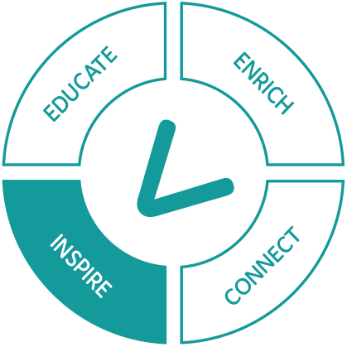
Regulation is a core and publicly valuable part of the work of government, but it is also complex, volatile and challenging. The NRCoP aims to inspire regulators that their work is intellectually, professionally and ethically worthwhile and the foundation for a rich and satisfying career. In its emotional dimension, the NRCoP works to give heart to regulators who find themselves constantly in the cross hairs of some or all of government, media, the community and duty holders.
“For regulatory staff in the QLD Department of Education, membership of NRCoP has opened the door to a world of quality regulatory practice, resources and colleagues. As a small regulator, the ability to network with and learn from other regulatory agencies has been critical to our regulatory journey, and there has been significant and sustained interest from staff in the learning opportunities offered by NRCoP.
NRCoP membership contributes strongly to our growing sense of regulatory professionalisation, and ensures that we are keeping current with best practice, emerging risks and contemporary research. And the flexible online professional development offered by NRCoP through the course of the COVID-19 pandemic has opened up the benefits of membership to a much broader range of staff across our regions as well as Brisbane.”
Erica McLuckie, Director Assessment and Quality Improvement, QLD Department of Education
“Engagement of our team in the National Regulators Community of Practice has been the game-changer for us in providing our people with inspiration to develop themselves as regulatory professionals. From our legislation and policy team through to our inspectors and investigators and everyone in between, we have been challenged, learned about new ways of working, lifted our awareness and capacity to reflect on our practice and built new relationships with colleagues across the breadth and diversity of regulators in Western Australia, across Australia and internationally. ANZSOG brings its thought leadership, access to academics, professionals and leaders and innovative methods of delivery and connection to the NRCoP. All regulatory professionals seeking to modernise and maximise the efficacy of their regulatory practice will benefit from participation.”
Lanie Chopping, WA Commissioner for Consumer Protection

Enrich
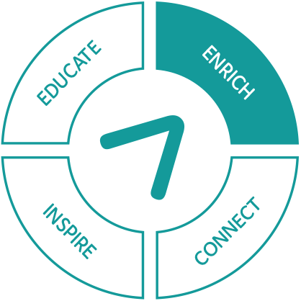
The NRCoP is committed to ensuring there is an enduring legacy from our learning opportunities for all regulators, whether or not they’ve been able to attend webinars and seminars. We do this in a number of ways.
The dedicated regulators webpage <https://www.anzsog.edu.au/regulators> on the ANZSOG site provides a rich array of resources from previous events, including slides, other relevant materials and links to recordings on ANZSOG’s YouTube channel. Regular communications alert our subscribers to the availability of these resources.
The NRCoP Regulation Policy and Practice collection <https://apo.org.au/collection/302958/regulation-policy-practice> on APO, the Analysis and Policy Observatory, was launched in March 2020 and has quickly grown to be the most visited collection on APO. The collection includes 1,151 resources from 1,125 authors from 346 organisations. The site has received almost 6,000 pageviews in a six-month period.
Every NRCoP subscriber receives a monthly newsletter from the collection, highlighting the latest developments of relevance and interest to regulators. We commission a guest editorial for each newsletter, highlighting the work and challenges of our participants.
Table: 2020 Guest Articles
Month | Article
May | Learning to be better regulators: the importance of training and development
June | COVID-19 and compliance: what makes people stick to the rules?
July | Good design leads to great digitisation for regulators
Aug | Three steps for regulators to embrace behavioural science
Sept | Regulation, trust and the professions
Oct | The role of artificial intelligence in regulatory decision-making
Nov | Regulatory stewardship: virtue, mechanism or both?
Dec | Performance reporting by regulators: are we measuring and reporting what matters?
“The Fair Work Ombudsman became a corporate member of NRCoP this year. So far, FWO staff have derived benefits from the NRCoP in multiple ways, including through its engaging newsletter, thought-provoking learning events, and networking opportunities that connect people from regulatory agencies across the country.
I would encourage departments and regulators to join the NRCoP so their staff can learn about the latest regulatory insights and techniques, and also share their own expertise with peers to help advance regulatory practices in Australia.”
Sandra Parker, Australian Fair Work Ombudsman

Educate
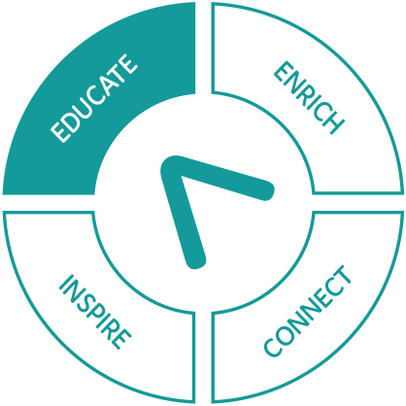
Inspired by the nested set of accredited qualifications for regulators in NZ, the NRCoP has embarked on a journey to discover whether Australian regulators and their leaders would welcome consistent, transferable professional development offerings. If the answer is yes: on what topics; formally accredited or informal but nationally recognised; and delivered by what kind of educational institution?
In 2020 the NRCoP commenced its work by establishing a sub-committee comprising national and state regulators, two experienced regulatory educators and the Chair in Regulatory Practice from Victoria University of Wellington. The following ‘problem statement’ has been agreed and will provide the basis for work in 2021.
- The absence of shared and consistent professional development affects regulators’ capacity to develop regulatory careers, through which they can build a ‘regulatory mindset’, share knowledge and apply their skills and capabilities to different problems
- Many staff of regulators don’t fully understand the purpose and role of a regulator, and how it differs from other activities in the public or private sector, to the detriment of the culture and effectiveness of regulators
- There are knowledge, skills and capability gaps that are reducing the effectiveness of regulators
- The cost of individual regulators developing and delivering their own bespoke training and professional development wastes time and resources and reduces the overall supply
“I passionately support the work of the NRCoP. As someone who has worked across many different regulators and regulatory areas – including agriculture, environment, forestry, transport and human services – many lessons and learnings can be shared with each other to improve skills and spark innovation, and also avoid reinventing the wheel. I particularly value that this community of practice covers the spectrum from technical and academic work to how it’s been applied in practice.”
Kate Maddern, Victorian Disability Worker Commission

The year ahead: future plans and directions
The NRCoP has an active and ambitious workplan for the year ahead, including:
- Parallel program of online webinars and face-to-face deliveries
- Forums in Perth, Brisbane and Melbourne
- New SA chapter
- Exploring consistent, nationally recognized professional development
- Support for new regulatory leaders
- Continuing a program of timely, thought provoking webinars on topics of interest and concern to regulatory practitioners
- As restrictions ease, resuming face-to-face seminars
- Again as restrictions ease, planning and delivering ‘satellite’ forums in Perth and Brisbane, in addition to a larger cross-jurisdictional annual forum in Melbourne
- Testing the feasibility of a business case, priorities and curriculum for nationally recognized professional education for Australian regulators, to be delivered by ANZSOG
- Launching a South Australian chapter
- Deepening cross-Tasman engagement
- Exploring ways to support new regulatory leaders without a background in regulation
- After our pilot initiative in 2020, looking for further opportunities for confidential, deep dive ‘facilitated conversations’ on particularly challenging issues
- Continuing to grow and develop the NRCoP/APO Regulation Policy and Practice collection
- Improving the depth and utility to regulators of the NRCoP website
- Supporting chapters to deliver small F2F work-in-progress and mentoring sessions for regulators in their jurisdiction

Thank you to our corporate members
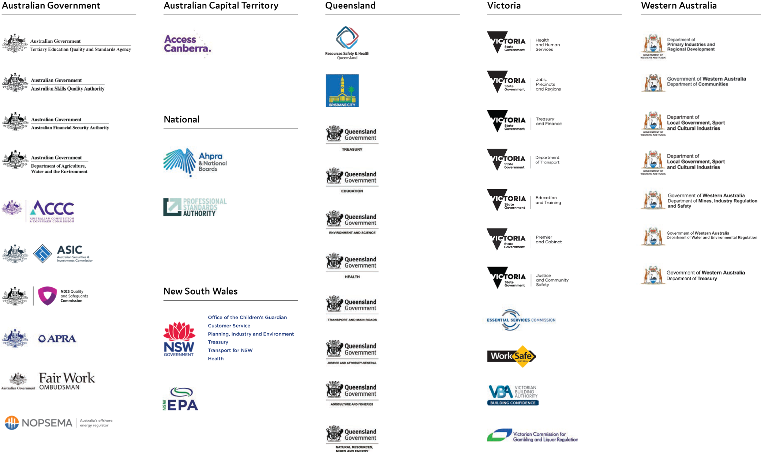

Australian Government
Australian Competition and Consumer Commission
Australian Financial Security Authority
Australian Prudential Regulation Authority
Australian Securities and Insurance Commission
Australian Skills Quality Authority
Department of Agriculture, Water and the Environment
Fair Work Ombudsman
National Disability Insurance Scheme (NDIS) Quality and Safeguards Commission
National Offshore Petroleum and Safety Management Authority
Tertiary Education Quality and Standards Agency

National
Australian Health Practitioner Regulation Agency
Professional Standards Authority

ACT Government
Access Canberra

New South Wales
Department of Customer Service
Department of Planning, Industry and Environment
Ministry of Health
NSW Environment Protection Authority
NSW Treasury
Office of the Children’s Guardian
Transport for New South Wales

Queensland
Brisbane City Council
Department of Agriculture and Fisheries
Department of Education
Department of Environment and Science
Department of Health
Department of Justice and Attorney-General
Department of Natural Resources, Mines and Energy
Department of Transport and Main Roads
Queensland Treasury
Resources Safety and Health Queensland

Victoria
Conservation Regulator
Department of Education and Training
Department of Health and Human Services
Department of Jobs, Precincts and Regions
Department of Justice and Community Safety
Department of Premier and Cabinet
Department of Transport
Department of Treasury and Finance
Essential Services Commission
Victorian Building Authority
Victorian Commission for Gambling and Liquor Regulation
WorkSafe

Western Australia
Department of Communities
Department of Local Government, Sport and Cultural Industries
Department of Mines, Industry Regulation and Safety
Department of Primary Industries and Regional Development
Department of Treasury
Department of Water and Environmental Regulation

Thank you to our national and chapter committees

National committee (Victorian members sit as Victorian committee)
Simon Corden, Chair, VIC Essential Services Commission
Monica Pfeffer, Secretariat, ANZSOG
Adam Beaumont, With-Purpose Consulting
Ashley Bunce, VIC Conservation Regulator
Martyn Campbell, incoming SA convenor, SafeWork SA
Jarrod Cowley-Grimmond, QLD convenor, Department of Regional Development, Manufacturing and Water
Matt D’Abbs, VIC Environment Protection Authority
Arie Freiberg, Academic Advisor, Monash/ANZSOG
Jenness Gardner, WA convenor (on leave), WA Economic Regulation Authority
Merrin Hambley, NSW member, Australian Competition and Consumer Commission
Christopher Ingham, Victorian Registration and Qualifications Authority
Germaine Larcombe, interim WA convenor, WA Department of Water and Environmental Regulation
Kathryn MacIver, NZ Government Regulatory Practice Initiative, Ministry of Business, Innovation and Employment
Kate Maddern, Victorian Disability Worker Commission
Roxane Marcelle-Shaw, NSW convenor, Professional Standards Authority
Cassandra Meagher, ServiceVictoria
Marianne Munro, VIC Department of Environment, Land, Water and Planning
Rowena Park, QLD member, Australian Securities and Investment Commission
Grant Pink, Pracademic Advisor, Recap Consultants
Jeroen van der Heijden, NZ Government Regulatory Practice Initiative, Victoria University of Wellington
Adam Watson, VIC WorkSafe

New South Wales
Rose Webb, sponsor, NSW Department of Customer Service
Roxane Marcell-Shaw, convenor, Professional Standards Authority
Matthew Barrett, NSW State Insurance Regulatory Authority
Peter Dunphy, SafeWork NSW
Jane Eldridge, Australian Health Practitioner Regulation Agency
Merrin Hambley, Australian Competition and Consumer Commission
Tony Kofkin, NSW Health Care Complaints Commission
Tracy Mackey, NSW Environment Protection Authority
Janet Schorer, NSW Office of the Children’s Guardian
David Snowden, AccessCanberra
Chris Walker, ANZSOG
Jackie Walsh, Australian Securities and Insurance Commission
Scott Wheeler, NSW Treasury

Queensland
David Mackie, sponsor, QLD Department of Justice and Attorney-General
Jarrod Cowley-Grimmond, convenor, Department of Regional Development, Manufacturing and Water
Omar Ameer, Queensland Building and Construction Commission
Brian Bauer, QLD Office of Fair Trading
Rose Bovey, QLD Health
Mary Doolan, Australian Financial Security Authority
Philip Halton, NDIS Quality and Safeguards Commission
Jennifer Kenny, QLD Department of Transport and Main Roads
Erica McLuckie, QLD Department of Education and Training
Rowena Park, Australian Securities and Investment Commission
Mark Stone, Resources Safety and Health QLD
Victoria Thomson, QLD Department of Justice and Attorney-General
Peter Thorning, QLD Office of Industrial Relations

Western Australia
Mike Rowe, sponsor, WA Department of Water and Environmental Regulation
Jenness Gardner, convenor, WA Economic Regulation Authority (on leave)
Germaine Larcombe, interim convenor, WA Department of Water and Environmental Regulation
Lyn Anderson, WA Department of Communities
Lanie Chopping, WA Department of Mining, Industrial Relations and Safety
Benjamin Ford, WA Treasury
Chris Mather, WA Department of Transport
David McLennan, City of Vincent
Nicola Perry, WA Department of Local Government, Sport and Cultural Industries
Neil Sarti, WA Department of Primary Industries and Regional Development
Alice Turnbull, National Offshore Petroleum Safety and Environmental Management Authority
Philip Wyles, WA Department of Training and Workforce Development

We acknowledge the Aboriginal and Torres Strait Islander peoples as First Peoples of Australia, and Māori as tangata whenua and Treaty of Waitangi partners in Aotearoa-New Zealand.

Follow us
ANZSOG website <https://www.anzsog.edu.au>
ANZSOG Facebook page <https://www.facebook.com/ANZSOG>
ANZSOG Twitter page <https://twitter.com/ANZSOG>
ANZSOG LinkedIn page <https://www.linkedin.com/school/anzsog>

