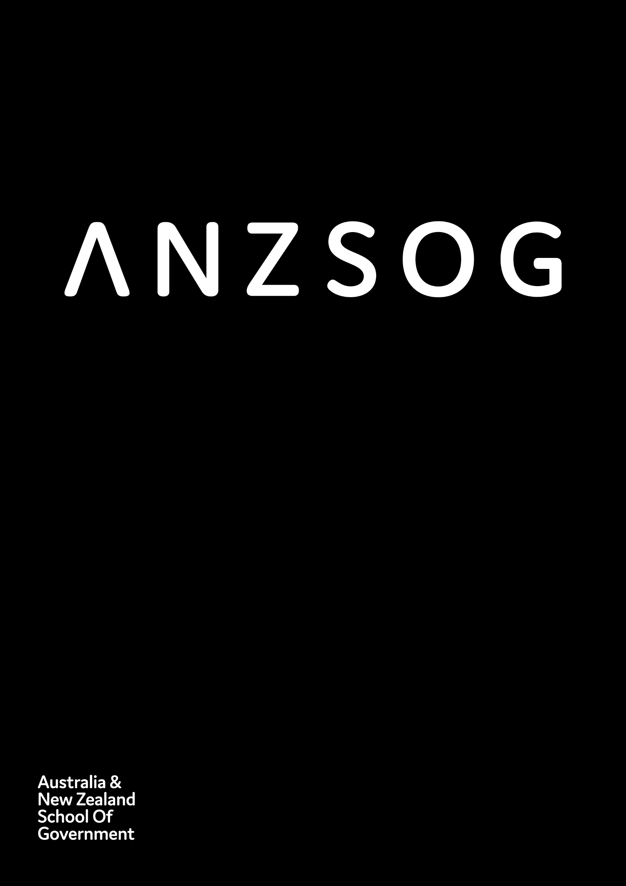
Impact Snapshot 2019-20
Owned by and working for the governments
of Australia and Aotearoa-New Zealand

Contents
Message from the Dean 3
Key achievements 2019-20 4
ANZSOG 5
Educate 6
Enrich 7
Inspire 8
Connect 9
Finances in brief 10
Workforce metrics 12
Who we are 13
Follow us 15

ANZSOG works for our government owners and with our university partners to lift the quality of public sector leadership across Australia and Aotearoa-New Zealand. Our work inspires and connects people across agencies, sectors, jurisdictions and nations.

Message from the Dean
COVID-19 has simultaneously reminded us of the necessity of good government, resulted in significant increases in trust in many of our institutions, and exposed flaws and strengths in existing systems. It has also highlighted that ANZSOG’s mission to lift the quality of public sector leadership across Australia and Aotearoa-New Zealand is more important than ever.
It has been a challenging year for us all. ANZSOG was not immune, but we have continued to work closely with our owner governments, member university networks and individual agencies.
We are continuing our work with the First Peoples of Australia and Aotearoa-New Zealand to ensure that Indigenous knowledge and culture inform our work with all public services.
We have also continued to strengthen the link between evidence and practice, through our focus on education, research and thought leadership.
In response to the pandemic we have adapted and moved a range of education and thought leadership deliveries online, and we look forward to returning to face to face and blended learning formats when we can.
Research activities, including The Bridge <https://www.anzsog.edu.au/resource-library/research/the-bridge>, and significant advisory work with governments, have been an important part of our work, and demonstrate our ongoing impact on the practice of public administration in Australia, Aotearoa-New Zealand and internationally.
This report provides a snapshot of how ANZSOG has adapted to challenging circumstances, particularly in the first six months of 2020 to continue to deliver public value.
Finally I would like to thank the ANZSOG staff and board for their work and support through very difficult times.
Professor Ken Smith, ANZSOG Dean and CEO

Key achievements 2019-20
- 14,948 participants in ANZSOG courses and events
- 210,000+ total downloads of ANZSOG/ANU Press titles
- 4.32/5 average overall evaluation score across all courses/workshops
- 718,724 total page views of the ANZSOG website
- 16,239 ANZSOG e-news subscribers
- 163,125 social media engagements
“Taking an opportunity to reflect on how you do things, making sure you’re connected to contemporary management techniques and leadership styles and continually learning is really important, and the difference with ANZSOG, and the value of ANZSOG, is that it’s aimed at the public sector.”
Ginna Webster, Executive Fellows Program graduate 2016, Towards Strategic Leadership graduate 2010 and Secretary of the Department of Justice, Tasmania
Ginna Webster <https://www.anzsog.edu.au/resource-library/news-media/how-anzsog-helps-ginna-webster-lead-in-uncertain-times>

ANZSOG
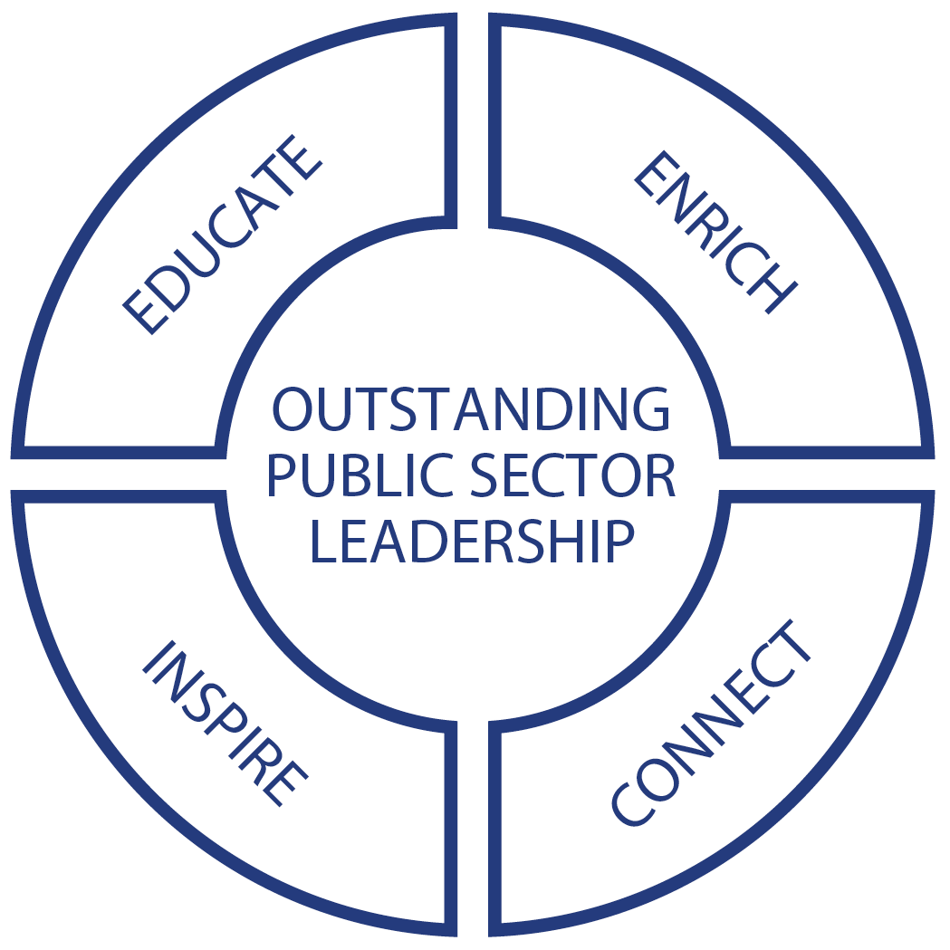

Educate

Leading in a crisis
In response to COVID-19, in early 2020 ANZSOG created and delivered the Leading in a Crisis (LIAC) series. This provided public sector leaders grappling with the crisis with the benefits of global expertise – when they needed it. A series of seven research papers synthesised the latest information on crisis management, leadership and communications, and featured contributions from academics in Sweden, the Netherlands, Australia, Aotearoa-New Zealand and the USA. In addition, LIAC included a webinar, Navigating leadership during COVID-19, facilitated by LIAC curator Professor Paul ‘t Hart and a post-crisis masterclass for senior public managers and ANZSOG alumni. ANZSOG delivered the series to senior public sector executives across Australia and Aotearoa-New Zealand, and almost 20,000 unique visitors viewed the papers on the ANZSOG website in just the first three months.

Encouraging innovation
Improving the public sector’s ability to innovate is an important step to improving public policy. In 2019 ANZSOG partnered with the Monash Sustainable Development Institute (MSDI) and Professor Beth Noveck’s US-based GovLab to improve innovation in the public sector. The project began with an Australia/Aotearoa-New Zealand first survey of attitudes to innovation among public servants and the publication of the “Today’s Problems, Yesterday’s Toolkit” report <https://www.anzsog.edu.au/resource-library/news-media/todays-problems-yesterdays-toolkit-public-service?searchword=today%27s+problems+yesterday%27s+toolkit>, which made recommendations for governments wanting to improve training in innovation. Professor Noveck facilitated workshops with public sector leaders in Melbourne and Canberra, and she and MSDI’s Professor Rod Glover are working with ANZSOG to develop a new course in public problem solving.
“In every subject they would throw you a real-life policy issue from a government department. You start thinking far more broadly outside of your own organisation. It taught me to better empathise with people and the work of other agencies. Now whenever I’m making a decision about something, I always think about who else might be impacted.”
Tracey Linford, Executive Master of Public Administration graduate 2007, Executive Fellows Program graduate 2016 and Deputy Commissioner Queensland Police
Tracey Linford < https://www.anzsog.edu.au/resource-library/news-media/public-value-and-the-covid19-response-tracy-linford?searchword=tracey+linford&_content-type=Resource+Library&published_date%5B%5D
=&published_date%5B%5D=&_resource-library=News+%26+Media&ordering=relevance+ASC&searchmodule
=131&limitstart=>

Enrich

A bridge between theory and practice
Public managers value academic research but do not always have time to read it. To help change this, in March 2020 ANZSOG launched The Bridge, a fortnightly e-newsletter and series of research briefs, which summarises the latest research and delivers it straight to the inboxes of public servants. Tackling topics including agile government, the dark side of public innovation, and understanding prevention and early intervention in public policy. The Bridge reaches a growing subscriber base of over 15,000 and the research briefs have been viewed by almost 8,000 people (as of the end of June 2020).

Helping WA Government design capability reviews
ANZSOG partnered with the Western Australia Public Sector Commission to undertake stakeholder engagement and research to design a Performance Improvement Framework for the whole of the Western Australia public sector. This project was a strong demonstration of ANZSOG’s capability in drawing together knowledge and experience globally and across jurisdictions, as well as the latest thinking and research in public administration, to have a significant impact on the Western Australia public sector’s approach to performance improvement across the sector. ANZSOG will publish a report and research findings to ensure other jurisdictions can benefit from the work.
“I just want to thank you for the consistently high standard of relevant materials you send out in your newsletters. I’m very impressed and have been finding them useful.”
Kellie William, Senior Project Officer Environmental Health, Brisbane City Council
“ANZSOG is really good at bringing together the academic literature and people with lived experience.”
Dan Craig, Executive Master of Public Administration student 2020 and Manager Kindergarten Reform Implementation Division, Early Childhood Education Group for the Victorian Department of Education and Training.

Inspire
“Times may be challenging but I absolutely believe politics can be a place for change, disruption, and ultimately a force for good. Good government matters because government affects everything.”
Prime Minister of New Zealand Jacinda Ardern

Jacinda Ardern address
In July 2019 ANZSOG and the City of Melbourne hosted New Zealand Prime Minister Jacinda Ardern’s address “Why does good government matter?” <https://www.anzsog.edu.au/resource-library/news-media/new-zealand-pm-jacinda-ardern-s-anzsog-address-why-does-good-government-matter?searchword=jacinda+ardern> at the Melbourne Town Hall. This ANZSOG event was held with a diverse invitation-only audience of 1700, including public sector leaders, community leaders and high school students. The event attracted 25,000 views via ANZSOG’s Facebook livestream and coverage in media outlets across Australia and Aotearoa-New Zealand. Ms Ardern thanked ANZSOG for the work it did to support public policy development in Australia and Aotearoa-New Zealand. Later in 2019, ANZSOG’s annual Alf Rattigan Address was delivered by former New Zealand Prime Minister Bill English, on “The limits of universal public services” <https://www.anzsog.edu.au/resource-library/news-media/alf-rattigan-lecture-bill-english-2019?searchword=bill+english&_content-type=Resource+Library&published
_date%5B%5D=&published_date%5B%5D=&_resource-library=News+%26+Media&ordering=relevance+ASC
&searchmodule=131&limitstart=>.
“Specifying results in numbers gives politicians and public servants clear direction. With data driven feedback loops, public servants have a consistent system of measurement and accountability around which to organise. Results cut through the fog of verbiage, good intentions, and useless statistics.”
Bill English, Former New Zealand Prime Minister

Nurturing First Peoples’ leaders
ANZSOG partnered with the Winston Churchill Memorial Trust in Australia and the Churchill Trust in Aotearoa-New Zealand in 2019 to offer two Indigenous fellowships as part of our commitment to building Indigenous leadership in public services. The winners – Alphonsus Shields from the Northern Territory Police Force and Dr Clive Aspin from the Aotearoa-New Zealand Health Quality and Safety Commission – will travel overseas to research community-based crime prevention and reducing rates of suicide for Indigenous peoples.

Connect
“The EMPA has helped me see the importance of building trust. Nothing we do from a policy or program perspective in government will work if we don’t invest in relationships – developing trust with community and with other critical stakeholders.”
Wendy Ah Chin, Executive Master of Public Administration graduate 2017 and Branch Manager, National Indigenous Australians Agency

Indigenising public services
Recognising the value of First Peoples’ knowledge and culture is critical for public services if they are to work with Indigenous communities to deliver public value. Central to achieving this is employing and retaining First Nations public servants at all levels. ANZSOG’s 2019 Indigenous Public Servant Forum brought together a group of 23 senior Indigenous public servants from eight Australian jurisdictions and Aotearoa-New Zealand to discuss how to improve Indigenous representation in the public sector. The group agreed to three priorities: establishing a cross-jurisdictional community of practice; developing ways to shift the mindset of non-Indigenous public servants; and examining ways to support Indigenous staff to succeed in the public sector while staying on Country.

Creating a regulators community
The ANZSOG/National Regulators Community of Practice (NRCoP) <https://www.anzsog.edu.au/regulators/whats-the-nrcop> is an active network connecting Australian public sector regulators from all levels of government and every regulatory sector, professional background, role and level of seniority. In 2019-20 regulators in four chapters in Perth, Brisbane, Sydney and Melbourne enjoyed face-to-face events plus the annual forum, ‘The Intelligent Regulator’ in Melbourne, featuring leading global thinker Bill Eggers. The onset of the pandemic in early 2020 resulted in a rapid pivot to a program of online webinars which have attracted participants from across Australia, Aotearoa-New Zealand and internationally. Speakers have included Professor Cory Coglianese and Simone Jackson.
The first annual survey of NRCoP participants found that:
- 86% had shared insights with others in their workplace and/or networks
- 72% had been able to apply insights gained from seminars to their work as a regulator.

Building ties with India
ANZSOG is building links between Australia, Aotearoa-New Zealand and India through international programs. In 2019, 20 senior Indian officials visited Sydney, Melbourne and Wellington, as part of the India Advanced Leadership Program, to meet and learn from senior officials, with the aim of building greater understanding and productive relationships. The program was led by Dr Pradeep Philip, Dr Jeff Harmer and Jan Henderson. The Victorian Department of Premier and Cabinet commissioned ANZSOG to deliver the three-year Victoria India Government Exchange Program to raise awareness of Victoria in India and build enduring partnerships. The first year saw six senior Victorian leaders travel to the Indian state of Karnataka for four-days to establish relationships with their counterparts, identify shared policy challenges and generate a constructive forward work agenda.

Finances in brief
In the 2019-20 financial year ANZSOG:
- Deferred programs in response to the impacts of COVID-19 resulting in reduced revenue of $2.17M
- Targeted reduction in expenditure of $1.96M to mitigate revenue reduction
- Incurred an additional $1.19M expenditure on strategic growth initiatives
- Saw a reduction of investment income of $2.59M due to adverse market conditions.

Income
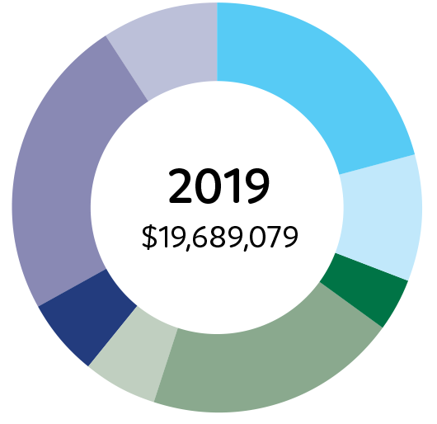
2019: $19,689,079
Executive Master of Public Administration 21%
Executive Fellows Program 10%
Towards Strategic Leadership 4%
Executive Education 20%
International Programs 6%
Member Contributions 6%
Investment 24%
Other Income Sources 9%
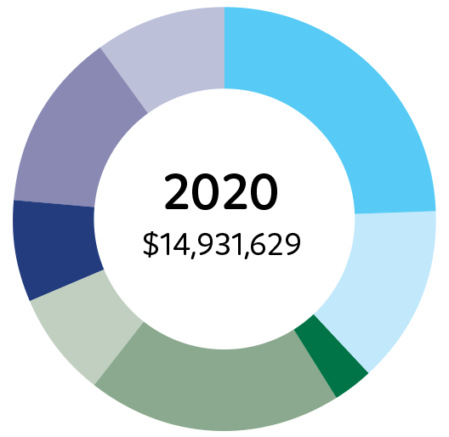
2020: $14,931,629
Executive Master of Public Administration 25%
Executive Fellows Program 14%
Towards Strategic Leadership 3%
Executive Education 20%
International Programs 8%
Member Contributions 8%
Investment 14%
Other Income Sources 10%

Expenses

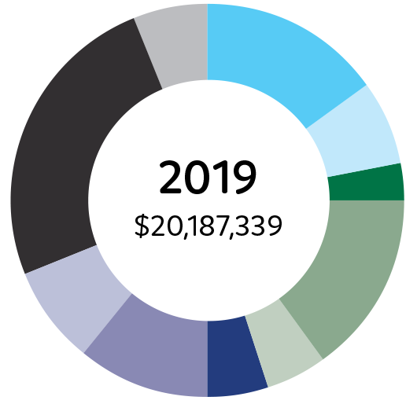
2019: $20,187,339
Executive Master of Public Administration 15%
Executive Fellows Program 7%
Towards Strategic Leadership 3%
Executive Education 15%
International Programs 5%
Research and Case Program 5%
Admin, Board, & Governance 11%
Marketing and Business Development 8%
Other Expenditures 25%
Strategy Expenditure 6%
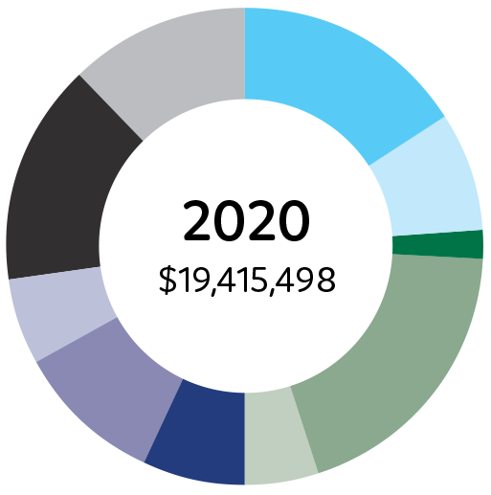
2020: $19,415,498
Executive Master of Public Administration 16%
Executive Fellows Program 8%
Towards Strategic Leadership 2%
Executive Education 19%
International Programs 5%
Research and Case Program 7%
Admin, Board, & Governance 10%
Marketing and Business Development 6%
Other Expenditures 15%
Strategy Expenditure 12%

Workforce metrics

Workforce composition (professional staff)

Gender
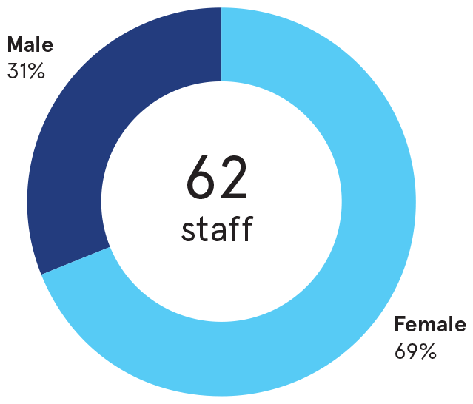
62 staff:
- Female 69%
- Male 31%

Age
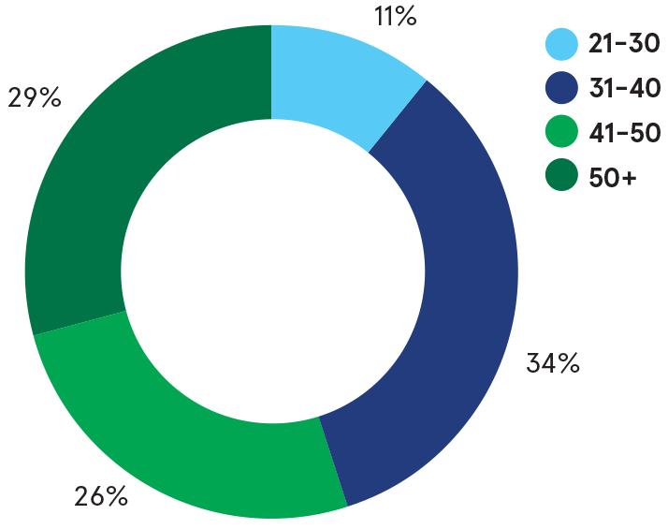
- Age 21-30: 11%
- Age 31-40: 34%
- Age 41-50: 26%
- Age 50+: 29%

Years of service
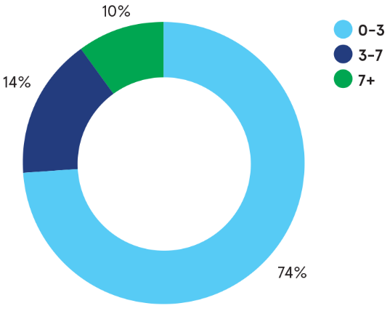
- 0-3 years: 74%
- 3-7 years: 14%
- 7+ years: 10%

Salary band by gender
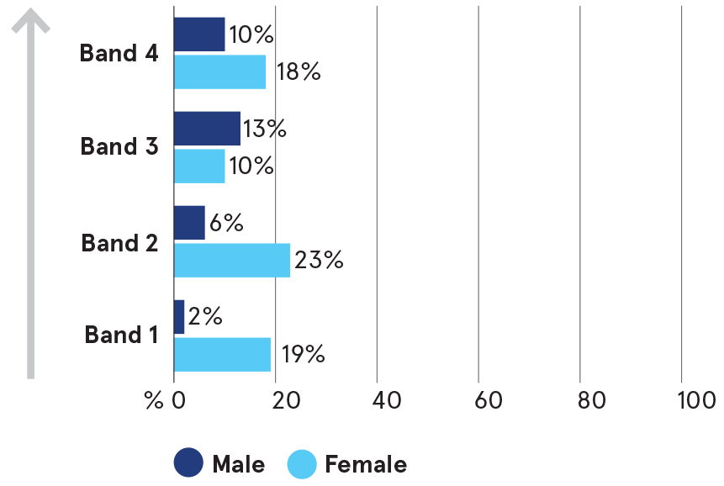
- Band 1: Male 2%; Female 19%
- Band 2: Male 6%; Female 23%
- Band 3: Male 13%; Female 10%
- Band 4: Male 10%; Female 18%

Who we are
Created by government for government, ANZSOG works with our owner governments and partner universities to strengthen the quality of public sector leadership in Australia and Aotearoa-New Zealand. We provide unique education programs, thought leadership and government-focused research that meet the contemporary challenges faced by public services. Our work inspires and connects people across agencies, sectors and jurisdictions.
Everything we do is designed to deliver better government and better outcomes for the public.

On 30 June 2020, the Board of Directors comprise:
- Mr Peter Hughes CNZM (Chair): Public Service Commissioner and Head of Service, Te Tumu Whakarae mō Te Kawa Mataaho
- Professor Ken Smith: CEO, ANZSOG
- Mr Chris Eccles AO: Secretary, Department of Premier and Cabinet (VIC)
- Professor Margaret Gardner AC: President and Vice-Chancellor, Monash University
- Ms Kathrina Lo: NSW Public Service Commissioner
- Dr Girol Karacaoglu: Head of School of Government, Victoria University of Wellington
- Ms Robyn Kruk AO: Board member, ANZSOG
- Ms Jodie Ryan: CEO, Department of the Chief Minister (NT)
- Mr Robert Setter: Commission Chief Executive, Queensland Public Service Commission
- Dame Karen Sewell DNZM, QSO: Board member and consultant, ANZSOG
- Professor Deborah Terry AO: Vice-Chancellor and President, The University of Queensland
- Mr Peter Woolcott AO: Australian Public Service Commissioner.

Government owners
- Australian Government
- Aotearoa-New Zealand Government
- Australian Capital Territory Government
- Northern Territory Government
- New South Wales Government
- Queensland Government
- Government of South Australia
- Tasmanian Government
- Victoria State Government
- Government of Western Australia

Member universities
- Australian National University
- Carnegie Mellon University, Australia
- Charles Darwin University
- Curtin University
- Flinders University
- Griffith University
- Melbourne Business School
- Monash University
- University of Melbourne
- University of New South Wales
- University of Queensland
- University of Sydney
- University of Canberra
- University of Tasmania
- Victoria University of Wellington

Affiliate partners
- Analysis & Policy Observatory (APO)
- China Executive Leadership Academy Pudong (CELAP)
- Department of Personnel and Training, Government of India
- Organisation for Economic Co-operation and Development (OECD)
- Singapore Civil Service College
- Lee Kuan Yew School of Public Policy
- Razak School of Government
- We acknowledge the Aboriginal and Torres Strait Islander peoples as First Peoples of Australia, and Māori as tangata whenua and Treaty of Waitangi partners in Aotearoa-New Zealand.
We acknowledge the Aboriginal and Torres Strait Islander peoples as First Peoples of Australia, and Māori as tangata whenua and Treaty of Waitangi partners in Aotearoa-New Zealand.

Follow us
ANZSOG website <https://www.anzsog.edu.au>
ANZSOG Facebook page <https://www.facebook.com/ANZSOG>
ANZSOG Twitter page <https://twitter.com/ANZSOG>
ANZSOG LinkedIn page <https://www.linkedin.com/school/anzsog>

