ANZSOG Impact snapshot 2018-19
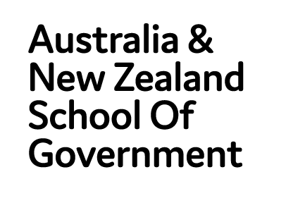
Owned by and working for the governments of Australia and New Zealand

MESSAGE FROM THE DEAN
ANZSOG is always adapting what we do to ensure we are preparing public service leaders for future challenges. Over the past financial year we have developed a new Strategic Plan to take us through to 2025. Last year, we invested $1.2 million to improve our capacity and governance. We have expanded our work with the Traditional Custodians and First Peoples of Australia and New Zealand. We have focused our research program to work closely with governments to produce outputs that meet their current needs and anticipate future requirements.
This report provides a snapshot of how ANZSOG is working to ensure we have a positive impact on governments across Australia and New Zealand and the communities they serve.
Professor Ken Smith, Dean and CEO, ANZSOG
“ANZSOG has given me another layer, another step up, to enhance what was already there. I now know how to navigate relationships for the benefit of the people who I’ve been trying to provide a platform for; which is vulnerable Aboriginal people. And now I truly understand what my purpose is.”
Paulleen Markwort, EMPA graduate, Acting Director Aboriginal Strategy and Oversight, Strategy and Planning at Victoria’s Department of Health and Human Services

KEY ACHIEVEMENTS 2018-19
Icon | Key Acheivement
 | 10,408 participants in ANZSOG courses and events
 | 200k+ downloads of ANZSOG/ANU press titles
 | 19,378 downloads of cases from the John L. Alford Case Library
 | 565,278 total page views of the ANZSOG website
 | 14,913 ANZSOG e-news subscribers
 | 87,872 ANZSOG social media engagements

EDUCATE

Tailored Learning
Since 2017, we have worked with the Tasmanian Government’s State Services Management Office to provide a comprehensive tailored learning program for the state’s senior public managers to build knowledge and capabilities
The program brought academics and practitioners from across Australia together to expose participants to new thinking, in an environment that encouraged genuine collaboration.
“We have a program that stretches participants in many leadership aspects by making full use of ANZSOG’s resources”
Jane Hanna, Tasmania
State Services Management Office Director

“The thing I loved about it the most is how it pushed you out of your comfort zone in a really safe way. When you look back at this course, you can see how clever they were and how they got us to work together and what they built over time.”
Stephanie Rowe EFP alum, Director of Compliance Services,
New Zealand Ministry for Primary Industries

ENRICH

Sparking debate
The Independent Review of the Australian Public Service (APS), chaired by David Thodey, is the biggest review in a generation and aims to transform the APS. It recognised ANZSOG’s depth and breadth of expertise by engaging us to use our worldwide network of academics to produce six research papers to guide the Review. Topics included integrity, contracting and commissioning, and the relationship between the APS and Ministers. The papers have received national media attention.
The Review said the papers:
“Provide an additional independent perspective, and are intended to support and enrich public discussion and debate.”

Building ethics and integrity
ANZSOG is making public sector ethics and integrity a key area of its practice by working with public sector commissions and individual agencies to build a greater understanding of issues relating to integrity. We are doing this by focusing on public sector integrity and ethics in deliveries, including work with the NSW Independent Commission Against Corruption to present the Strategic Responses to Corruption workshop and delivering a series of workshops on building a strong culture of integrity.

Bringing research to practitioners
Policy makers need access to robust, high-quality academic research when developing new policies and programs. But different cultures, incentives and expertise – and a lack of research translation – are barriers to the use of academic research by the public sector.
ANZSOG is making research more relevant and useful by funding.
The Mandarin to produce The Drop: a fortnightly email newsletter sent to 23,000 subscribers.

INSPIRE

Inspiring change in disability services
2009 Executive Master of Public Administration alum James Poskitt led the New Zealand Ministry of Social Development team which won a 2019 Spirit of Service Award for its work on disability system reform.
The Enabling Good Lives project aimed to give people with a disability and their families greater choice and control.
James says the program prepared him for the variety of challenges he would face as a public manager by giving him a “toolkit to use for his entire career”.
“This is about how people with a disability and government are partnering to lead a transformation. Collectively, we are creating the conditions for enduring partnership and change.”
James Poskitt

Innovating policy
When two Executive Master of Public Administration students met in 2015, they hatched an innovative plan which has had lasting, positive impacts.
Rod Chenhall worked for Corrective Services NSW and Graham Bradshaw headed up Standards and Services at Transport for NSW.
The pair used the skills they learned in the EMPA to create a pilot project where offenders on corrections orders performed much-needed maintenance work at train stations.
During its first year, Changing Outlooks delivered 7,255 hours of maintenance work worth $800,000, at a cost of $80,000. The project has now been extended to involve more agencies and different options for offenders.
“Offenders started to have a stake in that precinct and actually felt like they did something of value. Which for some of these people, I don’t think they’ve ever felt.”
Rod Chenhall

Sharing new ideas
ANZSOG’s Thought Leadership seminars bring inspirational thinkers - such as US innovation expert Beth Noveck, Professor Wolfgang Drechsler and the Grattan Institute’s John Daley - and new ideas to the public sectors of Australia and New Zealand.
In 2018-19, 4,691 people attended a range of free events across six jurisdictions, delivered in partnership with governments.
Attendees described them as: ”practical”, ”timely”, ”thought-provoking” and containing “detailed and in-depth analysis”.
“Loved this talk – lifted a veil from my eyes and allowed me to understand the world in new ways.”
Thought Leadership participant

CONNECT

Reimagining First Peoples’ affairs
The 2019 Reimagining Public Administration: First Peoples, governance and new paradigms conference was held in Melbourne with the financial support of the Australian Department of the Prime Minister and Cabinet. Over 400 delegates came together to imagine potential futures for First People’s Affairs in Australia and Aotearoa-New Zealand.
A total of 47 of the conference’s 54 speakers were First Peoples from Australia, New Zealand and the USA.
The conference has sparked a range of connections between First Peoples’ community leaders, public managers, academics and the not-for-profit sector, facilitating cross-jurisdictional sharing of ideas and success stories.

Using our Alumni’s skills and passion
ANZSOG’s alumni are a diverse network of more than 3,600 people based in 37 countries. They embody expertise, commitment and passion for delivering public value. In 2018, ANZSOG established an Alumni Advisory Council, to tap into the unique expertise of the alumni community and provide formal advice to ANZSOG about our future direction.
“The Alumni Advisory Council is about actually using the enormous brainpower and expertise that exists within the alumni network to solve real problems right now, and to connect people. We are at that point due to the critical mass of graduates across Australia and New Zealand,”
Simon Kent, Alumni Advisory Council Chair.

FINANCES IN BRIEF
In the 2018-19 financial year ANZSOG:
- Created a new team to focus on university relations
- Saw demand increase for courses tailored to meet the needs of our government owners
- Incurred costs for strategic work relating to Strategy 2025
- Increased investment in Better Evaluation to assist their establishment as a separate entity.

Revenue
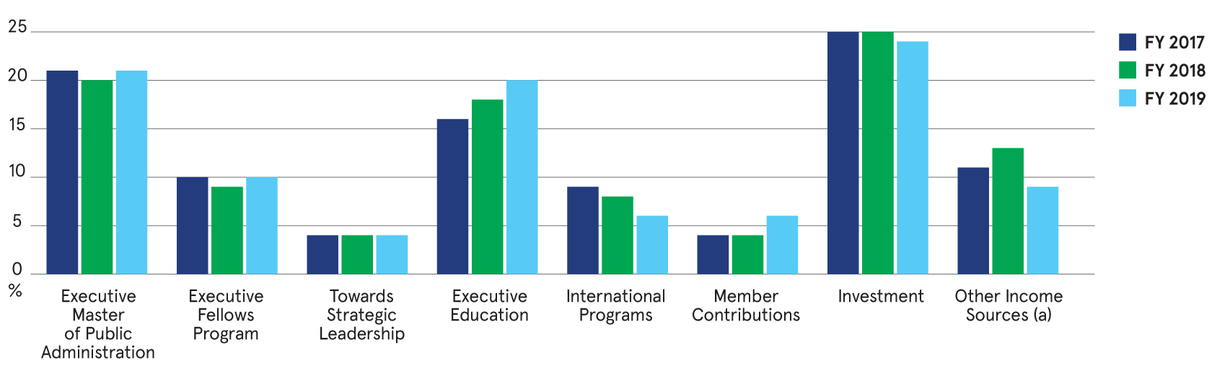

Revenue | FY2017 | FY2018 | FY2019
Executive Master of Public Administration | 21% | 20% | 21%
Executive Fellows Program | 10% | 9% | 10%
Towards Strategic Leadership | 4% | 4% | 4%
Executive Education | 16% | 18% | 20%
International Programs | 9% | 8% | 6%
Member Contributions | 4% | 4% | 6%
Investment | 25% | 25% | 24%
Other Income Sources (a) | 11% | 13% | 9%
Includes revenue derived from the Commonwealth and New Zealand Grant income. Also includes income from the Evaluation and Evidence Hub and Innovation/Thought Leadership activities.

Expenditure
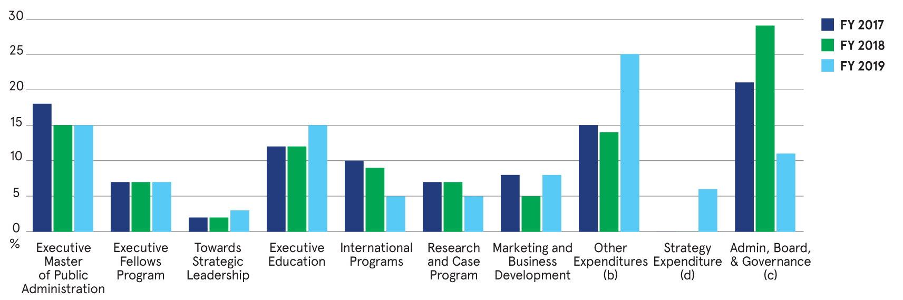

Expenditures | FY2017 | FY2018 | FY2019
Executive Master of Public Administration | 18% | 15% | 15%
Executive Fellows Program | 7% | 7% | 7%
Towards Strategic Leadership | 2% | 2% | 3%
Executive Education | 12% | 12% | 15%
International Programs | 10% | 9% | 5%
Research and Case Program | 7% | 7% | 5%
Marketing and Business Development | 8% | 5% | 8%
Other Expenditures (b) | 15% | 14% | 25%
Strategy Expenditure (d) | 0% | 0% | 6%
Admin, Board, & Governance (c) | 21% | 29% | 11%
Includes expenditure on the Evaluation and Evidence Hub, Innovation/Thought Leadership activities, University Relations and Academic Development
- Is attributed to School wide occupancy cost, Administration, Finance, HR and ICT. The decrease in FY 2018/19 is a result of administrative and occupancy expenses being distributed to the revenue generating cost centres. A further distribution of Finance, HR and ICT expenses will occur in future years
- Includes expenditure on Board approved Strategic Activities relating to the execution of Strategy 2025.

WORKFORCE METRICS

WORKFORCE COMPOSITION (PROFESSIONAL STAFF)

Gender
Gender | Percentage out of 61 staff
Male | 28%
Female | 72%

Age
Age | Percentage of staff
21-30 | 11%
31-40 | 38%
41-50 | 21%
50+ | 30%

Years of service
Years of service | Percentage of staff
0-3 | 89%
3-7 | 3%
7+ | 8%

Salary band by gender
Band | Gender | Percentage of staff
4 | Male | 24%
4 | Female | 76%
3 | Male | 41%
3 | Female | 59%
2 | Male | 18%
2 | Female | 82%
1 | Male | 18%
1 | Female | 82%

WHO WE ARE
ANZSOG was created by government, for government. Recognised as a world-leading organisation for public sector education, research and knowledge exchange, we bring together governments and universities across nations and jurisdictions.
Our core mission is to improve the lives of people in Australia and New Zealand by lifting the quality of public sector leadership through education, research and thought leadership.
“It really was life changing. It made me think about myself differently as a public sector leader and has given me a massive toolkit.”
Sonja Cox, EMPA graduate, Executive Director of People, Culture and Diversity
for the WA Public Sector Commission

Government owners

Member universities
- Australian National University
- Carnegie Mellon University, Australia
- Charles Darwin University
- Curtin University
- Flinders University
- Griffith University
- Melbourne Business School
- Monash University
- University of Melbourne
- University of New South Wales
- University of Queensland
- University of Sydney
- University of Canberra
- University of Tasmania
- Victoria University of Wellington

Affiliate partners
- Analysis & Policy Observatory (APO)
- China Executive Leadership Academy Pudong (CELAP)
- Department of Personnel and Training, Government of India
- Organisation for Economic Co-operation and Development (OECD)
- Singapore Civil Service College
- Lee Kuan Yew School of Public Policy
- Razak School of Government

(ANZSOG website) ANZSOG.EDU.AU

Follow us
Twitter: <https://twitter.com/ANZSOG>
Facebook: <https://www.facebook.com/ANZSOG/>
Linked In: <https://www.linkedin.com/school/anzsog/>
We acknowledge Aboriginal and Torres Strait Islander peoples as the First Peoples of Australia and Māori as tangata whenua and Treaty of Waitangi partners in Aotearoa-New Zealand.

