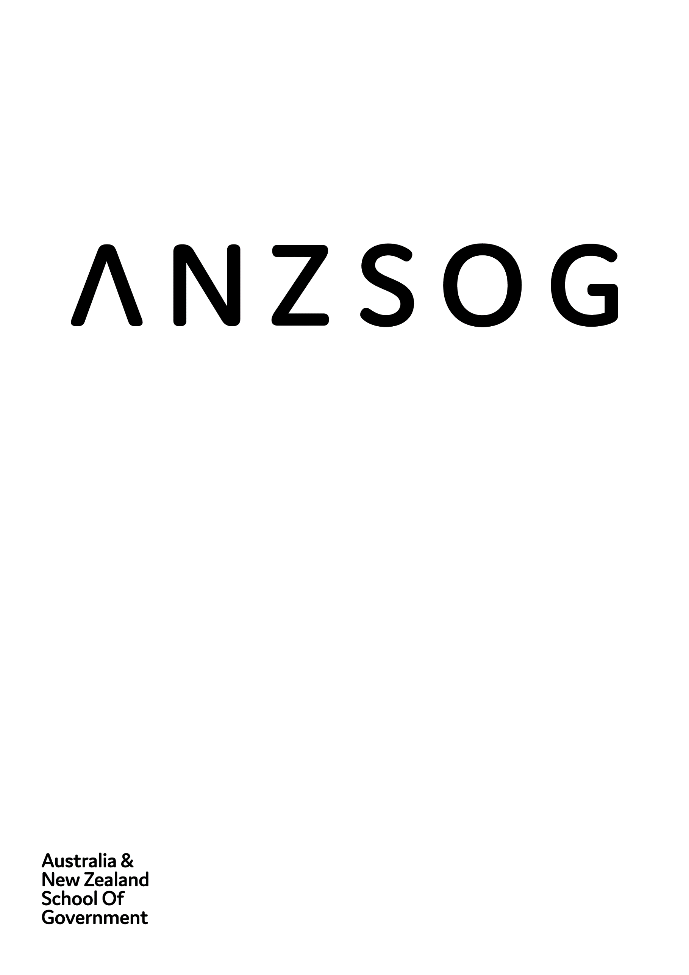
Impact Snapshot 2021
Owned by and working for the governments
of Australia and Aotearoa New Zealand

Contents
ANZSOG 3
Message from the Dean and CEO 4
Key achievements for 2021 5
Educate 6
Inspire 10
Enrich 14
Connect 16
Finances 20
Our workforce 21
Who we are 24
Follow us 26

ANZSOG
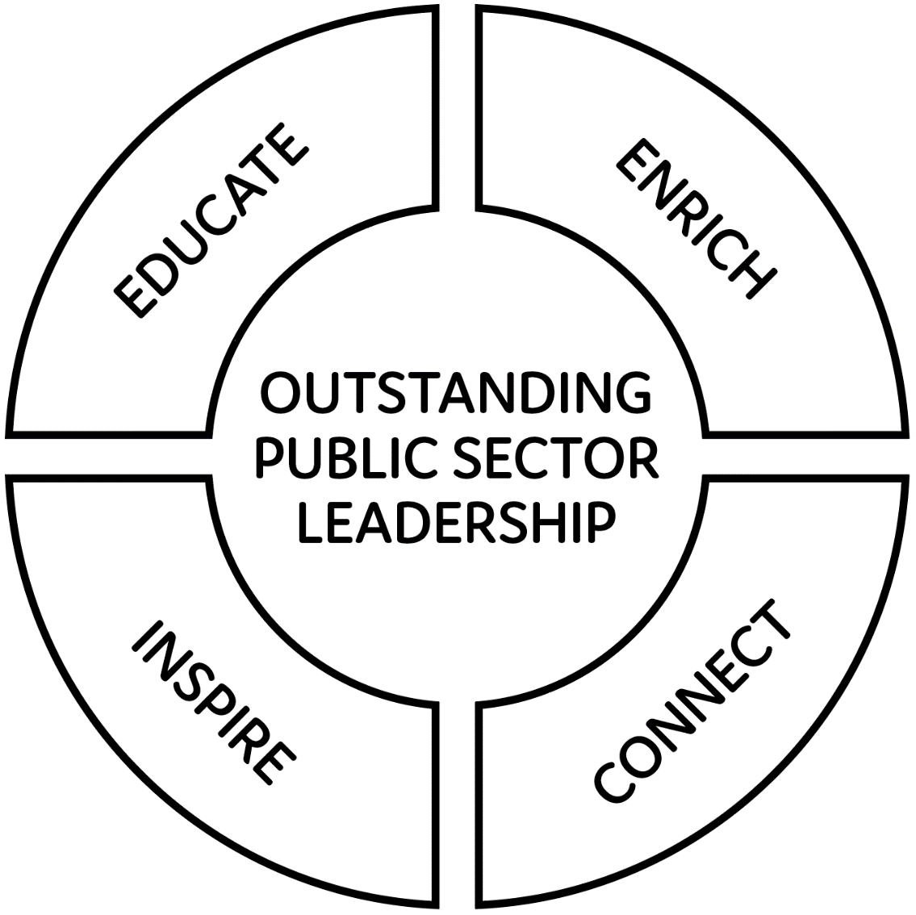
ANZSOG works for our government owners and with our university partners to lift the quality of public sector leadership across Australia and Aotearoa New Zealand. Our work inspires and connects people across agencies, sectors, jurisdictions and nations.

Message from the Dean and CEO
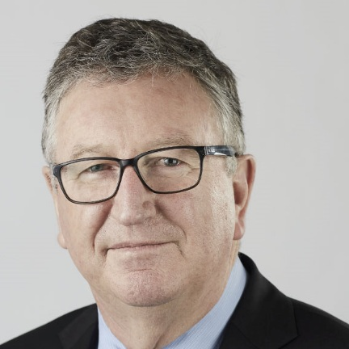
For ANZSOG, and our owner governments, 2021 was a second year of working in an environment shaped by COVID-19. It was a year of learning, reflection and strategic positioning. We remain uncertain about what changes will be transitory and those which have permanently changed how we work.
ANZSOG continues to deliver education, research and thought leadership programs which help governments address the extreme challenges posed by both the pandemic and general global uncertainty.
I have been delighted by the consistently strong response to our education programs – highlighting the desire among public sector leaders for high-quality relevant programs. Our flagship Executive Master of Public Administration has continued online, drawing external recognition for its reputation and quality.
Strong demand meant we ran two iterations of our Executive Fellows Program and Towards Strategic Leadership, and interest in our Deputies Leadership Program and the Future public sector leaders series was also strong. We have also increased the number of bespoke and custom education programs that we deliver to governments and agencies.
As part of a newly minted research strategy, we have begun two research projects which link universities with the ACT and NSW Governments respectively to look at the issues of flexible/remote work and the future of place-based services.
ANZSOG continues to incorporate First Peoples knowledge and culture into our curriculum. In 2021, we released our First Peoples Strategy and held our first virtual First Peoples conference Proud Partnerships in Place which brought together over 500 participants to exchange ideas and hear stories of success in Indigenous public administration.
We have been able to add to our network of universities with the addition of the University of Adelaide, a sixteenth member university, and have expanded our geographic footprint with the appointment of a Wellington-based director in Aotearoa New Zealand. Our Board of Directors has been expanded to allow for permanent representation from all our ten member jurisdictions.
The last two years have taught us to expect the unexpected, but I am confident that ANZSOG is well positioned to continue to help the governments of Australia and Aotearoa New Zealand as we slowly reopen to the world in 2022.
I would like to particularly thank ANZSOG board, staff and faculty for their dedicated work and commitment to our mission throughout 2021.
ANZSOG Dean and CEO Ken Smith AO, Enterprise Professor, University of Melbourne

Key achievements for 2021
- 8909 Total enrolments/registrations in ANZSOG programs
- 687,056 Unique Page Views for ANZSOG website (up 5% compared to 2020)
- 18,295 E-news subscribers (up 26.6% from end of 2020)
- 16,186 The Bridge subscribers (up 7.5% from end of 2020)
- 174,763 Social media engagement (up 52.9% compared to 2020)
- 20,443 John L. Alford Case Library downloads

Educate

Building on the Executive Master of Public Administration’s shift to online learning
Our flagship two-year Executive Master of Public Administration (EMPA) program has continued uninterrupted through the pandemic, with the program shifting to full online delivery while continuing to provide opportunities for the cohort to work together and build a network.
Online delivery allows us to use experts from the USA, Aotearoa New Zealand, and the Netherlands to give participants a global perspective.
Demand for the EMPA has been strong and the material has been adapted to reflect the challenges public managers are facing in the COVID environment. To ensure that we maintain and improve the quality of the EMPA, ANZSOG undertook an independent EMPA Academic Program Review to guide its future development and the reports from the Review will be published during 2022.

How independent assessors rated the Executive Master of Public Administration
“The EMPA is fit for purpose, that it has high standing with the relevant stakeholders, that it has an exceptionally well qualified academic staffing profile, and that ANZSOG’s framework for delivery is also fit for purpose.”
Compliance Review of the EMPA by Dr Michael Tomlinson and Emeritus Professor Valerie Braithwaite (Australian National University).
Manaia King, Executive Master of Public Administration graduate

Participants find the Executive Master of Public Administration relevant to their work
As part of the evaluation of the EMPA, ANZSOG looks at how relevant to their work participants find each subject. Below are their responses to the statement: ‘The learnings and insights from the subject are transferable to my workplace and can be applied to my organisational context’.
Subject | Mean response  (out of 5) | Percentage of respondents who agreed or strongly agreed
Delivering public value | 4.48 | 97%
Governing in a market economy | 4.25 | 95%
Designing public policies  and programs | 4.48 | 93%
Managing public sector organisations | 4.38 | 92%
Leading public sector change | 4.40 | 93%
Governing by the rules | 4.30 | 96%
Public financial management | 4.20 | 90%

What participants think of the Executive Master of Public Administration
“A great combination of very experienced, knowledgeable presenters. It’s a privilege to hear from so many great thinkers and operators who have strong public value, passion and commitment to the work they do! It’s been really inspiring.”
“Lots of ideas about value creation and co–production I can bring back to my teams and generate discussion about how we can incorporate these into our approach to regulatory work.”

Executive Fellows Program helps senior leaders make sense of the changing environment
The Executive Fellows Program (EFP) returned in 2021 with a new curriculum and a focus on helping participants understand both their own leadership and the social and economic issues and movements shaping their working environment. High demand led to two iterations of the program and the highest number of Aotearoa New Zealand participants in EFP history.
Three intensive sessions focused on leading the self and others, leading an organisation (including adaptive leadership) and systems leadership. These themes were explored using contemporary issues as a focal point, including the COVID-19 crisis response and recovery strategies, Black Lives Matter, the impact of climate change, and the #metoo movement.
4.66 / 5 EFP average participant evaluation
“The EFP gave me an in-depth understanding of change and how to manage change and some of the models around that – which is good because I’m taking my brand new organisation on a change journey. The whole experience gave me time to step out of what I was doing and step into the bigger picture of the public sector and the global situation.”
Ro Allen, Victorian Equal Opportunity and Human Rights Commissioner

Microcredentials offering flexible learning
ANZSOG partnered with Griffith University and Monash University in 2021 to deliver two microcredentialled courses - Making Better Decisions with Economic Thinking and Harnessing Behavioural Insights that gave participants the option of undertaking an assessed version of the course for credit towards a degree at the partner university. Led by Griffith University Business School Professor Ross Guest and Monash University’s BehaviourWorks team, the courses proved highly popular, with a total of 97 participants, and embodied our flexible approach to learning.

Unlocking the potential of Deputy leaders
The role of a Deputy leader in a government agency has become more complex and more influential in recent years. ANZSOG’s Deputies Leadership Program returned in 2021 with a new online format and a range of presenters with Deputy experience. It was designed to get the participants to think more broadly about the potential of their Deputy role, and encourage them to develop an integrity-based leadership style, as well as build a valuable professional network.
4.53 / 5 Average evaluation score

Inspire

How some of our over 3000 alumni are making a difference

Charlene Davison – Australia
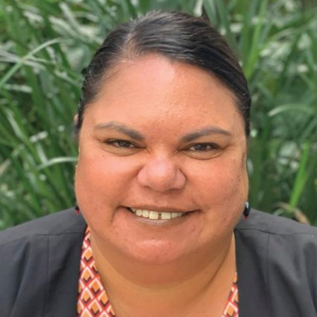
Charlene’s career has combined her passion for education with her belief in the need for more Aboriginal people in senior public sector roles to improve services for Aboriginal communities. The proud Biripi/Gadigal woman commenced her Executive Master of Public Administration in 2019 and, after 20 years of working in the NSW public service took up a new challenge in 2021 as Chief Executive Officer of Indigenous education not-for-profit GO Foundation.
“The tools and frameworks I learnt have been really important but the biggest thing is the self-belief. You understand that you are here for a reason, and that you’ve got a lot to contribute. I’ve come out of it with more confidence and more guts to stand up for what I believe in.”

David Simmonds – Australia
In his role as Director, Transport Accessibility & Inclusion, for the Department of Transport in Victoria, David is passionate about making sure that everyone can use Victoria’s buses, trams and trains. A sufferer from retinitis pigmentosa since his teens, he has used his lived experience of disability to make life easier for others. A recent recruit to the public service, he undertook ANZSOG’s Towards Strategic Leadership program in 2021 to broaden his perspective.
“Because the participants came from diverse areas and careers within government and from different geographic locations and cultures, there was a lot to learn from each other. After TSL, I listen more deeply to what is being communicated and I’m a better critic of myself.”

Director Paul James – New Zealand
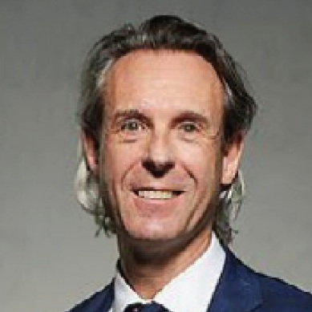
Paul was appointed as Secretary for Internal Affairs and Chief Executive for Te Tari Taiwhenua/Department of Internal Affairs in 2018. Of his varied career, he says his work as Director of Office of Treaty Settlements, which saw a significant increase in the rate of Treaty of Waitangi settlements achieved, was the most rewarding. He says an ANZSOG Executive Fellows Program in 2008 rekindled his love for public sector work and gave him a new understanding of leadership.
“I gained a whole lot of insight into myself as a leader. I think the EFP gave me some tools and frameworks, some richer lenses and a deeper appreciation of the things that really mattered in the leadership role I was playing.”

Janet Sparrow – Australia
Janet has 20 years of experience in environmental policies, programs and education initiatives. The Executive Master of Public Administration she completed in 2020 is already helping her with her new challenge as Manager, Strategy with Resilience in NSW. As well as helping communities rebuild and recover after natural disasters like floods, droughts and bushfires her organisation is developing a State Resilience Strategy that focuses on prevention, preparation and recovery, bringing together government, the not-for-profit sector and communities.
“The group work was also valuable because you meet amazing people you wouldn’t otherwise connect with. You build a network, find out more about what they do and draw out differences in approaches and disciplines that different people bring to their work.”

ANZSOG Alumni honoured in Queen’s Birthday and Australia Day Honours
The range and value of some of our alumni’s contributions to their communities is recognised each year in the Australia Day and Queen's Birthday Honours lists in Australia, and the State Service Commission Awards in Aotearoa New Zealand. Below are those recognised in 2021.

Order of Australia
Dr Gillian Ann Sparkes (Victorian Government – Towards Strategic Leadership 2010) was made a Member of the Order of Australia (AM) for significant service to environmental sustainability, and to public administration.

Public Service Medals
Jennifer Wilkinson (Commonwealth Government – Executive Fellows Program 2011): For outstanding public service in the development of fiscal policy, particularly in the formulation of the federal government’s economic response to COVID-19.
Lynn Glover (Victorian Government – Executive Fellows Program 2019) For outstanding public service to education and training in Victoria.
Dr David Howes (Victorian Government – Executive Master of Public Administration 2004) For outstanding public service to education in Victoria, including during the 2019/20 Victorian bushfires.
Nicholas Egan (Western Australian Government – Executive Master of Public Administration 2010) For outstanding public service as State Solicitor of WA.
Jodie Ryan (Northern Territory Government – ANZSOG Board member) For outstanding public service to the community of the NT through a range of roles.
Chris Faulkner (Commonwealth Government – Executive Master of Public Administration 2008): For outstanding public service to complex development of policy in support of Australians with a disability during the COVID-19 pandemic.
Jenny Atta (Victorian Government – Executive Fellows Program 2011): For outstanding public service to strategic social policy reform and delivery in Victoria.

Future public sector leaders program delivers fresh ideas
As part of our response to the COVID-19 pandemic ANZSOG began the Future public sector leaders (FPSL) series in the second half of 2020. It gave emerging leaders, and established leaders looking to refresh their approach, the chance to expose themselves to new thinking through a flexible series of online seminars. A positive response to the idea meant that FPSL has returned in 2021/22 as a permanent part of ANZSOG’s offering. Presenters include senior academics, former practitioners and politicians and the series covers policy development, leading with integrity, building partnerships with First Peoples, managing diversity and systems leadership.

First Peoples Strategy
A guiding principle of ANZSOG’s varied activities is to work with governments and communities across Australia and Aotearoa New Zealand to promote and prioritise the perspectives and contributions of First Peoples. In 2021 we launched our First Peoples Strategy after broad consultation with our owner governments, university partners and First Peoples. The Strategy has three broad objectives. We want to build a future where:
- First Peoples have increased success at all levels of the public sector
- Public services are increasingly culturally competent as a result of ANZSOG’s programs
- ANZSOG is a culturally confident organisation supporting the Australian and Aotearoa New Zealand governments
For the First Peoples Strategy to be successful, we must also recognise and be guided by First Peoples knowledges, values and ways of doing. We will work with our broader networks of First Peoples public sector leaders, alumni, researchers and community leaders to guide us and deliver on the objectives in this strategy.
While the implementation of the strategy is still evolving, we have already increased the number of Indigenous participants in programs and have increased our emphasis on First Peoples content in the Executive Master of Public Administration and the Executive Fellows Program.
Of current EMPA students, 62.2% agree that:
“The EMPA is enhancing my understanding of, and ability to engage with, First Peoples’ perspectives and priorities”

Enrich

Negotiating and delivering research projects on key public sector issues
ANZSOG's Research Strategy takes a demand-led, practice-driven and collaborative approach to research based on our unique ability to connect academics and practitioners. In 2021 we announced funding of two research projects that will bring together governments and universities to address issues brought into focus by the COVID-19 pandemic.
A partnership with the ACT Public Service (ACTPS) and the University of New South Wales’s Public Service Research Group will examine the impact of flexible working on the productivity, wellbeing and effectiveness of ACTPS workers and examine factors that can lead to more effective flexible working. The ACTPS says they “anticipate uncovering patterns in the evidence that will help us to prepare for both transformation and disruption”.
Another partnership with the New South Wales Department of Premier and Cabinet and the University of New South Wales Social Policy Research Centre (SPRC) will examine how place-based services are evolving and examine the effects of virtual and hybrid modes of service delivery on stakeholders and local communities.

Using our expertise to advise governments and agencies
During 2021, ANZSOG’s Research & Advisory team produced a range of reports and analytical work for agencies including the Commonwealth Government Department of Innovation, Science, Energy and Resources, the Commonwealth Department of Education Skills and Employment, the Australian Public Service Commission, the Victorian Public Sector Commission, and the Interjurisdictional Workforce Data Analytics Committee. This work allows us to use our expertise and networks to advise agencies on how to strengthen their capabilities and how they can adapt to the modern public sector environment and the impact of COVID-19.

Bridging the gap between research and academics
ANZSOG’s The Bridge Research Translation project entered its second year in 2021 and expanded its fortnightly readership to over 16,000 people. The Bridge offers readers a tailored summary of research that’s relevant to the public sector, as well as Research Briefs which summarise an academic article on issues such as: performance measurement in the public sector, growth-oriented leadership, and workplace gender equality
A survey of Bridge readers in 2021 showed that:
- 78% are in the public sector and 10% in the university sector
- 79% said they had shared Bridge content with colleagues
- 91% said they had used Bridge content in their daily work

Contributing our knowledge to create a better understanding of public servants
The Palgrave Handbook of the Public Servant examines what it means to be a public servant in today’s complex and volatile world. It was edited by Helen Dickinson, Helen Sullivan, and Hayley Henderson and comprises 96 contributions from scholars and practitioners with a variety of approaches from around the world. ANZSOG’s Professor Janine O’Flynn and Professor Catherine Althaus have made significant contributions to the book based on their extensive knowledge of the public service and experience in educating senior leaders, and were joined as ANZSOG contributors by Dr Avery Poole and Patrick Lucas.

New additions to the ANZSOG Case Library
The ANZSOG John L. Alford Case Library is an internationally recognised library of freely available public sector cases, which provide a unique resource centre for the advancement of interactive teaching.
In 2021 eight new cases were commissioned and written for the Case Library. It was also expanded to include the Wise Practice collection: a range of public administration and policy resources centred on the knowledge and culture of the First Peoples of Australia and Aotearoa New Zealand. These resources focus on stories which demonstrate how First Peoples culture, knowledge and perspectives can achieve successful outcomes when Indigenous communities and governments come together to work in partnership.

Partnering with the Australian Public Service Academy
The Australian Public Service launched its APS Academy led by EMPA alum Grant Lovelock in August 2021 to lift the capability of the APS and encourage an agency-wide approach to building skills. ANZSOG is an Academy partner and has provided its support and expertise in areas including regulatory leadership and development of integrity programs.
ANZSOG will continue to work with the Academy on its goal of equipping APS people and teams with the skills, tools and knowledge to deliver the best outcomes for the Australian community.

Connect

Virtual conference celebrates First Peoples’ Proud Partnerships

First Peoples conference
The ANZSOG 2021 virtual First Peoples public administration conference: Proud Partnerships in Place attracted over 500 participants to its four sessions in February/March. The conference shared stories of successful place-based partnerships between governments and First Peoples, based on trust, respect and giving genuine power to First Peoples. Of the 24 speakers, 21 were Indigenous including ministers from Australia and Aotearoa New Zealand. Other Aotearoa speakers included Justice Sir Joe Williams and Lil Anderson CEO of Te Arawhiti/Office for Māori Crown Relations. ANZSOG subsidised tickets for 102 community attendees, researchers and students and the virtual format made it easier for a wider audience and especially people in remote areas, to participate. To create a permanent, accessible record of the conference, recordings from the keynote addresses, panel discussions and yarning circles are now part of ANZSOG’s Wise Practice collection.
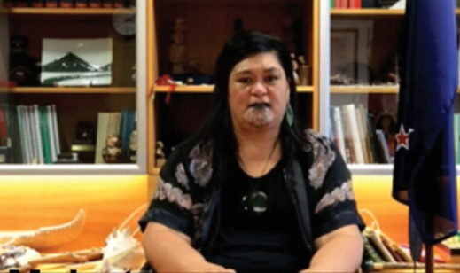
Nanaia Mahuta, Aotearoa New Zealand Foreign Minister
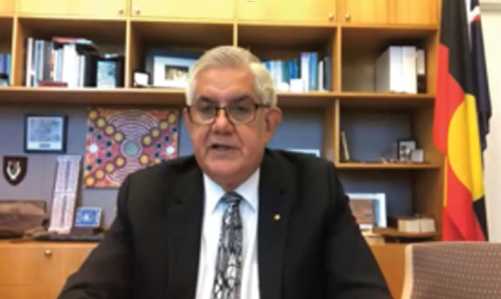
Ken Wyatt, Minister for Indigenous Australians
Overall Conference participant evaluation:
4.19 / 5 overall rating of the four events

What participants thought:
“I was impressed and reassured by the depth and spread of committed, smart, professional and articulate leaders from both jurisdictions.”
“Loved the virtual format and this worked well, also liked the fact it was spread out over four weeks. The calibre of the speakers was excellent. I enjoyed hearing about NZ and Australia experiences and being able to compare and contrast the two.”
“The conference was really great, worked well and was really informative. Took a lot away that I’ve taken to team meetings within my workplace.”

Inaugural First Peoples Scholarship awarded
Victorian public servant Brenda McDermott, a Palawa woman from the Manegin Community of North West Tasmania, has spent decades building fruitful relationships with Aboriginal communities in Gippsland and across Victoria. She has been awarded our inaugural First Peoples Scholarship and will be part of the 2022 ANZSOG Executive Master of Public Administration. She says this will give her the tools to understand the bigger picture of government, improve her leadership and give her knowledge she can bring back and share with communities.
“I’m interested in the process of government and leadership, and where I struggle as a community-based person is to learn about those ways of doing things. I’d like to learn how it all works. I’d also like to transfer that knowledge back through my networks with community groups, because it is also a big unknown space for many of our community members.”
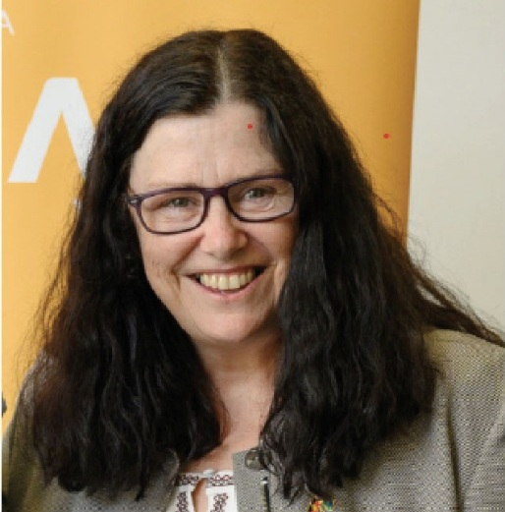
Brenda McDermott

New Partnership with Adelaide University
The University of Adelaide will become an ANZSOG member university, in a partnership which will open up new possibilities for education, thought leadership and research programs developed with its new Stretton Institute. It will become our 16th member university and our first for a decade.

Improving regulatory practice by bringing regulators together
The National Regulators Community of Practice (NRCoP) auspiced by ANZSOG provided opportunities throughout 2021 for regulators across Australia and Aotearoa New Zealand to meet virtually and be exposed to new ideas about regulation. With the roles and practice of many regulators changing as they responded to the challenges of COVID-19, getting access to new ideas and contact with fellow regulators has become increasingly important. Surveys of webinar participants found that 82% had shared ideas from the webinars with their workplace and 71% had applied them in their work. The NRCoP is also working on progressing a program of professional development for regulators based on the successful G-Reg program.
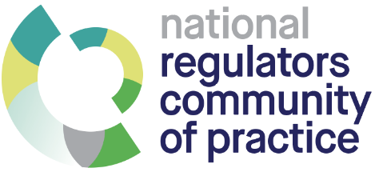
- 9,611 Total registrations for NRCoP’s 13 webinars in 2021
- 14,639 Views of NRCoP webinars via the ANZSOG YouTube channel
- 4.5 / 5 NRCoP Webinar average evaluation
- 6,042 Number of NRCoP Subscribers

“We recently used the APO Jobs Board to advertise a number of senior regulatory roles. We were delighted with the results – strong fields of well qualified candidates. The APO Jobs Board gave our recruitment campaign a great profile and much wider reach. It is a practical resource for quickly connecting regulators looking for their next challenge to opportunities in agencies across the community of practice”
Roxane Marcelle-Shaw, CEO / Executive Director, Professional Standards Authority
“I am completely thrilled to be able to hang out with the Regulators Community of Practice because as far as I can tell there is no such thing anywhere else on earth. The energy that has gone into this, and the commitment to the cross-domain learning that you've been able to derive from this, I think is a dream come true.”
Harvard University Professor Malcolm Sparrow

Finances
1 January 2021 – 31 December 2021
Figures covering revenue and expenditure across programs from Jan 1 - Dec 31, 2021.

Income
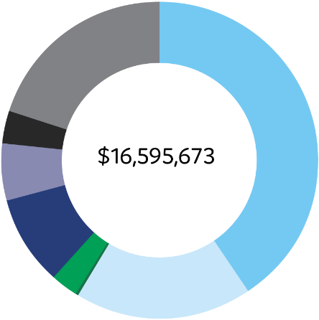
Total: $16,595,673
Foundation Programs 40.7%
Executive Education 18.2%
International Programs 0.1%
Research & Academic 2.9%
Other Events 9.2%
Member Contributions 5.9%
Other Income Sources 3.2%
Investment 19.9%
Note:
- Foundation Programs is comprised of EMPA, EFP and TSL
- Other income includes Jobkeeper

Expenses
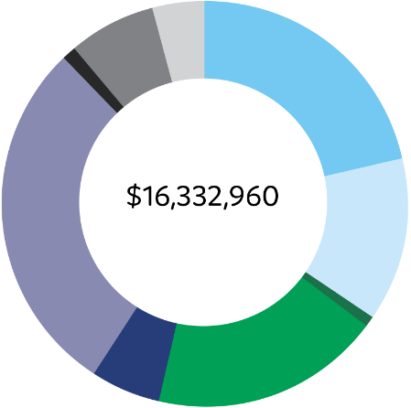
Total: $16,332,960
Foundation Programs 21.4%
Executive Education 13.3%
International Programs 0.7%
Research & Academic 18.3%
Other Events 5.5%
Admin, Board & Governance 28.8%
Strategic Expenditure 1.1%
Marketing and Business Development Expenses 7%
Other Expenditure 3.9%
Note:
- Research & Academic includes expenditure related to Seconded and funded academic positions
- Admin, Board and Governance include expenditure related to governance and operational support such as Finance, ICT, HR
- Other Expenditure include expenditure related to Investment management and Office Facilities

Our workforce
As of 31 December 2021

Board

Gender
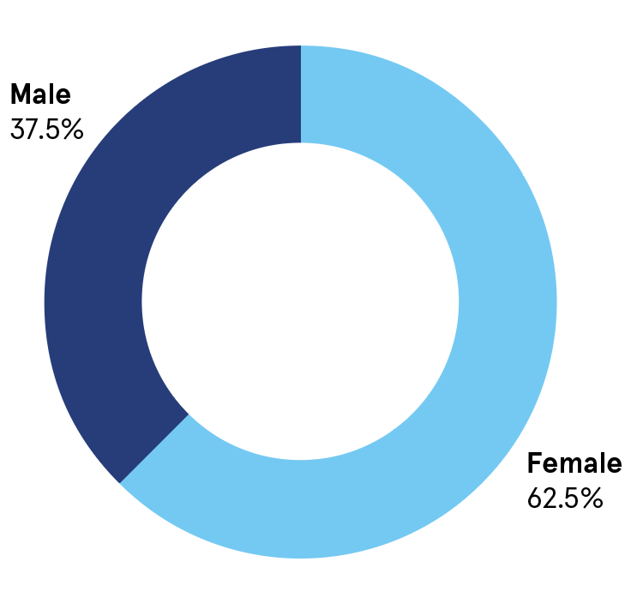
- Female 62.5%
- Male 37.5%

Age
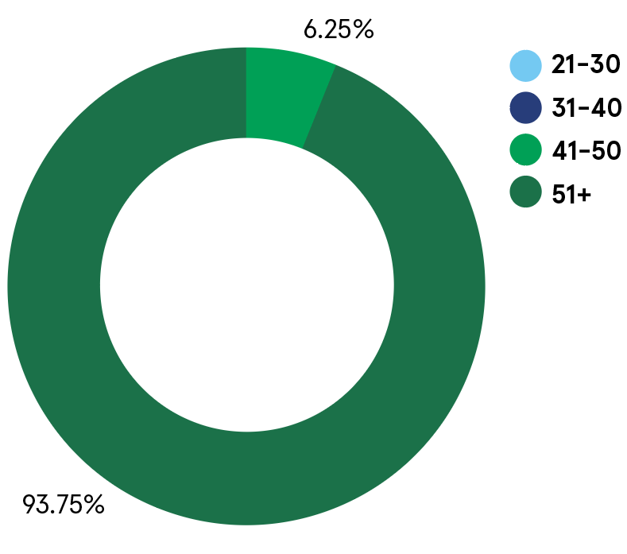
- Age 21-30: 0%
- Age 31-40: 0%
- Age 41-50: 6.25%
- Age 51+: 93.75%

Years of service
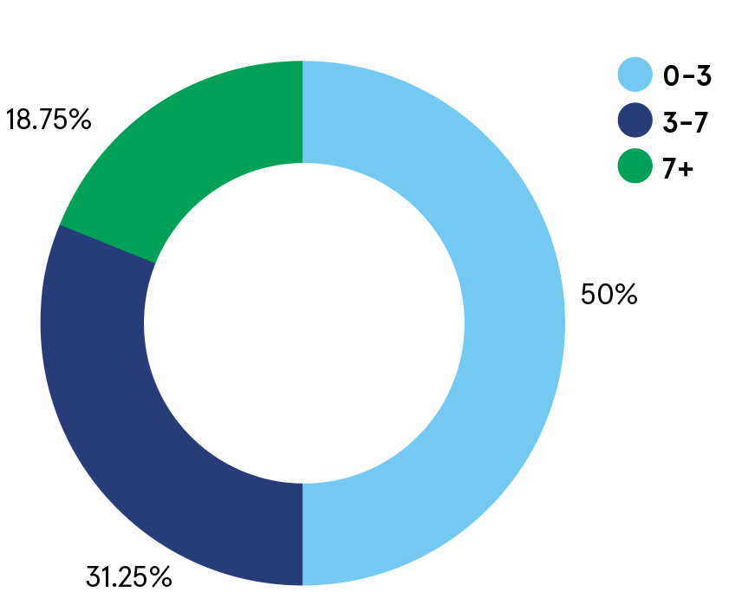
- 0-3 years: 50%
- 3-7 years: 31.25%
- 7+ years: 18.75%

Staff

Gender
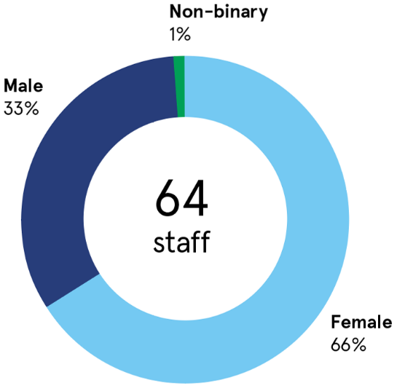
64 staff:
- Female 66%
- Male 33%
- Non-binary 1%

Age
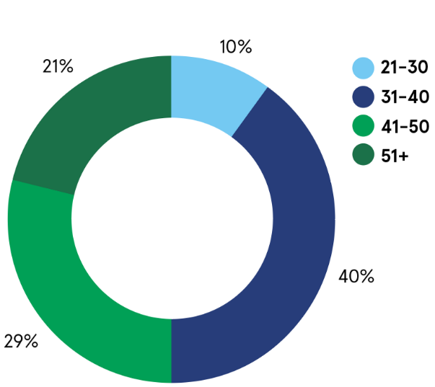
- Age 21-30: 10%
- Age 31-40: 40%
- Age 41-50: 29%
- Age 51+: 21%

Years of service
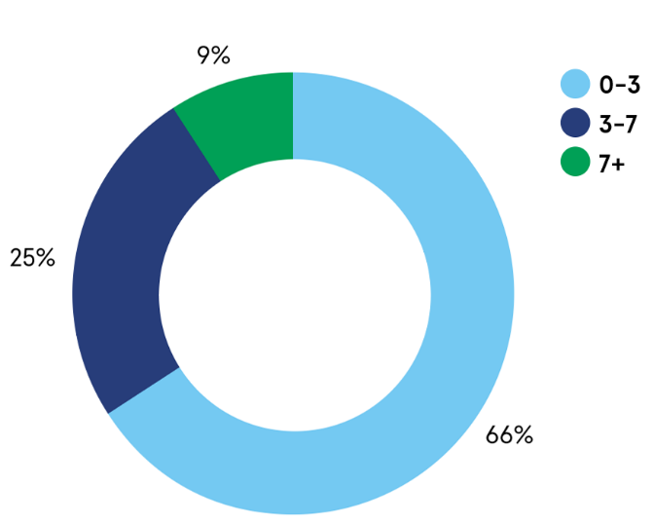
- 0-3 years: 66%
- 3-7 years: 25%
- 7+ years: 9%

Gender by band – staff
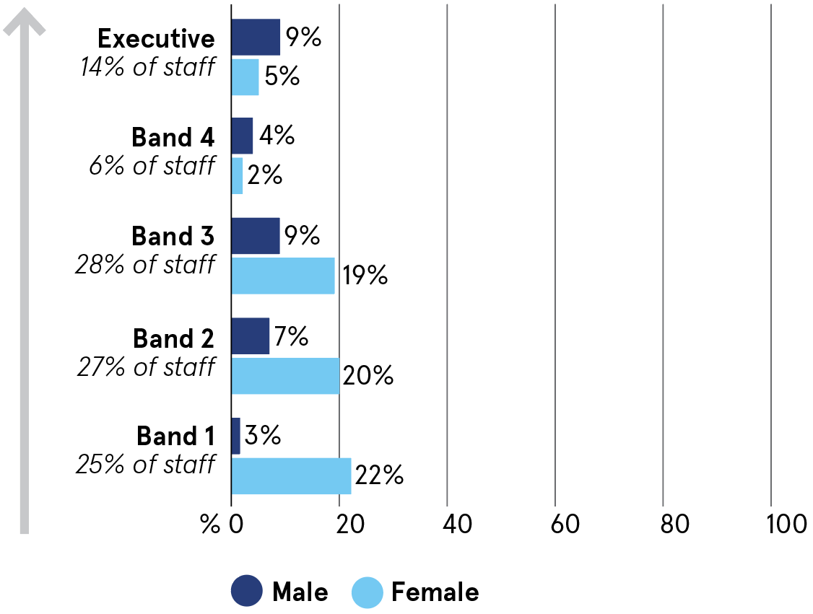
- Band 1 (25% of staff): Female 22%; Male 3%
- Band 2 (27% of staff): Female 20%; Male 7%
- Band 3 (28% of staff): Female 19%; Male 9%
- Band 4 (6% of staff): Female 2%; Male 4%
- Executive (14% of staff): Female 5%; Male 9%

Diversity
In 2021 we conducted our first diversity survey of staff, as part of our work to create a positive workplace culture that values the benefits diversity can bring to an organisation working in the Indo-Pacific region. Some of the key findings:
- 23% of staff were born outside Australia and Aotearoa New Zealand
- 27% spoke a language other than English with their family or community
- 60% have worked outside of Australia and/or Aotearoa New Zealand
- 5% have a disability

Who we are
Created by government for government, ANZSOG works with our owner governments and partner universities to strengthen the quality of public sector leadership in Australia and Aotearoa New Zealand. We provide unique education programs, thought leadership and government-focused research that meet the contemporary challenges faced by public services. Our work inspires and connects people across agencies, sectors and jurisdictions. Everything we do is designed to deliver better government and better outcomes for the public.

Our Board
ANZSOG’s Board sets the organisation’s strategic direction and oversees the effectiveness of delivery against strategy. During 2021 the Board was expanded from 12 to 15 members to ensure that all jurisdictions are permanently represented. As of December 31, 2021, the board consists of:
- Mr Peter Woolcott AO (Chair): Australian Public Service Commissioner
- Mr Peter Hughes CNZM: Te Tumu Whakarae mō Te Kawa Mataaho Public Service Commissioner - Head of Service, Te Kawa Mataaho Public Service Commission
- Professor Ken Smith AO: CEO, ANZSOG
- Professor Margaret Gardner AC: President and Vice-Chancellor, Monash University
- Mr Jeremi Moule: Secretary for the Victorian Department of Premier and Cabinet
- Ms Kathrina Lo: NSW Public Service Commissioner
- Professor Girol Karacaoglu: Head of School of Government, Victoria University of Wellington, New Zealand
- Ms Ann Sherry AO: Board member, ANZSOG
- Ms Jodie Ryan: CEO, Department of the Chief Minister (NT)
- Mr Robert Setter: Commission Chief Executive, Queensland Public Service Commission
- Ms Belinda Clark QSO: Board member, ANZSOG
- Professor Deborah Terry AO: Vice-Chancellor and President, The University of Queensland
- Ms Erma Ranieri: Commissioner for Public Sector Employment, SA
- Ms Kathy Leigh: Head of Service and Director-General | Chief Minister, Treasury and Economic Development Directorate, ACT Government
- Ms Jenny Gale: Secretary of Tasmanian Department of Premier and Cabinet and Head of State Service
- Ms Sharyn O'Neill: WA Public Sector Commissioner

Our member universities
Australian National University
Carnegie Mellon University, Australia
Charles Darwin University
Curtin University
Flinders University
Griffith University
Melbourne Business School
Monash University
University of Adelaide
University of Melbourne
University of New South Wales
University of Queensland
University of Sydney
University of Canberra
University of Tasmania
Victoria University of Wellington

Our affiliate partners
Analysis & Policy Observatory (APO)
China Executive Leadership Academy Pudong (CELAP)
Department of Personnel and Training, Government of India
Organisation for Economic Co-operation and Development (OECD)
Singapore Civil Service College
Lee Kuan Yew School of Public Policy
Razak School of Government

Our owner governments
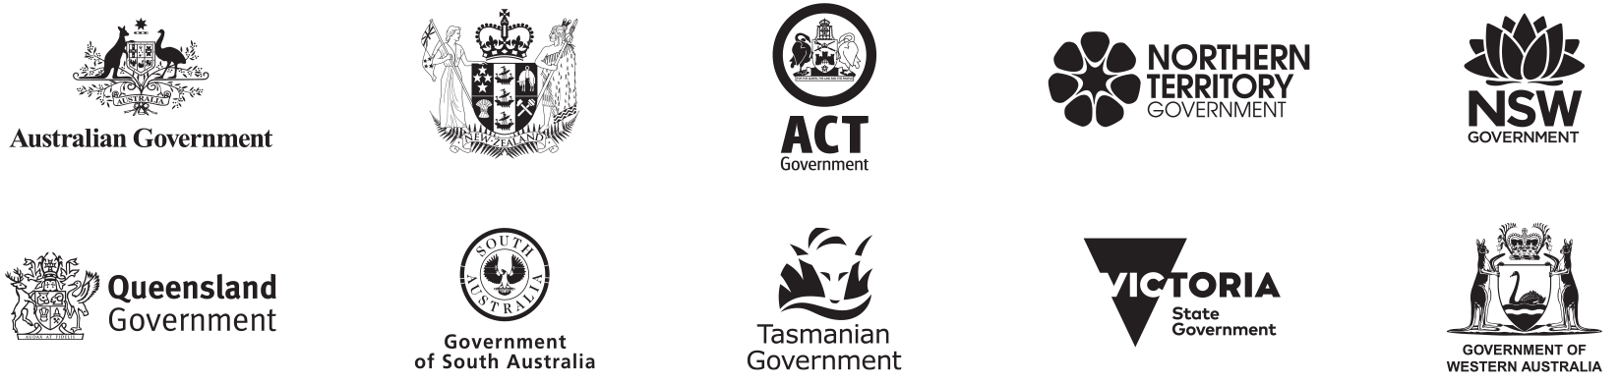

- Australian Government
- Aotearoa New Zealand Government
- Australian Capital Territory Government
- Northern Territory Government
- New South Wales Government
- Queensland Government
- Government of South Australia
- Tasmanian Government
- Victoria State Government
- Government of Western Australia

We acknowledge the Aboriginal and Torres Strait Islander peoples as First Peoples of Australia, and Māori as tangata whenua and Treaty of Waitangi partners in Aotearoa New Zealand.

Follow us
ANZSOG website
ANZSOG Facebook page
ANZSOG Twitter page
ANZSOG LinkedIn page

