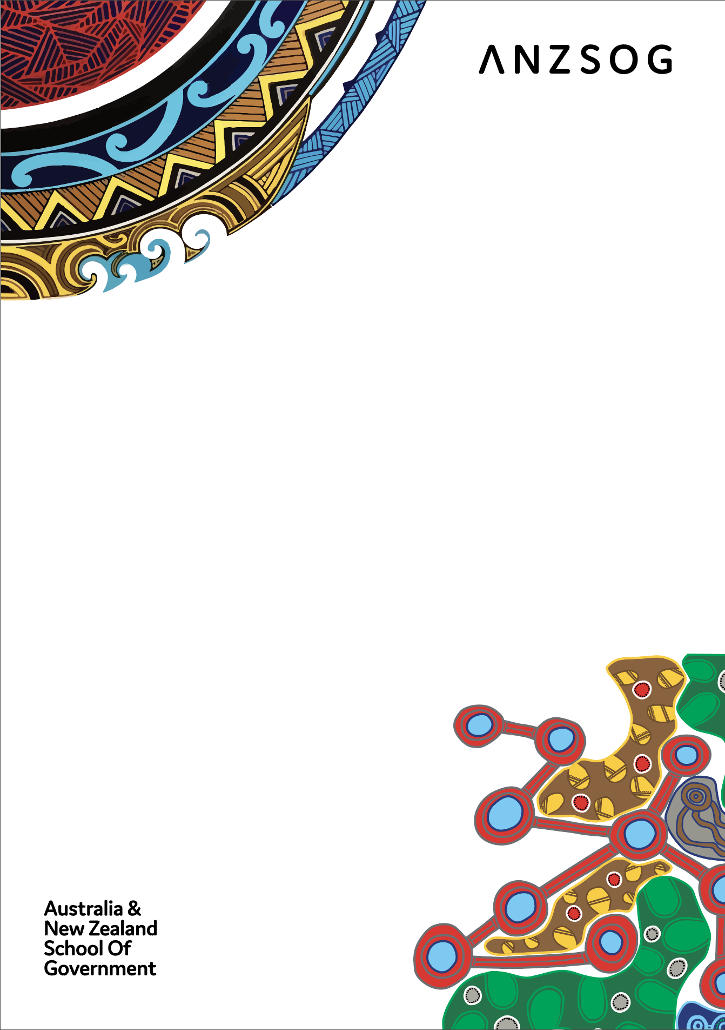
First Peoples Strategy

Contents
Acknowledgments 3
Message from the Dean 4
About ANZSOG 5
Why have a First Peoples Strategy? 6
Developing the First Peoples Strategy 7
ANZSOG First Peoples Strategy 8
First Peoples Strategy – monitoring, reporting and review 11
Glossary 12
Follow us 14

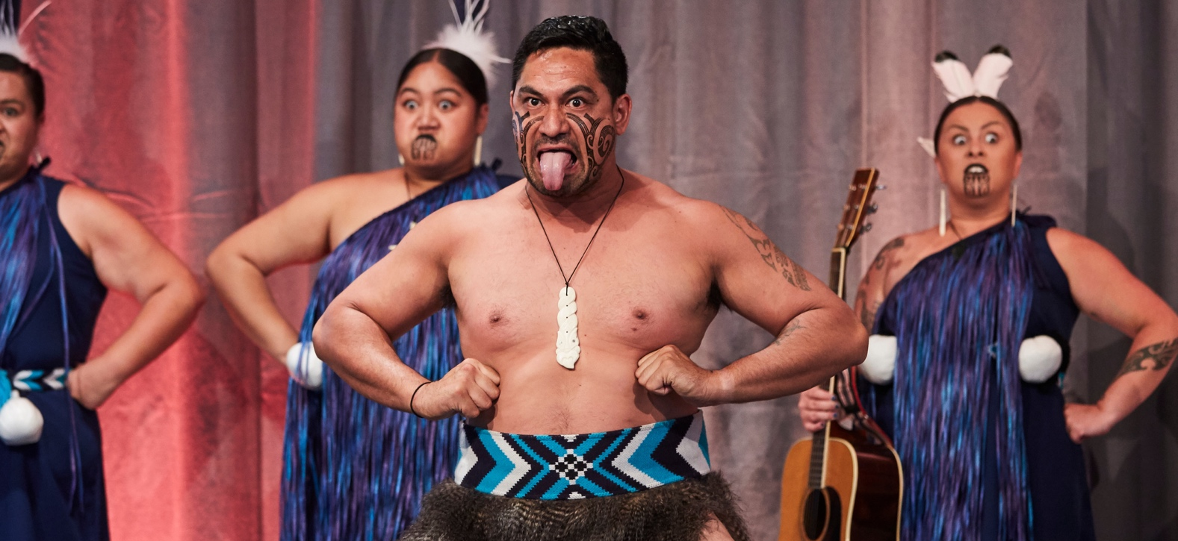
Nga Mātai Pūrua - the Melbourne-based kapa haka group performing haka, poi and waitai at the
2019 Reimagining Public Administration: First Peoples, governance and new paradigms conference <<https://www.anzsog.edu.au/conferences/previous-conferences/reimagining-public-administration>>

Acknowledgments
ANZSOG acknowledges Aboriginal and Torres Strait Islander Peoples as the First Peoples of Australia, and Māori as Tangata Whenua (people of the land) and Treaty of Waitangi partners with the Government in Aotearoa-New Zealand.
Development of the ANZSOG First Peoples Strategy was led by Kiel Hennessey, Strategy and Curriculum Lead – First Peoples Programs and Strategy. We would also like to thank the contributions and advice of the following in developing the strategy:
- ANZSOG Staff
- ANZSOG Alumni
- ANZSOG Faculty Leads
- ANZSOG Alumni Advisory Council
- Jurisdiction Leading Agencies and Partner Universities interviews, including at:
  - NSW Public Service Commission
  - ACT Chief Minister, Treasury and Economic Development Directorate
  - Australian Public Service Commission
  - Te Puni Kōkiri, Ministry of Māori Development
  - QLD Public Service Commission
  - South Australian Office of the Commissioner for Public Sector Employment
  - Tasmanian Government
  - VIC Public Service Commission
  - Office for Māori Crown Relations – Te Arawhiti
  - Monash University
  - Griffith University
  - University of Tasmania
  - Curtin University
  - Australian National University

Message from the Dean
ANZSOG is recognised globally as a leading provider of executive-level education for the public sector. For almost 20 years we have developed and delivered innovative leadership education programs. We are owned by, and work for, the governments of Australia and New Zealand and play a unique role in building the capacity of their current and future public services.
While First Peoples have participated in ANZSOG programs for many years as students and guest speakers, we have only recently begun incorporating First Peoples knowledge and culture into all our activities. This strategy consolidates our achievements to date and outlines the significant work we have ahead of us.
In order to deliver effective public policy and better outcomes for First Peoples, and progressively repair the impact of colonisation, our public services need to continuously change and adapt. ANZSOG will contribute to that change in understanding and approach.
Efforts to improve policy outcomes for First Peoples that centre on self-determination, will not succeed unless public services recognise the need to work with First Peoples communities as equals, and to incorporate First Peoples ways of being and knowing, across policy and program design and delivery.
Public services must work to recruit and retain First Peoples staff at all levels, foster First Peoples leadership inside and outside public services, and recognise and respect the existing strengths of First Peoples communities and styles of leadership.
ANZSOG’s mission is to lift the quality of public service leadership in Australia and New Zealand. Helping create culturally competent public services which value and include First Peoples perspectives and help build and strengthen First Peoples leadership, is a central part of that mission.
Artwork: Timeless – by Bigambul man Jordan Roser
Commissioned by ANZSOG for the 2017 Indigenous Affairs and Public Administration: Can’t we do better? conference <https://www.anzsog.edu.au/indigenous-affairs-conference>

About ANZSOG
ANZSOG was created in 2002 by government, and university members across Australia and New Zealand. Our purpose is to improve the lives of people in both nations by lifting the quality of public sector management. We work to create public value through education, thought leadership and research.
ANZSOG’s Strategy 2025 <https://www.anzsog.edu.au/preview-documents/publications-and-brochures/5430-anzsog-strategy-2025> lays out a vision to be a world-leader in public sector education, research and knowledge exchange. A guiding principle of the Strategy is a commitment to “working with communities across Australia and New Zealand to promote and prioritise the perspectives and contributions of First Peoples”.
Summary of ANZSOG Strategy 2025
Vision | Our vision is to be a world-leading organisation for public sector education, research and knowledge exchange.
Purpose | Our purpose is to improve the lives of people in Australia and New Zealand by lifting the quality of public sector leadership.
Values | Excellence  Collaboration  Integrity  Respect
Approach | Founded by government, for government. We work with our 10 owner governments and 15 university partners. We connect jurisdictions across Australia, New Zealand and the Indo-Pacific.
Objectives and strategic priorities | Outstanding public sector leadership  Educate  Enrich  Inspire  Connect
Guiding principles | Global reach, regional focus  Inclusion and diversity  First Peoples perspectives  Stewardship  Demand-led
Note: For more information, the full ANZSOG 2025 strategy can be found on the found at the ANZSOG corporate publications page <https://www.anzsog.edu.au/about/about-us/corporate-publications>.

Why have a First Peoples Strategy?
Aboriginal and Torres Strait Islander peoples occupy a unique position as the First Peoples of Australia and the caretakers and custodians of Country for over 60,000 years. Similarly, Māori have cared for and exercised sovereign political rights over Aotearoa-New Zealand for many generations and occupy a unique position as Treaty of Waitangi partners with the Crown for 180 years. Indigenous models of governance and political organisation are some of the oldest and longest continuing in the world and are a foundation for our understanding of distinctly Australian and New Zealand governance models.
Developing a First Peoples strategy also recognises the impact of colonisation on Indigenous peoples, and the long history of government policies and actions that have disadvantaged and discriminated against First Peoples in both Australia and New Zealand. The relationship between governments and First Peoples can be fraught and lacking in trust due to these histories. First Peoples make up a disproportionate representation of government service users, especially in welfare, health, and justice, as a direct result of, for example, inadequate housing and education systems. The public sector executives we educate have decision-making and policy responsibilities in many of these areas and need to understand Indigenous history, culture, and pedagogies, to better serve the needs and interests of First Peoples.
Equally we need better representation of First Peoples at all levels including senior decision-making levels in the public service to better serve communities. This requires culturally safe leadership programs that recognise the legitimate value of Indigenous knowledge and practice.
ANZSOG’s Strategy 2025 <https://www.anzsog.edu.au/preview-documents/publications-and-brochures/5430-anzsog-strategy-2025> commits to “working with communities across Australia and New Zealand to promote and prioritise the perspectives and contributions of First Peoples”. The ANZSOG First Peoples Strategy builds on this commitment. We aim to deliver actions that focus on core First Peoples principles and respectful engagement practices that enable First Peoples to lead. The key to this success will be our investment of resources, reciprocal and collaborative partnerships and open and transparent accountability across all deliverables.

Developing the First Peoples Strategy
The First Peoples Strategy was drafted in partnership with ANZSOG First Peoples staff and the executive and academic leadership, using the following sources of information:
- A thematic analysis of leading First Peoples strategies across Australia and New Zealand government jurisdictions, universities and non-government organisations. Over 60 strategies were reviewed capturing the main themes, including strategic objectives, identified actions and outcome measures, timeframes, evaluation processes and embedding First Peoples values and principles.
- Surveys of ANZSOG Staff, Executive and Academic Leadership, Faculty Leads and Alumni. Over 130 responses were received, capturing a wealth of information on working at ANZSOG, ANZSOG education offerings, and opportunities to strengthen curriculum development, and teaching and learning.
- Interviews across Australian and New Zealand government jurisdictions and university partners. Questions covered a range of areas including: First Peoples strategic and research priorities; cultural capability; examples of success; and learnings and First Peoples executive leadership. The interviews also covered what practical actions would be required to progress meaningful outcomes.

ANZSOG First Peoples Strategy
The First Peoples Strategy has three objectives. We want to help build a future where:
- First Peoples have increased success at all levels of the public sector
- Public services are increasingly culturally competent as a result of ANZSOG’s programs
- ANZSOG is a culturally confident organisation supporting the Australian and New Zealand governments
In implementing the First Peoples strategy, ANZSOG will be guided by the values and principles set out in Strategy 2025. But for the First Peoples strategy to be successful, we must also recognise and be guided by First Peoples knowledges, values and ways of doing. A critical part of an Indigenous worldview is the need to take a holistic approach to the strategy. Achieving our strategic objectives also requires looking at the bigger picture and how our actions work together and connect to achieve our goals. A Māori holistic approach will always involve the four dimensions of hauora (wellbeing): taha tinana (physical wellbeing), taha hinengaro (mental and emotional wellbeing), taha whanau (social wellbeing) and taha wairua (spiritual wellbeing).
First Peoples values are not inconsistent with the ANZSOG values, but how they apply in a First Peoples context is different. For instance:
- Excellence: In the First Peoples context, this means we are committed to providing a platform for First Peoples knowledge, culture and expertise in a way that celebrates innovation and excellence. It also means taking a strengths-based approach in our First Peoples work.
- Collaboration: This forms part of a broader value in First Peoples communities of relationality. Working relationally means investing in long-term relationships, understanding systems of relationships and developing genuine collaborative partnerships centred in reciprocity. In a First Peoples approach, relationships are not limited to just those between people, but extend to our relationships with Country, whenua (land), and all living things.
- Respect: This means respecting First Peoples expertise and centring Indigenous knowledge systems and ways of working. All relationships between ANZSOG and First Peoples should be founded in reciprocity and respect.
- Stewardship: Stewardship is essential to an Indigenous worldview, reflecting a responsibility to guide and care for relationships. It connotes a long-term focus with a duty to make decisions for Country and community.
The above interpretations of the ANZSOG values will guide the First Peoples strategy. The image below conceptualises the core principles and values underpinning the First Peoples strategy, with a holistic approach at the centre, and some of the core ANZSOG values and principles interconnecting through this central point. The concept of collaboration has been reconceptualised as relationality, and culture has been added as a central component of our approach.
ANZSOG recognises that as a non-Indigenous organisation we need First Peoples leading First Peoples work. In addition to First Peoples staff at ANZSOG, we will work with our broader networks of First Peoples public sector leaders, researchers and communities to guide us and deliver on the objectives in this strategy.
A First Peoples approach to the strategy
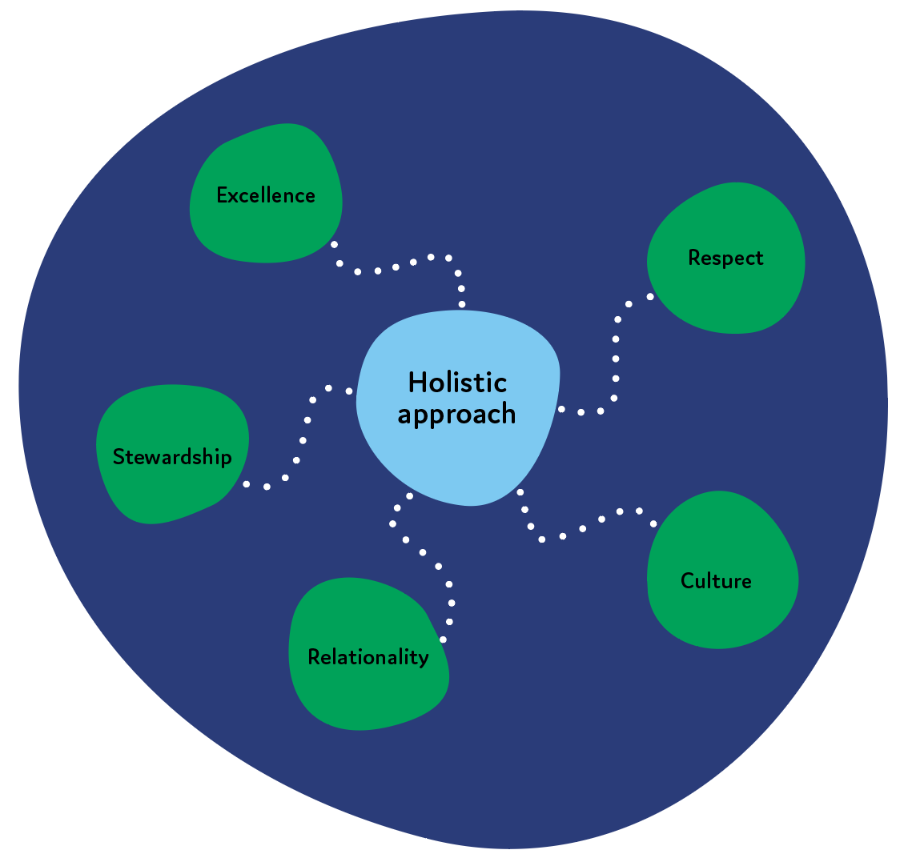

The following table outlines ANZSOG’s role in achieving the three strategic objectives through our programs and other activities. Specific accountabilities and performance metrics will be incorporated in the annual ANZSOG planning, budgeting and reporting cycle. The table also sets indicators for the next 3 years (2020-2022) to measure the success of ANZSOG.
ANZSOG First Peoples Strategic Plan
Strategic Objective | ANZSOG can contribute by: | Progress indicators
First Peoples succeed in the public sector | Ensuring ANZSOG courses are relevant and accessible to First Peoples and are culturally safe | Number of First Peoples undertaking ANZSOG foundation programs  Feedback on the quality of ANZSOG programs by First Peoples participants  Number of First Peoples faculty and presenters contracted by ANZSOG
 | Offering specific programs and activities to support First Peoples leadership | Number of First Peoples training, and leadership development activities offered  Evaluation scores of First Peoples specific programs
 | Engaging and supporting ANZSOG First Peoples alumni | Number of ANZSOG First Peoples alumni
 | Conducting research to progress First Peoples leadership in the public sector | Number of research projects relevant to First Peoples public administration topics
Public services are culturally competent | Ensuring our program participants are exposed to First Peoples perspectives in their courses, including practical ways to apply perspectives in their work | Quality and quantity of First Peoples content across ANZSOG programs.  Number of ANZSOG program participants exposed to First Peoples perspectives in ANZSOG courses.  Non-Indigenous alumni rate themselves as more culturally competent and culturally confident after completing ANZSOG programs
ANZSOG is a culturally confident organisation | Ensuring ANZSOG staff and Faculty are culturally confident | Number of ANZSOG staff who have completed cultural competency training (both Aboriginal and Torres Strait Islander and Māori training)
 | Ensuring representation of First Peoples across the organisation | Number of First Peoples recruited and retained in academic and professional at ANZSOG  Number of First Peoples recruited and retained in senior/ decision-making roles at ANZSOG
 | Ensuring respect and support for First Peoples culture and knowledge, including the diversity of those cultures | Presence of policies, activities and protocols which respect First Peoples culture and history
 |  | Presence of communications focusing on First Peoples success, research and news
 | Ensuring ANZSOG has reciprocal relationships with First Peoples and their communities | $Amount invested in First Peoples (scholarships, suppliers, or community partnerships)
 |  | Reputation of ANZSOG among First Peoples stakeholders

First Peoples Strategy – monitoring, reporting and review
- Monitoring: ANZSOG’s performance against the First Peoples strategy will be monitored on an ongoing basis. Accountability for implementation of the strategy, data collection and reporting will sit across the organisation, and be the ongoing responsibility of the ANZSOG Executive Management Team
- Reporting: ANZSOG will report progress on actions to the Board every 12 months, and will publish progress in ANZSOG’s annual Impact Snapshot.
- Review: The First Peoples Strategy will be reviewed in 2022, with a continuous quality improvement (CQI) goal of producing a further strategy encompassing 2023-2025, complementing the remaining Strategy 2025 reporting period.

Glossary
Alumni | A graduate of one of the ANZSOG foundation programs of EMPA, EFP or TSL.
ANZSOG | Australia and New Zealand School of Government.
Bespoke program | An ANZSOG workshop or program tailored to the specific needs of a government client. It can also include forums, seminars and other short courses outside ANZSOG’s foundation programs.
Cultural competence | Describes the ability to work effectively with different cultures. It reflects a basic understanding of cultural differences and histories and an ability to work respectfully with different cultures
Cultural confidence | Describes the level of confidence with which an individual or organisation works with different cultures. It describes a higher-level capability than cultural competence, reflecting an approach where individuals and organisations work actively with different cultures, demonstrate respect, and take initiative to deepen their understandings and know where to go for answers and advice.
Cultural safety | An environment that respects cultural identities, and is spiritually, socially and emotionally safe for people.
EFP | ANZSOG Executive Fellows Program.
EMPA | ANZSOG Executive Master of Public Administration.
Faculty | A person contracted by ANZSOG to lead a subject or bespoke workshop. The engagement should be for a minimum of 4 hours teaching in one subject or program.
First Peoples | Refers to Aboriginal and Torres Strait Islander peoples and Māori.
First Peoples specific programs | A program for a First Peoples cohort, including the Senior Indigenous Public Servant Forum.
Foundation programs | The ANZSOG EMPA, EFP and TSL programs.
Guest presenter | A person contracted by ANZSOG or by a subject/ workshop leader to present as a guest teacher, speaker or panel discussant. The engagement would be less than 4 hours per contract/ arrangement.
Identified role | An identified role where only Aboriginal or Torres Strait Islander or Māori are eligible to apply.
Mainstream program | A program not specifically targeted to First Peoples participants.
Mainstream role | A role which is not ‘identified’ and does not specifically focus on First Peoples.
Participants | Someone who has completed an ANZSOG program including a short courses or the Senior Indigenous Public Servant Forum or First Peoples Public Administration Conference.
Treaty of Waitangi | New Zealand’s founding document, signed between the Crown and 540 Māori chiefs in 1840.
TSL | ANZSOG Towards Strategic Leadership program.
Whenua | Māori word for land.

Te Haerenga – The Journey by Aaron Mctaggart, commissioned by ANZSOG for Proud partnerships in place: 2021 First Peoples Public Administration Virtual Conference <https://www.anzsog.edu.au/conferences/proud-partnerships-in-place>
Journey – Where we have been & where we are going by Wemba Wemba woman Emma Bamblett, commissioned by ANZSOG for the 2019 Reimagining Public Administration: First Peoples, governance and new paradigms conference <https://www.anzsog.edu.au/conferences/previous-conferences/reimagining-public-administration>

Follow us
ANZSOG website <https://www.anzsog.edu.au>
ANZSOG Facebook page <https://www.facebook.com/ANZSOG>
ANZSOG Twitter page <https://twitter.com/ANZSOG>
ANZSOG LinkedIn page <https://www.linkedin.com/school/anzsog>

